LeNet5/Computational Graph
Si-Sheng Young
M.S. Student
Institute of Computer and Communication Engineering (CCE)
National Cheng Kung University (NCKU)
Email:q36111037@gs.ncku.edu.tw

Abstract - LeNet-5 is a classic convolutional neural network architecture designed for handwritten digit recognition. The architecture consists of 7 layers, including 3 convolutional layers, 2 subsampling layers, and 2 fully connected layers. This time, we will implement LeNet5 using only numpy and without any deep learning-related packages, and then improve upon it.

Index Terms -classification、deep learning .、LeNet-5

I. Introduction
LeNet-5, introduced by Yann LeCun in 1998 as a convolutional neural network for recognizing handwritten digits, stands out as one of the most influential experimental systems in the early days of CNNs. While LeNet-5 was the first typical CNN architecture, it was AlexNet's innovative network structure that garnered the attention of many researchers. Subsequent studies expanded upon AlexNet to develop a variety of classic networks, classified into five main directions, The experiment is divided into three parts and can be summarized as follows:

A. Experiment description
1) Two-layer neural network: Implement two layer classification network without any deep learning based package.
2) LeNet5: Implement LeNet5 and use only numpy and OpenCV, change handwriting dataset to 32*32*3 RGB image with 65536 training data and 450 test data in 50 class.

3) Improved LeNet5 :

Activation function: x = Sigmoid(x) ==> x = x*sigmoid(x)
Kernel size: 5x5 ==> 3x3
Increase at least one convolution layer to LeNet5 (any position).

TABLE I
TRAIN PARAMETER
Network size (pts.) | Network size
Network size (pts.) | Two-layer neural network | LeNet5 | Improved LeNet5
6
8 | Section titlesª, references, tables, table namesª, table captions, figure captions, footnotes, text subscripts, and superscripts
9 |  | Abstract, Index Terms
10 | Authors' affiliations, main text, equations, first letter in section titlesª |  | Subheading
11 | Authors' names
22 | Paper title
ªUppercase
B. Preparing Your PDF Paper for IEEE Xplore©
Detailed instructions on how to prepare PDF files of your papers for IEEE Xplore© can be found at
http://www.ieee.org/pubs/confpubcenter
PDF job setting files for Acrobat versions 4, 5 and 6 can be found for downloading from the above webpage as well. The instructions for preparing PDF papers for IEEE Xplore© must be strictly followed.
II. related work
A. LeNet-5 and Deep-learning Classification
LeNet-5 is a deep learning architecture designed for image classification tasks. It was proposed by Yann LeCun et al. in 1998 and was one of the first successful convolutional neural network (CNN) models.

The architecture of LeNet-5 consists of seven layers, including three convolutional layers, two subsampling layers, and two fully connected layers. The convolutional layers extract features from the input image by convolving it with learned filters. The subsampling layers reduce the spatial dimensionality of the feature maps while preserving important information. The fully connected layers perform classification based on the extracted features.

LeNet-5 was originally designed for handwritten digit recognition and achieved state-of-the-art performance on the MNIST dataset. Since then, it has been used for various image classification tasks, including face recognition and traffic sign recognition. It has also served as the basis for more complex and powerful deep learning architectures, such as AlexNet, VGG, and ResNet.

Deep learning refers to a class of machine learning algorithms that use neural networks with multiple layers to extract high-level features from raw input data. Deep learning models have achieved state-of-the-art performance in a variety of tasks, including image and speech recognition, natural language processing, and game playing. Deep learning models can be supervised, unsupervised, or semi-supervised, and can be used for both classification and regression tasks.

In summary, LeNet-5 is a classic deep learning architecture designed for image classification tasks. It consists of multiple layers of neural networks that extract and classify features from raw input data. Deep learning is a broad class of machine learning algorithms that use neural networks with multiple layers to perform various tasks.

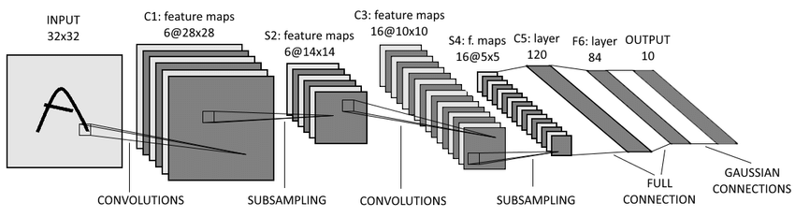
Fig. 1 LeNet-5Architecture diagram.
B. Dataset
This architecture was primarily designed for handwritten digit recognition and is considered one of the first successful applications of deep learning. The LeNet-5 dataset used for training and testing the network consists of 60,000 grayscale images of size 32x32 pixels, representing handwritten digits from 0 to 9. The dataset is split into 50,000 training images and 10,000 test images. Each image in the dataset is preprocessed by centering it and scaling its intensity values to the range of [0, 1]. The dataset is further augmented by applying random translations and rotations to the images, which helps to increase the size of the training set and improve the robustness of the network. The LeNet-5 dataset is widely used as a benchmark dataset for testing the performance of convolutional neural networks on image classification tasks.
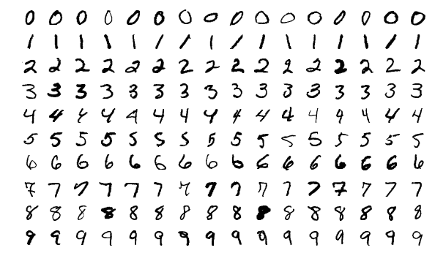
Fig. 2 LeNet-5 handwritten dataset.

In our experiment of implementing LeNet-5 using only numpy, we replaced the original handwritten digit recognition dataset with a more challenging animal recognition dataset. The dataset contains 50 different categories of dogs with varying sizes, and includes both RGB and grayscale images. In order to use the LeNet-5 architecture, we cropped all images to a size of 32x32 and removed the grayscale images. The dataset was then split into a training set of 65,536 images and a test set of 450 images, as well as a validation set.
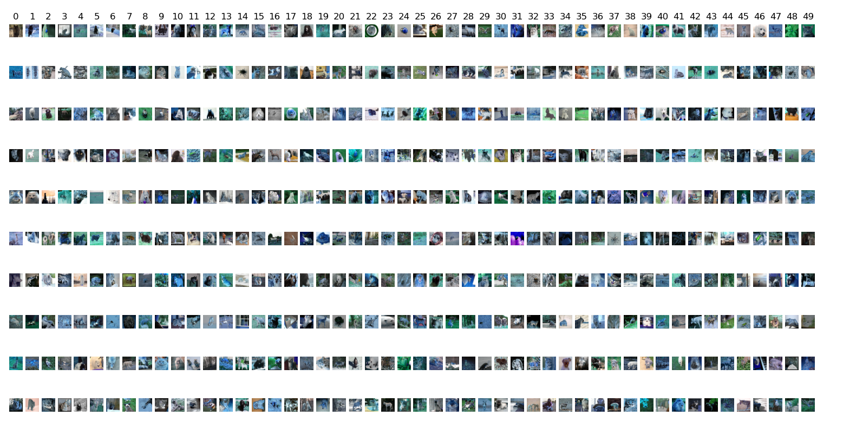
Fig. 3 LeNet-5 Animals dataset.

C. MODEL COMPONENTS
Define abbreviations and acronyms the first time they are used in the text, even if they have been defined in the abstract. Abbreviations such as IEEE, SI, MKS, CGS, ac, dc, and rms do not have to be defined. Do not use abbreviations in the title unless they are unavoidable.
D. Loss function
NLL (Negative Log-Likelihood) loss is a common loss function used in machine learning, particularly in classification tasks. It measures the difference between predicted probabilities and true probabilities of classes in a classification problem.

In a classification problem, the model assigns a probability to each class, and the true class is represented as a one-hot encoded vector with a value of 1 in the true class and 0 elsewhere. The NLL loss function calculates the negative logarithm of the predicted probability of the true class. Mathematically, it can be expressed as:

NLL Loss = -log(p_true)

where p_true is the predicted probability of the true class.

The NLL loss penalizes the model more for predictions that are further away from the true class, as the negative logarithm grows quickly as the predicted probability approaches zero. In other words, the NLL loss encourages the model to assign high probabilities to the true class and low probabilities to the other classes.

The NLL loss is commonly used in combination with softmax activation function, which converts the model's output into a probability distribution over the classes. It is often used as the loss function in multi-class classification problems, where the goal is to predict the correct class among several mutually
exclusive classes.

III. MODEL Architecture
A. Two-layer neural network
This is a Python implementation of a neural network class called "Neural Network". It has an initialization method that takes in the input size, hidden size, and output size as parameters, and initializes the weights randomly using a Gaussian distribution with a standard deviation of 0.1. The class also has a forward method that takes in an input X, calculates the output of the first layer using the tanh activation function, and the output of the second layer using the softmax activation function. It returns the output of the second layer.

The class also has a backward method that takes in the input X, the correct output y, and a learning rate as parameters. It calculates the gradients of the weights and biases using backpropagation, and updates them using gradient descent.

In particular, the backward method first calculates the gradient of the second layer using the difference between the predicted output and the correct output. It then calculates the gradient of the first layer using the backpropagation formula, and updates the weights and biases using the calculated gradients and the learning rate.

Overall, this class provides a basic implementation of a neural network with one hidden layer, using the tanh and softmax activation functions for the hidden and output layers, respectively.

B. LeNet5 implement with numpy
This is a Python code for a class called LeNet5, which is a convolutional neural network (CNN) model. The LeNet5 class inherits from the Net class, which is not shown in this code snippet.

The LeNet5 model consists of several layers, including two convolutional layers with ReLU activation functions and max pooling layers, three fully connected layers with LeakyReLU activation functions, and a softmax output layer. The first convolutional layer takes in RGB images with a shape of 3x32x32 and outputs 6 feature maps with a kernel size of 5x5. The second convolutional layer takes in the output of the first convolutional layer and produces 16 feature maps with a kernel size of 5x5. The max pooling layers reduce the spatial dimensions of the feature maps.

After the second max pooling layer, the output is flattened and passed through the fully connected layers. The first fully connected layer has 120 neurons, the second has 84 neurons, and the last fully connected layer has 50 neurons, which is the number of classes in the dataset. The output of the last fully connected layer is passed through the softmax activation function to produce a probability distribution over the classes.

The forward() method implements the forward propagation of the LeNet5 model. The input X is passed through the layers in the following order: convolutional layer 1, ReLU activation function, max pooling layer 1, convolutional layer 2, ReLU activation function, max pooling layer 2, flattening layer, fully connected layer 1, LeakyReLU activation function, fully connected layer 2, LeakyReLU activation function, fully connected layer 3, and softmax activation function. The output of the last layer is returned.

C. Improve LeNet5 implement with numpy
The following code is a Python implementation of a neural network called LeNet5_enhanca, which is an enhanced version of the original LeNet5 network.

The network architecture consists of several layers, including convolutional layers, activation layers, pooling layers, and fully connected layers. The input to the network is a 3x32x32 tensor.

The first layer is a convolutional layer with 3 input channels, 6 output channels, and a filter size of 3x3. The output size of this layer is 6x30x30. The activation function used is the sigmoid function.

The second layer is a max pooling layer with a filter size of 2x2, resulting in an output size of 6x15x15.

The third layer is another convolutional layer with 6 input channels, 10 output channels, and a filter size of 4x4. The output size of this layer is 10x12x12, and the activation function used is also the sigmoid function.

The fourth layer is another max pooling layer with a filter size of 2x2, resulting in an output size of 10x6x6.

The fifth layer is another convolutional layer with 10 input channels, 16 output channels, and a filter size of 3x3. The output size of this layer is 16x4x4, and the activation function used is again the sigmoid function.

The sixth layer is another max pooling layer with a filter size of 2x2, resulting in an output size of 16x2x2.

The seventh layer is another convolutional layer with 16 input channels, 20 output channels, and a filter size of 1x1. The output size of this layer is 16x2x2, and the activation function used is also the sigmoid function.

The eighth layer is a fully connected layer with 80 input neurons and 120 output neurons. The activation function used is the sigmoid function.

The ninth layer is another fully connected layer with 120 input neurons and 84 output neurons. The activation function used is again the sigmoid function.

The tenth layer is another fully connected layer with 84 input neurons and 50 output neurons. The activation function used in this layer is not specified.

The final layer is a softmax layer that produces the output of the network.

In the forward method, the input tensor is passed through each layer sequentially, and the output of the final layer is returned.

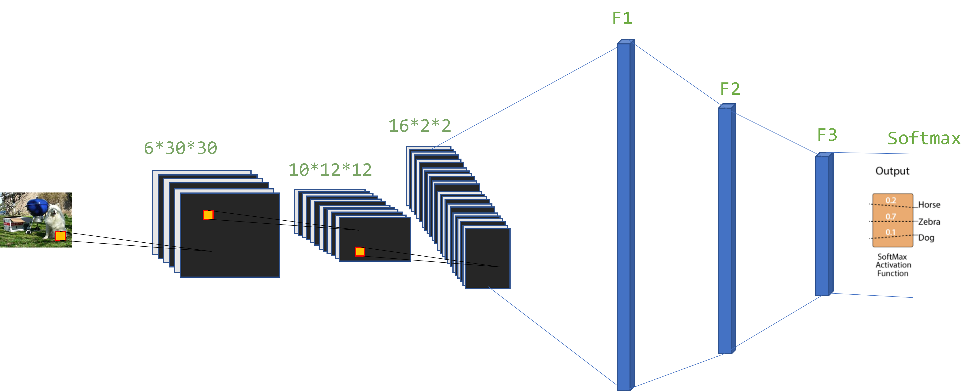
Fig. 4 Improve LeNet-5 Architecture diagram

IV. EXPERIMENTS
- Two-layer neural network result

The first experiment used a two-layer neural network trained for 1000 epochs with a learning rate of 0.000001. The loss showed a significant increase at the beginning of training, followed by a decrease in the middle epochs. Unfortunately, the classification accuracy did not decrease as the loss decreased. Therefore, simply calculating the loss by adding the logarithm of the top-5 scores of the outputs and the label was not appropriate.
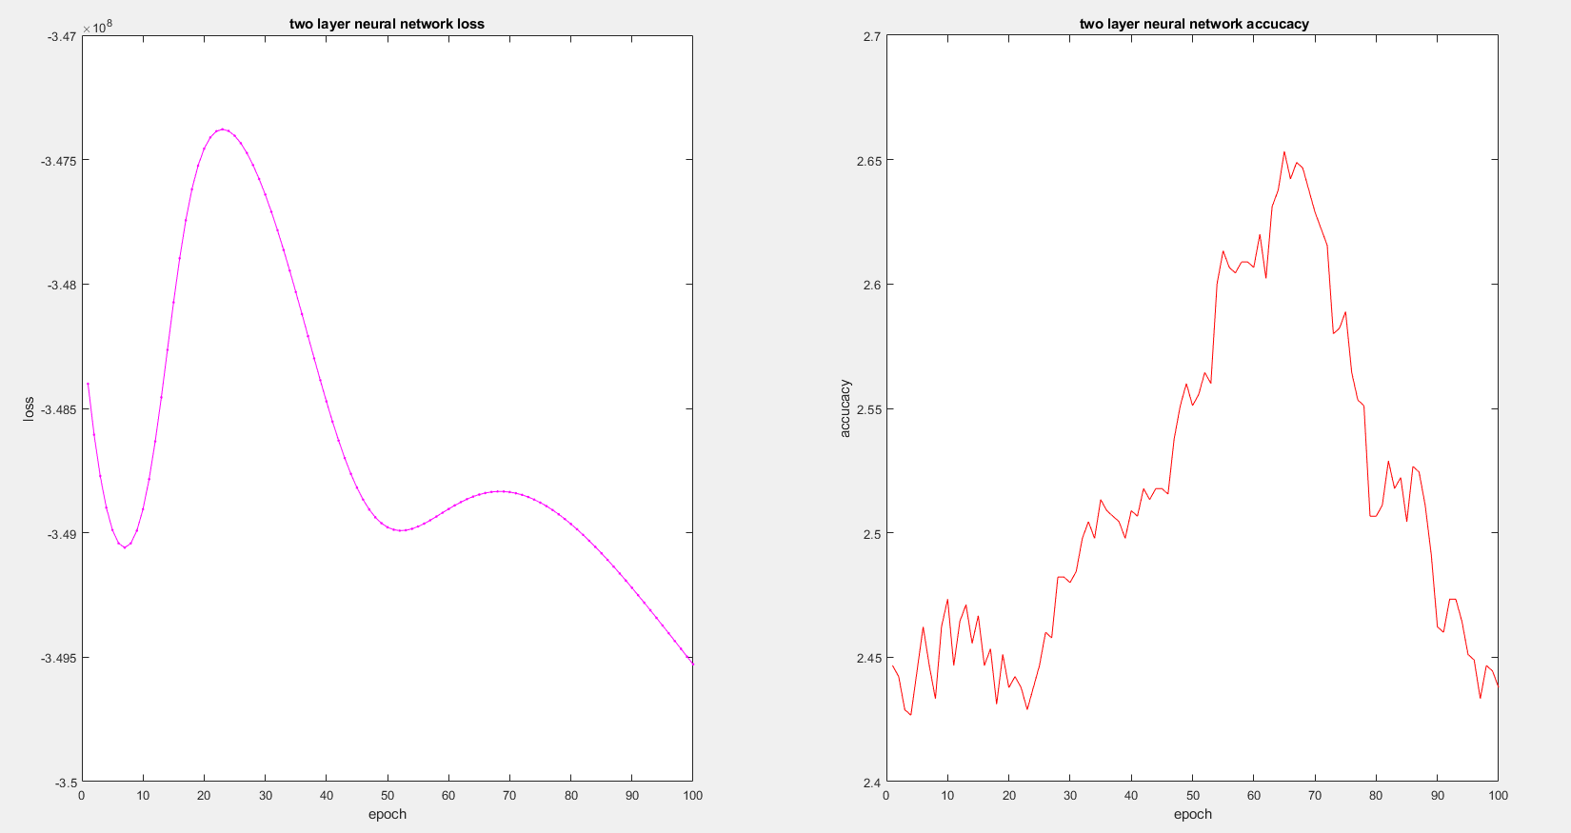
Fig. 5 Two-layer neural network loss (left)、accuracy (right) curve

- LeNet5 implement with numpy result
When implementing LeNet5, we used the Adam optimizer with a learning rate of 0.001 and beta ranging from 0.9 to 0.999. In terms of activation functions, we replaced the sigmoid function with a LeakyReLU with a negative slope of 0.01. We also adjusted the batch size to 500 and trained for 100 epochs. However, we observed that the loss converged early on around the second or third epoch and remained relatively stable with only slight oscillations throughout the rest of the training. The accuracy, on the other hand, showed significant fluctuations and did not exhibit a consistent increasing trend.

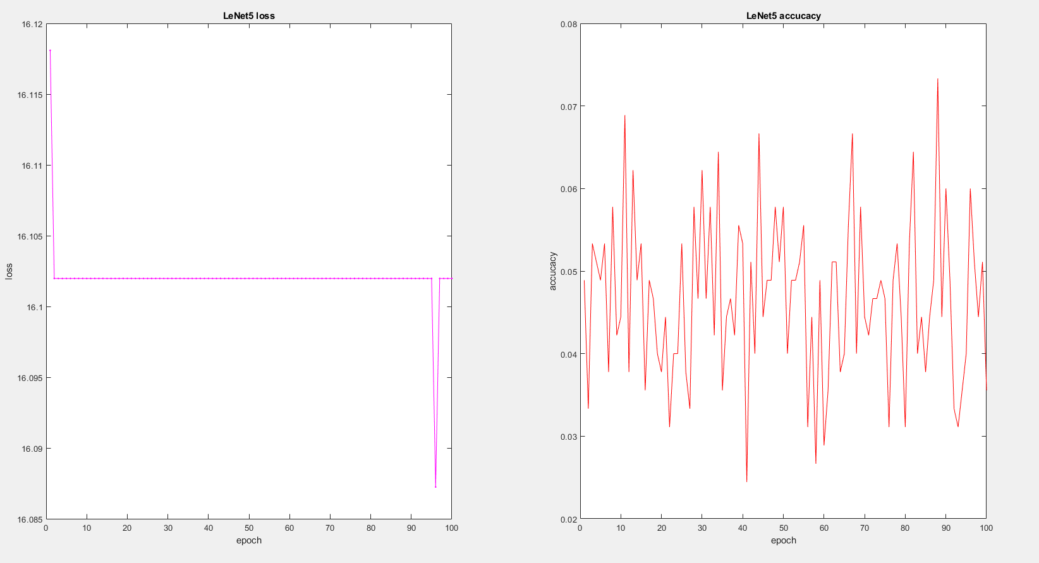
Fig. 6 B. LeNet5 loss (left)、accuracy (right) curve
- Improve LeNet5 implement with numpy result
In the third part, we improved upon LeNet5 by adding two more convolutional layers, bringing the total to four, which allowed us to extract more image features. We also replaced LeakyReLU with sigmoid output multiplied by the input to enhance the training process. With these changes, the loss curve can decrease during training without any noticeable impact on the dataset, optimizer, learning rate, or training epoch, which resulted in significantly better performance compared to the unchanged LeNet5 in the previous part. Although the accuracy still fluctuates greatly, the maximum accuracy achieved is nearly double that of the original LeNet5. Although the improvement did not produce outstanding results, it is clear that there is a significant improvement in performance.
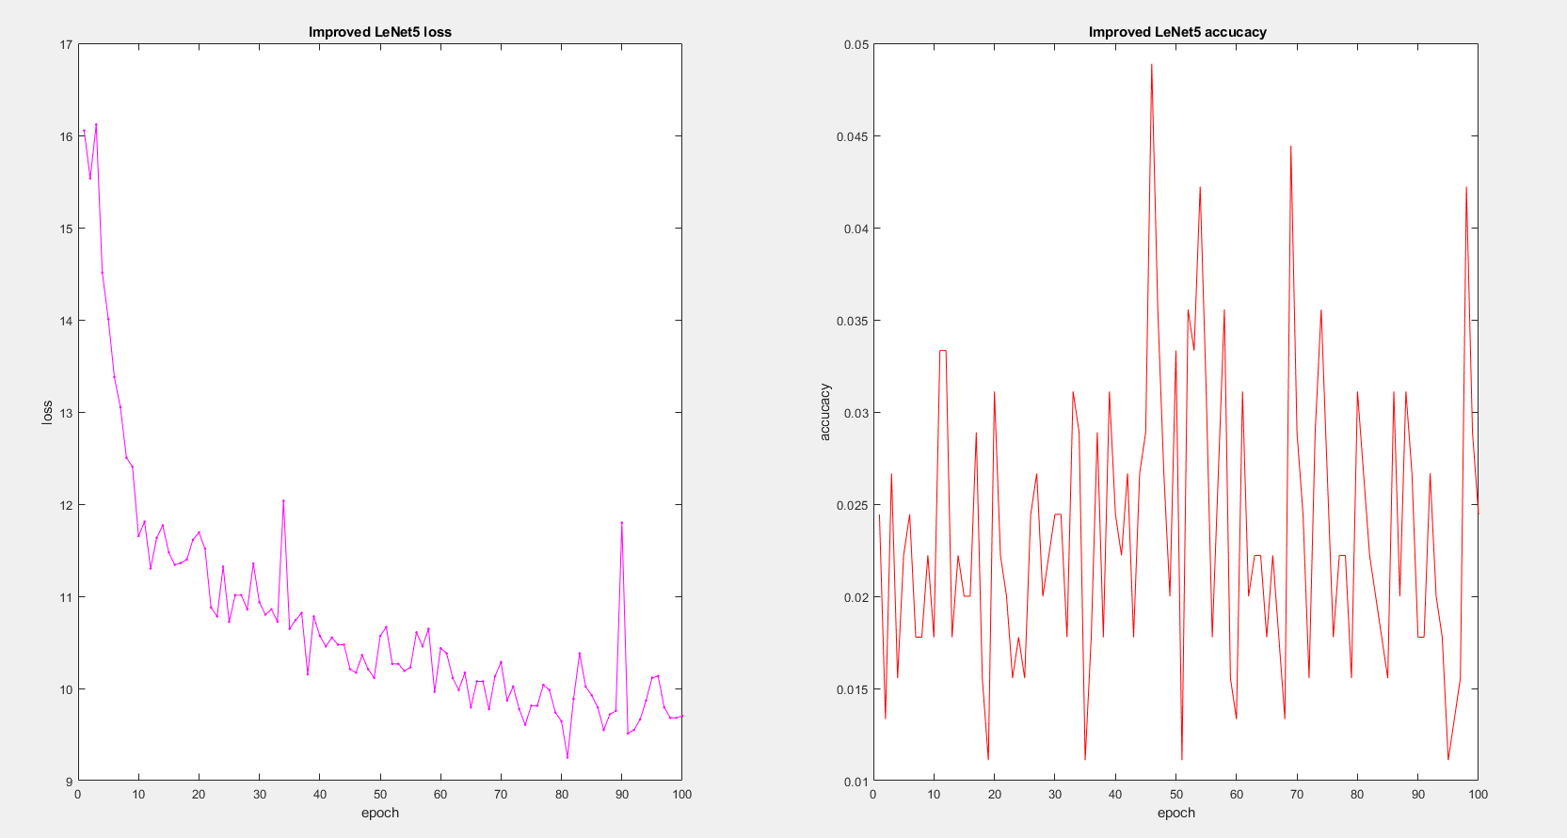
Fig. 6 .Improve LeNet5 loss (left)、accuracy (right) curve

CONCLUSION

The preferred spelling of the word “acknowledgment” in America is without an “e” after the “g.” Try to avoid the stilted expression, “One of us (R. B. G.) thanks …” Instead, try “R.B.G. thanks …” Put sponsor acknowledgments in the unnumbered footnote on the first page.
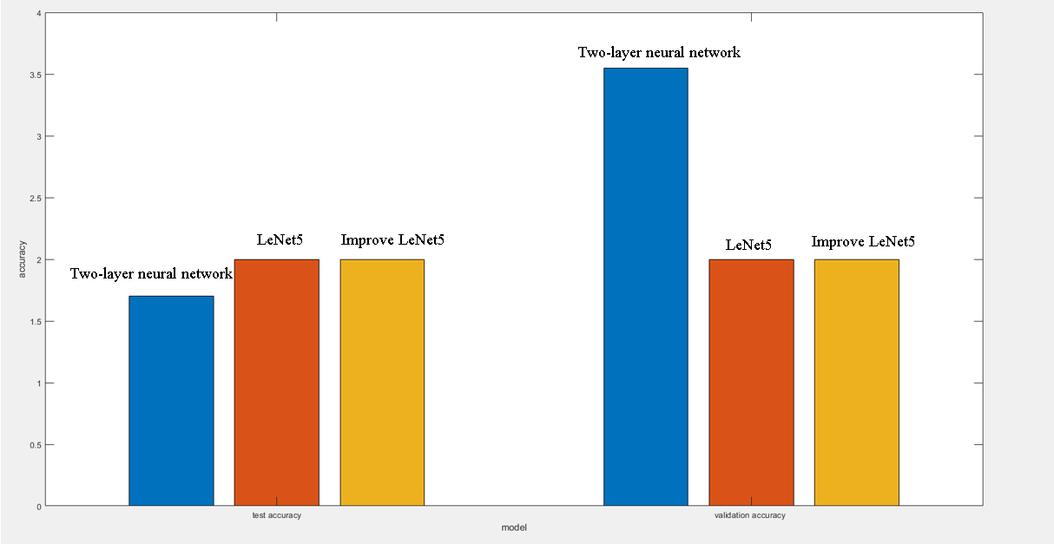
References
- M. King, B. Zhu, and S. Tang, “Optimal path planning,” Mobile Robots, vol. 8, no. 2, pp. 520-531, March 2001.
- H. Simpson, Dumb Robots, 3rd ed., Springfield: UOS Press, 2004, pp.6-9.
- M. King and B. Zhu, “Gaming strategies,” in Path Planning to the West, vol. II, S. Tang and M. King, Eds. Xian: Jiaoda Press, 1998, pp. 158-176.
- B. Simpson, et al, “Title of paper goes here if known,” unpublished.
- J.-G. Lu, “Title of paper with only the first word capitalized,” J. Name Stand. Abbrev., in press.
- Y. Yorozu, M. Hirano, K. Oka, and Y. Tagawa, “Electron spectroscopy studies on magneto-optical media and plastic substrate interface,” IEEE Translated J. Magn. Japan, vol. 2, pp. 740-741, August 1987 [Digest 9th Annual Conf. Magnetics Japan, p. 301, 1982].
- M. Young, The Technical Writer’s Handbook, Mill Valley, CA: University Science, 1989.

