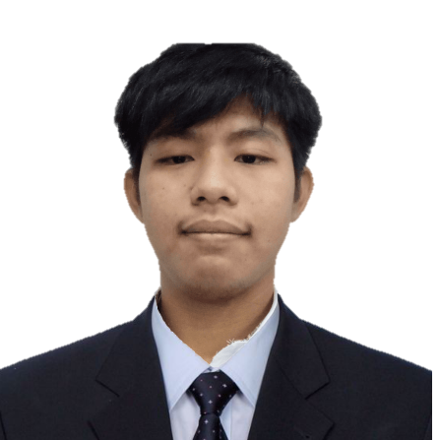-

**CSTA – Dean Lister**

**Certificate’s**

**Techtutor 2023 “Artificial Technology: The Life that is to Come”**

ACHIEVEMENT

**Present – College (Bachelor of Science in Information Technology)**

**Colegio de Sta. Theresa de Avila**

**Batch 2021 – Senior High School (Information and Communication Technology)**

**St. Theresa de Avila School of Novaliches**

**Batch 2019 – Junior High School**

**Llano High School**

**Batch 2015 – Elementary**

**Llano Elementary School**

EDUCATION

My passion for learning more about technology drives me to explore innovative solutions to real-world problems. I am eager to apply the skills and knowledge I have gained during my studies through this internship opportunity. Throughout my academic journey, I have learned different programming languages while creating our system for our thesis, which has helped me discover my true interests and strengths in development. In addition, I have worked with various tools such as SQL, HTML/CSS, PHP, and I am currently studying frameworks like Laravel. As a group leader, I effectively managed my team, fostering communication, collaboration, and a comfortable working environment. This internship offers me practical experience in an IT environment where I can work with professionals and contribute my skills and knowledge to development projects, allowing me to further enhance my abilities in this field.

ABOUT ME

*Full-Stack Developer*

BELLEN, JUSTICE MIJARES



Justice Bellen

* PHP
* HTML/CSS
* JavaScript
* Java
* Shell Script

E X P E R T I S E

* Computer Skills
* Critical Thinking
* Leadership
* Problem Solving
* Collaboration
* Adaptability
* Resilience
* Dependability
* Work Ethic

S K I L L S

github.com/givemesleep

Website URL

devjbellen@gmail.com

+63 994 362 5108

**Capstone Project**

* **Design and Development of Membership and Loan Management for Llano Multi-Purpose Cooperative**

PROJECTS

BLK 4 LOT 4 Myrna Subd.

Llano Road, Caloocan City

C O N T A C T