ASFFFFFFFFFFFFFsdafasdfsadfasdfds

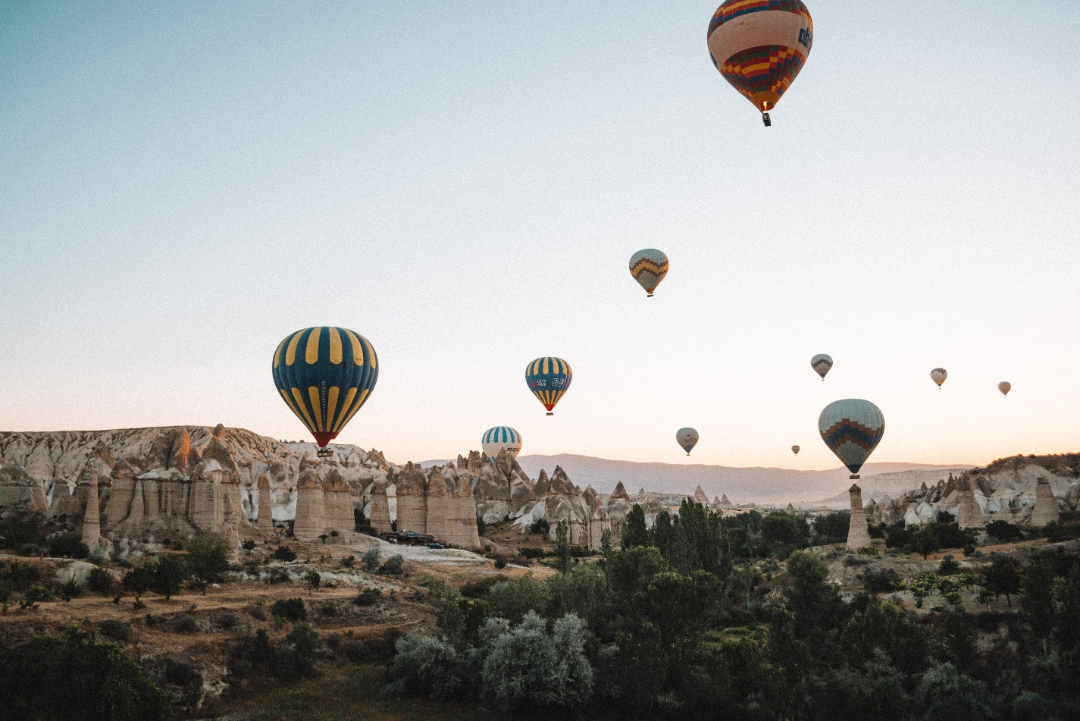

ASFFFFFFFFFFFFFsdafasdfsadfasdfds

ASFFFFFFFFFFFFFsdafasdfsadfasdfds

ASFFFFFFFFFFFFFsdafasdfsadfasdfds

ASFFFFFFFFFFFFFsdafasdfsadfasdfds

ASFFFFFFFFFFFFFsdafasdfsadfasdfds