GROUP 48

Restaurant Table Booking System
MVP Product, UI/UX, Database, API & Architecture Blueprint

Single source of truth for design, implementation, integration and team handoff

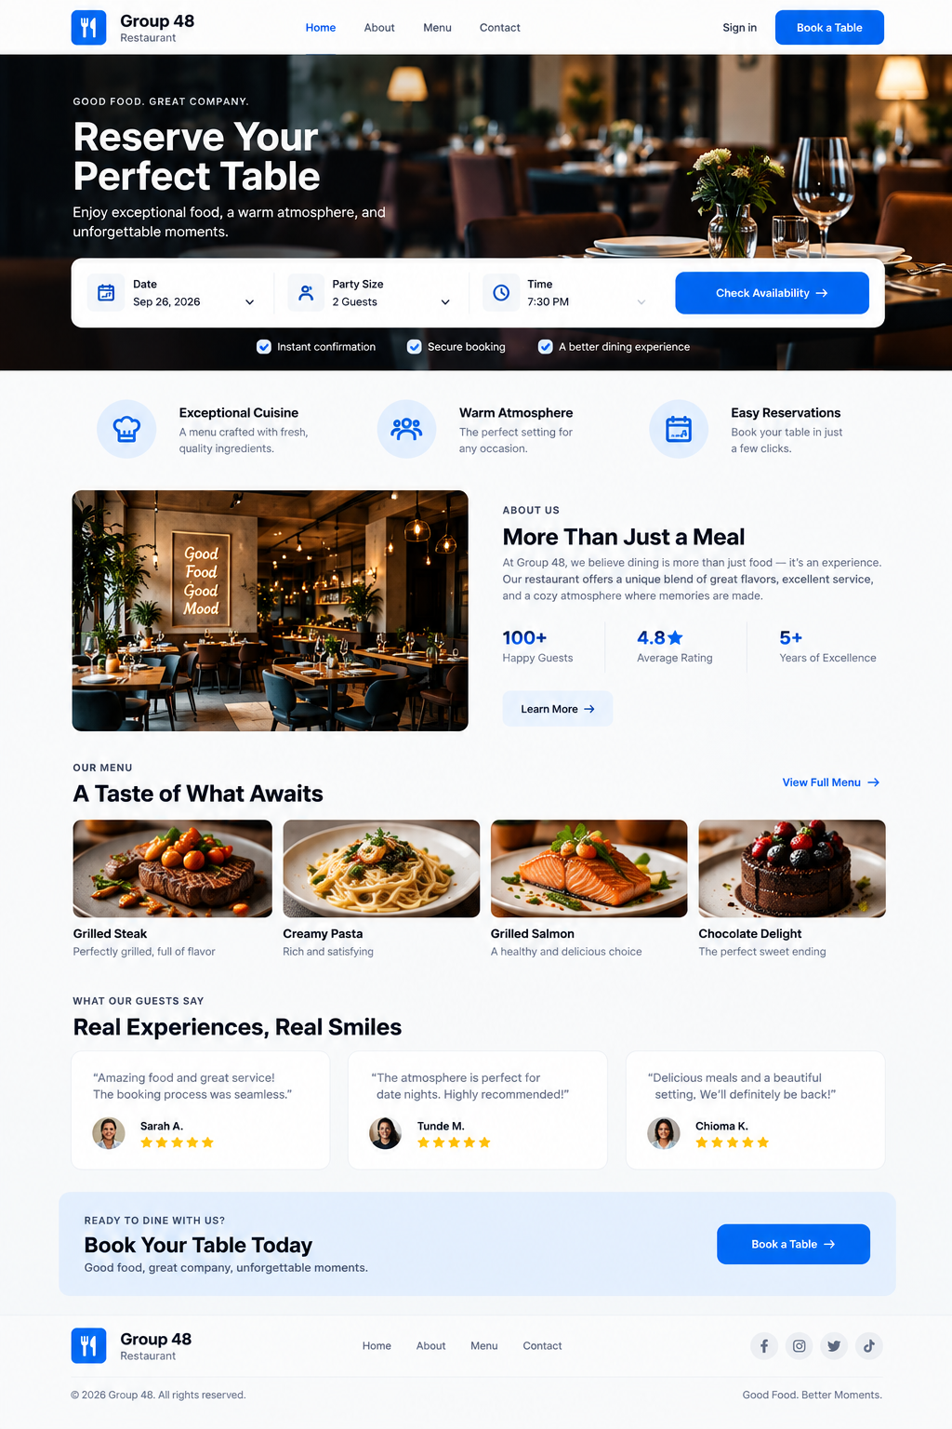
Customer-facing visual direction generated during planning.

1. Purpose & Product Definition
This document consolidates the Group 48 planning decisions into one implementation reference. It covers the locked MVP scope, customer/admin flows, generated screen direction, design system, database model and SQL schema, API contract, backend architecture and frontend architecture.

Product
A single-restaurant web application where customers can view restaurant information, check real table availability, select a suitable table and reserve it. Administrators manage tables, reservations and basic restaurant settings.

Locked MVP decisions
- Single restaurant; not a marketplace.
- Roles: CUSTOMER and ADMIN.
- Authentication is required to complete a reservation; availability browsing is public.
- Customers choose from suitable available tables; table capacity must be at least the party size.
- Reservation duration: 90 minutes. Slot start interval: 30 minutes.
- Confirmation is instant after the backend performs the final availability check.
- Reservation lifecycle: CONFIRMED → COMPLETED or CONFIRMED → CANCELLED.
- Customer may cancel a CONFIRMED reservation while its start time is still in the future.
- No direct rescheduling in the MVP: cancel the old reservation and create a new one.
- Admin manages tables, reservations, dashboard summary and restaurant settings.

Explicitly out of scope
Multiple restaurants, food ordering, delivery, online payments, guest booking, direct rescheduling, reviews/ratings as a backend feature, staff management beyond Admin, inventory, loyalty/rewards, advanced analytics and AI features.

2. User Flows
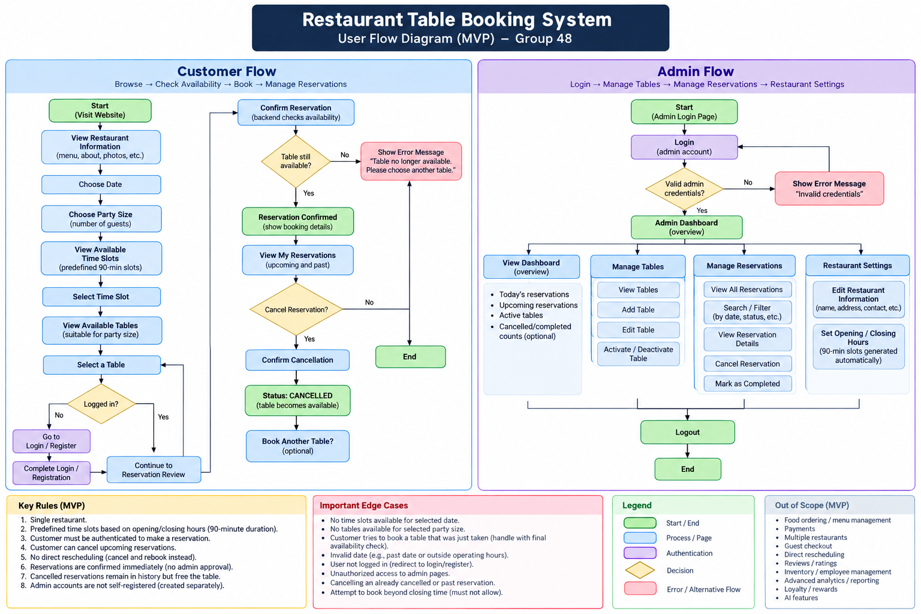
Generated end-to-end customer/admin flow diagram. Product rules in this document override any visual placeholder text.

Customer flow
Home → Book a Table → choose date and party size → choose an available 30-minute start slot → choose a suitable available table → review → authenticate if required → confirm → backend rechecks availability → success → My Reservations.

Admin flow
Admin Login → Dashboard → Table Management / Reservation Management / Restaurant Settings → Logout.
Important correction for generated mockups: remove Modify/Reschedule, Pending, No Show, Menu management, advanced analytics, Add Reservation and other controls not listed in the locked MVP.

3. Generated UI Screens & Visual References
Landing page / customer visual direction
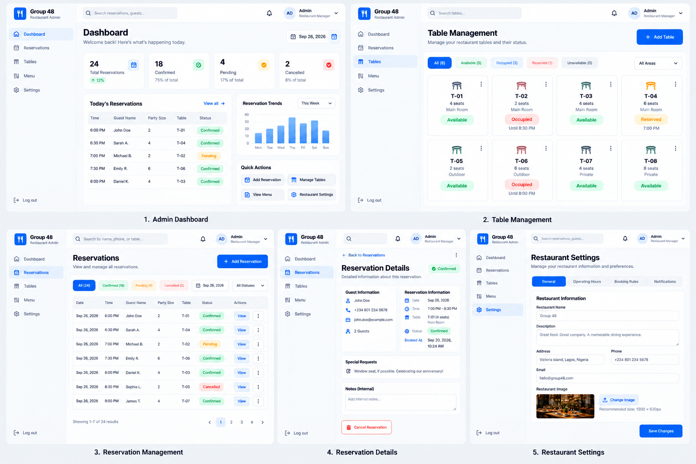
Customer booking screens
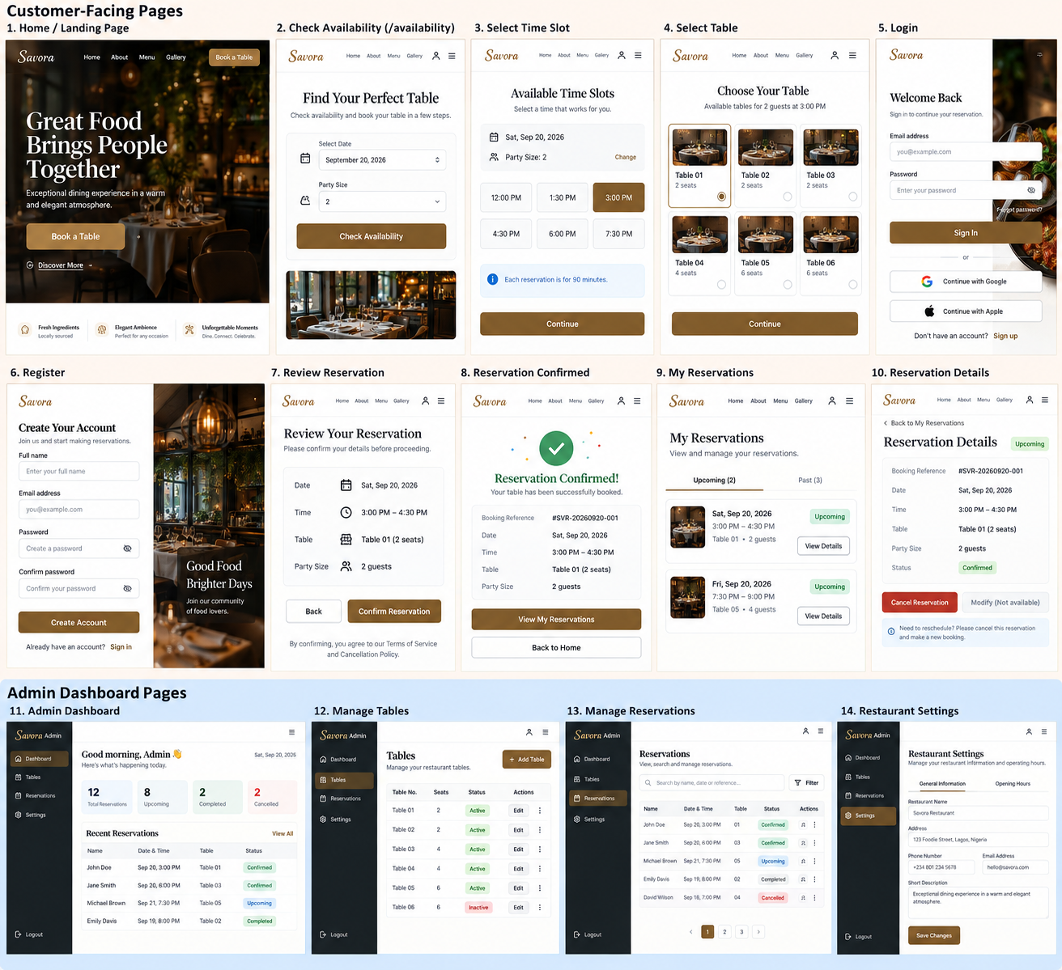
Expanded customer/admin screen exploration
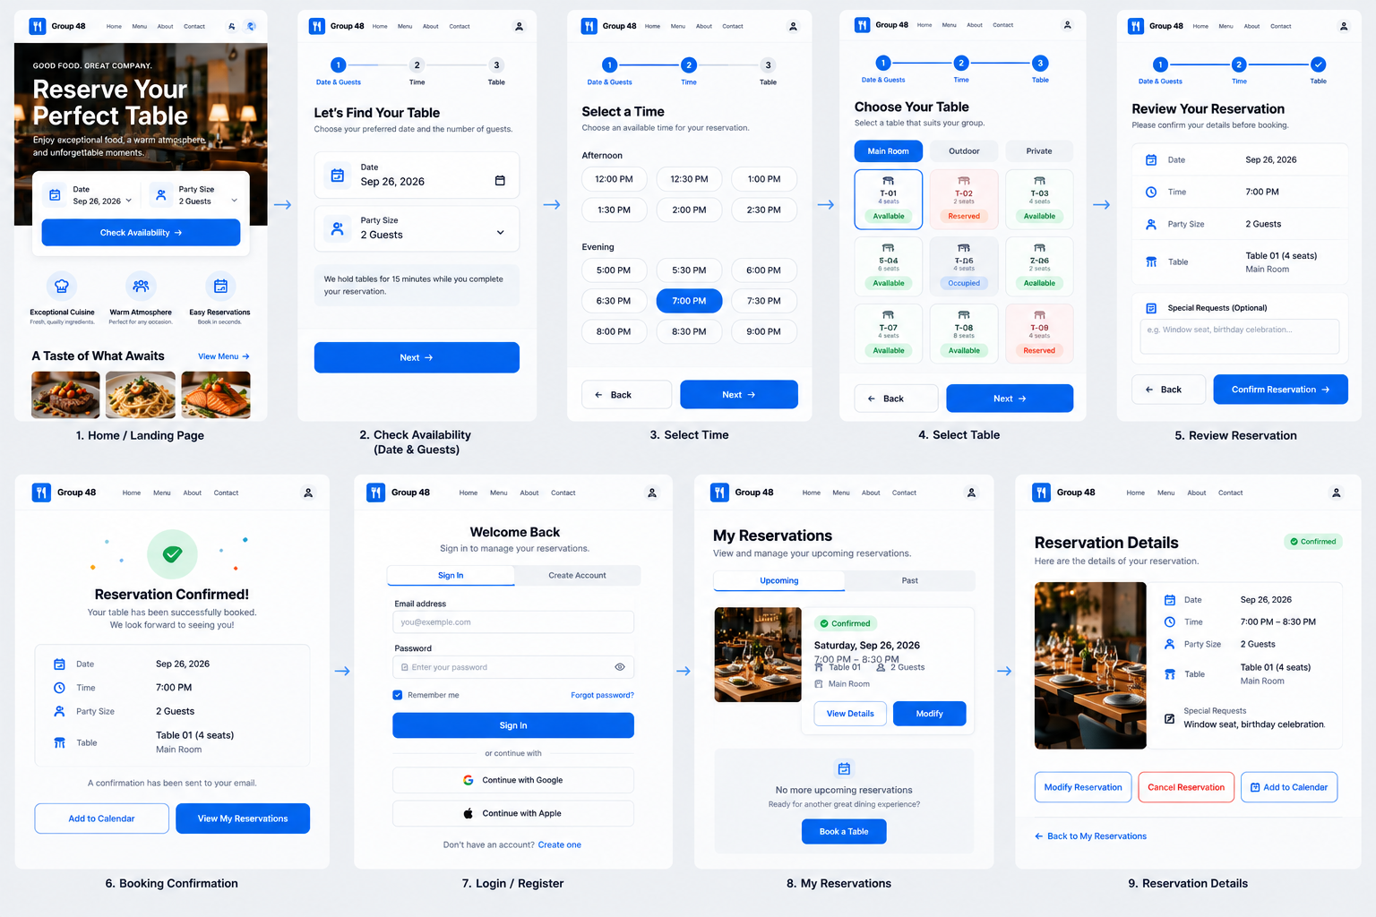
Admin dashboard and management visual direction
These images are visual references, not independent requirements. When a mockup conflicts with this blueprint, the locked product rules, database schema and API contract in this document take precedence.

4. Design System
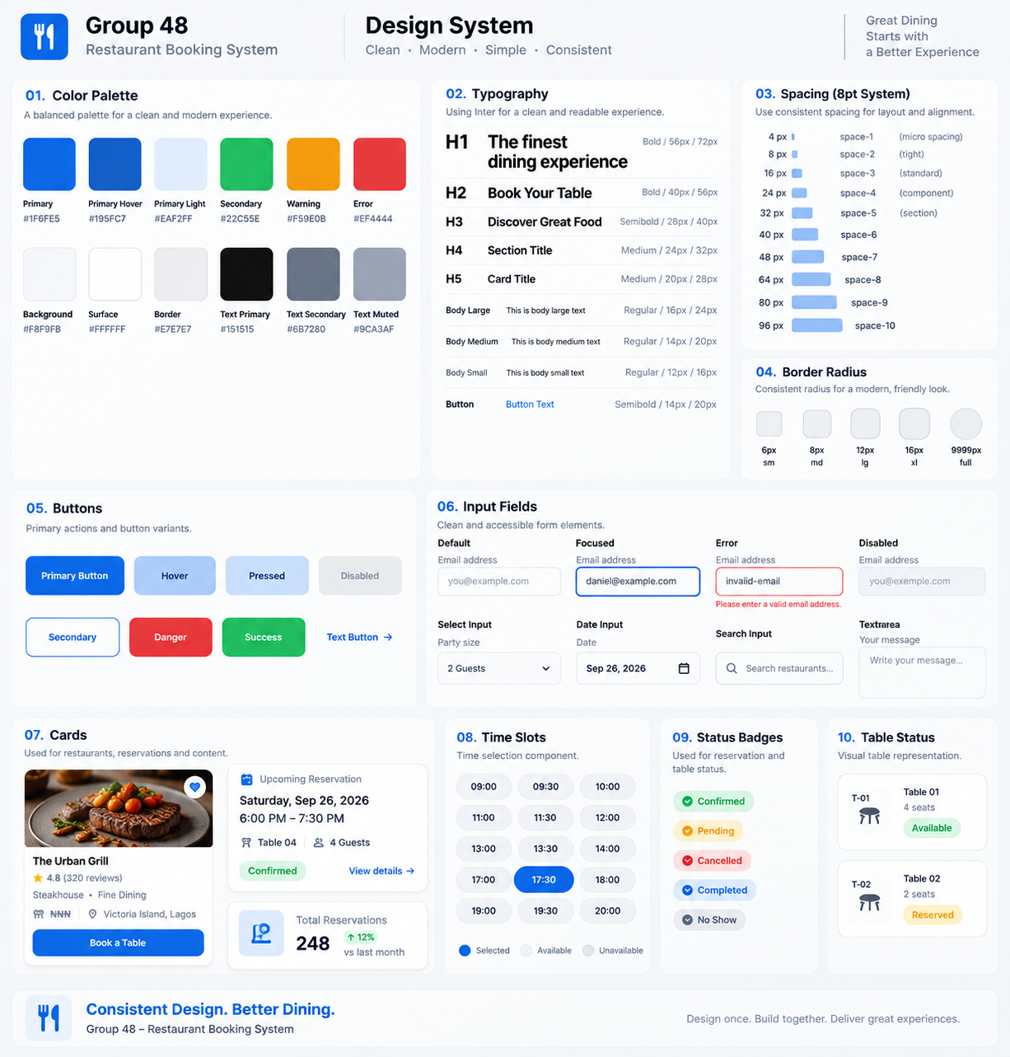
Generated design-system board. Use the corrected tokens and statuses below as authoritative.

Color tokens
Token | Value | Use
Primary Blue | #1F6FE5 | Primary CTA, selected state, interactive emphasis
Primary Hover | #195FC7 | Hover/pressed primary action
Blue Tint | #EAF2FF | Selected backgrounds and soft emphasis
Page Background | #F8F9FB | Application background
Surface | #FFFFFF | Cards, forms and panels
Primary Text | #151515 | Headings and main content
Secondary Text | #6B7280 | Supporting text
Border | #E7E7E7 | Inputs, cards and separators
Success | #22C55E | Successful/confirmed states
Warning | #F59E0B | Caution states
Error | #EF4444 | Validation/destructive/error states

Typography
Style | Weight | Size
H1 | 700 | 56px desktop; ~36–40px mobile hero
H2 | 700 | 40px
H3 | 600 | 28px
H4 | 500 | 24px
H5 | 500 | 20px
Body Large | 400 | 16px
Body Medium | 400 | 14px
Body Small | 400 | 12px
Button | 600 | 14px

Font family: Inter. Spacing follows an 8-point system with 4px micro-spacing: 4, 8, 16, 24, 32, 40, 48, 64, 80, 96.
Radius scale: 6px, 8px, 12px, 16px and 9999px. Cards use white surfaces, subtle borders, minimal shadow and approximately 24px padding.
Forms: 48–52px control height, 8px radius, 16px horizontal padding, labels above controls, blue focus treatment and red validation errors.

5. Frontend Architecture
Recommended: React + TypeScript, feature-oriented organization, one application for public/customer and admin experiences.
frontend/
├── src/
│ ├── components/
│ │ ├── ui/
│ │ └── layout/
│ ├── features/
│ │ ├── auth/
│ │ ├── booking/
│ │ ├── reservations/
│ │ ├── restaurant/
│ │ └── admin/
│ ├── pages/
│ │ ├── HomePage.tsx
│ │ ├── LoginPage.tsx
│ │ ├── RegisterPage.tsx
│ │ ├── BookingPage.tsx
│ │ ├── BookingSuccessPage.tsx
│ │ ├── MyReservationsPage.tsx
│ │ ├── ReservationDetailsPage.tsx
│ │ └── admin/
│ ├── services/
│ ├── context/
│ ├── hooks/
│ ├── routes/
│ ├── types/
│ ├── utils/
│ ├── App.tsx
│ └── main.tsx
└── ...

Frontend rules
- Use one multi-step /booking flow: Date + Party Size → Time → Table → Review → Confirm.
- Use AuthContext for user/authentication state and BookingContext for temporary booking selections.
- Use ProtectedRoute for authenticated customer pages and AdminRoute for admin pages; backend authorization remains the real security boundary.
- Keep API calls in a service/API layer instead of scattering raw fetch calls through components.
- Every data screen must handle loading, error and empty states separately.
- On a 409 booking conflict, explain that the table was just reserved and refresh availability.

Primary routes
Route | Access | Purpose
/ | Public | Restaurant landing/information
/booking | Public; auth required at final confirmation | Multi-step booking flow
/booking/success | Authenticated | Reservation confirmation
/login | Public | Sign in
/register | Public | Create customer account
/reservations | Authenticated | Customer reservations
/reservations/:id | Authenticated | Customer reservation detail
/admin | Admin | Dashboard
/admin/tables | Admin | Table management
/admin/reservations | Admin | Reservation management
/admin/reservations/:id | Admin | Admin reservation detail
/admin/settings | Admin | Restaurant settings

6. Backend Architecture
Stack: Node.js + Express + TypeScript + Drizzle ORM + Neon PostgreSQL. Validation is recommended with Zod.
Client
↓
Express Route
↓
Middleware (authentication / authorization / validation)
↓
Controller (HTTP translation)
↓
Service (business rules)
↓
Drizzle ORM
↓
Neon PostgreSQL
backend/
├── src/
│ ├── config/
│ ├── db/
│ │ ├── index.ts
│ │ ├── schema/
│ │ └── seed.ts
│ ├── modules/
│ │ ├── auth/
│ │ ├── availability/
│ │ ├── reservations/
│ │ ├── tables/
│ │ ├── restaurant/
│ │ └── admin/
│ ├── middleware/
│ ├── utils/
│ ├── types/
│ ├── app.ts
│ └── server.ts
├── drizzle/
├── tests/
├── drizzle.config.ts
├── tsconfig.json
└── package.json

Layer responsibilities
Layer | Responsibility
Route | HTTP method/path and middleware/controller wiring; no business logic.
Middleware | Authentication, admin authorization, request validation and global error handling.
Controller | Translate HTTP request into service call and service result into HTTP response.
Service | Core booking/auth/table/restaurant business rules.
Drizzle/DB | Persistence, relational queries, migrations and database constraints.

7. Database Model & PostgreSQL Schema
Database: PostgreSQL hosted on Neon. Drizzle ORM/Drizzle Kit will be used from TypeScript. The core entities are User, Table, Reservation and RestaurantSettings.
Entity | Important fields
User | id, name, email, password_hash, role, timestamps
Table | id, table_number, capacity, area, is_active, timestamps
Reservation | id, user_id, table_id, start_at, end_at, party_size, status, timestamps
RestaurantSettings | name, description, address/contact, opening/closing time, duration, interval, timezone

CREATE EXTENSION IF NOT EXISTS pgcrypto;
CREATE EXTENSION IF NOT EXISTS btree_gist;
CREATE TYPE user_role AS ENUM ('CUSTOMER','ADMIN');
CREATE TYPE reservation_status AS ENUM ('CONFIRMED','COMPLETED','CANCELLED');
CREATE TABLE users (
id UUID PRIMARY KEY DEFAULT gen_random_uuid(),
name VARCHAR(100) NOT NULL,
email VARCHAR(255) UNIQUE NOT NULL,
password_hash VARCHAR(255) NOT NULL,
role user_role NOT NULL DEFAULT 'CUSTOMER',
created_at TIMESTAMPTZ NOT NULL DEFAULT NOW(),
updated_at TIMESTAMPTZ NOT NULL DEFAULT NOW()
);
CREATE TABLE tables (
id UUID PRIMARY KEY DEFAULT gen_random_uuid(),
table_number VARCHAR(20) UNIQUE NOT NULL,
capacity INTEGER NOT NULL CHECK (capacity > 0),
area VARCHAR(50),
is_active BOOLEAN NOT NULL DEFAULT TRUE,
created_at TIMESTAMPTZ NOT NULL DEFAULT NOW(),
updated_at TIMESTAMPTZ NOT NULL DEFAULT NOW()
);
CREATE TABLE restaurant_settings (
id UUID PRIMARY KEY DEFAULT gen_random_uuid(),
name VARCHAR(150) NOT NULL,
description TEXT,
address TEXT NOT NULL,
phone VARCHAR(30),
email VARCHAR(255),
opening_time TIME NOT NULL,
closing_time TIME NOT NULL,
reservation_duration INTEGER NOT NULL DEFAULT 90 CHECK (reservation_duration > 0),
slot_interval INTEGER NOT NULL DEFAULT 30 CHECK (slot_interval > 0),
timezone VARCHAR(100) NOT NULL DEFAULT 'Africa/Lagos',
created_at TIMESTAMPTZ NOT NULL DEFAULT NOW(),
updated_at TIMESTAMPTZ NOT NULL DEFAULT NOW(),
CONSTRAINT valid_operating_hours CHECK (closing_time > opening_time)
);
CREATE TABLE reservations (
id UUID PRIMARY KEY DEFAULT gen_random_uuid(),
user_id UUID NOT NULL REFERENCES users(id),
table_id UUID NOT NULL REFERENCES tables(id),
start_at TIMESTAMPTZ NOT NULL,
end_at TIMESTAMPTZ NOT NULL,
party_size INTEGER NOT NULL CHECK (party_size > 0),
status reservation_status NOT NULL DEFAULT 'CONFIRMED',
created_at TIMESTAMPTZ NOT NULL DEFAULT NOW(),
updated_at TIMESTAMPTZ NOT NULL DEFAULT NOW(),
CONSTRAINT valid_reservation_time CHECK (end_at > start_at)
);
ALTER TABLE reservations
ADD CONSTRAINT prevent_double_booking
EXCLUDE USING gist (
table_id WITH =,
tstzrange(start_at, end_at, '[)') WITH &&
)
WHERE (status = 'CONFIRMED');
CREATE INDEX idx_tables_availability ON tables (is_active, capacity);
CREATE INDEX idx_reservations_user ON reservations (user_id);
CREATE INDEX idx_reservations_start_at ON reservations (start_at);
CREATE INDEX idx_reservations_status ON reservations (status);
CREATE INDEX idx_reservations_table ON reservations (table_id);
The [) time range is start-inclusive and end-exclusive, so a reservation ending at 20:30 does not conflict with another beginning at 20:30. The application performs a friendly availability check first; the exclusion constraint is the final race-condition guard.

8. Availability & Reservation Logic
- Input date + partySize; reject invalid/past input.
- Read restaurant opening/closing time, 90-minute duration, 30-minute slot interval and timezone.
- Generate starts every 30 minutes; only keep slots whose 90-minute interval ends by closing time.
- Suitable tables must be active and have capacity >= partySize.
- Overlap rule: newStart < existingEnd AND newEnd > existingStart.
- A time slot is shown only when at least one suitable table is free.
- The final reservation POST repeats all checks before insertion.
- A concurrent conflict returns HTTP 409; frontend refreshes available tables.

9. API Contract
Response convention:
Success: { "success": true, "message": "...", "data": { ... } }
Error: { "success": false, "message": "...", "errors": { ... } }
Method | Endpoint | Access | Purpose
POST | /api/auth/register | Public | Create CUSTOMER account; body: name, email, password.
POST | /api/auth/login | Public | Authenticate; return safe user + auth token.
GET | /api/auth/me | Auth | Return current safe user.
GET | /api/restaurant | Public | Public restaurant information/settings.
PATCH | /api/admin/restaurant | Admin | Update basic restaurant/contact/opening/closing settings.
GET | /api/availability | Public | Query date + partySize; return available start slots.
GET | /api/availability/tables | Public | Query date + time + partySize; return suitable free tables.
POST | /api/reservations | Auth | Create reservation from tableId, startAt, partySize; backend computes endAt.
GET | /api/reservations/me | Auth | Current customer's reservations.
GET | /api/reservations/:id | Auth | Customer's own reservation detail.
PATCH | /api/reservations/:id/cancel | Auth | Cancel own future CONFIRMED reservation.
GET | /api/admin/dashboard | Admin | Operational dashboard counts.
GET | /api/admin/tables | Admin | List tables.
POST | /api/admin/tables | Admin | Create table.
PATCH | /api/admin/tables/:id | Admin | Edit/deactivate table.
GET | /api/admin/reservations | Admin | List/filter all reservations.
GET | /api/admin/reservations/:id | Admin | Any reservation detail.
PATCH | /api/admin/reservations/:id/status | Admin | CONFIRMED → CANCELLED or COMPLETED.

HTTP status conventions
201 Created • 400 Validation error • 401 Unauthenticated • 403 Authenticated but unauthorized • 404 Not found/inaccessible • 409 Conflict.
Security rules: public registration never accepts ADMIN role; user ID for customer reservation actions comes from authentication, not request body; passwords are stored only as hashes; customer reservation lookup should not reveal another customer's reservation.

10. Frontend ↔ Backend Integration Map
Frontend service | Backend capability
auth.api.ts | Register, login, current user
availability.api.ts | Available slots and available tables
reservations.api.ts | Create, list, detail and cancel customer reservations
tables.api.ts | Admin table management
restaurant.api.ts | Public restaurant information + admin settings

Frontend route guards improve UX; backend middleware enforces security. The frontend must never be treated as the final authority for table availability.

11. Implementation Guardrails
- Do not code features that are outside the locked MVP without team agreement.
- Do not duplicate business rules independently in frontend and backend; backend is authoritative.
- Do not delete reservation rows when cancelled; change status to CANCELLED.
- Prefer table deactivation over deletion where historical reservations exist.
- Keep controllers thin; place business rules in services.
- Keep API calls out of random UI components; use the frontend API/service layer.
- Keep environment secrets out of Git and provide .env.example.
- Opening/closing hours are still to be finalized; example hours in mockups are not authoritative.
- The current SQL allows more than one restaurant_settings row; enforce singleton behavior in application/seed or tighten the schema during implementation.
- updated_at currently defaults on insert; implementation must explicitly update it or add a database trigger.

12. Team Handoff Checklist
- Review this document and the included generated screen references before implementation.
- Raise scope disagreements before task allocation; once locked, avoid silent feature changes.
- Use the design tokens and component rules consistently across customer and admin screens.
- Implement against the API contract rather than inventing endpoint shapes per developer.
- Use feature branches and pull requests; do not have the whole team work directly on main.
- After team allocation, document each member's owned features, dependencies and integration points.
Planning status: requirements, MVP/business rules, flows, UI direction, database/ERD, SQL schema, API contract, backend architecture and frontend architecture are complete. Next: team allocation → Git workflow → project setup → implementation → integration/testing/deployment/documentation.

Appendix A. Additional Uploaded References
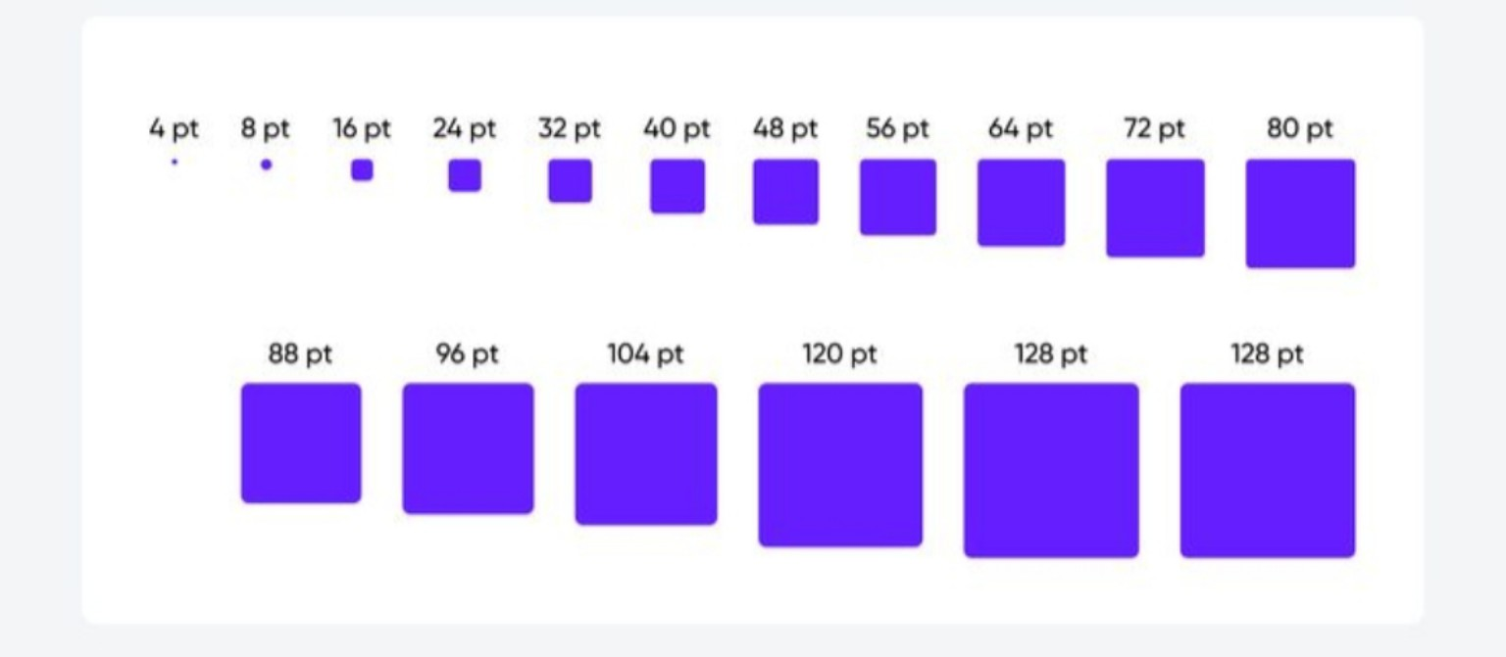
Screenshot_20260921-104928.jpg
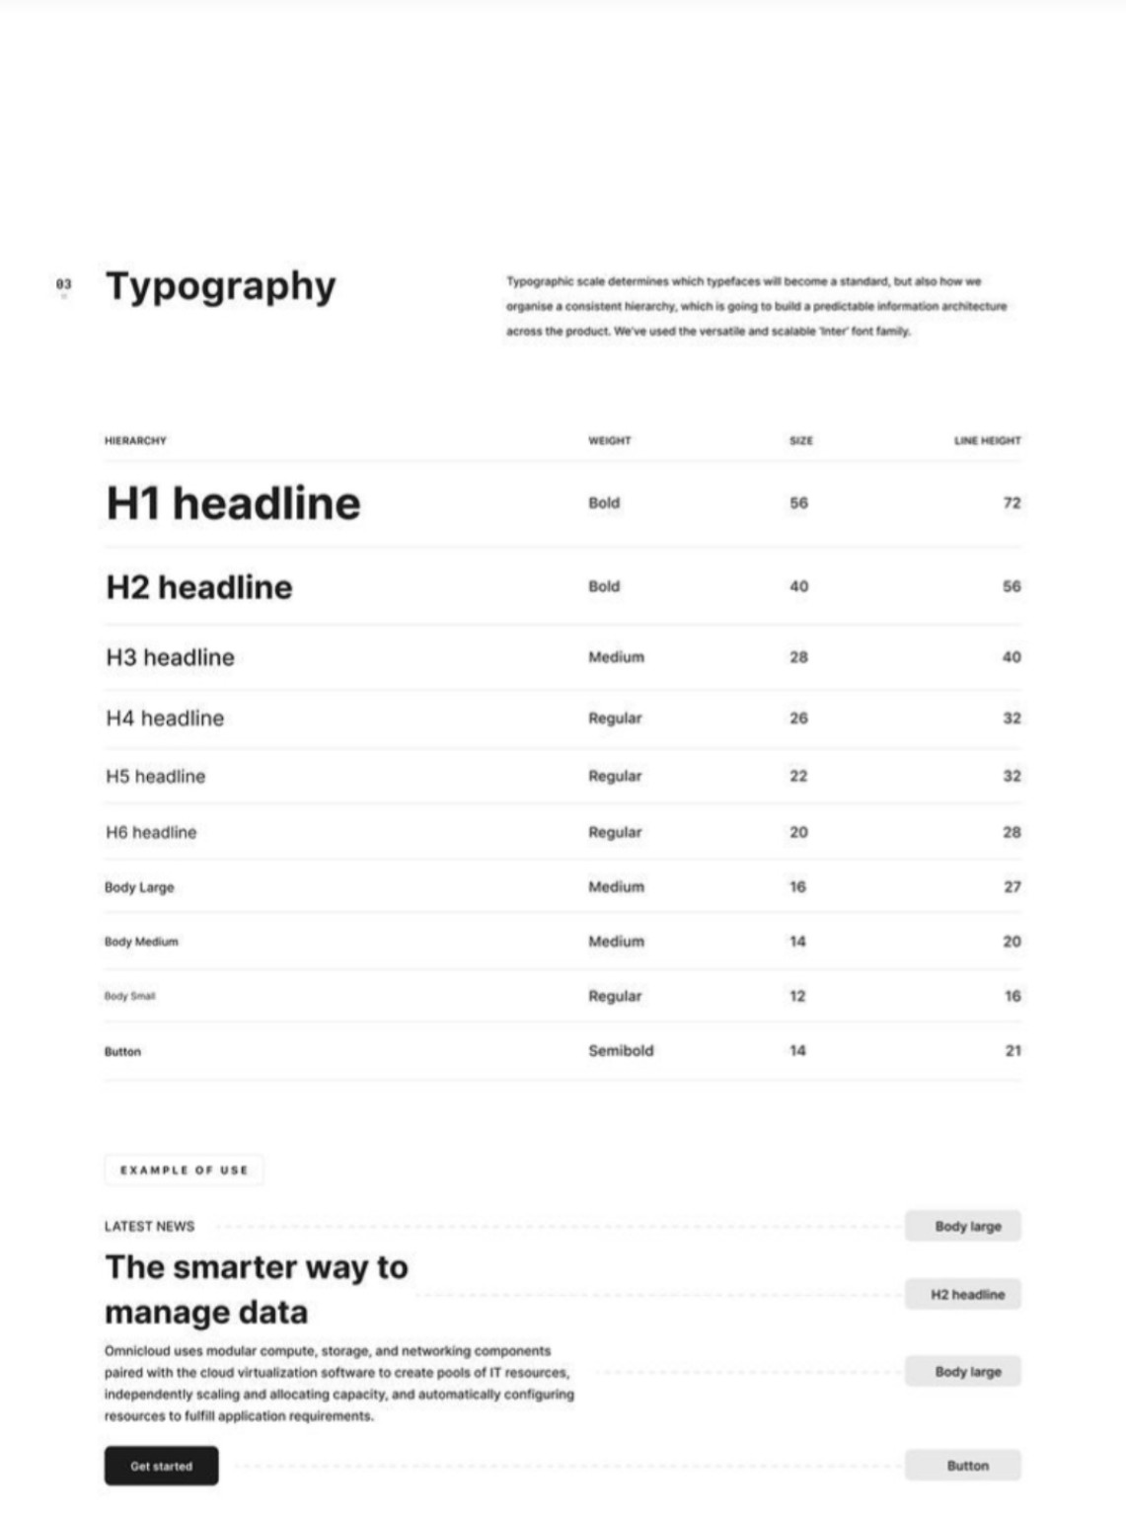
1000444816.jpg
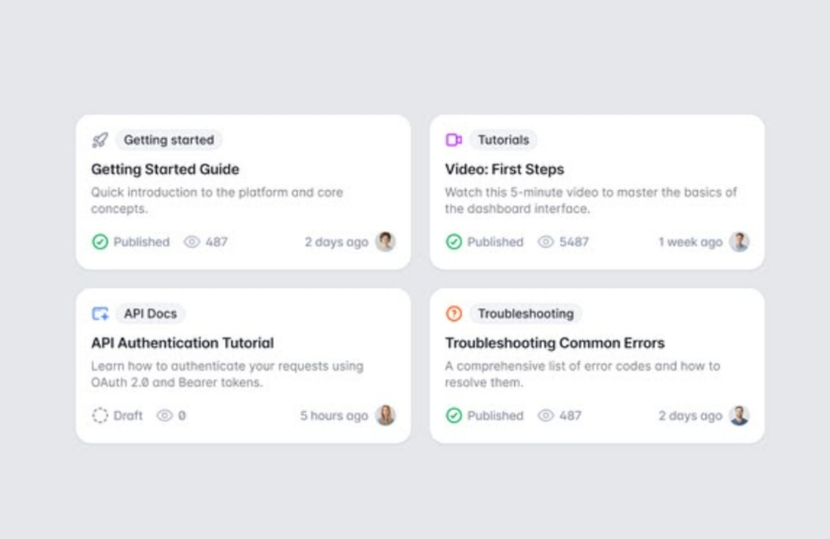
Screenshot_20260921-105432.jpg
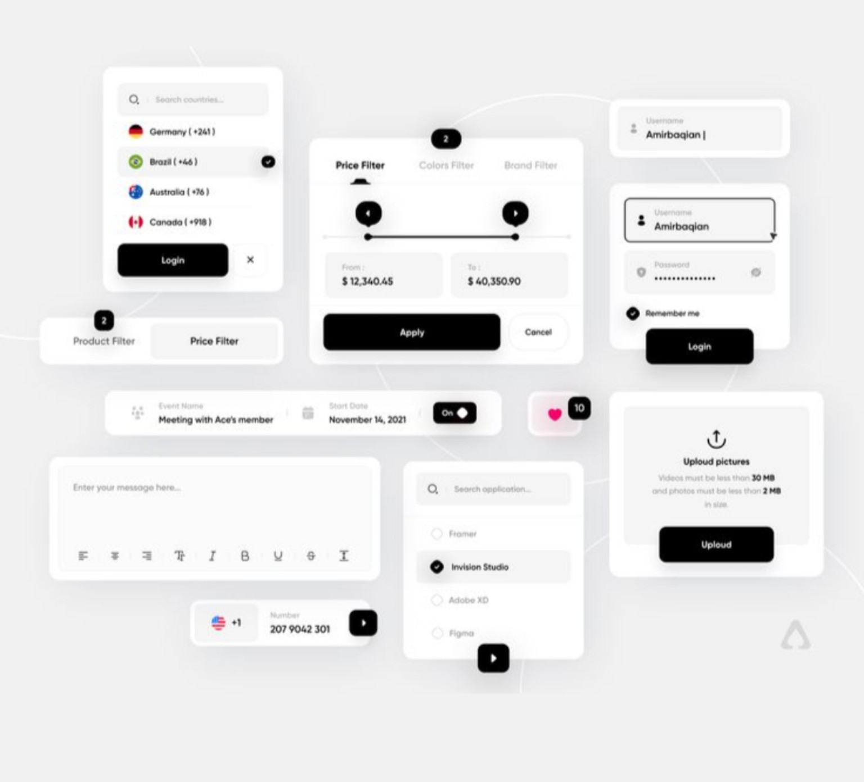
Screenshot_20260921-105953.jpg
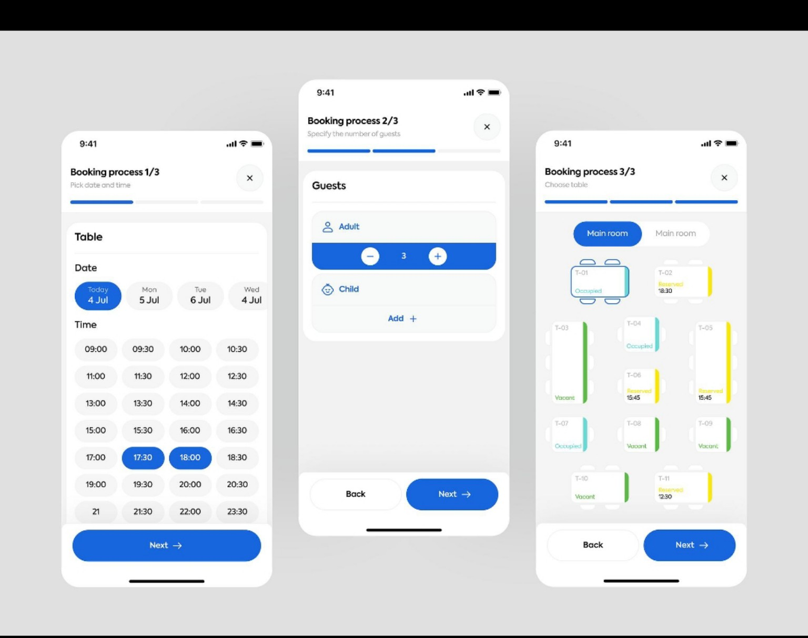
Screenshot_20260921-101224.jpg

