Discussion of the Overall Design

1. Class diagrams
For the sake of brevity we will only be showing the class diagrams of the upper two layers, of the class package
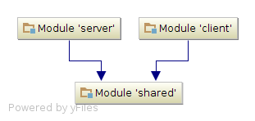
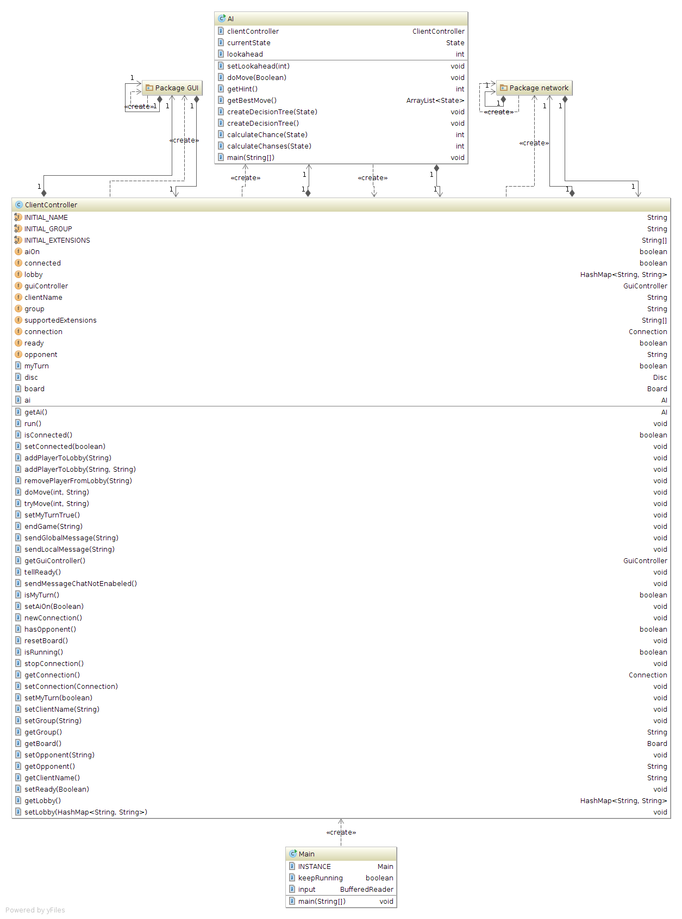
Main diagram above, and Client Diagram below
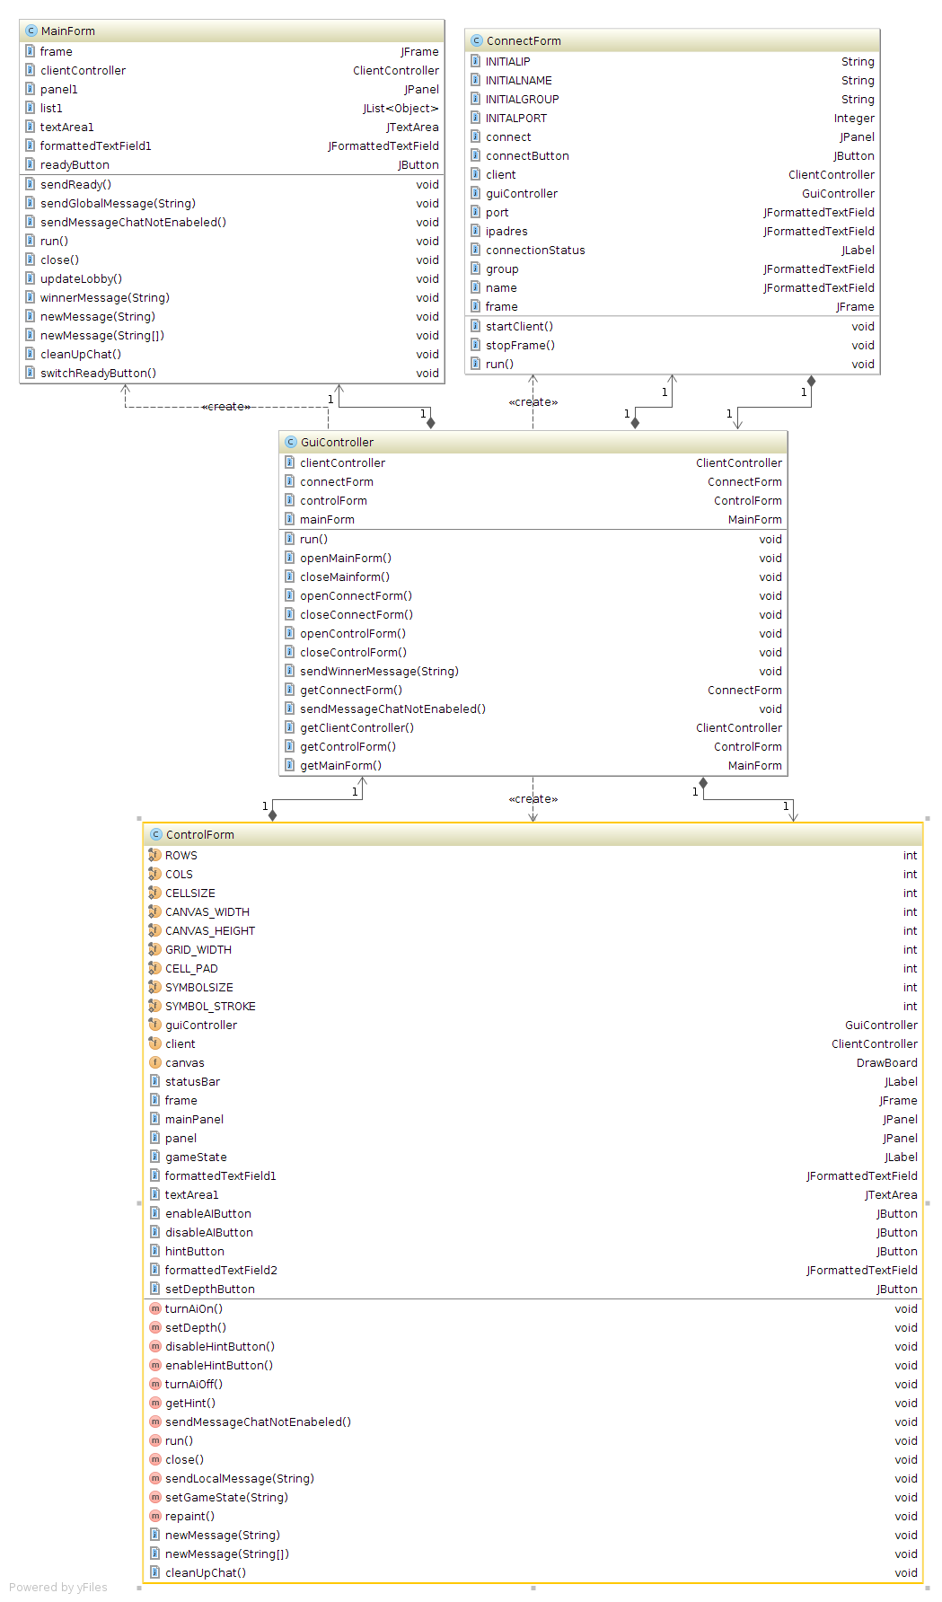
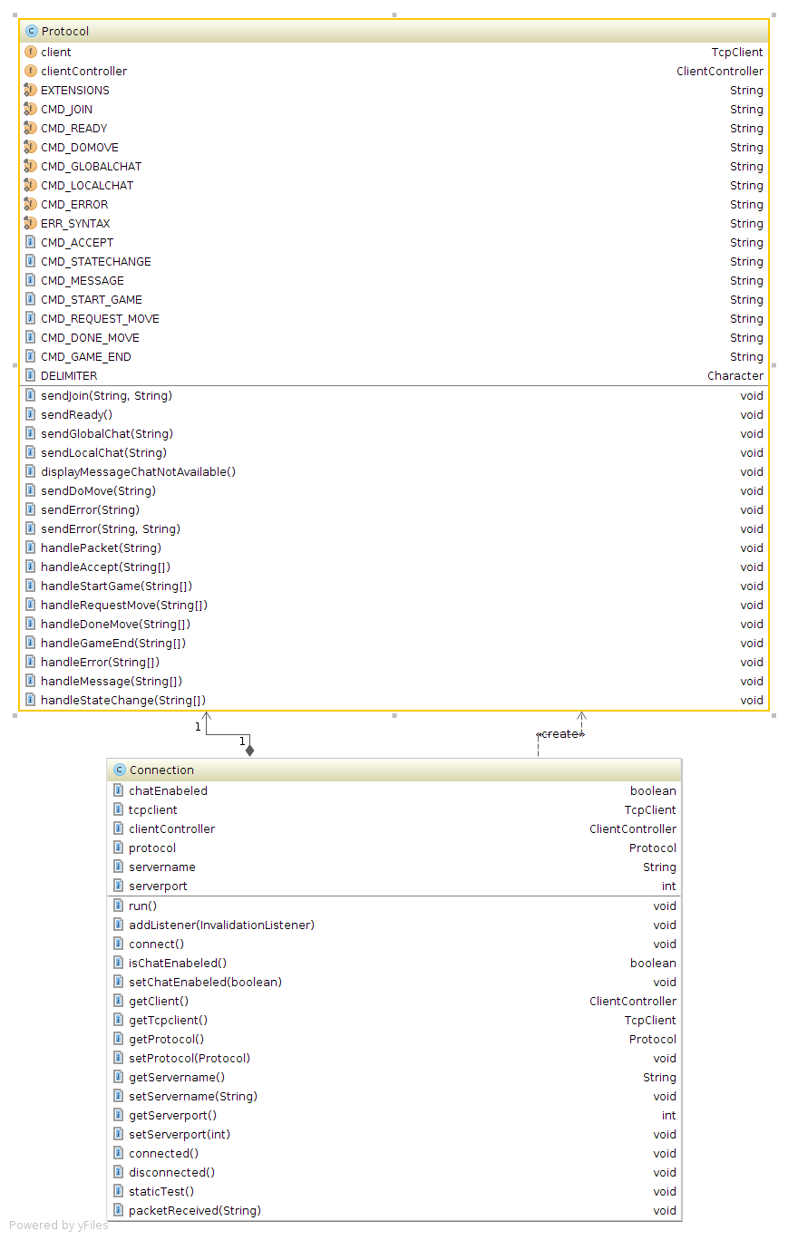
Above left Package Network, right package GUI
You can find these and all other Class Diagrams in the folder /Diagrams
In which they are ordered by hierarchy. For example; the diagram for the system is called diagram.png and can be found in the top folder. The diagrams for the package Client can be found in the folder client.

2. Systematic overview of the requirement implementations
The implementation of the requirements is split up in two sections (namely the server, and shared code), which discuss their requirement implementations individually and better reflect the code base which consists of three separate projects.

2.1 Server implementation
The server project contains a server.Main class which acts as the central hub. It contains the entry point and glues all separate subsystems together. It also contains the code that handles the input of standard input stream, which is used to execute commands. These commands can be used to start/stop the server, but also to inspect various states of the server such as the state of connected clients and currently active games.

All network I/O is routed through a special 'Protocol' class. Each client has its own instance of this class. When network data from a client has been received its Protocol instance will handle the data and call the appropriate subsystem classes. When a subsystem wants to send data to a client it goes through the client's Protocol instance. This method allows any future programmer to extend existing protocols or even define new protocols with minimal effort. It acts as an abstraction layer between the communication layer and the other subsystem logic.

Matchmaking has been implemented in the server.matchmaking.MatchMaker class.

Challenging has been implemented in the server.matchmaking.Challenger class.

The initial handshake has been implemented in the server.network.InitialProtocol class.

The default communication (as defined in the tutorial group) has been implemented in the server.network.DefaultProtocol class.

Each client has a session state which contains information (such as the used protocol/supported extensions) which is implemented in the server.player.Player class.

The creation and destruction of client sessions is implemented in the server.player.PlayerManager class.

Once a client has performed the handshake he must at all times be in a room. A room is an abstraction layer (defined in server.rooms.Room) which can refer to either the lobby (implemented in server.rooms.Lobby) or a game room (implemented in server.rooms.GameRoom). The creation and destruction of rooms is managed by a special class implemented in server.rooms.RoomManager.

2.2 Shared implementation
All the code that is shared between the client and server projects is stored in the shared project. This avoids writing duplicate code and ensures both server and client rely on the same logic when required.
The actual concept of a game and its underlying logic has been divided into three parts: a disc, a board and a game-state. The disc represents a physical disc on a board (or the lack of) and is implemented in the findfour.shared.game.Disc class. The board represents the physical board and all the logic which is required for one (such as placing a disc/checking for a winner) and is implemented in the findfour.shared.game.Board class. The game-state represents the actual state of the game and tracks states such as the player which is expected to make the next move. As most of the required logic was already implemented in the board it mostly acts as a wrapper to its personal board instance, with the addition of tracking some states the board has no concept of (such as who's turn it is). The game-state is implemented in the findfour.shared.game.GameState class.
The shared code-base also includes a basic logging system (implemented in findfour.shared.logging.Log) used to output information/warnings and errors. The destination of these log messages can vary as they are send to all findfour.shared.logging.LogListener instances registered on the log instance.
A very basic TCP client is implemented in findfour.shared.network.TcpClient. This allows the client project to use a simple, but high level TCP client without having to worry about all the low-level details.
A very basic multithreaded TCP server is implemented in findfour.shared.network.TcpServer. This allows the server project to use a simple, but high level TCP server without having to worry about all the low-level details.
The findfour.shared.utils.StringUtils class contains a series of helper methods to deal with the required string parsing.
The shared project also defines a series of exceptions in the findfour.shared namespace (ArgumentException/ArgumentNullException/ArgumentOutOfRangeException) which can be used throughout all code-bases to validate method parameters.

2.3. Client Implementation
Following are the client requirements:
1. The client should have a user friendly TUI, which provides several options to the user (e.g., possibility to a enter port number and IP address) to request a game at the server.
2. The client should support human players, and computer players with (some) artificially intelligent behaviour.
3. The thinking time of the computer player (and thus the power of the artificial intelligence) should be a parameter that can be changed via the client TUI.
4. The client provides a hint functionality. This shows a human player a possible move, as indicated by the computer player. The move may only be proposed, the human player should have the possibility to decide whether to play this move, or make a different one.
5. After the game is finished, the player should be able to start a new game.
6. If a player quits the game before it has finished, closes the UI, or the client crashes, the other players should be informed. In this case, the other players should be allowed to register again with the server to play the game.
7. A server might at all times disconnect. The clients should react to this in a decent way, closing all open connections etc.
8. The client should respect the protocol as defined for the tutorial group during the project session in Week 7, i.e.. the client should be able to communicate with all other servers from the tutorial group.
-Bron: Dictaat Software Systemen, Universiteit Twente

Requirement 1,
This is satisfied by ConnectForm, ControlForm and MainForm.
Requirement 2,
This is specifically satisfied by AI and ControlForm.
Requirement 3,
This is satisfied by AI and ControlForm.
Requirement 4,
This is satisfied by AI and ControlForm
Requirement 5,
This is specifically satisfied by MainForm and ControlForm
Requirement 6,
This is satisfied by ControlForm, which will get a message from the server that he has won and close the ControlForm window.
Requirement 7,
This is satisfied by TcpClient
If the server disconnects the client Closes
Requirement 8,
This is satisfied by Protocol.

3.1 The use of the Observer and Model-View-Controller patterns in the client
The client uses the model view controller design pattern, which means there is a main controller that handles the communication between the so called Models and Views.
The Models are used to define a representation of data and the way the application handles this data. Ans the Views are used to display data to the user, this can be done through a TUI or a GUI. And we chose to implement the latter, because we believe it to be user friendly .

A class diagram of all the classes can be found in /thisfolder/diagrams/client, these diagrams display the relations between all the classes and are meant to give a better understanding of the projects design.

In the dictate provided by the UTwente you are asked to use Observable/Observer, we did in some cases. However, we chose to not always use the Observer patern and used Events.
Additionally we did sometimes store data in the views (for example Chat), because of efficiency and ease of maintainability.
An overview of the classes:
Controller | View | Model
-GuiController  -ClientController | -ConnectForm  -ControlForm  -MainForm | -AI  -Protocol  -Connection  -Board(Shared package)  -TcpClient(Shared package)

3.2 The use of the Observer and Model-View-Controller patterns in the server
The server does not use any Model-View-Controller patterns as it only contains a simple TUI. It doesn't directly use any Observer patterns, but does something very similar through the event/command and log systems. For example the TcpClient will notify all the observers (event handlers) by raising the packetReceived event once network data is received.

4. Format of data storage and protocols
No custom data format is used, nor were any modifications made to the communication protocol as defined by the tutorial group INF-3.

5. Discussion per Class
The discussion of all the classes defined in the code-base has been split up into three sections (server/client and shared) to reflect the separate projects in which they are defined.

5.1 Server classes
Class: server.commands.CommandException
This class defines an exception which is thrown from the Command subsystem to indicate an error when invoking a method marked as a MethodHandler The exception should only be thrown to indicate a programming mistake has been made. This was rather trivial to accomplish as it is only thrown in two specific cases:
The type of a parameter in the handler method is not supported.
The invocation of the handler method raised an exception.
As the class represents a simple exception it does not use any other classes, with the exception of inheriting from RuntimeException
Class: server.commands.CommandHandler
This class defines an annotation which can be applied to methods to indicate they act as a command handler. It has no further responsibilities or constraints, it's simply a class used to add metadata to methods for the Java reflection system.
Class: server.commands.CommandInvoker
This class allows a class instance to register its defined command handlers through a registerHandlers method. It will loop through all declared methods and see if they fit the criteria of a command handler method. If a method is considered valid a CommandReference instance will be created around that method. The registered class instance can then call the invoke method which has a command parameter which is mapped to a CommandReference and a list of arguments. The method will attempt to invoke the method with the correct parameters. It acts as a simple and flexible system to implement command handling from command line input. It has no special requirements and relies on the CommandReference class to invoke the actual method. The command system avoids having to do tedious string parsing. Simply define a method with the parameters and it will do the parsing for you.
Class: server.commands.CommandReference
This class acts as a reference to a method. It only has an invoke method which will attempt to invoke the command handler method through reflection passing along the parameters it receives.
Class: server.matchmaking.Challenger
This class handles all challenge requests and responses. It has no special requirements as it receives data from the protocol layer which is properly validated. It depends on the PlayerManager class to retrieve session information for clients and uses the RoomManager to start games if a challenge was accepted.
Class: server.matchmaking.MatchMaker
This class handles the matchmaking between clients that do not support challenging or opt not to use it. It uses the RoomManager to start games if a match was found.
Class: server.network.DefaultProtocol
This class implements the protocol as defined by the tutorial group along with some of the defined extensions. Due to the structure of the project this class references nearly all other subsystems. It has no real requirements, but each instance has to be assigned to a Player instance which allows it to communicate with that player's client. It can be seen as a glue layer that moves all received network data to the correct subsystem and subsystems can call it to send data to the client.
Class: server.network.InitialProtocol
This class implements the handshake protocol. It refers to the PlayerManager class to create initial and final client sessions.
Class: server.network.Protocol
This class defines the abstract base of the protocol. Additional protocols can easily be implemented this way by implementing this class. It does not have any special requirements as it's mostly a blueprint. It does store a reference to the Player instance who owns the protocol which is required to send data to that player.
Class: server.network.StateCache
This class is a small utility class used to eliminate the amount of client state changes send to a client to a bare minimum. It only refers to the PlayerState enum to cache the last send state of a player to the client so that a new state change can be tested against this cache and not send the state change if not needed.
Class: server.player.Player
This class represents a client and contains all the state information required. It refers multiple classes such as PlayerState, Protocol, Room, TcpServer.Client and Disc. It doesn't contain much logic as it mostly contains simple getters and setters for various state related variables.
Class: server.player.PlayerManager
This class defines a subsystem which manages the creation and destruction of client sessions and allows other subsystems to query session information. It has no special requirements. It refers to multiple classes such as Player, Protocol, TcpServer.Client, MatchMaker and Challenger.
Class: server.player.PlayerState
A simple enum that defines all the possible states a client can be in.
Class: server.rooms.GameRoom
This class defines a room in which a game can be played. It extends from the abstract Room class. It refers to several classes such as Player, GameState and RoomManager. The class is designed to handle all actions which are local to the current game (such as local chat).
Class: server.rooms.Lobby
This class defines the lobby room in which all players are put that are not currently in a game. It exteds from the abstract Room class and does nothing more, but adds the handling of sending state changes to all the clients in the lobby.
Class: server.rooms.Room
This class defines an abstract base for the concept of a room in which players can reside. It contains little logic as it only has to manage the players currently in the room and have the ability to broadcast a chat message to all the players in the room.
Class: server.rooms.RoomManager
This class defines a subsystem which manages the creation and destruction of rooms. It will always have one constant Lobby reference and can have zero or more active game rooms at any given moment.
Class: server.Contains
A simple class that contains a few constant variables that can be referred to throughout the code-base. It has no special requirements or references as it only store a couple of constants such as the group number of the group that originally created it.
Class: server.IllegalInvokeException
Defines a simple exception which extends from RuntimeException. This exception should be thrown when a method is invoked when it should not have been invoked (for example calling the sendAccept method in the DefaultProtocol class, as this should only be called in the InitialProtocol).
Class: server.Main
This class is the main server class. It contains the entry point and stores references to all the subsystems. It has once special requirement, as the other subsystems always refer to this class through the constant static instance it uses a private constructor to ensure no other class can construct an instance except the main class itself during application startup. Besides storing the references to the subsystems it allows the server owner to enter commands through the command line to control the server and query information.

5.2 Client classes
Class: findfour.client.GUI.GuiController
This class manages the opening and closing of the GUI windows, these windows are created and managed by the following classes:
-ConnectForm
-ControlForm
-MainForm
The GuiController is a subController of the ClientController.

Class: findfour.client.GUI.ConnectForm
The ConnectForm creates a window that is used to fill in the data that is used to connect with the server. And is essentially part of the view.

To connect to the server it is required that the hostname is actually the hostname of the server and the port is the port on which the server listens. To ensure this, if the client can’t connect to the hostname on the specified port the window will display the message “Not connected” and the user could try to connect again using another hostname and/or port.

To fulfill its purpose, this class communicates with the following other classes:
-GuiController
-ClientController
These two classes are used to create a link with the rest of the application
-Connection
To set the variables needed to connect to a server, and start this connection

Class: findfour.client..GUI.ControlForm
The ControlForm is the class that is used to create the window that is used to play the game connect 4. And is essentially part of the view.

To ensure the player doesn’t make a move when it is not its move, a message is displayed that it is not the players turn.
It is also required that the user can’t ask for a hint if it is not the players turn, therefore the hintButton is turned off if it is not the players turn.
It is also required that if the AI is turned on, it cant be turned on again, same goes for turning it of.
Therefore we implemented that turning the AI on or off, will also manage the enabling of the buttons.

To fulfill its purpose, this class communicates with the following other classes:
-GuiController
-ClientController
These two classes are used to create a link with the rest of the application
-DrawBoard
This class is used to draw the gameBoard
The class DrawBoard is a nested class in the class ControlForm and it draws a board in a JPanel.

Class: findfour.client.GUI.MainForm
The MainForm is the class that is used to create the window that is used to handle a global chat and a lobby. And is also part of the view.

To ensure that the ready button is not used if the user has already send message, the button is disabled if the player has the state ready.

To fulfill its purpose, this class communicates with the following other classes:
-ClientController
-GuiController
These two classes are used to create a link with the rest of the application

Class: findfour.client.network.Connection
The connection class is used to setup a connection and communicate with the server.
And is part of the model.

The connection requires that the hostname and port are valid if it wants to connect to a server, if the hostname and port aren’t valid it will terminate and attempt to join. If a connection is accepted it won’t terminate and keep running.

To fulfill its purpose, this class communicates with the following other classes:
-ClientController
This class is used to create a link with the rest of the application
-Protocol
-Tcpclient
Both of the upper classes are used to set up a connection and handle input and output.

Class: findfour.client.network.Protocol
The Protocol class is used to handle the input from the server, and handle output according to the protocol defined by the project group INF-3. This class is part of the model.

To fulfill its purpose, this class communicates with the following other classes:
-ClientController
This class is used to create a link with the rest of the application
-Connection
-Tcpclient
Both of the upper classes are used to set up a connection and handle input and output.

Class: findfour.client.AI
The AI class is a class that takes a board and calculates what move to take next.
It takes a Board and calculates all possible moves. Then it ranks them and chooses based on this ranking what is the best move to take next. This can be done by calling the function :
doMove(),which will make a move based on the calculations
getHint(), which will return what col the AI would choose.

To fulfill its purpose, this class communicates with the following other classes:
-State
State is used to calculate possible moves
-ClientController
This class is used to create a link with the rest of the application

Class: findfour.client.AI.State
State is a function that extends a normal Board, to provide extra functionality needed to calculate all possible moves that can be made upto a certain depth.

For further information see Shared.Board

Class: findfour.client.ClientController
This class is used as the main controller of the client, hence its name.
As the controller it sets up all objects and manages the communication between model and view.

At the moment of instantiation it creates a GuiController, Connection, Board, AI and throughout the program it provides a link between them.

Class: findfour.client.Main
This class instantiates the ClientController and doesn’t have any other functionalities.

5.3 Shared classes
Class: findfour.shared.events.ClassUtils
A small utility class to deal with reflection class code. It has no special requirements, nor does it refer to other custom classes.
Class: findfour.shared.events.Event
A class that represents an event which has an unique identifier and stores references to methods that handle the event once invoked.
Class: findfour.shared.events.EventDispatcher
Defines a class on which events can be registered and classes can register their event handles, which will then be invoked if the given event is raised. It refers to the Event and MethodReference classes.
Class: findfour.shared.events.EventHandler
Defines an annotation which can be applied to methods to indicate they should handle an event. They have no special requirements and do not reference other custom classes.
Class: findfour.shared.events.EventRaiser
An abstract class on which event handlers can be registered. It has no special requirements. It stores a reference to an EventDispatcher and is a class which can be extended to avoid having to write boilerplate code when wanting to use the event system.
Class: findfour.shared.events.InvalidEventHandlerException
Defines a simple exception which is thrown when an event handler method failed to validate. It is used to notify the programmer during the event handler registration that he made a mistake in one or more of his handler methods. It does not reference other custom classes, nor does it have any special requirements.
Class: findfour.shared.events.MethodReference
Acts as a reference to a method which can be invoked with custom parameters. It requires the given parameters to be compatible with the method and the invoked method must not throw an exception. If it fails to meet these requirements a new RuntimeException will be thrown to inform the programmer.
Class: findfour.shared.game.Board
Defines a class that represents a physical connect4 game board. It has all the required logic to interact with a board, but has no concept of a game state or which player is expected to make a next turn. It refers to the Disc enum and the custom Argument exceptions.
Class: findfour.shared.game.Disc
Defines a simple enum which represents a physical disc, or the absence of one. It has no special requirements nor does it refer any other custom code.
Class: findfour.shared.game.GameState
Defines the concept of an active game and stores all the state information required such as the player which is expected to make the next move and the current state of the board. It mostly acts as a wrapper to the board class, with the added state information. It has no special requirements.
Class: findfour.shared.logging.ConsoleListener
Provides a LogListener implementation that outputs the received log messages to the standard output and standard error streams. It does not have any special requirements and only refers to the LogListener class which it implements.
Class: findfour.shared.logging.Log
Defines the main class of the logging system. You can register and unregister listeners on this class as well as send the log messages to all registered listeners. It also has a concept of log levels which can be used to filter messages that are above the current log level. This way if needed a lot of debug information can be logged, but once the code works these messages can easily be turned off.
Class: findfour.shared.logging.LogLevel
An enum that defines the various log levels. Each log level has an integer so that levels can easily be compared.
Class: findfour.shared.logging.LogListener
Defines an interface which classes must implement if they want to receive log messages. It has no special requirements and refers to no other code as it's only an interface.
Class: findfour.shared.network.TcpClient
Defines a simple, but high level TCP client which abstracts away all the low level network code so that external code does not have to worry about that. As it communicates through the event system any user of this class has to define their own event handler methods and register them. Apart from the event related code it does not reference any other custom code.
Class: findfour.shared.network.TcpServer
Defines a simple, but high level multithreaded TCP server which abstracts away all the low level network code so that external code does not have to worry about that. As it communicates through the event system any user of this class has to define their own event handler methods and register them. Apart from the event related code it does not reference any other custom code.
Class: findfour.shared.utils.Reference
Acts as a wrapper around a value so that you can effectively use it as a reference to a value. As Java does not support default values for generic types the initial value will remain unassigned unless specifically assigned in the constructor. It is up to the user of this class to be aware of this situation. It does not reference any other custom code.
Class: findfour.shared.utils.StringUtils
Defines an utility class to deal with various string operations. It has no special requirements and only refers to the Reference and ArgumentException classes.
Class: findfour.shared.ArgumentException
Defines an exception which can be thrown if a parameter of a method isn't considered valid. It extends RuntimeException and doesn't refer to other custom code. As it's only a simple wrapper around a RuntimeException it has no special requirements.
Class: findfour.shared.ArgumentNullException
Defines an exception which can be thrown if a parameter of a method is null, but shouldn't be allowed to be null. It extends ArgumentException, but other than that it doesn't refer to any other custom code. As it's only a simple wrapper around an ArgumentException it has no special requirements.
Class: findfour.shared.ArgumentOutOfRangeException
Defines an exception which can be thrown if a parameter of a method is outside the range which is considered valid. It extends ArgumentException, but other than that it doesn't refer to any other custom code. As it's only a simple wrapper around an ArgumentException it has no special requirements.

To fulfill the the preconditions in the most complex classes (based on highest WMC) one simply has to make sure all method parameters are valid and meet the defined JML contracts, along with having the application properly start up so that the execution does not begin from an error state. JML was added to these classes (server.Main, server.network.DefaultProtocol and findfour.shared.game.Board).

6. Test Report
As the server project is almost completely dependent on the current state which involves network and command line I/O testing it through unit tests is far from practical. This is why we decided to test the majority of the server code through system tests. As the server has the possibility to display and inspect detailed debugging information, combined with the Eclipse debugger it was far more effective to test the function of subsystems through telnet which allows us to set up the server in the state we want to test a specific piece of logic. One example would be the testing of the chat. We would start the server and then connect 2 telnet clients to the server. We would then send the following data:

telnet1: join client1 20 Chat
telnet2: join client2 20 Chat
telnet1: global_chat test from client 1

We could then, due to the debugging information, see exactly what the server was doing and see the result on our telnet clients as well.
The shared project does lend itself to automated unit testing for some of the classes. We used Junit to perform the tests. Three test classes can be found in the tests namespace of the Shared project which are designed to test the functionality of their target class.
Tests.game.BoardTests is designed to test the findfour.shared.game.Board class. Running the tests with EMMA we see an 83.3% coverage of the Board class. Apart from touching some of the Disc code the tests do not execute code outside the Board class. Nearly all of the missed code in the Board class is due to input validation. Extended tests that include all the possible ways the input validation could occur could be written, but we did not have the time to do so.
Tests.game.GameStateTests is designed to test the findfour.shared.game.GameState class. Running the tests with EMMA we see an 90.8% coverage of the GameState class. As the class depends on the Board and Disc classes it is logical we see a lot of coverage in them as well, but no coverage in any other class. From the coverage results we can see the test cases miss an input validation check on the makeMove method as well as not executing every possible branch in the isMoveValid method. The test cases could be extended to reach 100% coverage, but due to time constraints this was not done.
Tests.utils.StringUtilsTests is designed to test the findfour.shared.utils.StringUtils class. Runnng the tests with EMMA we see an 90.6% coverage. Apart from the Reference class (which is used in the tryParseInt method) no other classes are covered. The tests do not cover the exception that is thrown when you try to parse a bad format using parseInt. They also miss a few branches in the extractArgs method. With more time the coverage could have been extended to include those missed branches as well.
Most of the server logic was tested through simulating clients with telnet. This includes testing the matchmaking, chat and lobby extensions as well as playing the game and handling the disconnection of clients (both in lobby and during a game). An example would be having two telnet clients connected and executing the following commands.
Telnet1: join client1 20
Telnet1: ready_for_game
Telnet2: join client2 20
Telnet2: ready_for_game
At this point the server should have completed the handshake and started a matchmaking game between the two clients, which can be verified by looking at the debug output. The next step would be to test the disconnecting of one client. This can be done by closing one of the telnet clients. The server should catch the disconnect and end the game as one of the players has disconnected. This can again be verified through the debug output.
System testing of the client:
We mainly tested the client by just using it and trying all requirements
We tested if the protocol worked by:
Connecting, which also sends a join.
Chatting in game and in the lobby.
Playing two games.
We tested the AI by letting it play a game.
These test also confirmed that:
-local chat worked
-global chat worked
-setting up a connection worked
-a player could play multiple games in succesion

7. Metrics report
Client:
You can find the metrics report for the client in /Metrics/MetricsClient.xml
This report indicates that the average Operation Complexity of the client package is 1.45.
And that the class with the highest OC is client.GUI.ControlFormDrawBoard, which is probably because it has to draw the game board. And that is a complex operation.
The report also indicates that the average weighted method complexity (WMC) is 19.36,
whith a high on the Protocol class of 45. This is caused by the function handlePacket(), because the design complexity of this function is high compared to the average of other functions in the same class. However, the method doesn’t make unnecessary calls so it remains to have a high WMC.

8. Reflection on Planning
We wanted to be free to adjust our personal planning to the project planning, and that is why we decided to just plan general milestones and not every hour of the day like we did in week 4 of module 2. Because we believe that this would enable us to have a more pleasant working experience.

In our planning we said that the last milestone, this report, would have to be met at the deadline of 28-jan-2015. So we finished the report on that day. However, it could have been a good idea to have finished the project on an earlier date so that we would have had the ability to add more features to our implementation of connect-4.

The upside of our planning was that we didn’t have to make any adjustments, we had enough time for everything and finished everything in time. Although we have done everything according to the planning, this doesn’t imply it was a very good one. There are several things that could have been finished earlier than was put down in the planning, which would have given us more room to breathe.

In conclusion, our planning wasn’t optimal but it worked and we finished our project in time.
However, in the future we could improve by defining the time assigned to each milestone more precisely and set the date on which the project needs to be finished several days before the deadline. If we’d be student assistants next year, these would be the dos and dont’s we would give to students to help them with their planning.
- Do start early
- Do try to finish your project several days before the deadling
- Don’t think I’ll do it tomorrow, because you won’t.
- Don’t try to follow your planning if it doesn’t work, just make a new one.

