GIYOSDDINOV JAVOXIR

PRG003-3

1-DASTUR

Fibonachchining N - hadini qaytaruvchi funksiya hosil qiling.

DASTUR KODI:  
#include <iostream>

using namespace std;

int fibonachi(int nch);

int main()

{

int n;

cout<<"n= ";

cin>>n;

if(n>0){

cout<<n<<" chi haddagi son "<<fibonachi(n)<<endl;

}

else{

cout<<"fibonachini manfiy hadi bolishi mumkin emas"<<endl;

}

return main();

}

int fibonachi(int n)

{

if(n==1||n==2){

return 1;

}

int a=1,b=2;

int umum;

for(int i=3;i<n;++i){

umum=a+b;

a=b;

b=umum;

}

return b;

}

DASTUR NATIJASI

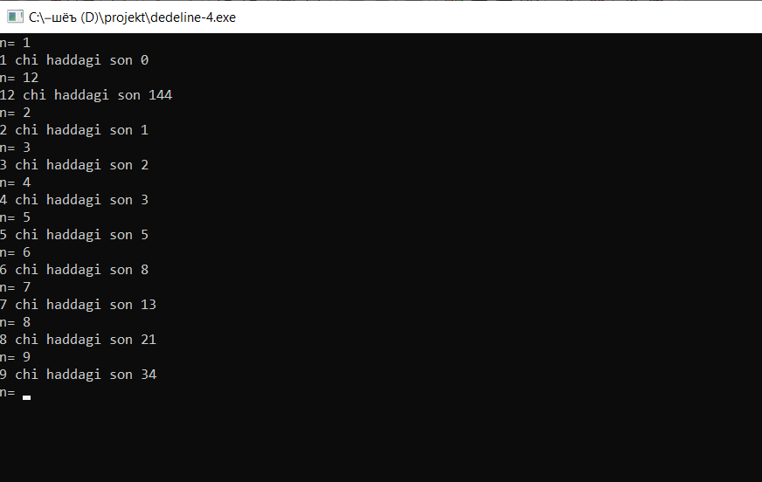

2-DASTUR

DASTUR KODI:  
Fibonachchi sonlarining dastlabki N tasini ekranga chiqaruvchi funksiya hosil qiling!

#include <iostream>

using namespace std;

void fibonachi(int N) {

int a = 0, b = 1, c;

for (int i=1;i<=N;i++){

cout<<a<<" ";

c=a+b;

a=b;

b=c;

}

cout<<endl;

}

int main() {

int n;

cout<<"n ni kiriting\n";

cin>>n;

fibonachi(n);

return 0;

}

NATIJASI:

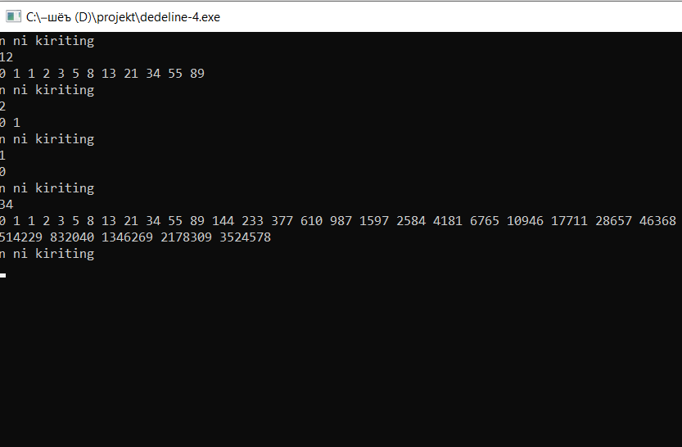

3-DASTUR

S

3-DASTUR

N - Fibonachchi sonini qaytaradigan recursive funksiya hosil qiling!

DASTUR KODI:

#include <iostream>

using namespace std;

int fibonachi(int n);

int main()

{

int n;

cout<<"n ni kirting"<<endl;

cin>>n;

cout<<fibonachi(n)<<endl;

return main();

}

int fibonachi(int n)

{

if(n<0) cout<<"aka had ham manfiy boladimi"<<endl;

else if(n==1) return 0;

else if(n==2) return 1;

else return fibonachi(n-1)+fibonachi(n-2);

}

DASTUR NATIJASI:

