Vaccine allocation project results

GMB

2022-04-12

# Introduction

This document brings together results from multiple model runs. It is intended to be re-run as the model is updated. NOTE: The setting for this run is: SLE

## Target questions

* What impact will the existing vaccination plan have on morbidity and mortality?
* What impact can be achieved under different levels of vaccine coverage?
* What are the potential benefits of expanding the immunisation schedule to include children?

## Overarching assumptions

Unless otherwise specified, key model assumptions in this run are:

| Variable | Value |
| --- | --- |
| Circulating strain | omicron |
| Length of model run | 52 |
| Proportion of population willing to be vaccinated | 0.88 |
| Daily capacity for vaccination (doses) | 11075 |
| Vaccine type used | Johnson & Johnson |

## Next steps for noting

* update of infection- and vaccine-derived immunity
* sensitivity analysis
  + turning on/off waning of vaccine-derived immunity
  + simulating outbreaks of different strains
  + experimenting with different age-prioritisation strategies
  + other?

# Impact of current program targets

Roll out of current program target (51.6% coverage) during or prior to an outbreak: 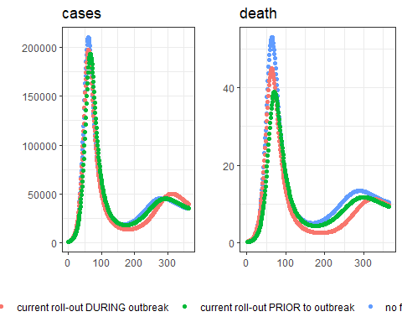

Absolute difference in outcomes

| death | hosp | severe_disease | YLL | cases | scenario |
| --- | --- | --- | --- | --- | --- |
| 221.3586 | 7695.918 | 2754.644 | 2396.533 | 1235.49 | 200% rollout speed |
| 613.2806 | 23629.208 | 7965.038 | 6905.777 | 131480.67 | 500% rollout speed |

Relative difference in outcomes

| death | hosp | severe_disease | YLL | cases | scenario |
| --- | --- | --- | --- | --- | --- |
| 6.021294 | 3.120741 | 5.365114 | 4.795128 | 0.0075287 | 200% rollout speed |
| 16.682180 | 9.581787 | 15.513197 | 13.817496 | 0.8012044 | 500% rollout speed |

# Varying levels of coverage

## Using current age-specific eligiblity

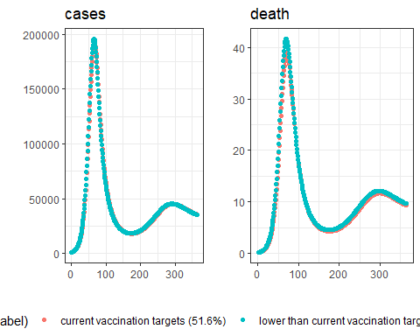

Absolute difference in outcomes

| death | hosp | severe_disease | YLL | cases | scenario |
| --- | --- | --- | --- | --- | --- |
| -210.9292 | -9047.878 | -2825.083 | -2447.452 | -127937.6 | lower than current vaccination targets (40.0%) |

Relative difference in outcomes

| death | hosp | severe_disease | YLL | cases | scenario |
| --- | --- | --- | --- | --- | --- |
| -5.404591 | -3.524183 | -5.202339 | -4.650242 | -0.7535803 | lower than current vaccination targets (40.0%) |

## Expanding eligibility to children

### Run current vaccine campaign, then expand to children

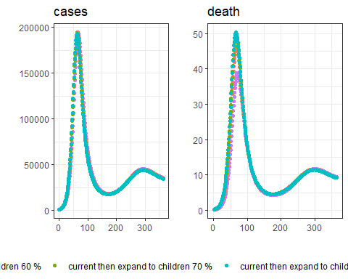

Absolute difference in outcomes

| death | hosp | severe_disease | YLL | cases | scenario |
| --- | --- | --- | --- | --- | --- |
| -351.7151 | -3066.9671 | -4885.170 | -3209.127 | 73265.5 | current then expand to children 60 % |
| -494.1642 | -2218.1131 | -6902.573 | -4355.234 | 151621.4 | current then expand to children 70 % |
| -531.4976 | -715.8247 | -7459.838 | -4562.560 | 202323.4 | current then expand to children 80 % |

Relative difference in outcomes

| death | hosp | severe_disease | YLL | cases | scenario |
| --- | --- | --- | --- | --- | --- |
| -9.011913 | -1.1945955 | -8.995951 | -6.097453 | 0.4315497 | current then expand to children 60 % |
| -12.661855 | -0.8639636 | -12.710961 | -8.275094 | 0.8930830 | current then expand to children 70 % |
| -13.618439 | -0.2788165 | -13.737156 | -8.669021 | 1.1917286 | current then expand to children 80 % |

### Expand to children now

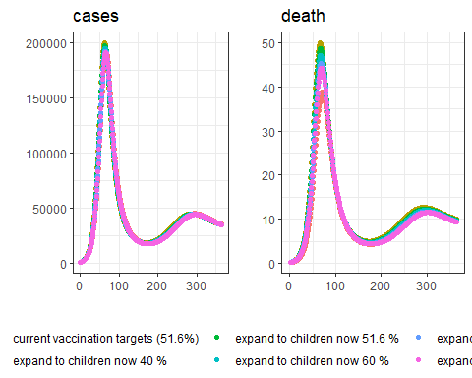

Absolute difference in outcomes

| death | hosp | severe_disease | YLL | cases | scenario |
| --- | --- | --- | --- | --- | --- |
| -708.7320 | -21621.040 | -9631.849 | -7582.423 | -217340.23 | expand to children now 40 % |
| -579.4027 | -12556.008 | -7964.873 | -5823.964 | -57156.27 | expand to children now 51.6 % |
| -460.5670 | -5492.133 | -6415.697 | -4302.514 | 57399.49 | expand to children now 60 % |
| -317.2602 | 2830.951 | -4529.006 | -2480.325 | 196883.37 | expand to children now 70 % |
| -239.6950 | 7339.716 | -3506.786 | -1493.647 | 274145.39 | expand to children now 80 % |

Relative difference in outcomes

| death | hosp | severe_disease | YLL | cases | scenario |
| --- | --- | --- | --- | --- | --- |
| -18.159675 | -8.421478 | -17.736874 | -14.406865 | -1.2801813 | expand to children now 40 % |
| -14.845899 | -4.890614 | -14.667168 | -11.065732 | -0.3366629 | expand to children now 51.6 % |
| -11.801001 | -2.139207 | -11.814388 | -8.174924 | 0.3380955 | expand to children now 60 % |
| -8.129085 | 1.102666 | -8.340082 | -4.712702 | 1.1596859 | expand to children now 70 % |
| -6.141649 | 2.858847 | -6.457683 | -2.837982 | 1.6147760 | expand to children now 80 % |

# Varying speed of vaccine roll-out

This section models varying speeds of vaccine roll-out *DURING* an outbreak. 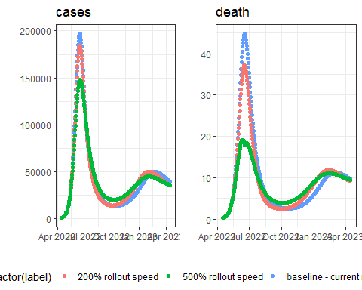

Absolute difference in outcomes

| death | hosp | severe_disease | YLL | cases | scenario |
| --- | --- | --- | --- | --- | --- |
| 221.3586 | 7695.918 | 2754.644 | 2396.533 | 1235.49 | 200% rollout speed |
| 613.2806 | 23629.208 | 7965.038 | 6905.777 | 131480.67 | 500% rollout speed |

Relative difference in outcomes

| death | hosp | severe_disease | YLL | cases | scenario |
| --- | --- | --- | --- | --- | --- |
| 6.021294 | 3.120741 | 5.365114 | 4.795128 | 0.0075287 | 200% rollout speed |
| 16.682180 | 9.581787 | 15.513197 | 13.817496 | 0.8012044 | 500% rollout speed |

# Sensitivity analysis (TBC)