Gizem Külekçi 25086

HW1_Part1:

Determining a threshold can be used to distinguish between activities that require and do not require movement. Activities that do not require movement have lower magnitude values than the activities that require movement. Between sitting data and standing data, it can be seen that magnitude values of sitting data much more smaller than the standing data. On the other hand, magnitude values of walking data and running data are closer to each other. But when looking closely, it can be seen that in running data there are more peaks per second than walking data. As a result, magnitude values (y axis) and peak rate can be used to distinguish activities.

1. **Walking**

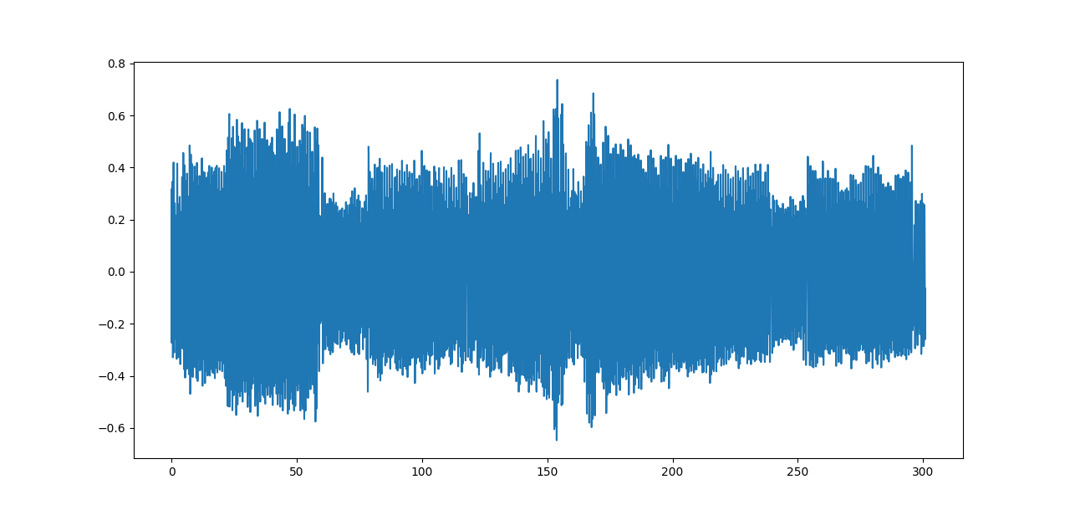

603 steps taken in 300 seconds

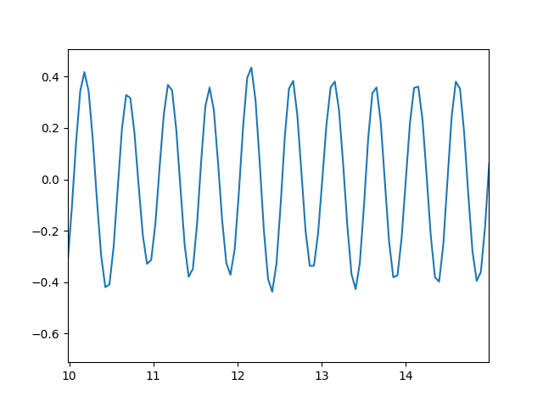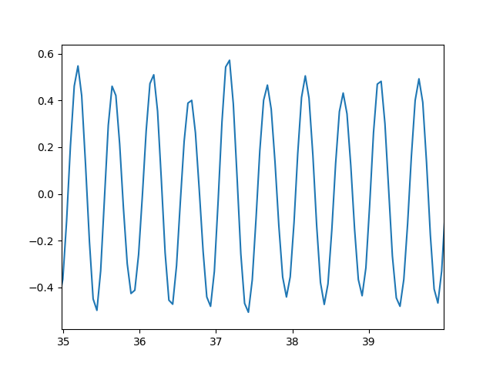

1. **Running**

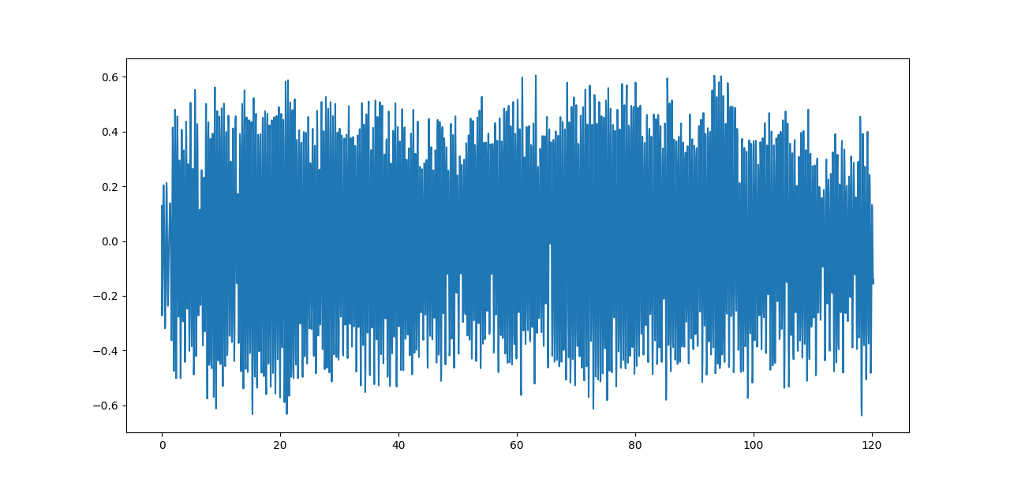

313 steps taken in 120 seconds

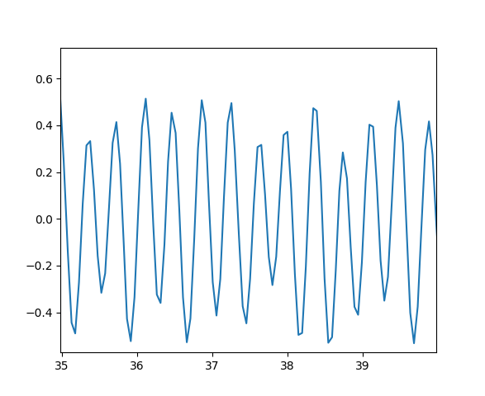running data


1. **Standing**

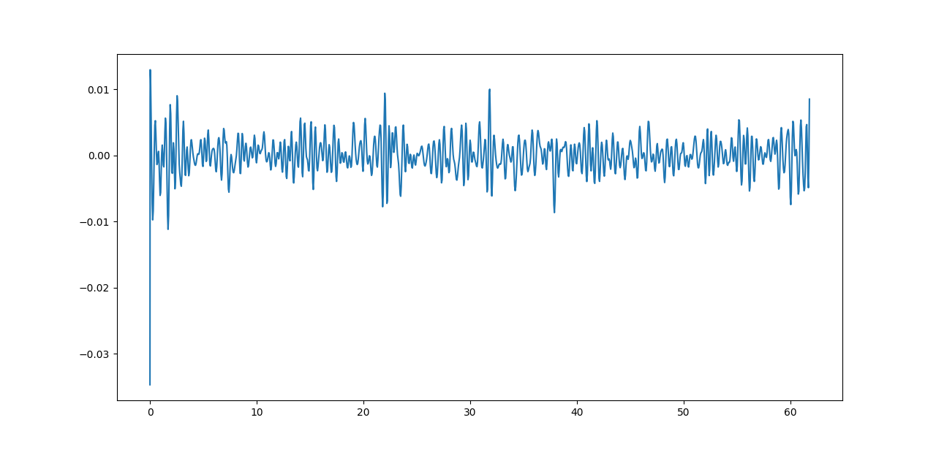

0 steps taken in 61 seconds

1. **Sitting**

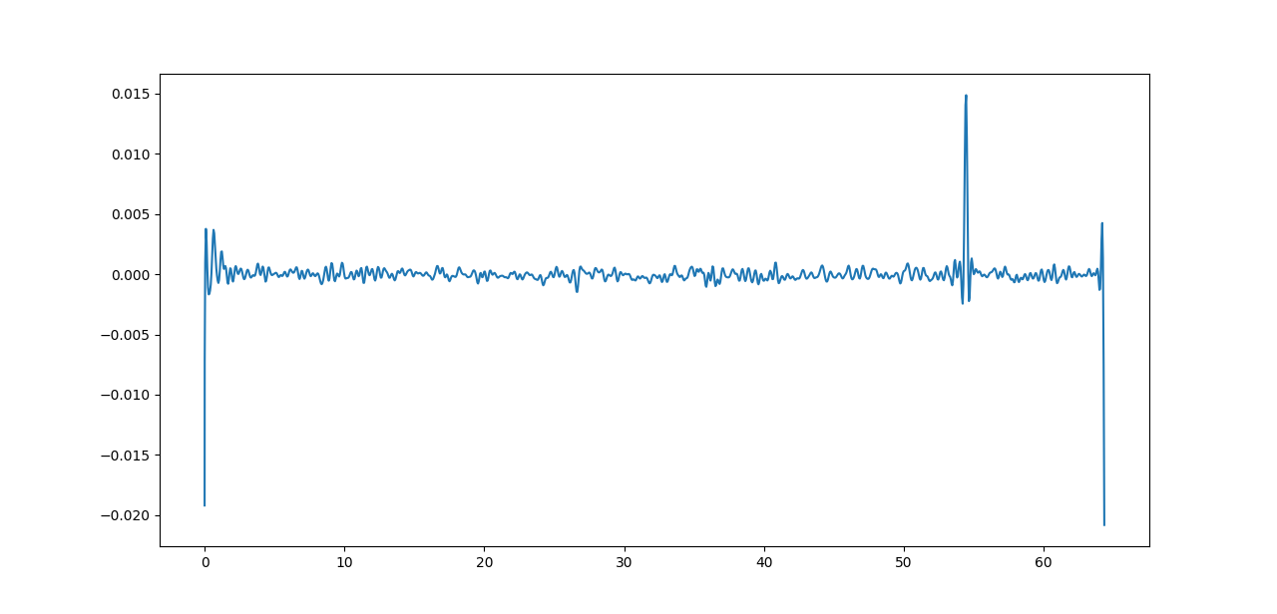

0 steps taken in 64 seconds