**T.C.**

**ESKİŞEHİR OSMANGAZİ ÜNİVERSİTESİ**

**MÜHENDİSLİK VE MİMARLIK FAKÜLTESİ**

**BİLGİSAYAR MÜHENDİSLİĞİ BÖLÜMÜ**

**DERSİN ADI:**

VERİ TABANI YÖNETİM

SİSTEMLERİ LABORATUVARI

**DENEY #6**

**Doç. Ahmet YAZICI**

Gizem Taşcı - 152120131100

**ESKİŞEHİR**

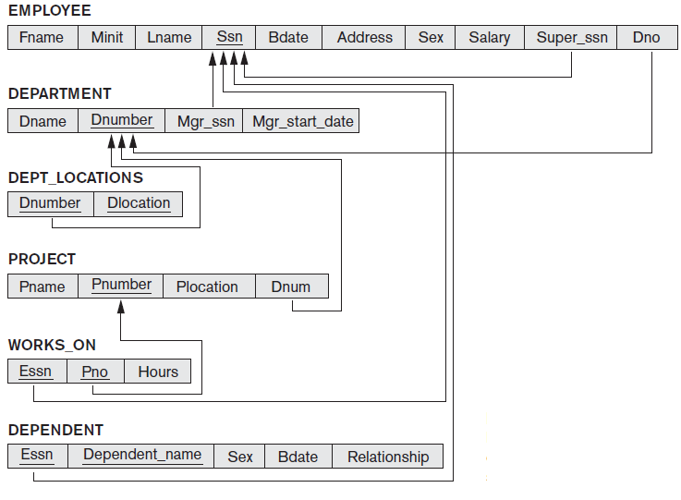

1. Create the tables that given below and insert at least 3 records inside the tables.

--Veri tabanında tutulacak tablolar oluşturuldu.

create table Department(

Dname varchar(30),

Dnumber int,

Mgr_ssn int,

Mgr_start_date date,

PRIMARY KEY(Dnumber)

)

create table Employee(

Fname varchar(30),

Minit varchar(10),

Lname varchar(30),

Ssn int,

Bdate date,

Aaddress varchar(100),

Sex varchar(2),

Salary float,

Super_ssn int,

Dno int,

PRIMARY KEY(Ssn),

FOREIGN KEY(Super_ssn) REFERENCES Employee,

FOREIGN KEY(Dno) REFERENCES Department

)

create table Dept_Locations(

Dnumber int,

Dlocation varchar(30),

PRIMARY KEY(Dnumber,Dlocation),

FOREIGN KEY(Dnumber) REFERENCES Department

)

create table Project(

Pname varchar(30),

Pnumber int,

Plocation varchar(30),

Dnum int,

PRIMARY KEY(Pnumber),

FOREIGN KEY(Dnum) REFERENCES Department

)

create table Works_On(

Essn int,

Pno int,

Hhours int,

PRIMARY KEY(Essn,Pno),

FOREIGN KEY(Essn) REFERENCES Employee,

FOREIGN KEY(Pno) REFERENCES Project

)

create table Ddependent(

Essn int,

Dependent_Name varchar(30),

Sex varchar(2),

Bdate date,

Relationship varchar(30),

PRIMARY KEY(Essn,Dependent_Name),

FOREIGN KEY(Essn) REFERENCES Employee

)

--Department tablosuna aşağıdaki 3 veri eklendi.

insert [dbo].[Department] ([Dname],[Dnumber],[Mgr_ssn],[Mgr_start_date])

values (N'Ar-Ge', 1, 3, CAST(N'2015-07-22'AS Date))

insert [dbo].[Department] ([Dname],[Dnumber],[Mgr_ssn],[Mgr_start_date])

values (N'Ar-Ge', 2, 5, CAST(N'2011-01-12'AS Date))

insert [dbo].[Department] ([Dname],[Dnumber],[Mgr_ssn],[Mgr_start_date])

values (N'Ar-Ge', 3, 3, CAST(N'2013-04-24'AS Date))

--Employee tablosuna aşağıdaki 3 veri eklendi.

insert [dbo].[employee] ([Fname], [Minit], [Lname], [Ssn], [Bdate], [Aaddress], [Sex], [Salary], [Super_ssn], [Dno])

values (N'Zeynep', N'H', N'Sezgin', 1,CAST(N'1980-09-10' AS Date), N'Atatürk Bulvarı', N'F', 5000, 1,3)

insert [dbo].[employee] ([Fname], [Minit], [Lname], [Ssn], [Bdate], [Aaddress], [Sex], [Salary], [Super_ssn], [Dno])

values (N'Hakan', N'Kadir', N'Balta', 1,CAST(N'1980-09-10' AS Date), N'Ali Sami Yen Sokak', N'M', 15000, 2,5)

insert [dbo].[employee] ([Fname], [Minit], [Lname], [Ssn], [Bdate], [Aaddress], [Sex], [Salary], [Super_ssn], [Dno])

values (N'Sinan', N'Aa', N'Gümüş', 1,CAST(N'1990-02-17' AS Date), N'Ali Sami Yen Sokak', N'M', 20000, 3,8)

2. Write SQL codes for following questions according to tables above.

1. Select the birthdate and address of the employee whose name is ‘Zeynep H Sezgin’

--Zeynep H. Sezgin isimli kişinin adresi ve doğum tarihi yazdırıldı.

select Bdate,Aaddress from Employee

where Fname='Zeynep',Minit='H',Lname='Sezgin'

1. Select the names of employees who have no dependents.(Hint: Exist)
2. Select the all employees whose address is in Erzurum, Turkey

--Adresi Erzurum olan tüm işçiler yazdırıldı.

select Fname,Minit,Lname from Employee

where Aaddress='Erzurum'

1. Select for the each department that has more than 4 employees, retrieve the department number and the number of its employees who are making more than 5082 TL.

--4 işçiye sahip ve 5082 TL'den fazla maaş veren tüm bölümler listelendi.

select * from Department where Dname in

(select Dname from Employee group by Dname

having min(salary)>=5082 and select Dname

from Employee group by Dnumber having count(*)>=4)