**TECHNICAL UNIVERSITY of GUZ**

**GRADUATE THESIS WRITING GUIDELINE**

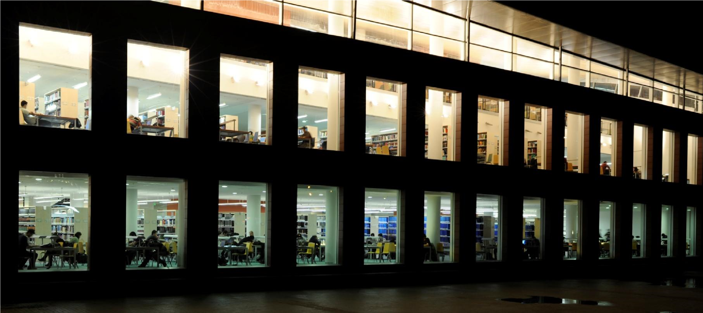

Valid after the approval TUGUZ Senate meeting 788 dated 18.11.2021

**NOVEMBER 2021**

# FOREWORD

Master's theses, Ph.D. or proficiency in arts dissertations submitted to ITU Graduate School must be written in accordance with the format stated in this guideline. Thesis writing guidelines in Turkish and English can be downloaded from the website ITU Library and the Graduate School [(](http://()[www.kutuphane.itu.edu.tr](http://www.kutuphane.itu.edu.tr/), and [www.lee.itu.edu.tr](http://www.lee.itu.edu.tr)[,](http://www.fbe.itu.edu.tr/) [)](http://www.eedmi.itu.edu.tr/). This thesis writing guideline states the format of theses prepared in ITU, however it does not provide a template or serve as an example).

This guideline has been prepared by combining the ITU experience and APA (American Psychological Association) rules, one of the internationally accepted writing guidelines. For issues not mentioned in this guideline, APA rules must be taken as reference. For further information regarding APA rules, please consult the APA website ([www.apastyle.org,](http://www.apastyle.org/) [www.apa.org)](http://www.apa.org/) or ITU Mustafa Inan Library for a printed copy of *Publication Manual of the American Psychological Association, Washington, 2010*.

# TABLE OF CONTENTS

**Page**

FOREWORD ii

TABLE OF CONTENTS iii

LIST OF FIGURES v

1. ORDER OF PRESENTATION FOR CHAPTERS 1

2. GENERAL FORMAT RULES 2

2.1 Paper Type and Printing 2

2.2 Page Format 2

2.2.1 Writing format 2

2.2.2 Margins 2

2.3 Fonts 4

2.4 Line Spacing and Paragraph Format 5

2.5 Page Numbering 5

2.6 Tables and Figures 6

2.7 Equations 7

2.8 Covers and Binding 8

2.8.1 Paperback inner and outer cover 8

2.8.1.1 Paperback outer cover 8

2.8.1.2 Paperback inner cover 9

2.8.2 Hardcover inner and outer cover 10

2.8.2.1 Hardcover outer cover 10

2.8.2.2 Hardcover outer cover spine title 11

2.8.2.3 Hardcover inner cover 11

2.9 Approval Page 12

3. SPELLING AND CHAPTER CONTENTS 15

3.1 Chapter Titles 15

3.2 Foreword 16

3.3 Table of Contents 16

3.4 Abbreviations, Lists of Tables, Figures, and Symbols (Nomenclature) 17

3.5 Summary in Turkish and English 17

3.6 Main Text Body 17

3.7 References 18

3.7.1 Quoting 18

3.7.2 Citing (indication of references in main text body) 20

3.7.2.1 Citing according to surname of author 20

3.7.2.2 Citing according to order of appearance 21

3.7.3 Listing of references 21

3.8 Footnotes 22

3.9 Appendices 23

3.10 Curriculum Vitae 24

# LIST OF FIGURES

**Page**

**Figure 2.1a:** Odd first page margins. 2

**Figure 2.2b:** Odd and even inner page margins. 3

**Figure 2.2:** Landscape-oriented page format. . …4

**Figure 2.3:** Hardcover page spine size and format. 11

# ORDER OF PRESENTATION FOR CHAPTERS

The presentation order of the thesis chapters must be as listed below;

1. Outer cover
2. Inner cover
3. Approval page
4. Dedication page (if existant)
5. Foreword
6. Table of contents
7. Abbreviations
8. Symbols (Nomenclature)
9. List of tables
10. List of figures
11. Summary (Turkish/English) (The summary in the language the thesis was written
12. must be placed first)
13. Introduction
14. Other chapters (Materials and Methods, Results and Discussion, etc…)
15. Conclusions
16. References
17. Appendices
18. Curriculum vitae

# GENERAL FORMAT RULES

## Paper Type and Printing

Theses must be printed/reproduced on A4 (21x29.7 cm) size, 80 g/m2 white, first quality paper. No distortion must occur during printing/reproduction, and the copies must be legible.

## Page Format

### Writing format

Paperback (white/carton) cover and hard (indigo blue for M.A and M.Sc., and black for Ph.D./cloth) must be duplex-printed. The first page of every chapter must be on an odd page.

### Margins

Page margins must be set as specified in Figures 2.1a and 2.1b.

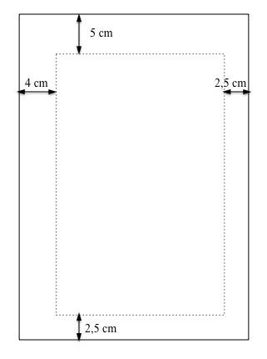

**Figure 2.1a:** Odd first page margins.

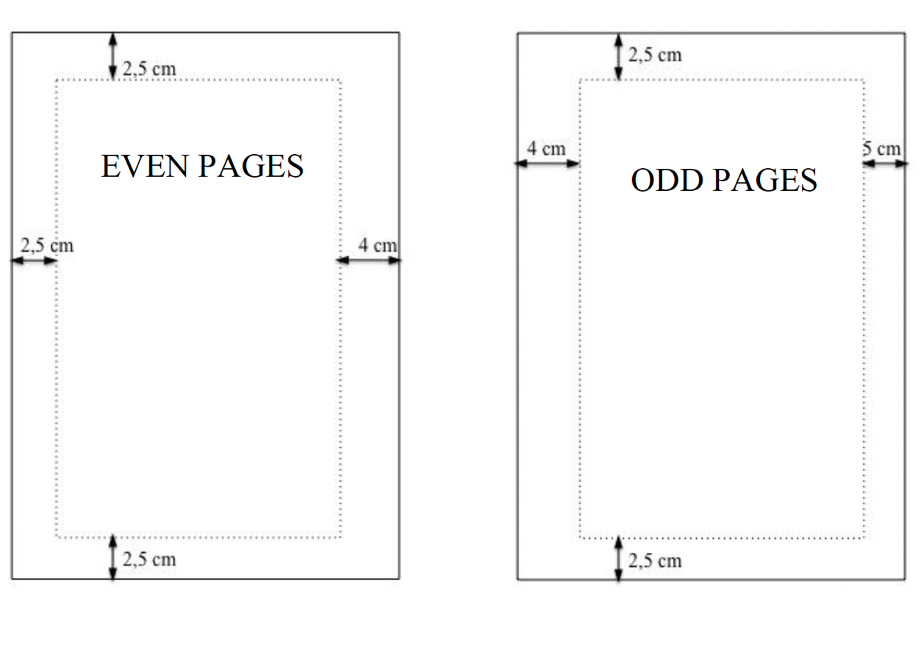**Figure 2.2b:** Odd and even inner page margins.

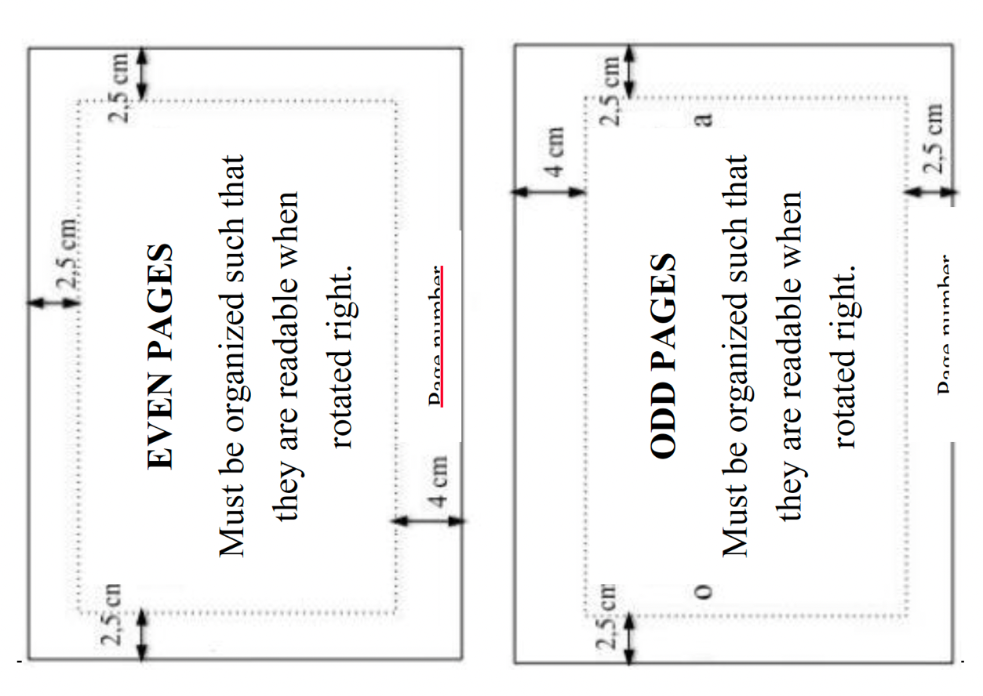

**Figure 2.2:** Landscape-oriented page format.

As shown in Figure 2.2, landscape-oriented pages must be organized such that they are readable when rotated right.

## Fonts

Throughout a thesis, Times New Roman 12 pt or Arial 11 pt font type/size must be used. However, the font chosen must be applied to the whole thesis. If required, the font size could be reduced by 1 pt.

Footnotes explaining a concept from the main text body must be written with 8 pt font size. Footnotes spanning more than 10 lines must be given as appendix.

In tables and figures, font size could be reduced to 8 pt, if necessary.

Tables must be prepared using the same font type as the thesis. The font type used in figures must be consistent throughout the thesis.

The font size used for long quotations indented from the left must be the same with the font size used in main text body (12 pt Times New Roman or 11 pt Arial).

The main text body must be written with regular (non-italics and non-bold) characters. Bold fonts must be used for titles. *Italic* characters must be used only when necessary (Nouns in Latin, abbreviations, theories/definitions, etc.).

One space distance must be placed after the commas and full stops.

## Line Spacing and Paragraph Format

The term “line spacing” refers to the distance between the lower baselines of two consecutive lines. Point is a font size unit which corresponds to 1/72” (0.376 mm).

The main text body must be written with 1.5 line spacing. Paragraphs must be justified aligned. Before and after each paragraph, 6 pt distance must be set. Additional blank lines must be deleted between paragraphs.

Abbreviations, Table of Contents, Lists of Tables and Figures, Foreword, Summaries, References, Appendices, CV, names and captions for tables and figures, and footnotes in main text body must be written with 1 line spacing.

Before and after first level titles, 72 pt and 18 pt paragraph spacing must be set, respectively.

Before and after second level titles, 18 pt and 12 pt paragraph spacing must be set, respectively.

Before and after third and fourth level titles, 12 pt and 6 pt paragraph spacing must be set, respectively.

Titles must not be the last line of a page, a title must be placed on the following page unless two more lines could be written after it. The first line of a paragraph cannot be the last line of a page, as the last line of a paragraph cannot be the first line of a page.

## Page Numbering

All of the pages within the thesis, except for outer and inner cover pages and their backsides, must be numbered.

Inner cover and its backside must be numbered as (i) and (ii), but the page numbers must not be shown. All pages starting from the approval page to the main text body must be numbered uninterruptedly with lowercase Roman numbers. The main text body (Introduction and the other chapters, Results and/or Discussion, References, Appendices and CV) must be numbered with Arabic (1, 2, 3, etc.) numbers.

Page numbers must be placed at the bottom center and 1.5 cm above the bottom of the page, in the direction of reading.

The font style used throughout the thesis must be used for page numbers, and the font size must be 11 pt for Times New Roman and 10 pt for Arial.

## Tables and Figures

Tables and figures must be placed after they are first cited in the main text body, but must be as close as possible, in accordance with the rules in this guideline. All tables and figures must be cited before they are used in the main text body.

All tables and figures must be horizontally centered on the page.

The numbering of the tables and the figures must be such that the first number is the number of the chapter the table/figure is placed under (for appendices, the letter of the appendix), and the second number is the number of order (i.e. **Table 1.2, Figure 3.5, Table A.1, Figure B.5**). The words “Table” and “Figure” and numbers must be bold.

Numbers and captions must be written below for figures and above for tables, and all lines are horizontally centered on the line.

For table numbers and captions, 1 line spacing, 12 pt (before) and 6 pt (after) paragraph spacing must be set. Table captions must be ended with a full stop. A table and its caption must be on the same page.

Multiple tables/figures could be placed on one page, however, table/figures spanning more than 4 consecutive pages must be given in appendices rather than the main text body.

The first paragraph following a table must have 12 pt (before) and 6 pt (after) paragraph spacing. Titles following a table must have the standard formatting as previously specified.

Tables’ first line must be double line.

Footnotes for a table must be written with 1 line spacing and a font size 2 pt smaller than the main text body.

For figure numbers and captions, 1 line spacing, 6 pt (before) and 12 pt (after) paragraph spacing must be set. Figure captions must be ended with a full stop. A figure and its caption must be on the same page.

For figures spanning more than one page, the same number and caption must be written below the continued figure, with the expression “continued” added in brackets (i.e. **Table 1.1 (continued):** Metal composition of wastes. **Figure 1.1 (continued):** Water supply network of Istanbul.).

Two and more page tables must include the column names in the continues pages.

Plots, images and musical notes must be numbered and captioned as figures. Musical notes must be written according to the format rules set by the ITU School of Traditional Turkish Music.

It is recommended that elements that increase the page thickness and disrupt the binding structure of theses such as folded pages or additional items embedded on pages are given as appendices.

## Equations

Equations must be written according to the rules specified below, using an equation editor.

Equations must be written with 1.5 line spacing.

6 pt paragraph spacing must be set before and after equations.

Additional blank lines must not be placed before and after equations (which would make 12 pt paragraph spacing before and after an equation).

Equations must be horizontally centered on a page.

The numbering of equations must be so that the first number is the number of the chapter the equation is placed under, and the second number is the number of order starting from one (i.e. **(1.1)**, **(1.2)** for equations in **Chapter 1, (2.1)**, **(2.2)** for equations in Chapter 2, etc.). The numbers must be **bold** and aligned horizontally right on the line the equation is placed. If necessary, sub-equations of an equation could be numbered as **(1.1a)** and **(1.1b)**, etc.

Equations in appendices must be numbered by the number of the appendix they are given in (i.e. Appendix A (**(A.1.1)**, **(A.1.2.)**)

## Covers and Binding

Theses written in Turkish must include English inner cover and; theses written in English must include Turkish inner covers. Rules regarding the paperback outer and inner covers are given individually below;

### Paperback inner and outer cover

#### Paperback outer cover

On the paperback outer cover, Times New Roman 12 pt font must be used. The expressions on the cover must be organized as follows;

3 cm below the top of the page

**ISTANBUL TECHNICAL UNIVERSITY** **GRADUATE SCHOOL**

must be placed, the star separator must be full and have 5 corners.

The thesis title must be placed between 8-10 cm below the top of the page, in three lines maximum. The font size for the thesis title is 12 pt, however, this may be reduced down to 10 pt in case the title doesn't fit in three lines.

15 cm below the top of the page, **M.A. THESIS,** **M.Sc. THESIS**, **Ph.D. THESIS**, or

**PROFICIENCY IN ARTS THESIS**,

16 cm below the top of the page, author’s **Name Surname**,

20 cm below the top of the page, **Department of ….....**,

21 cm below the top of the page, **….......... Programme**,

Regarding department/programme names, the names which are officially approved by the Graduate School must be used (i.e. **Department of Civil Engineering**, **Structure Engineering Programme**).

23 cm below the top of the page, **Thesis Advisor: …........**, title, name and surname of advisor,

26 cm below the top of the page, the month and the year at which the thesis is submitted to the graduate school (i.e. **JANUARY 2010**), must be written.

All these lines on the title page must be centered on the page, according to the margins.

The organization of the paperback outer cover page is given in the thesis template.

#### Paperback inner cover

On the paperback inner cover, Times New Roman 12 pt font must be used.

3 cm below the top of the page

**ISTANBUL TECHNICAL UNIVERSITY**  **GRADUATE SCHOOL**

must be placed, the star separator must be full and have 5 corners.

The thesis title must be placed between 8-10 cm below the top of the page, in three lines maximum. The font size for the thesis title is 12 pt, however, this may be reduced down to 10 pt in case the title doesn't fit in three lines.

15 cm below the top of the page, **M.A. THESIS,** **M.Sc. THESIS**, **Ph.D. THESIS**, or

**PROFICIENCY IN ARTS THESIS**,

16 cm below the top of the page, author’s **Name SURNAME**,

In the next line, **Student ID** example: (**501092205**),

20 cm below the top of the page, **Department of ….....**,

21 cm below the top of the page, **….......... Programme**,

Regarding department/programme names, the names which are officially approved by the Graduate School must be used (i.e. **Department of Civil Engineering**, **Structure Engineering Programme**).

23 cm below the top of the page, **Thesis Advisor: …........**, title, Name and SURNAME of advisor,

26 cm below the top of the page, **Date of Submission: Month, Year** (i.e. **Date of Submission: January 2010**) must be written.

All these lines on the title page must be centered on the page, according to the margins.

The organization of the paperback inner cover page is given in the thesis template.

### Hardcover inner and outer cover

#### Hardcover outer cover

M.A. and M.Sc. theses must have indigo blue, Ph.D. dissertations must have black cloth hard covers. On the outer cover page, the font style/size must be Times New Roman 12 pt.

3 cm below the top of the page, the name of the university and the Graduate School name must be written in one line.

The thesis title must be placed between 8-10 cm below the top of the page, in three lines maximum. The font size for the thesis must be set according to the length of the title.

15 cm below the top of the page, **M.A. THESIS,** **M.Sc. THESIS, Ph.D. THESIS, or**

**PROFICIENCY IN ARTS THESIS**,

16 cm below the top of the page, **Name Surname,**

20 cm below the top of the page, **Department of ….....,**

21 cm below the top of the page, **….......... Programme,**

Regarding department/programme names, those officially approved by the graduate school must be used (i.e. **Department of Civil Engineering**, **Structure Engineering Programme**).

26 cm below the top of the page, the month and the year at which the thesis is submitted to the graduate school (i.e. **JANUARY 2010**) must be written.

All these lines on the title page must be centered on the page, according to the margins.

The organization of the hardcover outer cover page is given in the thesis template.

#### Hardcover outer cover spine title

The font type/size for hardcover outer cover spine title must be Times New Roman 12 pt. On the spine, the first letter of the author's name, author's surname, the title of thesis and the year the thesis was approved must be written. All text must be horizontally and vertically centered in their individual cells, as shown in Figure 2.3.

Font size for the thesis title must be reduced if necessary to fit the specified cell.

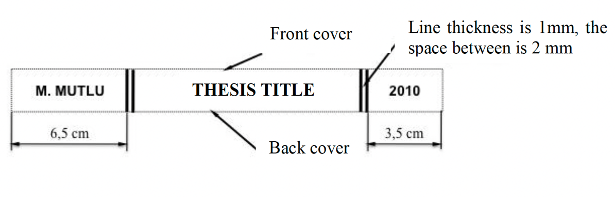

**Figure 2.3:** Hardcover page spine size and format.

#### Hardcover inner cover

On the paperback inner cover, Times New Roman 12 pt font must be used. The thesis title must be placed between 8-10 cm below the top of the page, in three lines maximum. The font size for the thesis title could be reduced to fit the title in three lines.

15 cm below the top of the page, **M.A. THESIS,** **M.Sc. THESIS, Ph.D. THESIS, or**

**PROFICIENCY IN ARTS THESIS**,

16 cm below the top of the page, author’s **Name Surname**,

In the next line, **Student ID** (i.e. **501092205**),

20 cm below the top of the page, **Department of ….....**,

21 cm below the top of the page, **….......... Programme**,

(Regarding department/programme names, the names which are officially approved by the Graduate School must be used (i.e. **Department of Civil Engineering**, **Structure Engineering Programme**).)

23 cm below the top of the page, **Thesis Advisor: …........**, Title, Name and SURNAME of advisor,

26 cm below the top of the page, **Date of Submission: Month, Year** (i.e. **Date of Submission: January 2010**) must be written.

All these lines on the title page must be centered on the page, according to the margins.

The organization of the paperback inner cover page is given in the thesis template**.**

## Approval Page

5 cm below the top of the page;

Name-SURNAME**,** a M.A./ M.Sc./ Ph.D. student of ITU **Graduate School,** student ID …....., successfully defended the thesis/dissertation entitled “THESIS TITLE”, which he/she prepared after fulfilling the requirements specified in the associated legislations, before the jury whose signatures are below.

10 cm below the top of the page;

**Thesis Advisor :**  **Prof. Dr. Name SURNAME**  **…..........................**

Name of Institution (Istanbul Technical University)

12 cm below the top of the page, name of the co-advisor (if exists) must be placed;

**Thesis Co-advisor :** **Prof. Dr. Name SURNAME …..........................**

Name of Institution (Istanbul Technical University)

14 cm below the top of the page;

**Jury Members : Prof. Dr. Name SURNAME …..........................**

Name of Institution (Yıldız Technical University)

Other members of the jury are listed with 2 cm intervals.

After the last line, left-aligned;

The date (as day month year) the thesis/dissertation was submitted to the institute must be written as **Date of Submission : 22 January 2010**. In the following line, the date (as day month year) the thesis/dissertation was successfully defended must be written as **Date of Defense : 21 February 2010**.

All the hardcover copies of theses must have signatures of the members of the jury next to their names. Since a thesis is approved by the common decision from the jury (unanimously or by the majority of the votes), individual votes of the members (such as APPROVED or REJECTED) must not be noted on this page.

Approval pages individually prepared for M.A., M.Sc. and Ph.D. theses are given in the thesis template.

# SPELLING AND CHAPTER CONTENTS

The spelling and punctuation rules must be followed either American English or English English through the theses.

In theses, SI units must be used but equivalents in MKS units may be additionally given in brackets.

Every symbol must be identified at its first appearance in a thesis.

Except for the foreword and footnotes, first person perspective must not be used while writing a thesis.

Theses must be prepared electronically, and printouts must be taken using a laser or liquid inkjet printer. Using typewriters or dot-matrix printers is not allowed.

Corrections, erasures or scrapings anywhere on a thesis made by hand or typewriters are not allowed.

Tables, plots, figures and equations in a thesis must be prepared using a computer. Corrections on these cannot be done by hand.

Appendices exceeding 10 pages must not be given in the main text body or appendices, but on storage media (i.e. CD, DVD, etc). Additional material of this kind must be placed in a CD envelope attached to the inner side of the back cover of the thesis. Name, SURNAME, Student ID, Thesis Title, and M.A./ M.Sc./ Ph.D. Thesis Appendices’ must be written on the media with an CD marker on the mentioned CD’s.

## Chapter Titles

All chapter titles in the thesis must be **bold**.

Titles of summaries in Turkish and English must be centered, whereas all the other titles must be justified aligned.

First level titles must be in capitals and bold (i.e. **1. INTRODUCTION**), and placed on an odd page in the direction of reading.

Second level titles must be bold and the first letter of each word in the title must be capital (i.e. **2.1 Process Qualification Analysis**).

Third and fourth level titles must be bold and only the first letter of the word the title begins with must be capital (i.e. **2.1.1 Process analysis using a histogram** or **3.1.1.2 Process analysis steps**).

Fifth and further level titles are not numbered and are not included in Table of Contents.

## Foreword

For the foreword, 1 line spacing must be set. The foreword, written as a first page of the thesis must not exceed 2 pages.

The acknowledgements must be given in this section.

After the foreword text, name of the author (right-aligned), and the date (as month, year) must be written (left-aligned). These two expressions must be in the same line.

In Foreword text all surnames written in capital letters (ie. Name SURNAME). Below the Name SURNAME occupation information written in the parentheses.

## Table of Contents

For the table of contents, 1 line spacing must be set, and the first element listed must be the foreword.

First level titles must be bold and in capitals, whereas only first letters of words in second level titles, and the first letter of the first word of third level titles must be in capitals in table of contents.

The space between all titles and their relevant page numbers must be filled with dots. The titles must not exceed the page number section, titles must be cut in a proper part to continue in the line below.

## Abbreviations, Lists of Tables, Figures, and Symbols (Nomenclature)

The abbreviations, tables, figures and symbols in a thesis must be listed individually. For these lists, 1 line spacing and 6 pt (before) and 6 pt (after) paragraph spacing must be set.

Lists of catalogues, periodicals, electronic references, and personal communications must be listed within the references section and not separately.

## Summary in Turkish and English

For thesis in Turkish, the summary in Turkish must have 300 words minimum and span 1 to 3 pages, whereas the extended summary in English must span 3-5 pages.

For thesis in English, the summary in English must have 300 words minimum and span 1-3 pages, whereas the extended summary in Turkish must span 3-5 pages.

A summary must briefly mention the subject of the thesis, the method(s) used and the conclusions derived.

References, figures and tables must not be given in Summary.

Above the Summary, the thesis title in first level title format (i.e., 72 pt before and 18 pt after paragraph spacing, and 1 line spacing) must be placed. Below the title, the expression **ÖZET** (for summary in Turkish) and **SUMMARY** (for summary in

English) must be written horizontally centered.

## Main Text Body

The main text body consists of the sections (with no limit for the number of pages) specified below:

Introduction

Other sections (Materials and Methods, Results and Discussion, etc.)

Conclusions.

Sections such as indexes or dictionaries must be given in appendices.

## References

The rules specified below must be followed for citing/referencing literature. Detailed information on referencing could be found on website of Graduate School and associated links.

### Quoting

Generally, quoting is done by remaining faithful to the original text in terms of words, spelling and punctuation. In case there is a mistake, the correct version is written in square brackets in the quoted text.

Short quotations (not longer than 40 words) must be given in quotation marks. Following the text quoted, the reference must be written and a full-stop must be placed afterwards.

Quotations longer than 40 words must not be shown in quotation marks. Instead, they must be indented 1 tab space (1.27 cm) from the left side of the page. The font size for long quotations indented from the left must be the same with the font size used in main text body. However, it is not advised to quote very long texts and to quote very frequently. Unlike short quotations, references of long quotations must be placed after the full stop. (i.e., .(p.196))

Example for a quotation longer than 40 words;

Main text Main text Main text Main text Main text Main text Main text Main text Main text Main text Main text Main text Main text Main text. Others have contradicted this view:

Co-presence does not ensure intimate interaction among all group members.Consider large-scale social gatherings in which hundreds or thousands of people gather in a location to perform a ritual or celebrate an event. In these instances, participats are able to see the visible manifestation of the group, the physicsl gathering, yet their ability to make direct, intimate connections with those around them is limited by the sheer magnitude of the assembly. (Purcell, 1997, pp. 111-112)

Example for a quotation at the beginning of a sentence;

According to Jones (1998), "Students often had difficulty using APA style, especially when it was their first time" (p. 199).

“Critser (2003) noted that despite growing numbers of overweight Americans, many health care providers still “remain either in ignorance or outright denial about the health danger to the poor and the young” (s. 5).

Critser (2003) noted that despite growing numbers of overweight Americans, many health care providers still “remain either in ignorance or outright denial about the health danger to the poor and the young” (Critser, 2003, s. 5).

Example for a quotation in the middle of a sentence;

Interpreting these results, Robbins et al. (2003) suggested that the “therapists in dropout cases may have inadvertently validated parental negativity about the adolescent without adequately responding to the adolescent’s needs or concerns” (p.

541) contributing to an overall climate of negativity.

Example for a quotation at the end of a sentence;

Confusing this issue is the overlapping nature of roles in palliative care, whereby

“medical needs are met by those in the medical disciplines; nonmedical needs may be addressed by anyone on the team” (Csikai & Chaitin, 2006, p. 112).

Detailed information on quoting could be found on websites of Graduate Schools and associated links.

### Citing (indication of references in main text body)

#### Citing according to surname of author

References are cited with the surname of author and year. In the references section, the references are listed alphabetically according to the surname of the author.

Citing of a reference at the beginning of or within a sentence must be as Boran (2003), whereas a citation at the end of a sentence must be as (Boran, 2003). The full-stop is placed directly after the citation.

A reference with two authors must be cited as Yılmaz and Johnson (2004) at the beginning of or within a sentence, or as (Yılmaz and Johnson, 2004) at the end of a sentence.

A reference with more than two authors must be cited as Yılmaz et al. (2004) at the beginning of or within a sentence, or as (Yılmaz et al, 2004) at the end of a sentence.

Different publications of an author published in the same year must be cited as Feray (2005a), Feray (2005b).

While citing multiple publications of an author in one pair of brackets; the most recent publication must be cited last. For example; Past research (Gogel, 1990, 2006, in pres).

While citing a part of a publication; the number of the page the cited material (chapter, table, figure, or equation) is on must be indicated. While citing, the expression “page” must be abbreviated, but “chapter” must not. For example; (Centers for Disease Control and Prevention, 2005, p. 10), (Shimamura, 1989, Chapter 3).

Citing multiple publications in one pair of brackets; (Berndt, 2002; Harlow, 1983)

Citing personal communication in main text body; (V.–G. Nguyen, personal communication, September 28, 1998), (J. Smith, personal communication, August 15, 2009).

In the references section, reference tags must be listed according to the surname of author, and URL tags must be listed according to the ‘URL’ letters alphabetically.

For citing of secondary references (In case the reference cites another reference), the secondary reference must be cited in brackets. In the references section, the reference tag is organized according to the secondary reference, the original reference must not be used as a tag. For example; In his e-mails, Smith argued that asynchronous line dancing would be the next Internet meme (as cited in Jones, 2010).

#### Citing according to order of appearance

References are cited by numbering and indicating the number in square brackets ([]) in the main text body. The first reference cited in a thesis is numbered [1] and the following references are numbered according to the order of appearance.

In the main text body, references must be cited as specified below:

1. Reference no. 1

[1-3] References from no.1 to 3 (thus, references 1,2 and 3)

[1,3] References no. 1 and 3

[1,3,8] References no.1, 3 and 8

[1,3-8] References no.1, and from no.3 to 8 (thus, references 1, 3, 4, 5, 6, 7 and 8)

Different volumes of a reference must be cited and numbered individually.

### Listing of references

All references cited in a thesis must be listed in the “REFERENCES” section.

References cited according to surname of author must be listed alphabetically according to the surname of author. References cited according to order of appearance must be numbered and listed in numeric order, according to the order of appearance.

Publications of the same author published in different years must be listed starting from the older to the more recent. Publications of the same author published in the same year are listed alphabetically according to their titles. In order to provide distinction, the year specified for such references must be succeeded with a letter starting from a.

One-author publications of an author must be listed before that author's multi-author publications. The surname of the second author must be taken into account for alphabetical listing for multi-author publications of the same author. In case the surnames of second authors are the same, the surnames of third authors are taken into account.

Publications of different authors with the same surname must be listed according to the title of the publication.

In case the author of a publication is a corporation, the name of the corporation is regarded as the author, and must be listed in references according to this name.

In case an author or editor is not specified for a reference, the citing tag must be defined according to its title. In references section, listing of such references must be done according to the title. In case the title begins with a number, the reading of that number is taken into account for listing.

For references section, 72 pt before, 18 pt after paragraph spacing and 1 line spacing must be set.

## Footnotes

Footnotes could be used in thesis to add content-expanding, content-enhancing, or additional information.

Footnote numbers must be placed directly after a quotation. In case the quotation is a paragraph, the footnote numbers must be placed directly after the last word of the paragraph (as superscript). In case the quotation is a concept or a noun, footnote numbers must be placed directly after that concept or noun (as superscript).

Footnote numbers in the main text body must be indicated as subscript1, as shown. A punctuation mark must not be placed after the number.

Footnotes must be written with a font size 2 pt smaller than the main text body font size.

1 space must be set between footnote line and footnote number, 1/2 space must be set between footnote number and the first line of the footnote. Footnotes must be separated from the main text body with a thin horizontal line.

Detailed information on footnotes could be found on the websites of Graduate Schools and associated links.

## Appendices

Appendices must be numbered using letters (i.e. Appendix A, Appendix B, Appendix C, etc.). Subsections of appendices could be numbered as Appendix A1, Appendix A2, Appendix B1, Appendix B2.

Before the appendices section, a cover page with the title APPENDICES which lists the numbers and names of appendices must be inserted.

Every appendix section must start with its number and name, i.e. **Appendix A** Name of appendix

Tables and figures given in appendices must be numbered with the number of the appendix they are in ( i.e. **Table A.1**, **Table A.2**, **Figure A.1**, **Figure A.2**).

Equations given in appendices must be numbered with the number of the appendix they are in ( i.e. **(A 1.1)**, **(A 1.2)**).

Related material larger than A4 paper-size (such as maps) must be given in appendices, not in the main text body.

Sections such as indexes and dictionaries must be given in appendices.

Additional material on storage media (CD, DVD etc.) must be placed in an envelope attached to the inner side of the back cover of the thesis. The name of the author of thesis and the appendix number must be specified on such additional material. Also, the number and name of such material must be listed on the appendices cover page (**Appendix C** Computer program codes CD).

## Curriculum Vitae

CV section is prepared according to the format specified in App. C.

Name, surname, information and dates on B.Sc. and M.A./ M.Sc. education must be written.

Picture, place and date of birth, address, e-mail address should not be added and professional experience, rewards, publications and patents are optional to add in CV.

Following the CV, publications/presentations on the thesis must be listed under the title **PUBLICATIONS/PRESENTATIONS ON THE THESIS**. The listing must be done according to the citing rules specified previously. Publications and presentations listed here must not be repeated in the general publication list of the author.

The organization of the CV page is given in the thesis template.