Final Project

Xavier Cho

Computer Graphics – CSCE A385

Dr. George Kamberov

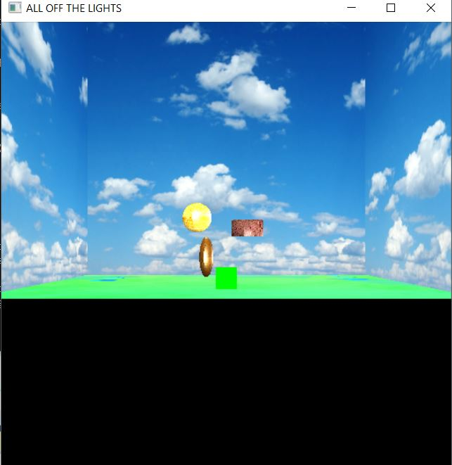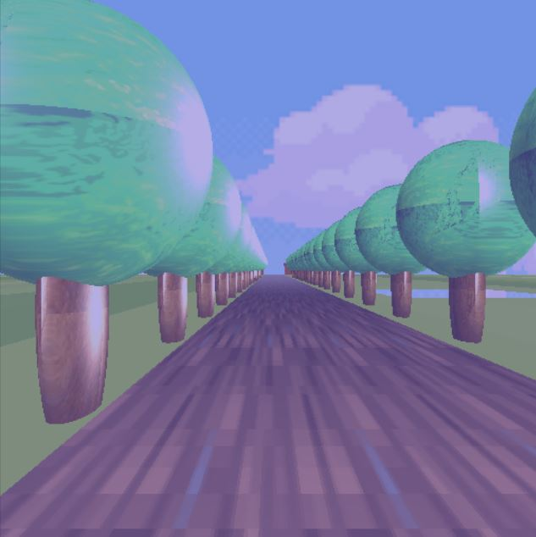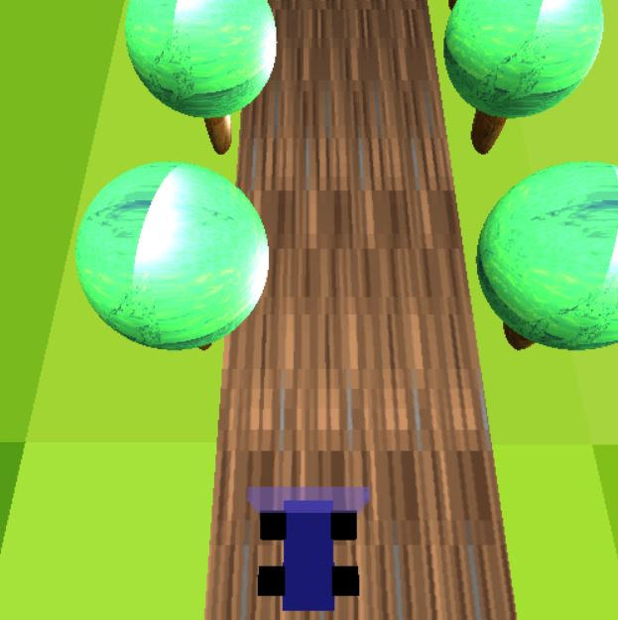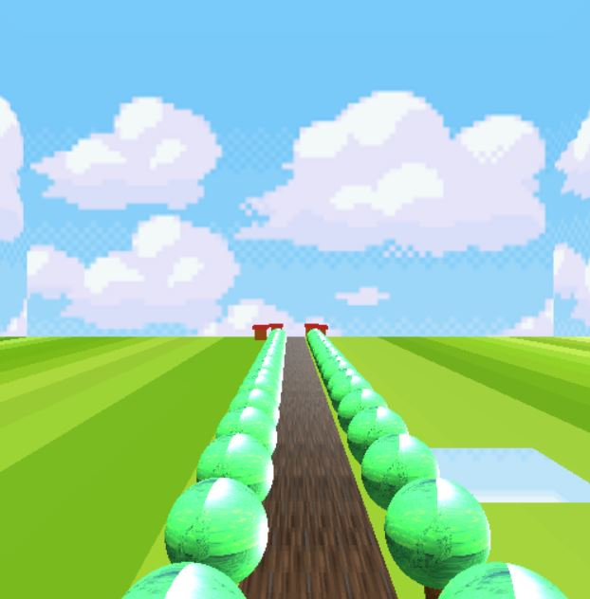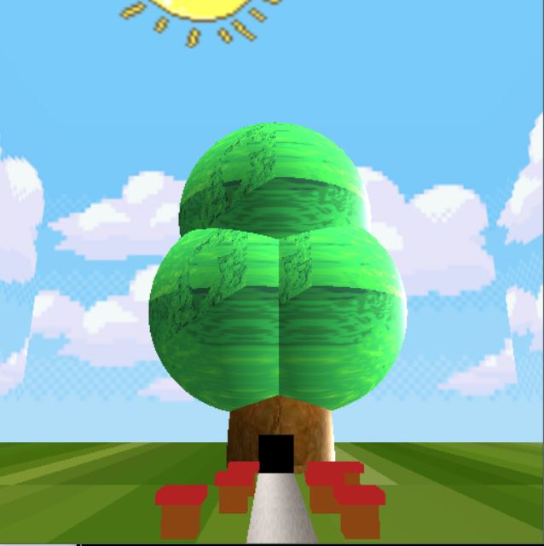

The first way to attack the low level requirements was to initially grab our previous homework 5 and integrate the skybox given. After integrating the different shaders from the sky box I observing how the shapes are all moving via keys, I implemented the cylinder and transformed it into the ground and texturing the cylinder to as a really huge piece of land /terrain implementing this there exists my understanding via specify a texture image adding lights and manipulation in the fragment, managing texture images and color as well as manipulation within the data structure of the hierarchical tree. Grabbing the shaders from previous homework, I was able to create a road based on the spinning rectangle example; Utilizing the green cube I was able to construct houses and a vehicle adding the line from homework 2 to contain the cube and scale and translate the object by manipulating the alpha value and adding “glBlendFunc(GL_SRC_ALPHA, GL_ONE_MINUS_SRC_ALPHA);” in the “init” function. To make the scene more than just terrain I added a giant tree house that has an entrance containing objects inside of a lit room of the giant tree, past the village.

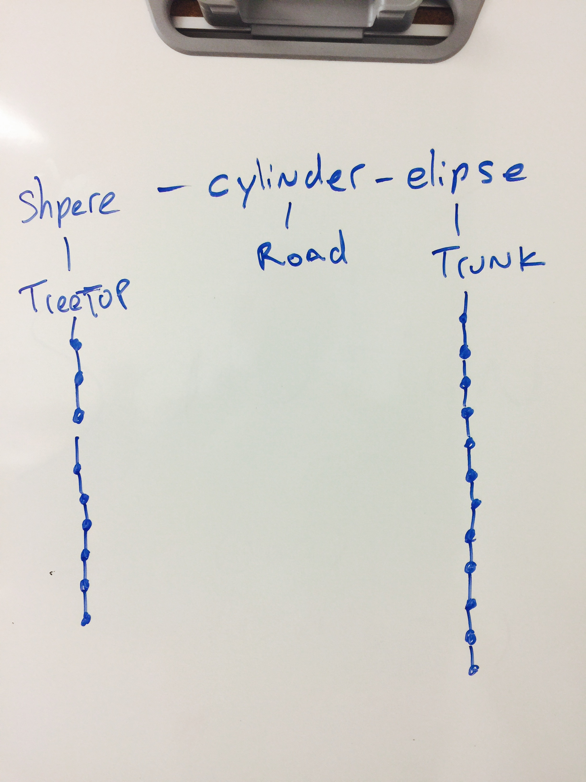

From the other trees that were created from the hierarchical shapes I was able to instance my trees generating a line on both sides utilizing “glDrawArraysInstanced(GL_TRIANGLES, 0, num_vertexes,Numi);” and my numerical variable to set a certain amount. Creating the functionality so that the car would move in my display the idea of utilizing the dot method regarding to the eye to track first the body then after the wheels generating when you move in the x direction and the z direction the vehicle would follow the arrow keys. Then adding a flag that would be able to switch views of the vehicle by a conditional when pressing the “v” or “V” key via shift, one could change the value there by switch views to the chopper mode. When looking down you can see that the vehicle is able to move when you go on the x direction and the z direction. Other camera functionalities to not make sure that one is not going through the ground disabling in the glut key up and down was commenting out the “n” variables for stabilize the vehicle.

Most of the difficulties I had with this final is generating collision detection as well as performing with the buffers, keeping track of the number of buffers one has for a project was quite the challenge I’ll be able to research and hopefully add in other projects. Another thing I wanted to add was adding the .obj files I was having difficulties adding the functionality to the .obj file after loading the object; it was difficult to make the object move as well as adding the textures to the file that came with the object. Index organization was getting confusing after a certain number of times, as well as troubleshooting the expansion of data or buffers based on the size of this project. Regarding feedback for the class to have a lab based on the many questions as well as to have feedback for the students in a more elegant time frame if possible;

Resources:

<https://www.siggraph.org/education/materials/HyperGraph/modeling/mod_tran/3drota.htm>

[http://lhh.tutor.com/?ProgramGUID=5740cad3-446b-4af2-94b3-be3d53860642#](http://lhh.tutor.com/?ProgramGUID=5740cad3-446b-4af2-94b3-be3d53860642)

<https://www.youtube.com/watch?v=vcMox6i8f4Y&t=108s>

<https://www.youtube.com/watch?v=Js2Ypw-4l8E&t=300s>

<https://www.youtube.com/watch?v=N60lBZDEwJ8&t=21s>

<https://www.youtube.com/watch?v=PTTN9i5IUbA>

http://stackoverflow.com/questions/tagged/opengl

<https://www.youtube.com/watch?v=ITfkvQdWaRA>

<https://www.youtube.com/watch?v=FVrSqb_1TS4>

<https://www.youtube.com/watch?v=DLKN0jExRIM&t=491s>

https://www.youtube.com/watch?v=RnXDUFq7T6A&t=8s