A Database called ‘gizem’ should be created.

A Table called ‘USER’ should be created.

CREATE TABLE USER(

id int NOT NULL AUTO_INCREMENT,

name varchar(255) NOT NULL,

surname varchar(255),

age int,

PRIMARY KEY (ID)

);

I used Hibernate for Data Operations, and hibernate configuration can be seen below “application.properties” file.

**Here you can see the login form**

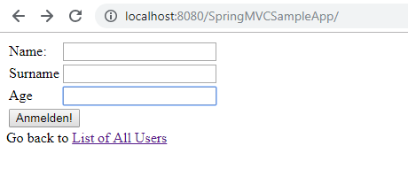

**Age Check API:** When I entered 14 and leaved the age field.

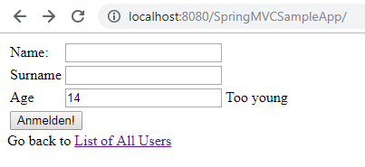

* When I entered 88 and leaved the field.

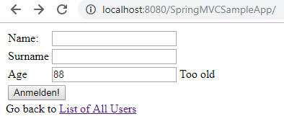

-Prime Case:

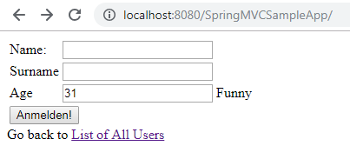

**Listing Users:** If you want to list users already recorded in database, you can click List of all users.

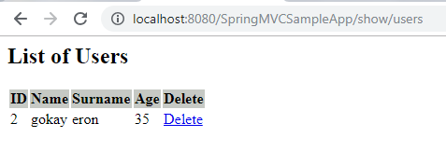

**Deleting Users:** I deleted the User below.

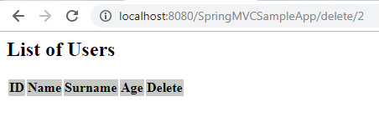

**Saving A User:** I saved a valid user below.

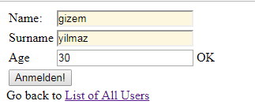

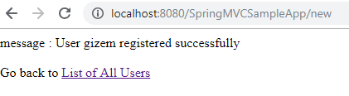

**Note: If you have any problem while deploying to tomcat, you can copy view files from WEB-INF/classes folder to WEB_INF/views folder.**