Gizzle Bautista

CC53 MIS - S0261553

Email: gizzle.bautista@cqumail.com

COIT20253 Business Intelligence using Big Data

Assignment 2

Due Date: 31 May 2016

Lecturer: Meena Jha

Course Coordinator: Meena Jha

Table of Contents

Introduction 3

Definition of Terms 3

Big Data Value Creation Process 4

Big Data Use Case 5

Big Data Strategy for Wavesound 6

Business Initiatives, Objectives and Tasks 6

Technology Stack 7

Data Analytics and MDM 8

NoSQL 8

Role of Social Media in Wavesound’s Decision Making Process 9

Reflections and Conclusions 9

References 11

# **Introduction**

Decision support systems (DSS) are created to help organizations make fact-based business decisions. This report aims to do a market research on how Big Data fits in an organization’s decision making process. Specifically, this report will discuss how big data can be used by decision support systems that is meant for traditional publishers. Relevant definitions and terminologies will be presented to provide a clear context of the report.

Wavesound Pty. Ltd., being a publisher of large prints to Australian libraries and vendor of Zinio magazine app, is the organization chosen for discussion. This report will also analyze a value chain and use case which Wavesound could use. With the value chain and use case presented, the Big Data Strategy created for Wavesound will then be discussed which aims to solve a current business problem.

Also, the roles of data analytics, master data management, NoSQL, and social media in the decision making practice of the organization will be tackled. Finally, this report aims to provide a recommendation for Wavesound and present a conclusive finding, with positive and negative view points, on the use of Big Data DSS systems.

## **Definition of Terms**

Market research is defined by ICC/ESOMAR (2008) as a systematic way of collecting and interpreting data, using statistics and analytics, to support in decision making. Big Data refers to the combination of data from several sources that could lead to better decision making strategies (Press 2014). While Blackman (2016) cited Gartner’s definition of business intelligence as “an umbrella term that includes the applications, infrastructure and tools, and best practices that enable access to and analysis of information to improve and optimize decisions and performance.”

According to Le (2015), BI is the successor of DSS with aims of solving business problems with less algorithm involved. For Tay (2013), value chain identification is a way for organizations to find its weak points and recognize its strong activities. Then, a use case diagram, as per SourceMaking (n.d.), involves actors, relationships and business use cases or activities. “Big data analytics examines large amounts of data to uncover hidden patterns, correlations and other insights” with the capability of uncovering insights for immediate actions (SAS Institute n.d.). While, NoSQL databases means it’s not reliant with Structured Query Language schema (Vaughan 2013). Lastly, Oracle (2013) defined Master Data Management as the consolidation of technologies, applications, and master data that will result to fact-based decision making.

# **Big Data Value Creation Process**

In creating business strategies, value chain identification can serve as a guide (Hertog 2014). According to Tay (2013), starting with the identification of the value chain in creating business strategies is a good idea since it forms a systematic view of the whole company. As a sample value chain, the figure below displays Amazon com inc’s value chain which could help in converting inputs into products or services (OS Financial Trading System 2011).

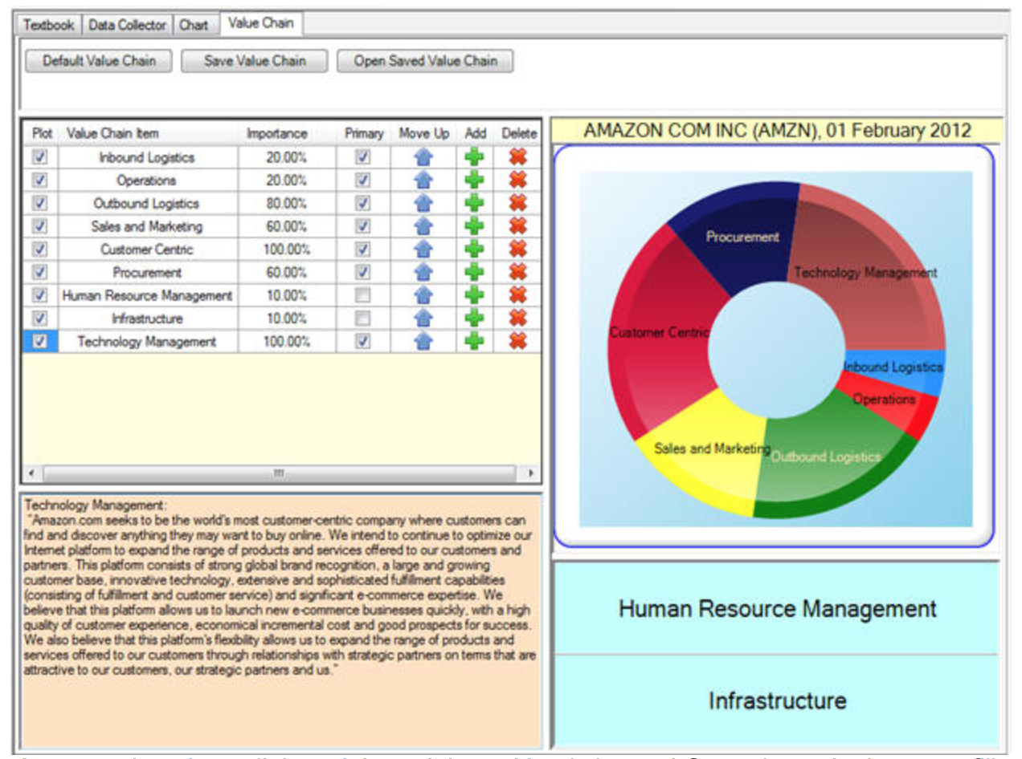

Source: OS Financial Trading System 2011

# **Big Data Use Case**

After identifying the value streams in the organization and making sure that the processes are streamlined and analyzed, the process evaluation of where big data technology could be mostly benefited should start. With this, creating a use case for the processes could help in providing operational snapshots thus lead to choosing the right business intelligence analytics tools to use (Sherman 2015).

For the sales and marketing value stream, the figure below shows the use case for relevancy and retention boost (Search Technologies n.d.). Search Technologies (n.d.) explains the figure below as how, “a powerful search engine helps clean and enrich research documents’ metadata to ensure users find the most relevant content and explore related content easily. Then, through machine learning and predictive analytics, the publisher will be able to serve content in a particular order in which the user’s most favorite content appear in the top results. How do they know for sure? Because they can repeatedly test and score the search engine’s performance offline to predict search accuracy and abandonment rates before putting the engine into production on the live website.”

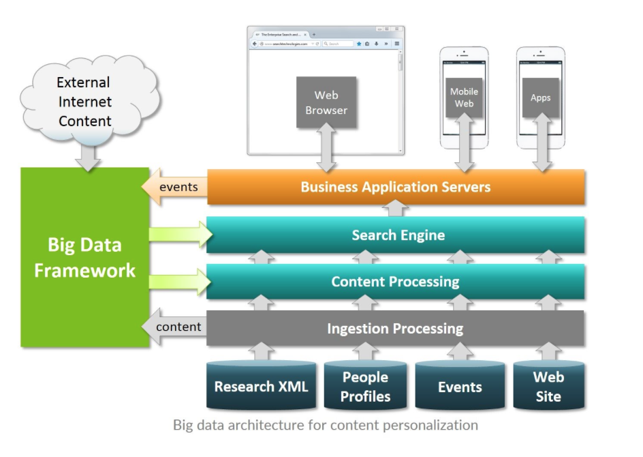

Source: Search Technologies n.d.

# **Big Data Strategy for Wavesound**

In creating a big data strategy, a problem must be identified first. Which would have been achieved by doing the value chain and process analysis via the creation of use case. Having been employed by Wavesound for six months, I have realized that meeting customer satisfaction is one of the company’s weaknesses as it often times fail to meet its’ delivery due dates, meet its sales quota (as the Warehouse Manager would often remind the servicing staff), and have troubles with over production (disposing tons of large print copies as a resort).

Thus, the business strategy, initiatives, objectives and tasks below were specifically created to answer that problem.

# **Business Initiatives, Objectives and Tasks**

The business initiatives are what the organization hopes to achieve. As for the Outcome, Critical Success Factor (CSFs), & Tasks states what needs to be done.

BUSINESS STRATEGY:

Improve Customer Satisfaction to Meet Monthly Sales Quota and Reduce Over Production

BUSINESS INITIATIVES:

1. Increase customer engagement for better understanding of library and reader needs

2. Efficient content recommendation for production control and delivery

3. Efficient use of social media and website for market forecasting to drive production and order requests

OUTCOME & CRITICAL SUCCESS FACTOR:

1. Develop detailed knowledge & predictive insights into reading patterns, readers' behaviour & author's success factor

2. Uncover & integrate customer-specific insights back into operational, marketing & loyalty systems

3. Expand collection of user data leveraging subscribers' behaviour on the website, Zinio app, social media, e-mail, and survey.

TASKS:

1. Track & monitor operational tasks

2. Collect transactional & non-transactional data

3. Analyse collected data to identify reader interests & book performance

4. Review operational processes

DATA SOURCES:

1. Website
2. Social Media
3. Zinio App
4. Operational data
5. Marketing data
6. Customer data

# **Technology Stack**

The technology stack refers to the big data technology requirements of an organization. This discusses the steps in order to make the big data business strategy into action.

For Wavesound, the below proposed KPI was created to be able to measure the progress and success of each business initiative which then **identify the supporting business intelligence**.

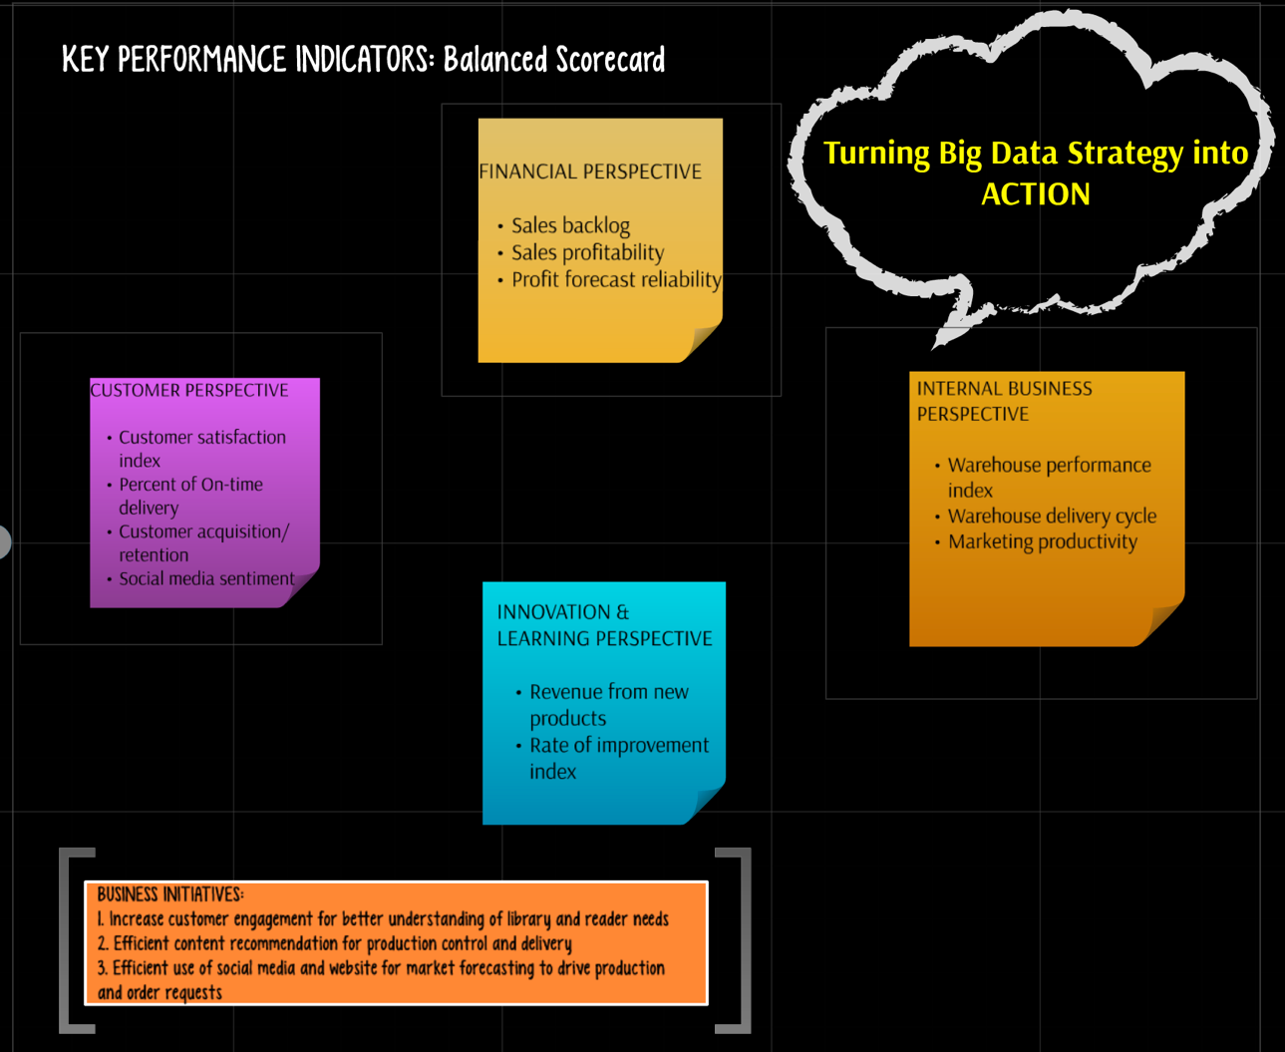

In **identifying advanced analytics**, business questions and business decisions should be established to support the business initiatives. While identifying the analytic algorithms and modeling requirements support each key tasks. Finally, in **identifying data warehouse requirements** the supporting data should also be clearly identified.

# **Data Analytics and MDM**

In the big data strategy presented previously in this report, the data sources cited are website, social media, zinio app, operational data, marketing data and customer data. Identifying these sources of data is the first step in master data management (Maginfo 2015). Also, according to the video, data governance should be implemented wherein the identification of how data are stored, updated, and maintained will be handled.

With the correct data management and analysis, reader analytics can then be pursued. As per Rhomberg (2014), “Reader analytics can highlight that a book that didn’t sell actually engages readers very strongly, but that the cover was poorly designed (the most common error), that a stronger book launched at the same time and overshadowed the book”. Another main point raised by the author is that data analytics do not make the decision for the organization but it helps the organization to allocate precious marketing budget on the right books.

# **NoSQL**

It is essential for businesses nowadays to invest in a database because everything is moving online and organizations are most likely dependent on their website and/or mobile application (Nusca 2015). According to Davenport (2014), traditional publishers will be left out in the cold if they don’t find a way to have a direct contact with their customers. Also, the author pointed out that “social media has to be mined for sentiment along with clickstream data”. Additionally, the article enunciated that the goal is not to sell content but to extract information and build customer loyalty.

Furthermore, according to Stephan (2013), businesses now are transferring to NoSQL from relational databases due to the need for scalability and flexibility. The article mentioned content management as one of the use cases that NoSQL can best address. Images, comments, videos and other user-generated content can easily be incorporated to generate new content by using NoSQL (Stephan 2013).

# **Role of Social Media in Wavesound’s Decision Making Process**

Teradata Perspectives (2015) cites how correlating social media strategies with KPIs could help in determining probable ROIs. Additionally, the article states “Search activity contains information about the success of a new product. Search drives revenue.” Thus, tracking search and social data, organizations could measure consumers’ interest and use it for market or performance strategy (Teradata Perspective 2015).

Another insight comes from Hung’s (2016) article, wherein the author cited that “content is information and so are views, likes, shares, follows, retweets, comments, and downloads”. Additionally, the blog post states that past performances are no longer the only gauge of probable product success. Thus, the author concluded that ignoring big data is a threat to the business.

# **Reflections and Conclusions**

Based on the literatures discussed in this report, a big data strategy for Wavesound could be generated, to follow and implement, in order to gain profit and reduce costs. First, Wavesound need to clearly identify its value streams. The need for streamlining is extremely high as it is usually the cause of delays which might cause problems in retaining relevancy in the publishing business.

Secondly, to streamline the processes, the warehouse department of Wavesound should create use case diagrams which could expose problem areas or opportunities where the business could engage more. It is highly possible that duplication of tasks can be found that leads to customer dissatisfaction. With the analysis of data sources (inputs, outputs, etc.), the specifics of where big data technology can be applied will be achieved. Lastly, the proposed big data strategy can then be turned into action by identifying relevant business questions and analytics.

It is also important not to overlook the data sources included in the big data strategy as they are as important in implementing the big data technology. Data governance is then recommended to make sure that relevant data is updated, stored and handled correctly. Otherwise, it could lead to a more damaging business decision caused by a wrong marketing forecast due to incorrect pull of data. Thus data analytics, specifically readers analytics, come into play for traditional publishers.

Another area where Wavesound could benefit from big data is with its Zinio app and company website. The sample use case presented in this report is highly useful and relevant. With big data technology, a powerful search engine, reader behavioral analytics and customer data analysis could provide not only high customer satisfaction but also astounding profit.

Going in depth with the reader behavioral analytics, it could also determine which magazines are checked out but left unread. This will help the company identify later on if certain magazines are worth including in their subscription. Also, since libraries are the main clients of Wavesound, being able to predict first the upcoming fiction best-sellers (which most-likely can be determined by author performance analysis or by book performance through social media) than its competitors will definitely benefit the company. All of which, NoSQL can be of help.

With the benefits cited, cons could also be expected. Investing in big data technology for a small company, with financial constraints and overseas stakeholders, it might be near to impossible. Additionally, privacy issues regarding reader behavioral analysis could raise a bigger problem for the company. However, with the right strategy, analysis, and determination, Wavesound (and other traditional publishers facing the challenge of digital publishing) could easily find ways to make it possible.

# **References**

Blackman, A 2016, *What is business intelligence,* viewed 29 May 2016, <http://business.tutsplus.com/tutorials/what-is-business-intelligence--cms-23412>

Davenport, T 2014, *Book publishing’s big data future,* viewed 30 May 2016, <https://hbr.org/2014/03/book-publishings-big-data-future/>

Harmon, P (ed) 2014, Business process change: a business process management guide for managers and process professionals, 3rd edn, Elsevier, USA.

Hung, D 2016, *The impact of big data on social media marketing strategies,* viewed 30 May 2016, http://tech.co/impact-big-data-social-media-marketing-strategies-2016-01

ICC/ESOMAR 2008, *ICC/ESOMAR on market and social research,* viewed 29 May 2016, <https://www.esomar.org/uploads/public/knowledge-and-standards/codes-and-guidelines/ICCESOMAR_Code_English_.pdf>

Le, ThienSi 2015, *Relationship of BI & DSS,* viewed 29 May 2016, https://www.linkedin.com/pulse/relationship-bi-dss-thiensi-le

Maginfo 2015, *What is master data management?,* viewed 30 May 2016, https://www.youtube.com/watch?v=fH03Rj4O0PU

Nelson, P n.d., *How big data helps online publishers boost revenue and retention,* viewed 7 May 2016, http://www.searchtechnologies.com/big-data-online-publishing

Nusca, A 2015, *Why your company should care about its database,* viewed 30 May 2016, http://fortune.com/2015/01/29/couchbase-nosql-database/

OS Financial Trading System 2011, The value chain and Amazon.com, viewed 31 March 2016, <http://www.ftsmodules.com/public/texts/valuationtutor/VTchp3/topic4/topic4.htm>

Oracle 2013, *Overview: Oracle master data management,* viewed 29 May 2016, <http://www.oracle.com/us/products/applications/master-data-management/mdm-overview-1954202.pdf>

Press, G 2014, *12 Big Data Definitions: What’s Yours?*, viewed 11 April 2016, <http://www.forbes.com/sites/gilpress/2014/09/03/12-big-data-definitions-whats-yours/2/#58cc49291fd7>.

Rhomberg, A 2016, *Data vs. instinct – the publishers dilemma,* viewed 31 May 2016, http://www.digitalbookworld.com/2016/data-vs-instinct-the-publishers-dilemma/

SAS Institute Inc n.d., *Big data analytics*, viewed 29 May 2016, <http://www.sas.com/en_us/insights/analytics/big-data-analytics.html#modal1>

Sherman, R n.d., *Business use cases can determine the right BI analytics tool*, viewed 29 May 2016, http://searchbusinessanalytics.techtarget.com/feature/Which-BI-analytics-tool-does-my-company-need

Stephan, T 2013, *10 use cases where NoSQL will outperform SQL*, viewed 29 May 2016, <http://www.networkworld.com/article/2999856/big-data-business-intelligence/10-use-cases-where-nosql-will-outperform-sql.html>

SourceMaking n.d., *Use case diagrams,* viewed 29 May 2016, <https://sourcemaking.com/uml/modeling-business-systems/external-view/use-case-diagrams>

Tay, M 2013, *Business process architecture - from value chain to process*, viewed 4 April 2016, <http://blog.maxconsilium.com/2013/08/business-process-architecture-from.html>

Teradata Perspectives 2015, Capitalize on social media with big data analytics, viewed 30 May 2016, <http://www.forbes.com/sites/teradata/2015/05/27/capitalize-on-social-media-with-big-data-analytics/#329167c9ca3e>

Vaughan, J 2013, *The buzz: what are NoSQL databases?*, viewed 30 May 2016, <http://searchdatamanagement.techtarget.com/news/2240181822/The-buzz-What-are-NoSQL-databases>