Gizzle Bautista ( S0261553 )

COIT20245 – Introduction to Programming

TEST CASES:

1. Test Scenario: User input with days validation

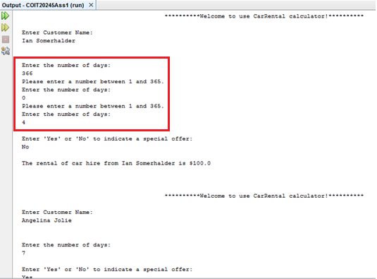

1. Test Scenario: Special offer computation

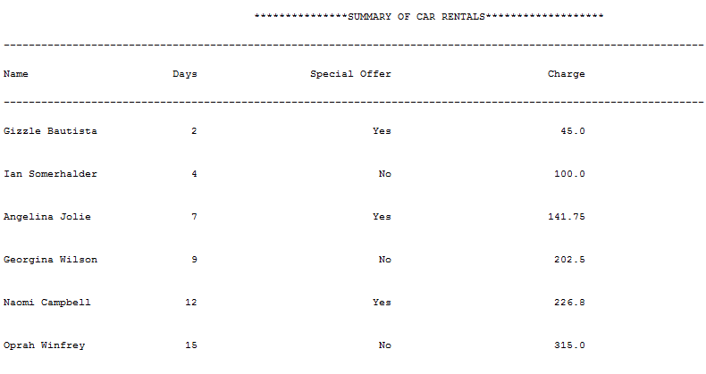

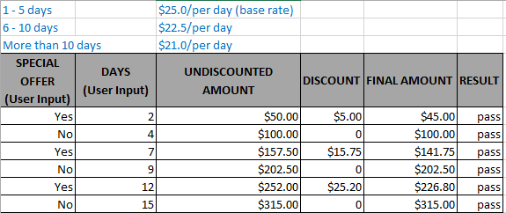

1. Test Scenario:

3.1. Display customer spending most and least rental

3.2. Display statistics bar chart showing how many rents that are less than and greater than/equal 7 days

