**Licenses:**

**Generic Character Asset v 0.2**

[Generic Character Asset v 0.2 by brullov](https://brullov.itch.io/generic-char-asset)

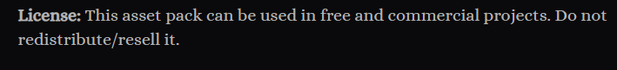

**Oak Woods — Environment Asset 🍂**

<https://brullov.itch.io/oak-woods>



**2D Environment Platformer Asset Pack: Castle of Despair**

[2D Environment Platformer Asset Pack: Castle of Despair by brullov](https://brullov.itch.io/2d-platformer-asset-pack-castle-of-despair)

**Monsters Creatures Fantasy**

[Monsters Creatures Fantasy by LuizMelo](https://luizmelo.itch.io/monsters-creatures-fantasy)

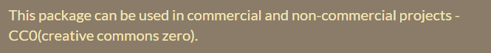

**Spikes**

[Spikes by Omniclause](https://omniclause.itch.io/spikes?download)

**Sounds:**

[**https://sfxr.me/**](https://sfxr.me/)(Hit/Jump)

[**https://pixabay.com/users/freesound_community-46691455/**](https://pixabay.com/users/freesound_community-46691455/)

<https://pixabay.com/sound-effects/sword-sound-2-36274/> (Sword)

<https://pixabay.com/sound-effects/game-over-arcade-6435/> (Game Over)

