
Date:
22nd Dec 2021
Prepared For:
Mr. Gabriel Jones
Prepared By:
AIS Technolabs
Staff Space App
Version: v1.2

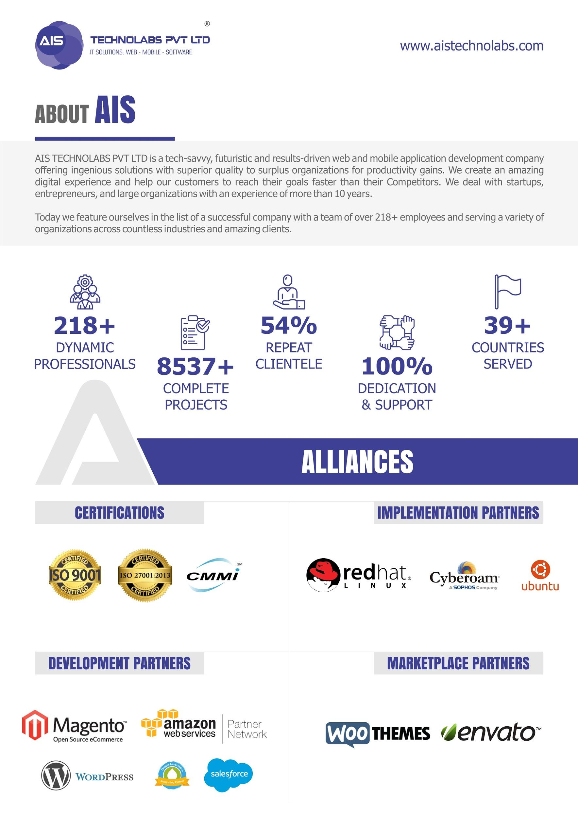
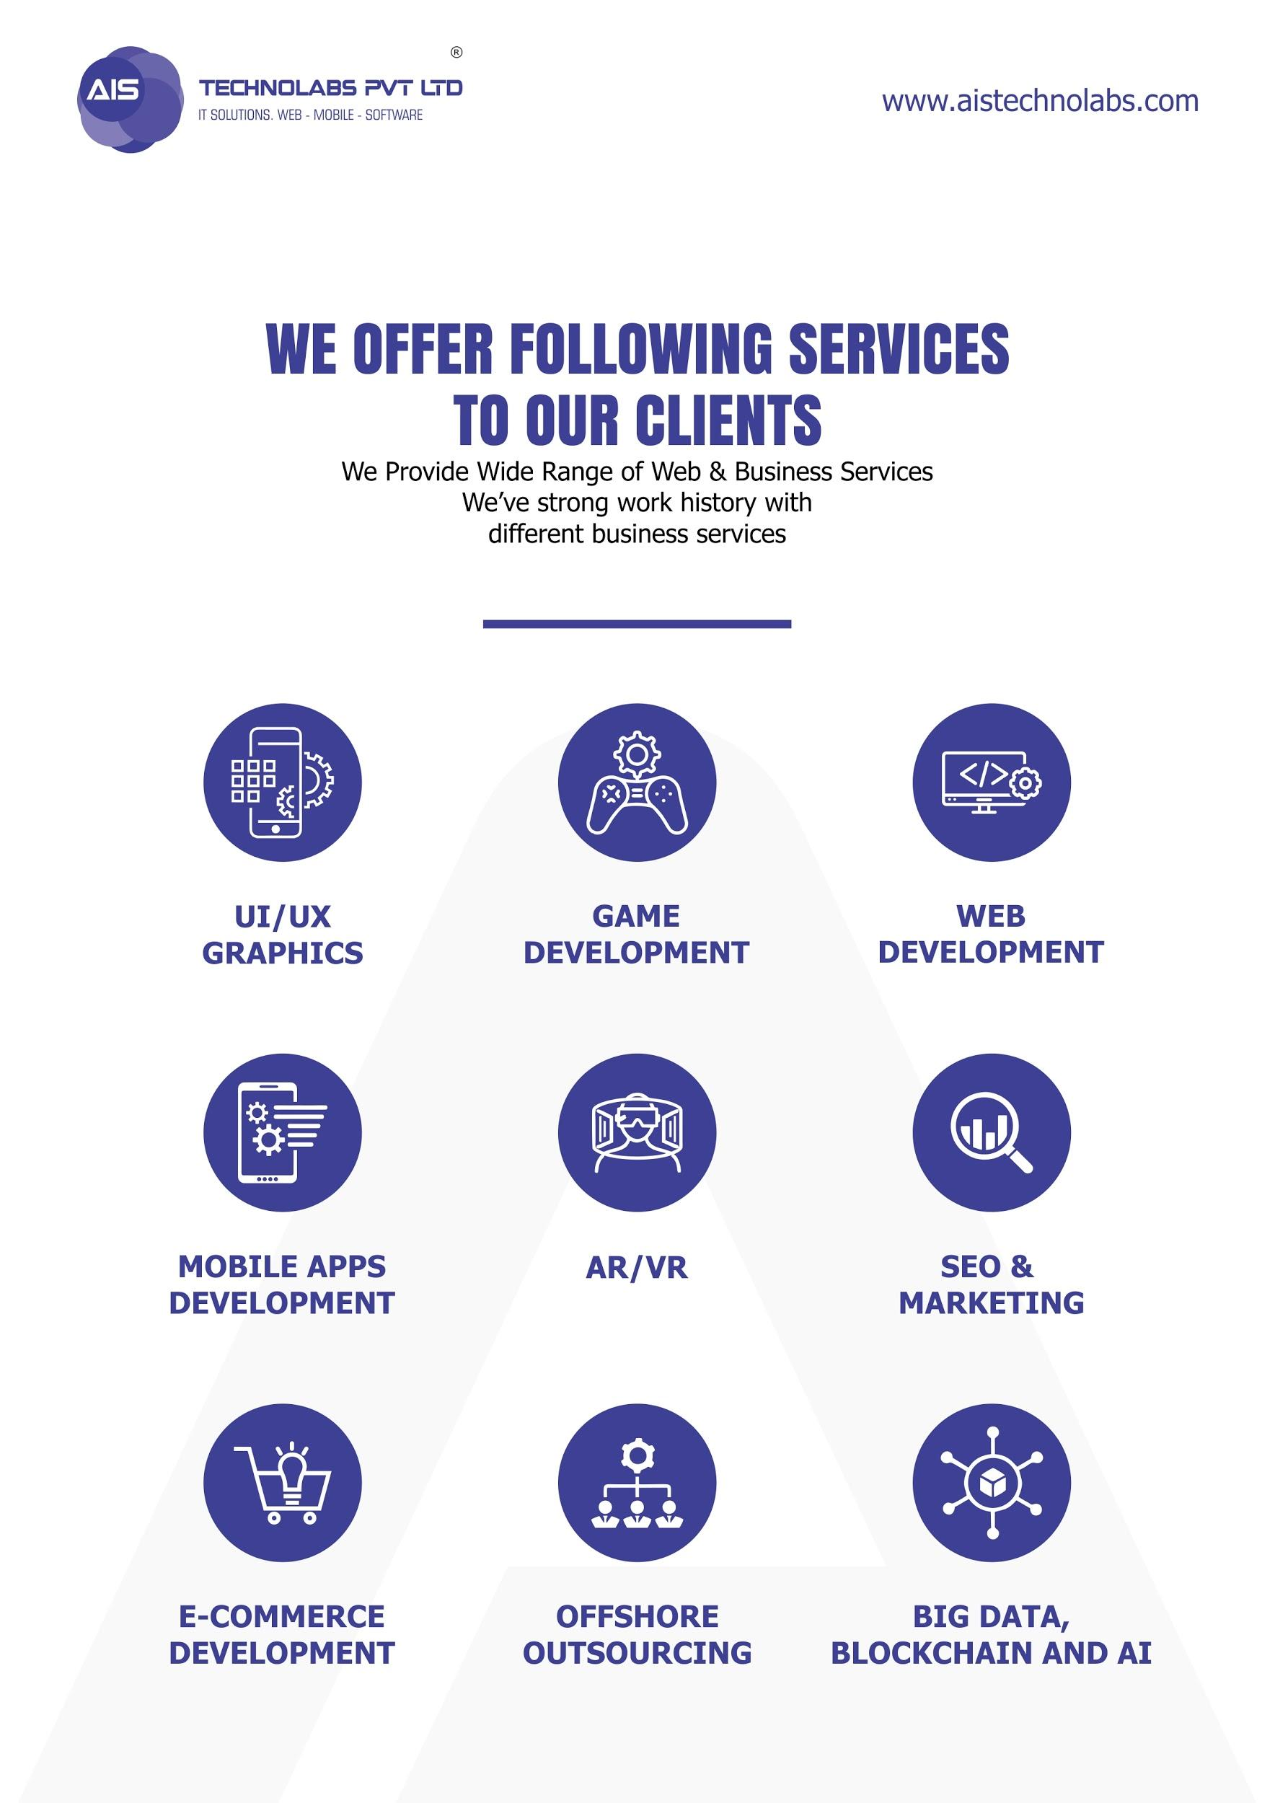
Table of Content
1. Revision History 6
2. Acronyms & Abbreviations 7
3. Responsibility 8
4. Objectives of the Document 8
5. Organizational classification of the Document 8
6. Project Title – Initial Details 9
6.1 Purpose of Project 9
6.2 Scope of work 9
7. Applicant Features (Mobile Apps) 10
7.1 Login 10
7.2 Forgot Password 10
7.3 Sign up 10
7.4 Home screen 11
7.5 Job Details 12
7.6 My Jobs 12
7.7 My Events Listing 12
7.7.1 Add New Event 14
7.7.2 Add New Job 14
7.7.3 Job Details 14
7.8 Ratings and Reviews 15
7.9 Chats 15
7.10 Notifications 15
7.11 Profile Management 16
8. Restaurant User Features (Mobile App) 17
8.1 Login 17
8.2 Forgot Password 17
8.3 Sign up 17
8.4 Home screen 18
8.4.1 Job Details 18
8.4.2 Add New Job 19
8.5 My Events Listing 19
8.5.1 Add New Event 20
8.5.2 Add New Job 21
8.5.3 Job Details 21
8.6 Ratings and Reviews 21
8.7 Chats 22
8.8 Notifications 22
8.9 Profile Management 22
9. Admin Features (Web Panel) 23
9.1 Login 23
9.2 Dashboard 23
9.3 Applicant Management 23
9.4 Restaurant User Management 23
9.5 Restaurant Jobs Management 24
9.6 Event Management 24
9.7 CMS Pages Management 25
9.8 Notifications 25
9.9 Profile Settings 26
10. Considerations 27
11. Technology 28

Table of tables
Table 1 Document Information 6
Table 2 Document Version Control 6
Table 3 Acronyms and abbreviations 7
Table 4 Document Classification 8

Warning: A printed document may not contain the up to date information! The current document located in the specified path shown in the footer.

Revision History
Document Information
Table 1 Document Information
Document Information
Project: | Applicant Space App
Document Version | 1.2
Document Status | Client Update
Author(s): | Jack – Project Manager
Filename: | FRD_Applicant-Space_App_V1.2

Document Version Control
Table 2 Document Version Control
Revision | Date of issue | Pages Affected | Reason | Summary of Change
1.0 | 23.11.2021 | All | Initial Draft | Original
1.1 | 01.12.2021 | 9 to 18, 21 to 26 | Client Updates | Client Updates
1.2 | 22.12.2021 | 10,11,12,14,17, 18,19,21,22 | Client Updates | Client Updates

Acronyms & Abbreviations
Table 3 Acronyms and abbreviations
Acronym Definition
CN | Gabriel Jones
AIS | AIS Technolabs
ITIL | Information Technology Infrastructure Library IT Infrastructure Library®
ISO/IEC 27001 | International Organization for Standardization part of the ISO/IEC 27000 family of standards
GIS | Geographic Information System
OS | Operating systems
PM | Jack
Backend | Development Part of the Project
Frontend | Designing Part of the Project
Project Name | Staff Space

Responsibility
The Quality Management Officer (QMO) makes the structuring of QM Quality Documents and the review (before circulation).
Jack is in charge for any further editing and optimizing.
Gabriel jones’s Approval
Bert Looking for Approve/disapprove any additional work request

Objectives of the Document
This document is to ensure that we are on same page before starting the new project together. Please go through the same and let us know if there is any query/concern regarding any of listed points in this document.
The purpose of the Functional Requirement Document (FRD); a functional requirement defines a purpose or function of a system and its components. A function is described as a set of inputs, the behavior, and outputs. Functional requirements may be technical details, data manipulation, calculations and processing and other specific functionality that define what a system is supposed to accomplish. Functional requirements specify particular results of a system and drive the application architecture of a system.

Organizational classification of the Document
All documentation, communication and / or material produced by this report is deemed proprietary of AIS Technolabs (hereafter referred to as AIS) and [Gabriel jones] (hereafter referred to as CN); any other party may have access to any of this material only through a written authorization from Gabriel jones or AIS. The report classified as confidential and not subject to the publication of the public, any request to access them should be prior authorized from AIS.
Table 4 Document Classification
Document Classification
Type | Departments
Classified with access permission to | Gabriel jones

Project Title – Initial Details

Purpose of Project
- Applicant Space App provides a way to connect the Restaurant or event organizers who need applicant for their restaurant and events and the applicant are looking and working in the service industry for short term and long term.

Scope of work
- We will have the following users involved:
- Applicant
- Restaurant User
- Admin Web Panel

Applicant Features (Mobile Apps)

Login
- User will be able to login to the website via the following details.
  - Email
  - Password
- User will be able to view the Forgot password link.
- User will be able to view the Sign up link.

Forgot Password
- By clicking on “Forget Password” link on the Login page, Applicant will be directed to the “Reset Password” page.
- Applicant will be able to enter his/her registered email id.
- Email address must be in registered on the application. Else an error Pop-up will be appear.
- By clicking on "Reset" button, an email will be sent to Applicant's registered email ID which contains reset password link.
- By clicking on "Reset Password" link, applicant will be directed to Reset Password page via browser.
- Applicant will be able to create a new password by entering following details:
  - New Password
  - Confirm Password.

Sign up
- User will be able to Sign up to the app via the following details.
  - User type selection
    - Applicant (Selected)
    - Restaurant
- User will be able to fill the sign up details in two steps.
  - Step-I
    - First Name
    - Last Name
    - Profile image (optional)
    - Email ID
    - Phone Number
    - Password
  - Step-II
    - Access location pop up or manual selection by city and state.
    - Required Job Category for Job Search (Optional)
      - Wait Applicant / Chef and Chef Helper / Bar Tender / Management
      - Single or Multiple Selection
    - Required Job Availability
      - Part time
      - Full time
    - Current Job Details
      - Current Job title selection or manual input
      - Current working place
        - Company Name
        - Country
        - State
        - City
      - Month and Year Selection
    - Previous Job Details (optional)
    - Description about themselves
      - Maximum 250 words will be allowed
    - Resume (uploading Doc in .PDF or .DOCX format)
- Note: The user type selection will be non-changeable so the user will not be able to change their User Type.

Home screen
- User will be able to view the following on the home screen for Applicant.
- User will be able to view the list of Jobs and Restaurants / Events in need of applicant by their location.
- User will be able to view the details of the Job / Restaurant or Event.
- When the job posted is for a Restaurant Job
  - Title
  - Description
  - Job category
  - Job Type (Part Time / Full Time / Job Based)
  - Number of personals needed.
  - Restaurant name
  - Address
  - Phone number
  - Description
  - Images
  - Ratings and Reviews by users
- When the job posted is for an Event
  - Title
  - Description
  - Job category
  - Job Type (Part Time / Full Time / Job Based)
  - Number of personals needed.
  - Event Date/s and Time
  - Last Date to apply
  - Salary selection (Hour based / Job Based) and amount
  - Event Full Address
- User will be able to filter the list by job category, Part Time / Full Time, Location (City and State), Restaurant Job / Event.
- User will be able to search for a Job or event.
- User will be able to view the notifications.
- User will be able to navigate to the Chats.
- User will be able to navigate to My Jobs.
- User will be able to navigate to their profile.

Job Details
- User will be able to view the following details when applying for a Job.
- User will be able to view the details of a Job.
  - Title
  - Job Description
  - Job Category
  - Type – Event or Restaurant
  - Job Type (Part Time / Full Time / Job Based – when event)
  - Job Location
  - Posted Date and Time
  - Total Number of Positions
  - Salary receivable (Hour Based / Job Based)
- User will be able to apply for a Job.
- User will be able to chat to the Event Organizer or Restaurant owner.

My Jobs
- User will be able to view the list of the Jobs which they have applied for by the following.
  - Jobs listing with status – approved, rejected or pending.
  - Job Details
  - Ratings and Reviews – user will be able to view add ratings and reviews to the Job creator when the user approves by the restaurant or applicant.
  - User will be able to chat with the applicant.

My Events Listing
- User will be able to view the list of events created by the following.
  - Title
  - Event Image
  - Event Start Date and Time
  - Event End Date and Time
  - Event Full Address
  - Total Number of Added Jobs.
- User will be able to view the event details by the following.
  - Title
  - Event Image
  - Description
  - Event Start Date and Time
  - Event End Date and Time
  - Event Full Address
  - Actions - Edit, Delete, View Event Details, View Job Listing, and Add new Job.
- User will be able to view the job details.
  - Title
  - Job Description
  - Job Category
  - Job Type (Part Time / Full Time)
  - Posted Date and Time
  - Total Number of Positions
  - Applied users listing
  - Salary receivable (Hour Based / Job Based)
  - Event End Date and Time
  - Job Status
- User will be able to edit and delete a Job or Event.
- User will be able to add a new event and add new job.
- User will be able to view the applied applicant details.
  - First and Last name
  - Profile image
  - Email
  - Phone number
  - Required Job Category for Job Search (Optional)
    - Wait Applicant / Chef and Chef Helper / Bar Tender / Management
    - Single or Multiple Selection
  - Required Job Availability
    - Part time
    - Full time
  - Current Job Details
    - Current Job title
    - Current working place
    - Month and Year Selection
  - Previous Job Details (optional)
  - Description about themselves
  - Download Resume
- User will be able to chat with the applicant.
- User will be able to approve or reject an applicant.
- User will be able to view the Ratings and Reviews added by other users (both applicant and restaurant)

Add New Event
- User will be able to add the event details by the following.
  - Title
  - Event Image
  - Description
  - Contact Number
  - Event Start Date and Time
  - Event End Date and Time
  - Event Full Address
  - Last Date to Apply
- User will be able to save the event details and add a Job for the event.

Add New Job
- User will be able to add new job by the following.
  - Title
  - Job Description
  - Job Category
  - Job Type (Part Time / Full Time)
  - Total Number of Positions
  - Salary receivable (Hour Based / Job Based)
- User will be able to Post the Job and go back to the event details screen.

Job Details
- User will be able to view the details of a Job.
  - Title
  - Job Description
  - Job Category
  - Job Type (Part Time / Full Time / Job Based – when event)
  - Posted Date and Time
  - Total Number of Positions
  - Applied users listing
  - Salary receivable (Hour Based / Job Based)
  - Job Status
- User will be able to view the list of applicants.
- User will be able to approve or reject an applicant.
- User will be able to chat with the applicants.
- When the restaurant user has approved the users as personal needed (for ex. if the user has defined 3 personal needed then when the user has approved 3 users) then the job will automatically marked as complete and will be stopped showing to the applicants looking for a job. All the pending applicants will also be marked as rejected.
- User will be able to view the ratings and reviews added by other users.
- User will be able to add rating and review for applicant after they have approved the applicant for a job.
- User will be able to add new Job.

Ratings and Reviews
- When any job approved by the restaurant user and event job user, then the user will be able to add Ratings and Reviews by the following:
- Rating by applicant for jobs (both event and restaurant job).
  - Management (1-5)
  - Employee Treatment (1-5)
  - Salary (1-5)
  - Environment (1-5)
  - Review (Text) (optional)
- When the user approved the created event job, then the user will be able to add Ratings and Reviews by the following:
- Rating by a User for applicant for event jobs
  - Work (1-5)
  - Professionalism (1-5)
  - Behavior (1-5)
  - Review (Text) (Optional)

Chats
- User will be able to view the chats by the following.
  - First and Last Name
  - Profile Image
- User will be able to view the messages with newest first.
- User will be able to view a chat details.
- User will be able to reply to a user.
- Note: we have considered send text messages only from the chat details.

Notifications
- User will be able to view the following Notifications.
  - Applied Job Application Status Change.
  - New Jobs in their Location.
  - New Message.
  - New Job application applied in event jobs.
  - When any user gives the ratings and reviews to this user.

Profile Management
- User will be able to manage their profile by the following details.
- User will be able to view and edit their profile details.
  - First Name
  - Last Name
  - Profile image (optional)
  - Email ID
  - Phone Number
  - Description about themselves
  - Required Job Category for Job Search (Optional)
    - Wait Applicant / Chef and Chef Helper / Bar Tender / Management
    - Single or Multiple Selection
  - Required Job Availability
    - Part time
    - Full time
  - Current Job Details
    - Current Job title selection or manual input
    - Current working place
    - Month and Year Selection
  - Previous Job Details (optional)
  - Description about themselves
  - Resume
    - Uploading Doc in .PDF or .DOCX format
    - Download uploaded resume
- User will be able to change their password from this section.
- User will be view the following CMS Pages.
  - About us
  - Privacy Policy
  - Terms and Conditions
- User will be able to logout from the application.

Restaurant User Features (Mobile App)

Login
- User will be able to login to the app via the following details.
  - Email
  - Password
- User will be able to view the Forgot password link.
- User will be able to view the Sign up link.

Forgot Password
- By clicking on “Forget Password” link on the Login page, User will be directed to the “Reset Password” page.
- User will be able to enter his/her registered email id.
- Email address must be in registered on the application. Else an error Pop-up will be appear.
- By clicking on "Reset" button, an email will be sent to User's registered email ID which contains reset password link.
- By clicking on "Reset Password" link, User will be directed to Reset Password page via browser.
- User will be able to create a new password by entering following details:
  - New Password
  - Confirm Password.

Sign up
- User will be able to Sign up to the app via the following details.
  - User type selection
    - Applicant
    - Restaurant (Selected)
- User will be able to fill the sign up details in two steps.
  - Step-I
    - Restaurant name
    - Logo
    - Email ID
    - Phone Number
    - Password
  - Step-II
    - Address
      - Country
      - State
      - City
    - Description
      - Maximum 250 words will be allowed
    - Images
      - Maximum up to 5 Images
  - Note: The user type selection will be non-changeable so the user will not be able to change their User Type.

Home screen
- User will be able to view the following on the home screen for Restaurant User.
- User will be able to view the list of all the Active Jobs added by the user.
- For the restaurant user, there will be 2 types of Jobs added (Restaurant Job and Event Job), when the user add the jobs directly then it is added as a Restaurant Job and when the user add the job from an Event then it is added as an Event Job.
- User will be able to view following details of the job post:
  - Job Title/Event Name
  - Description
  - Job category
  - Job Type (Part Time / Full Time / Job Based)
  - Number of openings
  - No. of Applications received
  - Post Date
- User will be able to filter the jobs by Status (Active / Inactive).
- User will be able to view the job details by selecting a Job.
- User will be able to add a New Job.
- User will be able to navigate to the list of their added events.
- User will be able to search for a Job.
- User will be able to view the notifications.
- User will be able to navigate to the Chats.
- User will be able to navigate to their profile.

Job Details
- User will be able to view the details of a Job.
  - Title
  - Job Description
  - Job Category
  - Job Type (Part Time / Full Time / Job Based – when event)
  - Posted Date and Time
  - Total Number of Positions
  - Applied users listing
  - Salary receivable (Hour Based / Job Based)
  - Job Status
- User will be able to view the list of applicants.
- User will be able to approve or reject an applicant.
- User will be able to chat with the applicants.
- When the restaurant user has approved the users as personal needed (for ex. if the user has defined 3 personal needed then when the user has approved 3 users) then the job will automatically marked as complete and will be stopped showing to the applicants looking for a job. All the pending applicants will also be marked as rejected.
- User will be able to view the ratings and reviews added by other users.
- User will be able to add rating and review for applicant after they have approved the applicant for a job.
- User will be able to add new Job.

Add New Job
- User will be able to add new job by the following.
  - Title
  - Job Description
  - Job Category
  - Job Type (Part Time / Full Time)
  - Total Number of Positions
  - Salary receivable (Hour Based / Job Based)
- User will be able to Post the Job and go back to the home screen.

My Events Listing
- User will be able to view the list of events created by the following.
  - Title
  - Event Image
  - Event Start Date and Time
  - Event End Date and Time
  - Event Full Address
  - Total Number of Added Jobs.
- User will be able to view the event details by the following.
  - Title
  - Event Image
  - Description
  - Event Start Date and Time
  - Event End Date and Time
  - Event Full Address
  - Last Date to Apply
  - Actions - Edit, Delete, View Event Details, View Job Listing, and Add new Job.
- User will be able to view the job details.
  - Title
  - Job Description
  - Job Category
  - Job Type (Part Time / Full Time)
  - Posted Date and Time
  - Total Number of Positions
  - Applied users listing
  - Salary receivable (Hour Based / Job Based)
  - Event End Date and Time
  - Job Status
- User will be able to edit and delete a Job or Event.
- User will be able to add a new event and add new job.
- User will be able to view the applied applicant details.
  - First and Last name
  - Profile image
  - Email
  - Phone number
  - Required Job Category for Job Search (Optional)
    - Wait Applicant / Chef and Chef Helper / Bar Tender / Management
    - Single or Multiple Selection
  - Required Job Availability
    - Part time
    - Full time
  - Current Job Details
    - Current Job title
    - Current working place
    - Month and Year Selection
  - Previous Job Details (optional)
  - Description about themselves
  - Download Resume
- User will be able to chat with the applicant.
- User will be able to approve or reject an applicant.
- User will be able to view the Ratings and Reviews added by other users (both applicant and restaurant)

Add New Event
- User will be able to add the event details by the following.
  - Title
  - Event Image
  - Description
  - Event Start Date and Time
  - Event End Date and Time
  - Event Full Address
  - Last Date to Apply
- User will be able to save the event details and add a Job for the event.

Add New Job
- User will be able to add new job by the following.
  - Title
  - Job Description
  - Job Category
  - Job Type (Part Time / Full Time)
  - Total Number of Positions
  - Salary receivable (Hour Based / Job Based)
- User will be able to Post the Job and go back to the event details screen.

Job Details
- User will be able to view the details of a Job.
  - Title
  - Job Description
  - Job Category
  - Job Type (Part Time / Full Time / Job Based – when event)
  - Posted Date and Time
  - Total Number of Positions
  - Applied users listing
  - Salary receivable (Hour Based / Job Based)
  - Job Status
- User will be able to view the list of applicants.
- User will be able to approve or reject an applicant.
- User will be able to chat with the applicants.
- When the restaurant user has approved the users as personal needed (for ex. if the user has defined 3 personal needed then when the user has approved 3 users) then the job will automatically marked as complete and will be stopped showing to the applicants looking for a job. All the pending applicants will also be marked as rejected.
- User will be able to view the ratings and reviews added by other users.
- User will be able to add rating and review for applicant after they have approved the applicant for a job.
- User will be able to add new Job.

Ratings and Reviews
- When the user approved the created event or restaurant job, then the user will be able to add Ratings and Reviews by the following:
- Rating by a User for applicant for event jobs
  - Work (1-5)
  - Professionalism (1-5)
  - Behavior (1-5)
  - Review (Text) (Optional)

Chats
- User will be able to view the chats by the following.
  - First and Last Name
  - Profile Image
- User will be able to view the messages with newest first.
- User will be able to view a chat details.
- User will be able to reply to a user.
- Note: we have considered send text messages only from the chat details.

Notifications
- User will be able to view the following Notifications.
  - New Message.
  - New Job application applied in restaurant jobs.
  - New Job application applied in event jobs.
  - When any user gives the ratings and reviews to this user.

Profile Management
- User will be able to manage their profile by the following details.
- User will be able to view and edit their restaurant details.
  - Restaurant name
  - Logo
  - Address
  - Description
  - Email
  - Phone number
  - Images
    - Maximum up to 5 Images
- User will be able to change their password from this section.
- By clicking on "View Reviews" button on the Profile page, User will be able to view the reviews added by the applicants.
- User will be view the following CMS Pages.
  - About us
  - Privacy Policy
  - Terms and Conditions
- User will be able to logout from the application.

Admin Features (Web Panel)

Login
- Admin will able to login with the following details.
  - Email
  - Password
- Admin will able to reset password from forgot password link.

Dashboard
- Admin will be able to view the following on the Dashboard.
  - Total number of Active Cuisines.
  - Total number of Active Applicants Registered.
  - Total number of Active Restaurant users Registered.
  - Total number of Active Restaurant Jobs Posted.
  - Total number of Active Event Jobs Posted.
  - Total number of Active Events.

Applicant Management
- Admin will be able to manage the Applicants listing via the following details.
  - First Name
  - Last Name
  - Profile image (optional)
  - Email ID
  - Phone Number
  - Actions – Edit, Delete and Block/Unblock, User Details.
- Admin will be able to view the Applicant details.
  - First Name
  - Last Name
  - Profile image (optional)
  - Email ID
  - Phone Number
  - Description about themselves
  - Download Resume
- Admin will be able to edit and delete an Applicant.
- Admin will be able to block an Applicant.
- Admin will be able to view the ratings and reviews of an applicant.

Restaurant User Management
- Admin will be able to manage the Restaurant users listing via the following details.
  - Restaurant Name
  - Email ID
  - Phone number
  - Actions – Edit, Delete and Block/Unblock, User Details.
- Admin will be able to view/edit the restaurant details.
  - Restaurant name
  - Logo
  - Email ID
  - Phone Number
  - Address
  - Description
  - Images
- Admin will be able to edit and delete a Restaurant user.
- Admin will be able to block a Restaurant user.
- Admin will be able to view the ratings and reviews of a Restaurant.

Restaurant Jobs Management
- Admin will be able to manage the Jobs by the following details.
- Admin will be able to view all the Jobs listing Posted by all the users.
  - Title
  - Job Category
  - Job Type (Part Time / Full Time)
  - Posted Date and Time
  - Actions - Edit, Delete and Block/Unblock, Job Details
- Admin will be able to view the job details.
  - Title
  - Job Description
  - Job Category
  - Job Type (Part Time / Full Time)
  - Posted Date and Time
  - Total Number of Positions
  - Total number of Positions
  - Total number of applied users
  - Number of users approved
  - Salary receivable (Hour Based / Job Based)
  - Job Status
    - Open
    - Closed
- Admin will be able to Block or Unblock a Job.
- Admin will be able to delete a Job
- Note: When the admin deletes or blocks a Job or job status is closed, then the job will not be able to view by the applicants.

Event Management
- Admin will be able to manage the Events by the following details.
- Admin will be able to view the list of all the events.
- Admin will be able to view the event details by the following.
  - Title
  - Event Start Date and Time
  - Event End Date and Time
  - Actions - Edit, Delete and Block/Unblock, Event Details.
- Admin will be able to view all the Jobs Posted for an event by all the users.
- Admin will be able to view the job details.
  - Title
  - Event Image
  - Description
  - Event Start Date and Time
  - Event End Date and Time
  - Event Full Address
- Admin will be able to view following details of the job in the selected particular event
- Title
- Job Description
- Job type
- Posted Date
- Total number of positions
- Total number of applied users
- Number of users approved
- Salary receivable (Hour based / Job Based)
- Job status (OPEN/CLOSE)
- Admin will be able to Block or Unblock a Job.
- Admin will be able to delete a Job or Event.
- Note: When the admin deletes or blocks a Job or job status is closed, then the job will not be able to view by the applicants.

CMS Pages Management
- Admin will be able to manage the following CMS pages.
  - About Us.
  - Privacy Policy.
  - Terms and Conditions

Notifications
- Admin will be able to view the following notifications.
  - New applicant registered
  - New restaurant user registered
  - New event added.
  - New job added in event or in restaurant.

Profile Settings
- User will able to manage below details from profile settings.
- User will be able to Edit Profile details.
- User will be able to Change Password.
- User will be able to Logout.

Considerations
- We have Considered English language only.
- We have considered a Single application for both Applicant and Restaurant Users.
- We have not considered any kind of subscription plan for using the application, instead the user will need to pay a single amount when downloading the application.
- We have considered that when signing up the user will need to select their User Type (Applicant/Restaurant) and it will be non-changeable.

Technology
- We have considered the following Technology.
  - Technical Stack: HTML 5, CSS3, JavaScript, NodeJS
  - Programing Language: NodeJS, Native Application
  - Database: MongoDB
  - Deliverables: Mobile (Android and iOS) Apps + Admin

