Problem 1
from numbers import Real
from typing import Sequence
from typing import List
from typing import Union
from typing import overload
from testif import testif

class NVector:
def __init__(self, *num_seq) -> None:
''' create a vector from either a sequence or seperate numbers
preconditions:
- must have at least one argument
- must contain only real numbers
postconditions:
- the vector is created with the given elements'''
num_list = []
if len(num_seq) == 0:
raise TypeError("must have at least one argument")
if len(num_seq) == 1:
first_arg = num_seq[0]
if isinstance(first_arg, (list, tuple)): # if input is list or tuple
self._elements: List[Real] = list(first_arg)
else:
self._elements = [first_arg]
else: # more than one argument was given
self._elements = list(num_seq)

for element in self._elements:
if not isinstance(element, Real):
raise TypeError("all elements must be a real number")

def __len__(self) -> int:
'''returns the length of the vector.'''
return len(self._elements)

def __getitem__(self, index) -> int:
'''return item at index, negative numbers work like standard lists
parameters:
index - the integer of the requested elements place
raises:
TypeError: if index is not valid list index
IndexError: if index is outside valid range of list'''
return self._elements[index]

def __setitem__(self, index, value) -> None:
'''set item at index, negative numbers work like standard lists
parameters:
index - the integer of the requested elements place
value - the new value to set at the given index
raises:
TypeError: if index is not valid list index or value is not a real number
IndexError: if index is outside valid range of list'''
if not isinstance(value, Real):
raise TypeError("value must be a real number")
self._elements[index] = value

def __str__(self) -> str:
'''returns a string representation of the vector.
parameters:
none
returns:
str - the string representation of the vector'''
return str(self._elements)

def __eq__(self, other) -> bool:
'''returns True if the vectors are equal, False otherwise.
parameters:
other - the other vector to compare with
returns:
bool - True if the vectors are equal, False otherwise'''
if not isinstance(other, NVector):
return False
return self._elements == other._elements

def __ne__(self, other) -> bool:
'''returns True if the vectors are not equal, False otherwise.
parameters:
other - the other vector to compare with
returns:
bool - True if the vectors are not equal, False otherwise'''
return not self.__eq__(other)

def __add__(self, other) -> "NVector":
'''returns the sum of two vectors.
parameters:
other - the other vector to add
returns:
NVector - the sum of the two vectors'''
if not isinstance(other, NVector):
raise TypeError("other must be an NVector")
if len(self._elements) != len(other._elements):
raise ValueError("vectors must have the same length")
return NVector(*[a + b for a, b in zip(self._elements, other._elements)])

def __radd__(self, other) -> "NVector":
'''returns the sum of two vectors from the right.
parameters:
other - the other vector to add
returns:
NVector - the sum of the two vectors'''
return self.__add__(other)

def __mul__(self, scalar) -> "NVector":
'''returns the scalar multiplication of the vector.
parameters:
scalar - the scalar to multiply the vector by
returns:
NVector - the resulting vector after scalar multiplication'''
if not isinstance(scalar, Real):
raise TypeError("scalar must be a real number")
return NVector(*[a * scalar for a in self._elements])

def __rmul__(self, scalar) -> "NVector":
'''returns the scalar multiplication of the vector from the right.
parameters:
scalar - the scalar to multiply the vector by
returns:
NVector - the resulting vector after scalar multiplication'''
return self.__mul__(scalar)

def zeros(self, n: int) -> "NVector":
'''returns a vector of zeros with the specified length.
parameters:
n - the length of the vector
returns:
NVector - the vector of zeros'''
if not isinstance(n, int) or n <= 0:
raise ValueError("n must be a positive integer")
return NVector(*[0] * n)

def main() -> None:
print("Z Number: Z23652485")
"""Run checks for NVector using the testif helper."""
vector = NVector(1, 2, 3, 4)
sequence_vector = NVector([1, 2, 3, 4])
other_vector = NVector(4, 3, 2, 1)

testif(vector == sequence_vector, "sequence constructor", "vectors match", "vectors do not match")
testif(len(vector) == 4, "__len__ works", "length is 4", "length is not 4")
testif(vector[2] == 3, "__getitem__ works", "index 2 is 3", "index 2 is not 3")

vector[3] = 10
testif(vector[3] == 10, "__setitem__ works", "index 3 is 10", "index 3 was not updated")
testif(str(vector) == "[1, 2, 3, 10]", "__str__ works", "string is correct", "string is incorrect")
testif(vector != other_vector, "__ne__ works", "vectors differ", "vectors should differ")
testif(vector + other_vector == NVector(5, 5, 5, 11), "__add__ works", "sum is correct", "sum is incorrect")
testif(vector.__radd__(other_vector) == NVector(5, 5, 5, 11), "__radd__ works", "sum is correct", "sum is incorrect")
testif(vector * 2 == NVector(2, 4, 6, 20), "__mul__ works", "product is correct", "product is incorrect")
testif(2 * vector == NVector(2, 4, 6, 20), "__rmul__ works", "product is correct", "product is incorrect")
testif(vector.zeros(3) == NVector(0, 0, 0), "zeros works", "three zeros returned", "incorrect zero vector")

if __name__ == "__main__":
main()

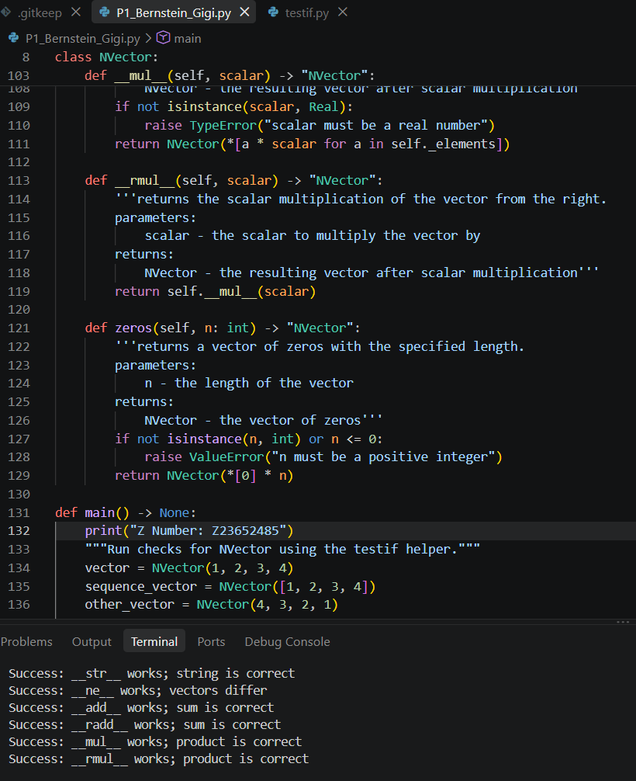

Problem 2

class ParkingPermit:
'''Base class for parking permits.
attributes:
owner_name (str): name of permit owner
months_purchased (int): number of months the permit is valid for
fee_schedule (dict): dictionary of fees associated with the permit
methods:
cost() -> float: calculates the total cost of the permit based on fee schedule
__str__() -> str: returns a string representation of the permit
__repr__() -> str: returns a detailed string representation of the permit
'''
def __init__(self, owner_name: str, months_purchased: int, fee_schedule: dict) -> None:
'''initializes a ParkingPermit instance.
parameters:
owner_name (str): name of permit owner
months_purchased (int): number of months the permit is valid for
fee_schedule (dict): dictionary of fees associated with the permit
'''
self.owner_name = owner_name
self.months_purchased = months_purchased
self.fee_schedule = fee_schedule

def cost(self) -> float:
'''calculates the total cost of the permit based on the fee schedule.
parameters:
none
returns:
float - the total cost of the permit'''
total = 0
for fee_type, fee_amount in self.fee_schedule.items():
total += fee_amount
return total

def __str__(self) -> str:
'''returns a string representation of the permit.
parameters:
none
returns:
str - a string representation of the permit'''
return f"ParkingPermit(owner_name={self.owner_name}, months_purchased={self.months_purchased}, fee_schedule={self.fee_schedule})"

def __repr__(self) -> str:
'''returns a detailed string representation of the permit.
parameters:
none
returns:
str - a detailed string representation of the permit'''
return f"ParkingPermit(owner_name={self.owner_name}, months_purchased={self.months_purchased}, fee_schedule={self.fee_schedule})"

class StudentPermit(ParkingPermit):
'''class representing a student parking permit
inherits from ParkingPermit
attributes:
num_vehicles (int): number of vehicles covered by the student permit'''
def __init__(self, owner_name: str, months_purchased: int, fee_schedule: dict, num_vehicles: int) -> None:
'''initializes a StudentPermit instance.
parameters:
owner_name (str): name of the permit owner
months_purchased (int): number of months the permit is valid
fee_schedule (dict): dictionary of fees associated with the permit
num_vehicles (int): number of vehicles covered by the student permit
returns:
none'''
super().__init__(owner_name, months_purchased, fee_schedule)
self.num_vehicles = num_vehicles

def cost(self) -> float:
'''calculates the total cost of the student permit.
parameters:
none
returns:
float - total cost of the student permit'''
total = super().cost()
total += 25 * self.months_purchased
if self.num_vehicles > 1:
total += 10 * (self.num_vehicles - 1)
return total

def __str__(self) -> str:
'''returns a string representation of the student permit.
parameters:
none
returns:
str - a string representation of the student permit'''
return f"StudentPermit(owner_name={self.owner_name}, months_purchased={self.months_purchased}, fee_schedule={self.fee_schedule}, num_vehicles={self.num_vehicles})"

def __repr__(self) -> str:
'''returns a detailed string representation of the student permit.
parameters:
none
returns:
str - a detailed string representation of the student permit'''
return f"StudentPermit(owner_name={self.owner_name}, months_purchased={self.months_purchased}, fee_schedule={self.fee_schedule}, num_vehicles={self.num_vehicles})"

class FacultyPermit(ParkingPermit):
'''class representing a faculty parking permit
inherits from ParkingPermit
attributes:
garage_access (bool): indicates if the faculty permit includes garage access'''
def __init__(self, owner_name: str, months_purchased: int, fee_schedule: dict, garage_access: bool) -> None:
'''initializes a FacultyPermit instance.
parameters:
owner_name (str): name of the permit owner
months_purchased (int): number of months the permit is valid
fee_schedule (dict): dictionary of fees associated with the permit
garage_access (bool): indicates if the faculty permit includes garage access
returns:
none'''
super().__init__(owner_name, months_purchased, fee_schedule)
self.garage_access = garage_access

def cost(self) -> float:
'''calculates the total cost of the faculty permit.
parameters:
none
returns:
float - total cost of the faculty permit'''
total = super().cost()
total += 40 * self.months_purchased
if self.garage_access:
total += 15 * self.months_purchased
return total

def __str__(self) -> str:
'''returns a string representation of the faculty permit.
parameters:
none
returns:
str - a string representation of the faculty permit'''
return f"FacultyPermit(owner_name={self.owner_name}, months_purchased={self.months_purchased}, fee_schedule={self.fee_schedule}, garage_access={self.garage_access})"

def __repr__(self) -> str:
'''returns a detailed string representation of the faculty permit.
parameters:
none
returns:
str - a detailed string representation of the faculty permit'''
return f"FacultyPermit(owner_name={self.owner_name}, months_purchased={self.months_purchased}, fee_schedule={self.fee_schedule}, garage_access={self.garage_access})"

def main():
'''main function to demonstrate the use of StudentPermit and FacultyPermit classes.'''
student_permit = StudentPermit("Abby West", 6, {"monthly": 50}, 1)
faculty_permit = FacultyPermit("JStella Rose", 12, {"monthly": 100}, True)

print("name: Gigi Bernstein")
print("Z number: Z23652485")

print(student_permit)
print(f"student permit cost: {student_permit.cost()}")

print(faculty_permit)
print(f"faculty permit cost: {faculty_permit.cost()}")

if __name__ == "__main__":
main()

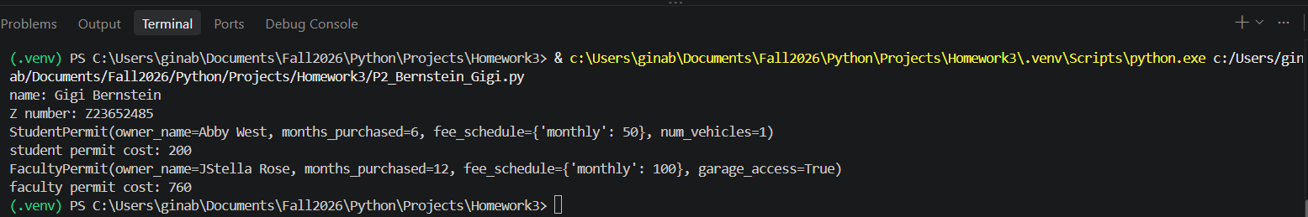

Problem 3
'''predator-prey-human simulation on a 2d island grid.'''

from __future__ import annotations

import random
from typing import Type

import matplotlib.pyplot as plt

class Island:
'''n-by-n grid that stores prey, predators, and humans'''

def __init__(self, n: int, prey_count: int = 0, predator_count: int = 0, count_humans: int = 0) -> None:
'''create an island and randomly place the initial population
preconditions:
- n is positive;
- all population counts are nonnegative;
- their sum does not exceed grid capacity
postconditions:
- grid contains the requested number of each class'''
if n <= 0:
raise ValueError("island size must be positive")
populations = (prey_count, predator_count, count_humans)
if any(count < 0 for count in populations):
raise ValueError("population counts cannot be negative")
if sum(populations) > n * n:
raise ValueError("initial population exceeds island capacity")

self.grid_size: int = n
self.grid: list[list[Animal | int]] = [[0 for _ in range(n)] for _ in range(n)]
self.init_animals(prey_count, predator_count, count_humans)

def init_animals(
self, prey_count: int, predator_count: int, count_humans: int
) -> None:
'''randomly place requested numbers of prey, predators, and humans
paramaters:
- prey_count: number of prey to place
- predator_count: number of predators to place
- count_humans: number of humans to place
returns: None'''
self._place_random_animals(prey_count, Prey)
self._place_random_animals(predator_count, Predator)
self._place_random_animals(count_humans, Human)

def _place_random_animals(self, count: int, animal_class: Type[Animal]) -> None:
'''place count instances of animal_class in randomly selected empty cells
paramaters:
- count: number of animals to place
- animal_class: the class of animals to place
returns: None'''
placed = 0
while placed < count:
x = random.randrange(self.grid_size)
y = random.randrange(self.grid_size)
if not self.animal(x, y):
self.register(animal_class(island=self, x=x, y=y))
placed += 1

def clear_all_moved_flags(self) -> None:
'''reset every animal's moved flag before a new time unit begins
paramaters: None
returns: None'''
for column in self.grid:
for occupant in column:
if isinstance(occupant, Animal):
occupant.clear_moved_flag()

def size(self) -> int:
'''return the length of one side of the square island
paramaters: None
returns: int'''
return self.grid_size

def register(self, animal: Animal) -> None:
'''place animal in the grid cell matching its current coordinates
paramaters:
- animal: the animal to place
returns: None'''
self.grid[animal.x][animal.y] = animal

def remove(self, animal: Animal) -> None:
'''empty animal's current grid cell if that cell still contains it
paramaters:
- animal: the animal to remove
returns: None'''
if self.grid[animal.x][animal.y] is animal:
self.grid[animal.x][animal.y] = 0

def animal(self, x: int, y: int) -> Animal | int:
'''return the occupant at (x, y), or -1 when coordinates are out of bounds
paramaters:
- x: the x-coordinate
- y: the y-coordinate
returns: Animal | int'''
if 0 <= x < self.grid_size and 0 <= y < self.grid_size:
return self.grid[x][y]
return -1

def __str__(self) -> str:
'''return a grid display with the island's lower-left cell at the bottom
paramaters: None
returns: str'''
rows: list[str] = []
for y in range(self.grid_size - 1, -1, -1):
row = []
for x in range(self.grid_size):
occupant = self.grid[x][y]
row.append(str(occupant) if isinstance(occupant, Animal) else ".")
rows.append(" ".join(row))
return "\n".join(rows)

def count_prey(self) -> int:
'''return the number of Prey objects currently on the grid
paramaters: None
returns: int'''
return sum(
isinstance(occupant, Prey)
for column in self.grid
for occupant in column
)

def count_predators(self) -> int:
'''return the number of Predator objects currently on the grid
paramaters: None
returns: int'''
return sum(
isinstance(occupant, Predator)
for column in self.grid
for occupant in column
)

def count_humans(self) -> int:
'''return the number of Human objects currently on the grid
paramaters: None
returns: int'''
return sum(
isinstance(occupant, Human)
for column in self.grid
for occupant in column
)

class Animal:
'''Base class for entities that move and breed on an Island.'''

breed_time: int
breed_clock: int

def __init__(self, island: Island, x: int = 0, y: int = 0, s: str = "A") -> None:
'''initialize an animal at (x, y) on island with display symbol s
paramaters:
- island: the island on which the animal resides
- x: the x-coordinate
- y: the y-coordinate
- s: the display symbol
returns: None'''
self.island: Island = island
self.name: str = s
self.x: int = x
self.y: int = y
self.moved: bool = False

def position(self) -> tuple[int, int]:
'''return the animal's current (x, y) coordinates
paramaters: none
returns: tuple[int, int]'''
return self.x, self.y

def __str__(self) -> str:
'''return the animal's one-character grid symbol
paramaters: none
returns: str'''
return self.name

def check_grid(self, type_looking_for: type = int) -> tuple[int, int] | int:
'''return a neighboring cell containing the exact requested type, or 0
paramaters:
- type_looking_for: the type of animal to look for
returns: tuple[int, int] | int'''
offsets = ((-1, 1), (0, 1), (1, 1), (-1, 0), (1, 0), (-1, -1), (0, -1), (1, -1))
for dx, dy in offsets:
x = self.x + dx
y = self.y + dy
if 0 <= x < self.island.size() and 0 <= y < self.island.size():
if type(self.island.animal(x, y)) is type_looking_for:
return x, y
return 0

def _move_to(self, location: tuple[int, int]) -> None:
'''move this animal into location and mark it as moved for this time unit
paramaters:
- location: the (x, y) coordinates to move to
returns: none'''
self.island.remove(self)
self.x, self.y = location
self.island.register(self)
self.moved = True

def move(self) -> None:
'''move to the first neighboring empty cell unless already moved
paramaters: none
returns: None'''
if not self.moved:
location = self.check_grid(int)
if isinstance(location, tuple):
self._move_to(location)

def breed(self) -> None:
'''create an offspring in a neighboring empty cell when breed_clock expires
paramaters: none
returns: none'''
if self.breed_clock <= 0:
location = self.check_grid(int)
if isinstance(location, tuple):
self.breed_clock = self.breed_time
offspring = type(self)(self.island, x=location[0], y=location[1])
self.island.register(offspring)

def clear_moved_flag(self) -> None:
'''mark the animal as not yet moved during the next time unit
paramaters: none
returns: none'''
self.moved = False

class Prey(Animal):
'''An animal that moves and breeds but does not eat other animals.'''

breed_time: int = 3

def __init__(self, island: Island, x: int = 0, y: int = 0, s: str = "O") -> None:
'''create prey and initialize its breeding clock from Prey.breed_time
paramaters:
- island: the island on which the prey resides
- x: the x-coordinate
- y: the y-coordinate
- s: the display symbol
returns: None'''
super().__init__(island, x, y, s)
self.breed_clock = self.breed_time

def clock_tick(self) -> None:
'''advance the breeding clock by one time unit
paramaters: none
returns: none'''
self.breed_clock -= 1

class Predator(Animal):
'''An animal that eats prey and starves when it cannot eat in time.'''

breed_time: int = 6
starve_time: int = 3

def __init__(self, island: Island, x: int = 0, y: int = 0, s: str = "X") -> None:
'''create a predator and initialize breeding and starvation clocks
paramaters:
- island: the island on which the predator resides
- x: the x-coordinate
- y: the y-coordinate
- s: the display symbol
returns: None'''
super().__init__(island, x, y, s)
self.starve_clock: int = self.starve_time
self.breed_clock = self.breed_time

def clock_tick(self) -> None:
'''advance clocks and remove the predator if its starvation clock expires
paramaters: none
returns: none'''
self.breed_clock -= 1
self.starve_clock -= 1
if self.starve_clock <= 0:
self.island.remove(self)

def eat(self) -> None:
'''eat a neighboring Prey, move into its cell, and reset starvation
paramaters: none
returns: none'''
if not self.moved:
location = self.check_grid(Prey)
if isinstance(location, tuple):
prey = self.island.animal(*location)
if isinstance(prey, Prey):
self.island.remove(prey)
self._move_to(location)
self.starve_clock = self.starve_time

class Human(Animal):
'''An animal that periodically hunts predators and can itself starve.'''

hunt_time: int = 4
starve_time: int = 12
breed_time: int = 8

def __init__(self, island: Island, x: int = 0, y: int = 0, s: str = "H") -> None:
'''create a human with clocks initialized from Human's class attributes
paramaters:
- island: the island on which the human resides
- x: the x-coordinate
- y: the y-coordinate
- s: the display symbol
returns: None'''
super().__init__(island, x, y, s)
self.hunt_clock: int = self.hunt_time
self.starve_clock: int = self.starve_time
self.breed_clock = self.breed_time

def eat(self) -> None:
'''hunt at each hunt_time interval, eating a neighboring Predator if found
paramaters: none
returns: none

A successful hunt moves the human into the predator's cell and resets its
starvation clock. Prey are never targeted by this method.
'''
self.hunt_clock -= 1
if self.hunt_clock > 0:
return
self.hunt_clock = self.hunt_time
if not self.moved:
location = self.check_grid(Predator)
if isinstance(location, tuple):
predator = self.island.animal(*location)
if isinstance(predator, Predator):
self.island.remove(predator)
self._move_to(location)
self.starve_clock = self.starve_time

def clock_tick(self) -> None:
'''advance human clocks and remove the human if it starves
paramaters: none
returns: none'''
self.breed_clock -= 1
self.starve_clock -= 1
if self.starve_clock <= 0:
self.island.remove(self)

def main(
predator_breed_time: int = 6,
predator_starve_time: int = 3,
initial_predators: int = 10,
prey_breed_time: int = 3,
initial_prey: int = 50,
size: int = 10,
ticks: int = 1000,
human_hunt_time: int = 4,
human_starve_time: int = 12,
human_breed_time: int = 8,
initial_humans: int = 2) -> tuple[list[int], list[int], list[int]]:
'''Run the island simulation, plot populations, and return their histories.
parameters:
- the *_time arguments set class clock periods
- the initial_* arguments set starting populations
- size is the grid width
- ticks is capped at 1000
- set starting populations; size is the grid width; ticks is capped at 1000.
- simulation stops after 20 time units in a row with unchanged counts or when tick limit is reached
returns:
- returned lists include time zero.
'''
if ticks < 0:
raise ValueError("ticks cannot be negative")
if any(clock <= 0 for clock in (
predator_breed_time,
predator_starve_time,
prey_breed_time,
human_hunt_time,
human_starve_time,
human_breed_time,)):
raise ValueError("all clock periods must be positive")

Predator.breed_time = predator_breed_time
Predator.starve_time = predator_starve_time
Prey.breed_time = prey_breed_time
Human.hunt_time = human_hunt_time
Human.starve_time = human_starve_time
Human.breed_time = human_breed_time

island = Island(size, initial_prey, initial_predators, initial_humans)
print("Initial island:")
print(island)

prey_history = [island.count_prey()]
predator_history = [island.count_predators()]
human_history = [island.count_humans()]
unchanged_ticks = 0
stability_window = 20

# Snapshotting ensures every animal present at tick start acts at most once.
for tick in range(min(ticks, 1000)):
island.clear_all_moved_flags()
animals = [
occupant
for column in island.grid
for occupant in column
if isinstance(occupant, Animal)
]
for animal in animals:
if island.animal(animal.x, animal.y) is not animal:
continue
if isinstance(animal, (Predator, Human)):
animal.eat()
animal.move()
animal.breed()
animal.clock_tick()

current_counts = (
island.count_prey(),
island.count_predators(),
island.count_humans(),
)
previous_counts = (
prey_history[-1],
predator_history[-1],
human_history[-1],
)
prey_history.append(current_counts[0])
predator_history.append(current_counts[1])
human_history.append(current_counts[2])
unchanged_ticks = unchanged_ticks + 1 if current_counts == previous_counts else 0

if tick % 10 == 0:
print(f"Tick {tick + 1}: prey={current_counts[0]}, predators={current_counts[1]}, humans={current_counts[2]}")
if unchanged_ticks >= stability_window:
print(f"Populations remained constant for {stability_window} ticks.")
break

print("name: Gigi Bernstein")
print("Z number: Z23652485")

print("Final island:")
print(island)

plt.plot(prey_history, label="Prey")
plt.plot(predator_history, label="Predators")
plt.plot(human_history, label="Humans")
plt.xlabel("Time unit")
plt.ylabel("Population")
plt.title("Island Population Over Time")
plt.legend()
plt.tight_layout()
plt.show()
return prey_history, predator_history, human_history

if __name__ == "__main__":
main()

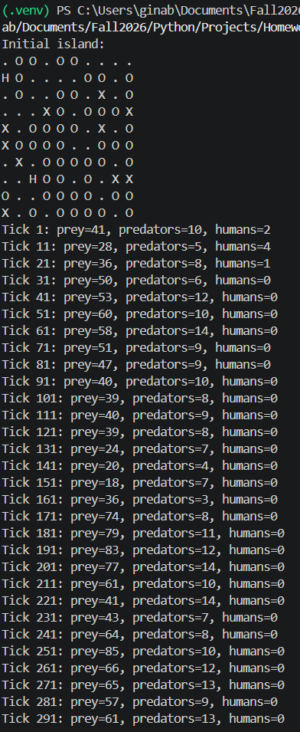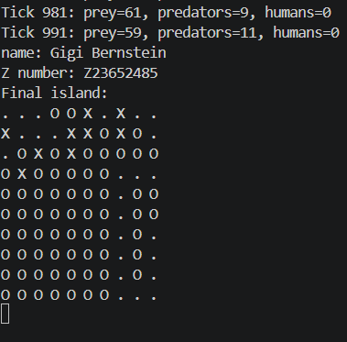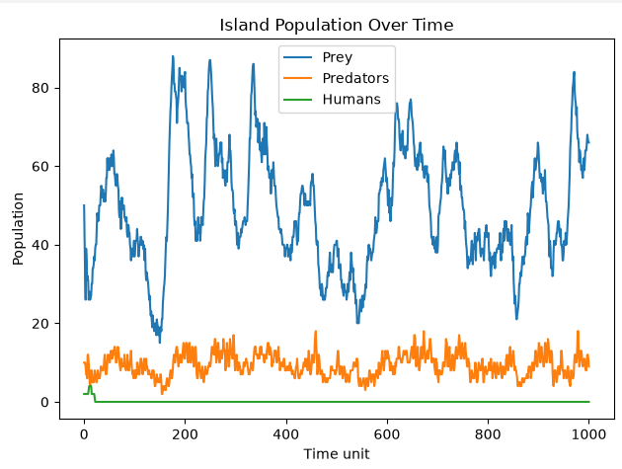

Problem 4
'''simple non-interactive text-file editing commands and demonstrations.'''

from __future__ import annotations

import os
import stat
import tempfile
from pathlib import Path

from testif import testif

def _validate_text(value: str, parameter_name: str) -> None:
''' checks if text is string
parameters:
value: the text to validate.
parameter_name: the name of the parameter for error messages
return:
none
raise:
TypeError: if value is not a string.'''
if not isinstance(value, str):
raise TypeError(f"{parameter_name} must be a string")

def _write_atomically(filename: str, content: str) -> None:
'''replaces filename with content, but leaves the original intact if theres a failure.
parameters:
filename: the path to the file to replace
content: the new content to write to the file
return:
none
raise:
OSError: if there is an error writing to the temporary file or replacing the original file
'''
path = Path(filename)
try:
existing_mode = stat.S_IMODE(path.stat().st_mode)
except FileNotFoundError:
existing_mode = None

with tempfile.TemporaryDirectory(dir=path.parent) as temp_directory:
temporary_path = Path(temp_directory) / path.name
temporary_path.write_text(content, encoding="utf-8")
if existing_mode is not None:
temporary_path.chmod(existing_mode)
os.replace(temporary_path, path)

def ed_read(filename: str, from_pos: int = 0, to: int = -1) -> str:
'''read and return the file text in the half-open interval [from_pos, to).

preconditions: \
- filename is a path string
- from_pos and to are integers
- from_pos is nonnegative
- to is -1 or nonnegative.
postconditions:
- the file is unchanged and the requested text is returned
- if to is greater than the file length, raise IndexError
- File I/O errors propagate to the caller
'''
_validate_text(filename, "filename")
if not isinstance(from_pos, int) or isinstance(from_pos, bool):
raise TypeError("from_pos must be an integer")
if not isinstance(to, int) or isinstance(to, bool):
raise TypeError("to must be an integer")
if from_pos < 0:
raise ValueError("from_pos cannot be negative")
if to < -1:
raise ValueError("to must be -1 or nonnegative")

content = Path(filename).read_text(encoding="utf-8")
if to > len(content):
raise IndexError(f"to ({to}) exceeds file length ({len(content)})")
end = len(content) if to == -1 else to
return content[from_pos:end]

def ed_find(filename: str, search_str: str) -> list[int]:
'''return:
- list of the non-overlapping start positions of search_str in the file.

preconditions:
- filename and search_str are strings.
postconditions:
- file is unchanged
- an empty search string matches each character boundary, including after final character
- File I/O errors propagate to the caller
'''
_validate_text(filename, "filename")
_validate_text(search_str, "search_str")
content = Path(filename).read_text(encoding="utf-8")
if search_str == "":
return list(range(len(content) + 1))

positions: list[int] = []
start = 0
while True:
position = content.find(search_str, start)
if position == -1:
return positions
positions.append(position)
start = position + len(search_str)

def ed_replace(
filename: str,
search_str: str,
replace_with: str,
occurrence: int = -1,
) -> int:
'''replace all or one indexed non-overlapping occurrence in a file.

preconditions:
- filename, search_str, and replace_with are strings
- occurrence is -1 (replace all) or a nonnegative integer
postconditions:
- returns the number of replacements
- An occurrence index beyond the matches returns 0 without changing the file
- The file is atomically replaced only after its new contents are ready
- File I/O errors propagate to the caller
'''
_validate_text(filename, "filename")
_validate_text(search_str, "search_str")
_validate_text(replace_with, "replace_with")
if not isinstance(occurrence, int) or isinstance(occurrence, bool):
raise TypeError("occurrence must be an integer")
if occurrence < -1:
raise ValueError("occurrence must be -1 or nonnegative")

path = Path(filename)
content = path.read_text(encoding="utf-8")
positions = (
list(range(len(content) + 1))
if search_str == ""
else ed_find(filename, search_str)
)

if occurrence == -1:
if not positions:
return 0
updated_content = content.replace(search_str, replace_with)
replacement_count = len(positions)
elif occurrence >= len(positions):
return 0
else:
position = positions[occurrence]
updated_content = (
content[:position]
+ replace_with
+ content[position + len(search_str):]
)
replacement_count = 1

_write_atomically(filename, updated_content)
return replacement_count

def ed_append(filename: str, string: str) -> int:
'''Append string to filename, creating the file if it does not exist.

preconditions:
- filename and string are strings
postconditions:
- returns the number of characters appended
- File I/O errors propagate to the caller
- the target is replaced only after the updated contents have been written successfully
'''
_validate_text(filename, "filename")
_validate_text(string, "string")
path = Path(filename)
try:
original_content = path.read_text(encoding="utf-8")
except FileNotFoundError:
original_content = ""
_write_atomically(filename, original_content + string)
return len(string)

def test_ed_find() -> bool:
'''test ed_find's positions, missing matches, and empty-string behavior'''
with tempfile.TemporaryDirectory() as temp_directory:
filename = str(Path(temp_directory) / "find_test.txt")
ed_append(filename, "abc abc ab")
positions_match = ed_find(filename, "abc") == [0, 4]
no_match = ed_find(filename, "xyz") == []
empty_match = ed_find(filename, "") == list(range(11))
return all((
testif(positions_match, "ed_find positions", "found both matches", "wrong positions"),
testif(no_match, "ed_find missing text", "returned no matches", "unexpected match"),
testif(empty_match, "ed_find empty string", "found text boundaries", "wrong boundaries"),
))

def test_ed_replace() -> bool:
'''test ed_replace's all, indexed, absent-index, and empty-string cases'''
with tempfile.TemporaryDirectory() as temp_directory:
filename = str(Path(temp_directory) / "replace_test.txt")
ed_append(filename, "one two one")
replaced_all = ed_replace(filename, "one", "1") == 2
all_content_correct = ed_read(filename) == "1 two 1"
replaced_one = ed_replace(filename, "1", "first", 1) == 1
one_content_correct = ed_read(filename) == "1 two first"
beyond_matches = ed_replace(filename, "1", "unused", 2) == 0
unchanged_on_missing = ed_read(filename) == "1 two first"
empty_replaced = ed_replace(filename, "", "|", 0) == 1
empty_content_correct = ed_read(filename) == "|1 two first"
return all((
testif(replaced_all and all_content_correct, "ed_replace all", "replaced both matches", "all replacement failed"),
testif(replaced_one and one_content_correct, "ed_replace occurrence", "replaced indexed match", "indexed replacement failed"),
testif(beyond_matches and unchanged_on_missing, "ed_replace missing occurrence", "left file unchanged", "changed file unexpectedly"),
testif(empty_replaced and empty_content_correct, "ed_replace empty string", "replaced at selected boundary", "empty search failed"),
))

def main() -> None:
'''run unit tests and demonstrate each editing command on a temporary file'''
test_ed_find()
test_ed_replace()

with tempfile.TemporaryDirectory() as temp_directory:
filename = str(Path(temp_directory) / "editor_demo.txt")
appended = ed_append(filename, "0123456789")
ed_append(filename, "0123456789")
print(f"ed_append wrote {appended} characters")
print(f"ed_read(3, 9): {ed_read(filename, 3, 9)}")
print(f"ed_read(3): {ed_read(filename, 3)}")
print(f"ed_find('345'): {ed_find(filename, '345')}")
print(f"ed_find('356'): {ed_find(filename, '356')}")
replacements = ed_replace(filename, "345", "ABCDE", 1)
print(f"ed_replace occurrence 1 replaced {replacements} match")
print(f"Final file contents: {ed_read(filename)}")
print("name: Gigi Bernstein")
print("Z number: Z23652485")

if __name__ == "__main__":
main()

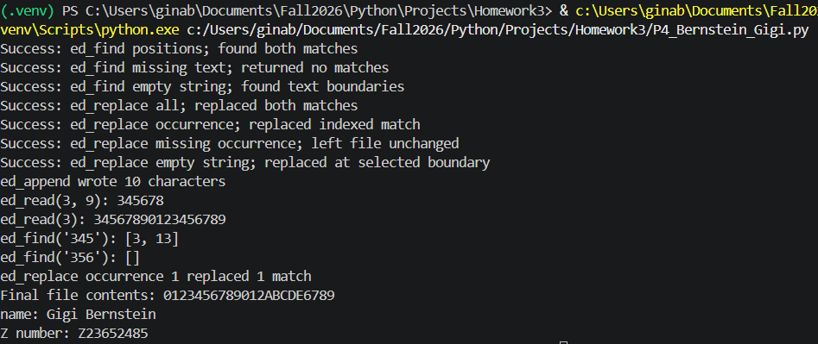

Problem 5

import math
import turtle
from testif import testif

def strB(n: int, base: int = 10) -> str:
'''return n as a string of digits in base, using A-Z for values above 9'''
if type(n) is not int or type(base) is not int:
raise TypeError("n and base must be integers")
if n < 0:
raise ValueError("n must be non-negative")
if not 2 <= base <= 26:
raise ValueError("base must be between 2 and 26")

digits = "0123456789ABCDEFGHIJKLMNOPQRSTUVWXYZ"
if n < base:
return digits[n]
return strB(n // base, base) + digits[n % base]

def test_strB() -> bool:
'''check zero, decimal output, alphabetic digits, and a large conversion'''
return all((
testif(strB(0) == "0", "strB zero", "returned 0", "incorrect zero representation"),
testif(strB(1234) == "1234", "strB decimal", "returned 1234", "incorrect decimal representation"),
testif(strB(1234, 16) == "4D2", "strB hexadecimal", "returned 4D2", "incorrect hexadecimal representation"),
testif(strB(123456789, 26) == "AA44A1", "strB base 26", "returned AA44A1", "incorrect base-26 representation"),
))

def Cnk_m(n: int, k: int, memo: dict[tuple[int, int], int] | None = None) -> int:
'''return n choose k recursively, saving intermediate results in memo'''
if type(n) is not int or type(k) is not int:
raise TypeError("n and k must be integers")
if n < 0 or k < 0 or k > n:
raise ValueError("n and k must satisfy n >= k >= 0")
if memo is None:
memo = {}

if k == 0 or k == n:
return 1
key = (n, k)
if key not in memo:
memo[key] = Cnk_m(n - 1, k - 1, memo) + Cnk_m(n - 1, k, memo)
return memo[key]

def test_Cnk_m() -> bool:
'''check the binomial coefficient base cases and recursive values'''
return all((
testif(Cnk_m(0, 0) == 1, "Cnk_m zero", "returned 1", "incorrect zero case"),
testif(Cnk_m(8, 0) == 1, "Cnk_m k zero", "returned 1", "incorrect k=0 case"),
testif(Cnk_m(8, 8) == 1, "Cnk_m k equals n", "returned 1", "incorrect k=n case"),
testif(Cnk_m(30, 15) == 155117520, "Cnk_m recursive", "returned 155117520", "incorrect coefficient"),
))

def run_Cnk() -> None:
'''print several binomial coefficients for a console demonstration'''
for n, k in ((5, 2), (20, 10), (30, 15)):
print(f"C({n}, {k}) = {Cnk_m(n, k)}")

def make_pairs(seq1: list, seq2: list, accumulator: list | None = None) -> list:
'''recursively pair corresponding elements until either list ends'''
if accumulator is None:
accumulator = []
if not seq1 or not seq2:
return accumulator
accumulator.append((seq1[0], seq2[0]))
return make_pairs(seq1[1:], seq2[1:], accumulator)

def test_make_pairs() -> bool:
'''check paired values, unequal lengths, and empty-list boundaries'''
return all((
testif(make_pairs([1, 2, 3], [4, 5, 6]) == [(1, 4), (2, 5), (3, 6)], "make_pairs equal", "paired all values", "incorrect equal-length pairs"),
testif(make_pairs([1, 2, 3], [4, 5]) == [(1, 4), (2, 5)], "make_pairs shorter second", "stopped at second list", "incorrect shorter-second result"),
testif(make_pairs([1, 2], [4, 5, 6]) == [(1, 4), (2, 5)], "make_pairs shorter first", "stopped at first list", "incorrect shorter-first result"),
testif(make_pairs([], [4, 5, 6]) == [], "make_pairs empty first", "returned empty list", "incorrect empty-first result"),
testif(make_pairs([1, 2, 3], []) == [] and make_pairs([], []) == [], "make_pairs empty second and both", "returned empty lists", "incorrect empty-list result"),
))

def _leaf_centerline_point(progress: float, blade_length: float, curve_amount: float) -> tuple[float, float]:
return curve_amount * math.sin(math.pi * progress), blade_length * progress

def _draw_leaf_vein(
length: float,
base_heading: float,
side: int,
recursion_level: int,
curved: bool,
branch_angle: float = 52,
) -> None:
start_position = turtle.position()
turtle.setheading(base_heading + side * branch_angle)

if curved:
for _ in range(10):
turtle.forward(length / 10)
turtle.left(side * 0.8)
else:
turtle.forward(length)

end_heading = turtle.heading()
if recursion_level > 1:
child_length = length * 0.48
_draw_leaf_vein(child_length, end_heading, -1, recursion_level - 1, curved, 34)
_draw_leaf_vein(child_length, end_heading, 1, recursion_level - 1, curved, 34)

turtle.penup()
turtle.goto(start_position)
turtle.setheading(base_heading)
turtle.pendown()

def _draw_leaf(
recursion_level: int,
petiole_length: float,
curved: bool,
start_position: tuple[float, float],
) -> None:
if recursion_level < 1:
raise ValueError("recursion_level must be at least 1")
if petiole_length <= 0:
raise ValueError("petiole_length must be positive")

turtle.delay(0)
turtle.penup()
turtle.goto(start_position)
turtle.setheading(90)
turtle.pendown()
turtle.forward(petiole_length)

blade_length = petiole_length * 1.5
curve_amount = blade_length * 0.24 if curved else 0
blade_start = turtle.position()

if curved:
for step in range(1, 41):
progress = step / 40
x, y = _leaf_centerline_point(progress, blade_length, curve_amount)
turtle.goto(blade_start[0] + x, blade_start[1] + y)
else:
turtle.forward(blade_length)

station_count = max(4, recursion_level * 2 + 2)
for station in range(1, station_count + 1):
progress = station / (station_count + 1)
if curved:
x, y = _leaf_centerline_point(progress, blade_length, curve_amount)
tangent = math.degrees(
math.atan2(
blade_length,
curve_amount * math.pi * math.cos(math.pi * progress),
)
)
else:
x, y = 0, blade_length * progress
tangent = 90

turtle.penup()
turtle.goto(blade_start[0] + x, blade_start[1] + y)
turtle.setheading(tangent)
turtle.pendown()
vein_length = blade_length * 0.34 * math.sin(math.pi * progress)
_draw_leaf_vein(vein_length, tangent, -1, recursion_level, curved)
_draw_leaf_vein(vein_length, tangent, 1, recursion_level, curved)

turtle.penup()
turtle.goto(blade_start[0] + curve_amount * math.sin(math.pi), blade_start[1] + blade_length)
turtle.setheading(90)
turtle.pendown()

def draw_leaf_straight(
recursion_level: int,
petiole_length: float,
start_position: tuple[float, float] = (0, 0),
) -> None:
'''draw a vertical, straight-midrib leaf with recursively branching veins'''
_draw_leaf(recursion_level, petiole_length, curved=False, start_position=start_position)

def draw_leaf_curved(
recursion_level: int,
petiole_length: float,
start_position: tuple[float, float] = (0, 0),
) -> None:
'''draw a vertical leaf with a curved midrib and curved recursive veins'''
_draw_leaf(recursion_level, petiole_length, curved=True, start_position=start_position)

class ParkingPermit:
'''Base class for parking permits.
attributes:
owner_name (str): name of permit owner
months_purchased (int): number of months the permit is valid for
fee_schedule (dict): dictionary of fees associated with the permit
methods:
cost() -> float: calculates the total cost of the permit based on fee schedule
__str__() -> str: returns a string representation of the permit
__repr__() -> str: returns a detailed string representation of the permit
'''
def __init__(self, owner_name: str, months_purchased: int, fee_schedule: dict) -> None:
'''initializes a ParkingPermit instance.
parameters:
owner_name (str): name of permit owner
months_purchased (int): number of months the permit is valid for
fee_schedule (dict): dictionary of fees associated with the permit
'''
self.owner_name = owner_name
self.months_purchased = months_purchased
self.fee_schedule = fee_schedule

def cost(self) -> float:
'''calculates the total cost of the permit based on the fee schedule.
parameters:
none
returns:
float - the total cost of the permit'''
total = 0
for fee_type, fee_amount in self.fee_schedule.items():
total += fee_amount
return total

def __str__(self) -> str:
'''returns a string representation of the permit.
parameters:
none
returns:
str - a string representation of the permit'''
return f"ParkingPermit(owner_name={self.owner_name}, months_purchased={self.months_purchased}, fee_schedule={self.fee_schedule})"

def __repr__(self) -> str:
'''returns a detailed string representation of the permit.
parameters:
none
returns:
str - a detailed string representation of the permit'''
return f"ParkingPermit(owner_name={self.owner_name}, months_purchased={self.months_purchased}, fee_schedule={self.fee_schedule})"

class StudentPermit(ParkingPermit):
'''class representing a student parking permit
inherits from ParkingPermit
attributes:
num_vehicles (int): number of vehicles covered by the student permit'''
def __init__(self, owner_name: str, months_purchased: int, fee_schedule: dict, num_vehicles: int) -> None:
'''initializes a StudentPermit instance.
parameters:
owner_name (str): name of the permit owner
months_purchased (int): number of months the permit is valid
fee_schedule (dict): dictionary of fees associated with the permit
num_vehicles (int): number of vehicles covered by the student permit
returns:
none'''
super().__init__(owner_name, months_purchased, fee_schedule)
self.num_vehicles = num_vehicles

def cost(self) -> float:
'''calculates the total cost of the student permit.
parameters:
none
returns:
float - total cost of the student permit'''
total = super().cost()
total += 25 * self.months_purchased
if self.num_vehicles > 1:
total += 10 * (self.num_vehicles - 1)
return total

def __str__(self) -> str:
'''returns a string representation of the student permit.
parameters:
none
returns:
str - a string representation of the student permit'''
return f"StudentPermit(owner_name={self.owner_name}, months_purchased={self.months_purchased}, fee_schedule={self.fee_schedule}, num_vehicles={self.num_vehicles})"

def __repr__(self) -> str:
'''returns a detailed string representation of the student permit.
parameters:
none
returns:
str - a detailed string representation of the student permit'''
return f"StudentPermit(owner_name={self.owner_name}, months_purchased={self.months_purchased}, fee_schedule={self.fee_schedule}, num_vehicles={self.num_vehicles})"

class FacultyPermit(ParkingPermit):
'''class representing a faculty parking permit
inherits from ParkingPermit
attributes:
garage_access (bool): indicates if the faculty permit includes garage access'''
def __init__(self, owner_name: str, months_purchased: int, fee_schedule: dict, garage_access: bool) -> None:
'''initializes a FacultyPermit instance.
parameters:
owner_name (str): name of the permit owner
months_purchased (int): number of months the permit is valid
fee_schedule (dict): dictionary of fees associated with the permit
garage_access (bool): indicates if the faculty permit includes garage access
returns:
none'''
super().__init__(owner_name, months_purchased, fee_schedule)
self.garage_access = garage_access

def cost(self) -> float:
'''calculates the total cost of the faculty permit.
parameters:
none
returns:
float - total cost of the faculty permit'''
total = super().cost()
total += 40 * self.months_purchased
if self.garage_access:
total += 15 * self.months_purchased
return total

def __str__(self) -> str:
'''returns a string representation of the faculty permit.
parameters:
none
returns:
str - a string representation of the faculty permit'''
return f"FacultyPermit(owner_name={self.owner_name}, months_purchased={self.months_purchased}, fee_schedule={self.fee_schedule}, garage_access={self.garage_access})"

def __repr__(self) -> str:
'''returns a detailed string representation of the faculty permit.
parameters:
none
returns:
str - a detailed string representation of the faculty permit'''
return f"FacultyPermit(owner_name={self.owner_name}, months_purchased={self.months_purchased}, fee_schedule={self.fee_schedule}, garage_access={self.garage_access})"

def main():
'''main function to demonstrate the use of StudentPermit and FacultyPermit classes.'''
test_strB()
test_Cnk_m()
test_make_pairs()
student_permit = StudentPermit("Abby West", 6, {"monthly": 50}, 1)
faculty_permit = FacultyPermit("Stella Rose", 12, {"monthly": 100}, True)

print("name: Gigi Bernstein")
print("Z number: Z23652485")

print(student_permit)
print(f"student permit cost: {student_permit.cost()}")

print(faculty_permit)
print(f"faculty permit cost: {faculty_permit.cost()}")

print("\nleaf drawings:")
turtle.setup(width=700, height=500)
turtle.title("recursive leaves")
draw_leaf_straight(2, 80, (-160, -180))
draw_leaf_curved(2, 80, (160, -180))
turtle.penup()
turtle.goto(-230, -225)
turtle.write("Straight", align="center", font=("Arial", 14, "normal"))
turtle.goto(160, -225)
turtle.write("Curved", align="center", font=("Arial", 14, "normal"))
turtle.done()

if __name__ == "__main__":
main()

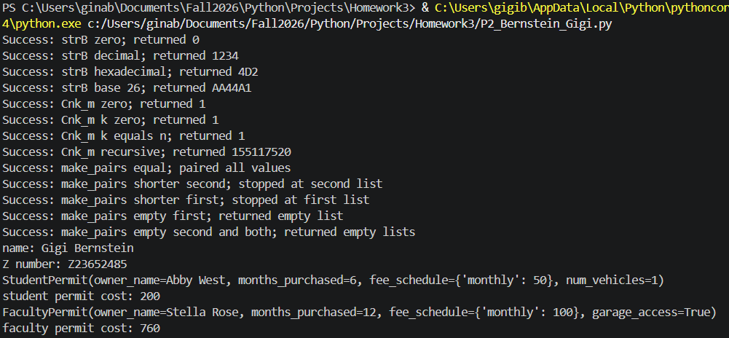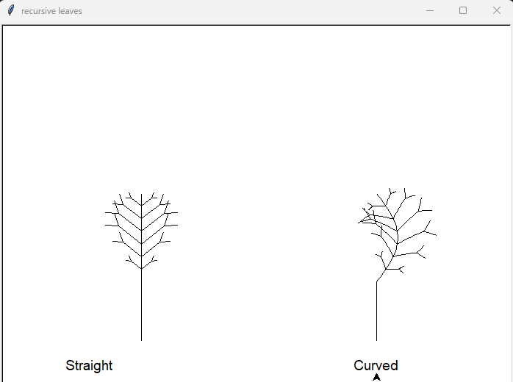

Problem 6
"""Estimate storage used by a tree of files and folders."""

from __future__ import annotations

import unittest

class Entry:
"""Base class for a named filesystem entry."""

def __init__(self: Entry, name: str, parent: Entry | None = None) -> None:
"""Initialize an entry with its name and optional parent."""
self.name: str = name
self._parent: Entry | None = parent

def parent(self: Entry) -> Entry | None:
"""Return this entry's parent, or None when it is a root entry."""
return self._parent

def size(self: Entry) -> int:
"""Return the entry's size in bytes."""
raise NotImplementedError("Entry subclasses must implement size().")

def absolute_path(self: Entry) -> list[Entry]:
"""Return entries from this entry up to and including the root."""
if self._parent is None:
return [self]
return [self, *self._parent.absolute_path()]

class File(Entry):
"""A file with a fixed, nonnegative storage size."""

def __init__(self: File, name: str, bytes_used: int, parent: Entry | None = None) -> None:
"""Initialize a file and reject negative storage sizes."""
super().__init__(name, parent)
if bytes_used < 0:
raise ValueError("bytes_used must be nonnegative.")
self.bytes_used: int = bytes_used

def size(self: File) -> int:
"""Return the number of bytes used by this file."""
return self.bytes_used

class Folder(Entry):
"""A folder containing files and other folders."""

def __init__(self: Folder, name: str, parent: Entry | None = None) -> None:
"""Initialize an empty folder."""
super().__init__(name, parent)
self._children: list[Entry] = []

def add(self: Folder, entry: Entry) -> None:
"""Add an entry as a child and set its parent to this folder."""
entry._parent = self
self._children.append(entry)

def size(self: Folder) -> int:
"""Return the combined size of all files in this folder tree."""
return sum(entry.size() for entry in self._children)

def children(self: Folder) -> tuple[Entry, ...]:
"""Return this folder's direct children as an immutable tuple."""
return tuple(self._children)

def find_large_files(entry: Entry, minimum_size: int) -> list[File]:
"""Find files at least minimum_size bytes below entry.

If entry is a File, return that file when it meets the threshold;
if entry is a Folder, search all of its descendants recursively.
"""
if isinstance(entry, File):
return [entry] if entry.size() >= minimum_size else []
if isinstance(entry, Folder):
return [
file
for child in entry.children()
for file in find_large_files(child, minimum_size)
]
return []

class EntryHierarchyTests(unittest.TestCase):
"""Tests for recursive size, search, and absolute-path behavior."""

def setUp(self: EntryHierarchyTests) -> None:
"""Create a three-level nested tree for each test."""
self.root = Folder("root")
self.archive = Folder("archive")
self.department = Folder("department")
self.lab = Folder("lab")
self.root.add(self.archive)
self.archive.add(self.department)
self.department.add(self.lab)
self.root.add(File("readme.txt", 300))
self.archive.add(File("dataset.csv", 1800))
self.department.add(File("notes.txt", 900))
self.lab.add(File("simulation.bin", 6400))
self.lab.add(File("image.raw", 2100))

def test_find_large_files_in_folder_at_two_thresholds(self: EntryHierarchyTests) -> None:
"""Return all nested files meeting each requested threshold."""
self.assertEqual(
{file.name for file in find_large_files(self.root, 1000)},
{"dataset.csv", "simulation.bin", "image.raw"},
)
self.assertEqual(
{file.name for file in find_large_files(self.root, 2500)},
{"simulation.bin"},
)

def test_find_large_files_when_entry_is_file(self: EntryHierarchyTests) -> None:
"""Search a file entry itself, including threshold boundaries."""
large_file = self.lab.children()[0]
self.assertIsInstance(large_file, File)
self.assertEqual(find_large_files(large_file, 6400), [large_file])
self.assertEqual(find_large_files(large_file, 6401), [])

def test_absolute_path_runs_from_entry_to_root(self: EntryHierarchyTests) -> None:
"""Return the current entry followed by each ancestor."""
simulation_file = self.lab.children()[0]
self.assertEqual(
[entry.name for entry in simulation_file.absolute_path()],
["simulation.bin", "lab", "department", "archive", "root"],
)

def test_root_absolute_path_contains_only_root(self: EntryHierarchyTests) -> None:
"""Return a one-entry path for a root folder."""
self.assertEqual(self.root.absolute_path(), [self.root])

def build_example_hierarchy() -> Folder:
"""Build and return a sample hierarchy with four folder levels."""
root = Folder("university")
archive = Folder("archive")
department = Folder("physics")
lab = Folder("research-lab")
root.add(archive)
archive.add(department)
department.add(lab)
root.add(File("catalog.txt", 300))
archive.add(File("enrollment.csv", 1800))
department.add(File("schedule.txt", 900))
lab.add(File("simulation.bin", 6400))
lab.add(File("image.raw", 2100))
return root

def demonstrate() -> None:
"""Print recursive size, searches at two thresholds, and one path."""
root = build_example_hierarchy()
print(f"Total storage: {root.size()} bytes")
for minimum_size in (1000, 2500):
names = [file.name for file in find_large_files(root, minimum_size)]
print(f"Files at least {minimum_size} bytes: {names}")
example_file = find_large_files(root, 6400)[0]
print("Absolute path:", [entry.name for entry in example_file.absolute_path()])

if __name__ == "__main__":
unittest.main(exit=False)
demonstrate()



