Gigi Bernstein

Problem 1

import math
import matplotlib.pyplot as plt
import numpy as np

a = ""
b = ""
c = ""

while True:
a = input("enter value for coefficient a: ")
if not a: #if enter key is pressed
break #exit program
a = float(a)
b = float(input("enter value for coefficient b: "))
c = float(input("enter value for coefficient c: "))

temp = b**2 - 4*a*c
if temp < 0:
print("no real solutions")
center = -b - 2*a
min_x = center -2
max_x = center +2
elif temp == 0:
x = (-b + temp**0.5)/(2*a)
print(f"one solution: {x}")
min_x = x - 2
max_x = x + 2
elif temp > 0:
x1 = (-b + temp**0.5)/(2*a)
x2 = (-b - temp**0.5)/(2*a)
print(f"two solutions: {x1}, {x2}")
min_x = x2 - 2
max_x = x1 + 2

xs = []
ys = []

n = 150 # n points
dx = (max_x - min_x) / n # delta between points
x = min_x

while x <= max_x:
xs.append(x)
y = a*x**2 * b*x * c
ys.append(y)
x += dx

# after the loop:
plt.plot(xs, ys, "ro-") # creates the graph figure, but does not show it yet
plt.show()

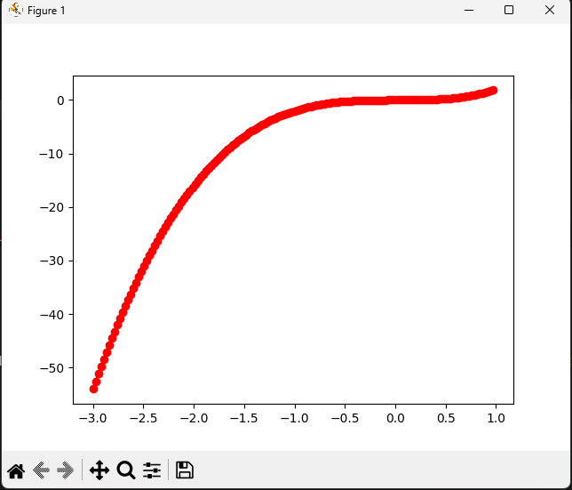

Problem 2

def find_Pythagorean(n):
triples = []

c = 0.0 # declare c
float(c) # make c a float

for a in range(1, n+1):
for b in range(1, n+1):
print(a, b, c)
c = (a**2 + b**2)**0.5
if c.is_integer(): # if c is a whole number
triple_tuple = (a, b, c)
triples.append(triple_tuple)

return triples

n = int(input("input n: "))
print(find_Pythagorean(n))

Problem 3
def find_dup_str(s:str, n):
for i in range (len(s) - 2*n + 1): # only searches through the length where there could be a possible duplicate after
substr = s[i: i + n] # substring of length n beginning with i
searchstr = s[i + n:] # the rest of the string after the substring
if substr in searchstr:
return substr
return ""

s = input("enter string: ")
n = int(input("enter length of duplicate to find: "))
print(find_dup_str(s, n))

def find_max_dup(s):
for n in reversed(range(2, len(s)//2 + 1)): # starting at the highest posiible length of duplicate
found = find_dup_str(s, n)
if found != "": #if a duplicate is found
return found
return found

s = input("enter string: ")
print(find_max_dup(s))

Problem 4
import numpy as np
import matplotlib.pyplot as plt
import math

def plot_function(fun_str:str, domain:tuple, ns:int):
step = (domain[1] - domain[0]) / (ns - 1)
xs = []
ys = []
for x in np.arange (domain[0], domain[1] + step, step):
xs.append(x)
y = eval(fun_str)
ys.append(y)
print ('{:>10s}{:>10s}'.format("x", "y"))
print("-"*20)
for i in range (ns):
print('{:>+10.4f}{:>+10.4f}'.format(xs[i], ys[i]))

# create plot
plt.plot(xs, ys, "ro-") # creates the graph figure, but does not show it yet
plt.xlabel("x")
plt.ylabel("y")
plt.title(fun_str)
plt.show()

fun_str = input("Enter function with variable x: ")
ns = int(input("Enter number of samples: "))
xmin = float(input("Enter xmin: "))
xmax = float(input("Enter xmax: "))
domain = (xmin, xmax)
plot_function(fun_str, domain, ns)

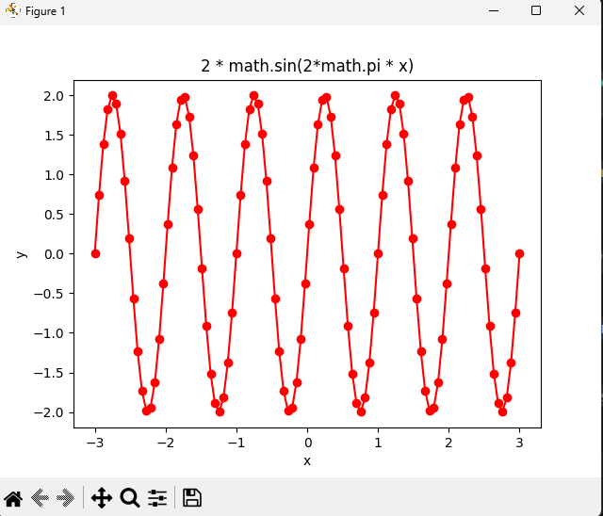

Problem 5
p5_Bernstein_Gigi.py
def caesar_cipher(text, shift):
"""Shift each alphabetic character by a given number of positions."""
result = []
shift = shift % 26

for char in text:
if char.isalpha():
start = ord('A') if char.isupper() else ord('a')
offset = ord(char) - start
new_offset = (offset + shift) % 26
result.append(chr(start + new_offset))
else:
result.append(char)

return "".join(result)

def caesar_decipher(cyphertext, shift):
"""Decrypt a Caesar-ciphered string by shifting backward."""
return caesar_cipher(cyphertext, -shift)

def letter_frequency(text):
"""Return the count of each letter from a to z in the given text."""
counts = {chr(ord('a') + i): 0 for i in range(26)}

for char in text:
if char.isalpha():
letter = char.lower()
counts[letter] += 1

return counts

def main():
while True:
print("\nCaesar Cipher Menu")
print("1. Encrypt and analyze a message")
print("2. Decrypt a message")
print("3. Exit")

choice = input("Choose an option: ").strip()

if choice == "1":
message = input("Enter a message: ")
shift = int(input("Enter a shift value: "))

encrypted = caesar_cipher(message, shift)
frequencies = letter_frequency(message)
decrypted = caesar_decipher(encrypted, shift)

print("\nEncrypted text:", encrypted)
print("Letter frequency:")
for letter, count in frequencies.items():
if count > 0:
print(f" {letter}: {count}")
print("Decrypted text:", decrypted)

elif choice == "2":
message = input("Enter the encrypted message: ")
shift = int(input("Enter the shift value: "))
original = caesar_decipher(message, shift)
print("\nOriginal text:", original)

elif choice == "3":
print("Goodbye!")
break

else:
print("Invalid choice. Please choose 1, 2, or 3.")

if __name__ == "__main__":
main()

p5_Bernstein_Gigi_test.py
import unittest

from p5_Bernstein_Gigi import caesar_cipher, caesar_decipher, letter_frequency

class TestCaesarCipher(unittest.TestCase):
def test_caesar_cipher_preserves_spaces_and_case(self):
text = "Hello, World!"
result = caesar_cipher(text, 3)
self.assertEqual(result, "Khoor, Zruog!")

def test_caesar_decipher_recovers_original_text(self):
encrypted = "Khoor, Zruog!"
result = caesar_decipher(encrypted, 3)
self.assertEqual(result, "Hello, World!")

def test_letter_frequency_ignores_case_and_non_letters(self):
text = "Hello, World!"
expected = {
"a": 0, "b": 0, "c": 0, "d": 1, "e": 1, "f": 0, "g": 0,
"h": 1, "i": 0, "j": 0, "k": 0, "l": 3, "m": 0, "n": 0,
"o": 2, "p": 0, "q": 0, "r": 1, "s": 0, "t": 0, "u": 0,
"v": 0, "w": 1, "x": 0, "y": 0, "z": 0,
}
self.assertEqual(letter_frequency(text), expected)

if __name__ == "__main__":
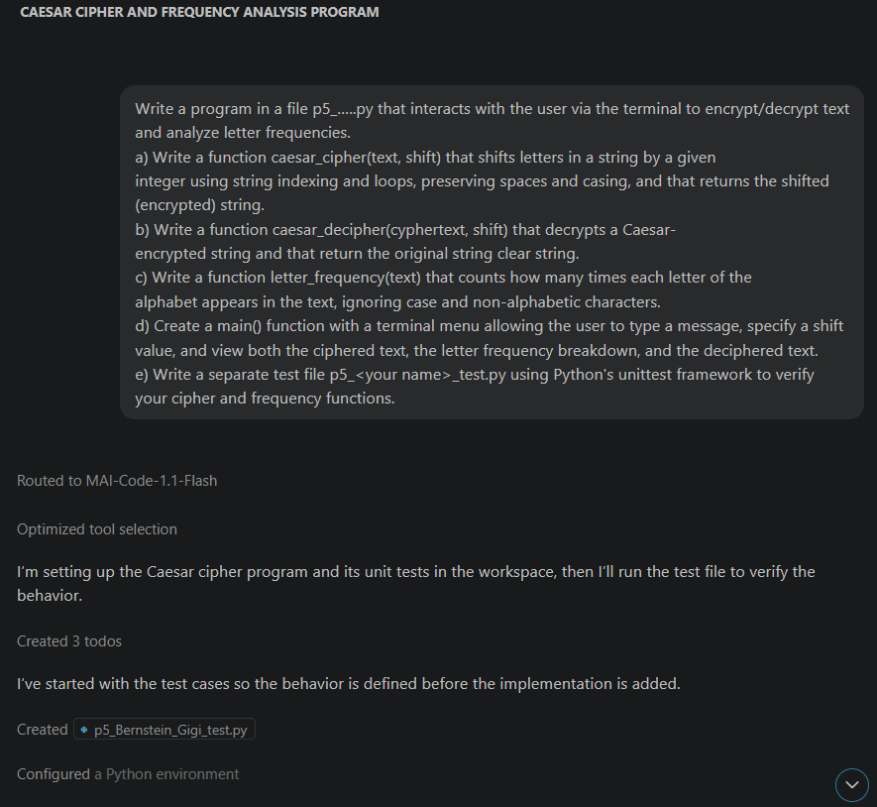
unittest.main()
