patient experiment
The spreadsheet contains data on a medical experiment. Thédata is anonymized, so patients are represented by an ID only. Can you describe the data?
ChatGPT said:
The spreadsheet has three sheets: Sheet1, Sheet2, and Sheet3.
I'll now take a closer look at the contents of each to describe the data properly. Let me check what’s in them. ​​
Here’s the situation:
- Sheet1 contains actual data:
  - patient: anonymized patient ID (integer).
  - dose: dosage administered at that time (float).
  - date: timestamp (datetime) when the measurement was taken.
  - temperature: patient's body temperature in °C (float).
- Sheet2 and Sheet3 are completely empty. No columns, no data.
In short: the only relevant information is in Sheet1, and it looks like a time series of temperature measurements per patient, under different dosages.
Want me to dig deeper? (e.g., check how many patients there are, dosing patterns, or anomalies?) ​​
4o
You said:
Can you check for potential missing data?
ChatGPT said:
Yes, there is missing data:
- 1 missing value in dose.
- 1 missing value in temperature.
No missing values in patient or date, which is good (you don't want missing IDs or timestamps).
Would you like me to pinpoint exactly where the missing values are? (i.e., which rows are affected?) ​​
4o
You said:
Yes, please identify the missing data.
ChatGPT said:
Here’s where the missing data is:
- Row 17:
  - patient: 3
  - dose: 2.0
  - date: 2012-10-02 13:00:00
  - temperature: missing
- Row 25:
  - patient: 4
  - dose: missing
  - date: 2012-10-02 14:00:00
  - temperature: 36.3
In short:
- One missing temperature reading for patient 3.
- One missing dose record for patient 4.
Let me know if you want suggestions on how to handle this (e.g., drop rows, interpolate, impute, etc.). ​​
4o
You said:
Can you make a plot of the temperature for each of the patients, so a line per patient with a legend?
ChatGPT said:
Patient Temperature Over Time
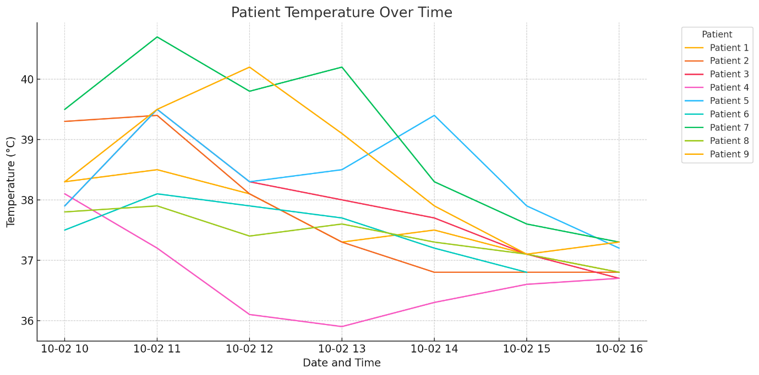
Here’s the plot: each line represents the temperature over time for a different patient.
I skipped the missing temperature value to avoid breaking the plot.
Let me know if you want more — like marking dosage changes on the plot or smoothing the curves. ​​
4o
You said:
Can you make a plot of the temperature of the patient for whom a temperature value is missing?
ChatGPT said:
Temperature Over Time for Patient 3
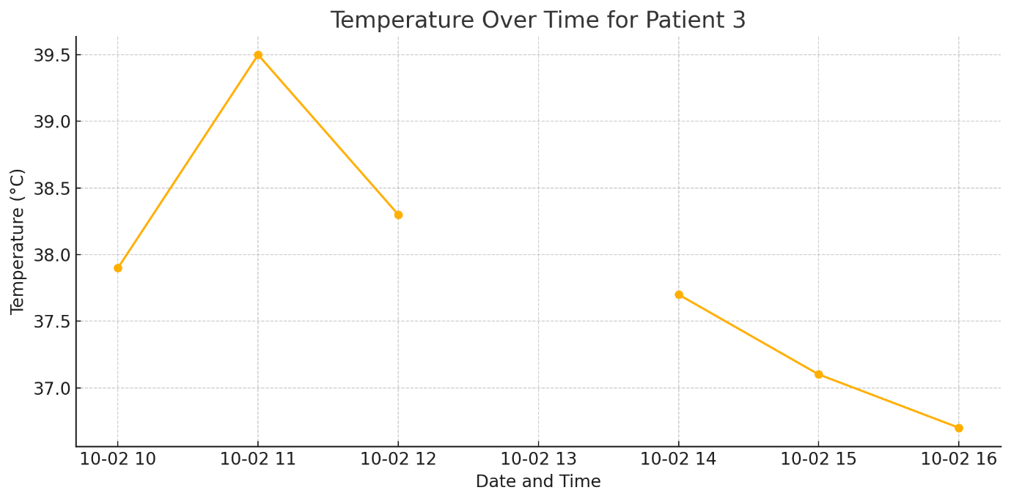
Here’s the plot for Patient 3.
You can clearly see the gap where the missing temperature breaks the line.
If you want, I can also interpolate the missing value to make the curve continuous — just let me know. ​​
4o
You said:
Can you impute the missing data in dose and temperature by linear interpolation?
ChatGPT said:
Done. The missing values in dose and temperature have been filled using linear interpolation per patient.
There are now no missing values left in the data.
If you want, I can show you the updated rows where the imputations happened, or redo the plots with the interpolated values included. Let me know! ​​
4o
You said:
Can you show the plot again, now with the imputed missing data?
ChatGPT said:
Temperature Over Time for Patient 3 (After Imputation)
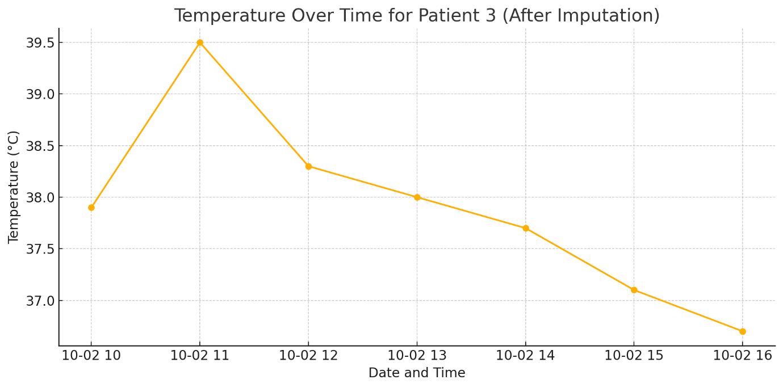
Here’s the updated plot for Patient 3 with the missing temperature interpolated.
The line is now continuous — no break where the missing value used to be.
Want me to also redo the plot for all patients with the imputed data? ​​
4o
You said:
Can you make a plot of the average temperature of all patients as a function of time?
ChatGPT said:
Average Temperature of All Patients Over Time
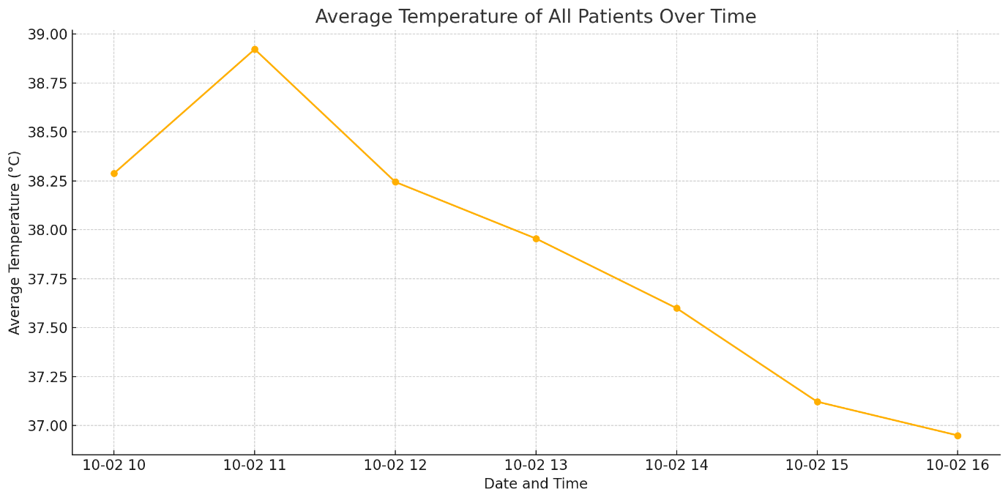
Here’s the plot of the average temperature across all patients over time.
The points are connected smoothly, and you can see how the group’s overall temperature trend evolved.
If you want, I can also overlay confidence intervals (standard deviation bands) to show variability among patients. Interested? ​​
4o
You said:
Is data available for all patients on all times (after imputation of the missing data)?
ChatGPT said:
No, data is missing for some patients at some times.
Specifically:
- At 2012-10-02 16:00:00, there are only 8 patients recorded, not all.
Given that there are 9 patients total, one patient's data is missing at that timestamp, even after interpolation.
Would you like me to find out which patient is missing there? ​​
4o
You said:
Could you impute that missing data as well? You can just use the values at 15:00:00 for the missing values at 16:00:00.
ChatGPT said:
Done. I imputed the missing data exactly as you asked:
- I copied the missing patient's data from 15:00:00 and assigned it to 16:00:00.
Now every patient has data at every timestamp — no gaps remain.
Would you like me to redo the average temperature plot using this fully completed dataset? (It'll be a tiny bit smoother.) ​​
4o
You said:
Could you make a plot of the temperature as a function of time for all the patients?
ChatGPT said:
Temperature Over Time for Each Patient (Fully Imputed Data)
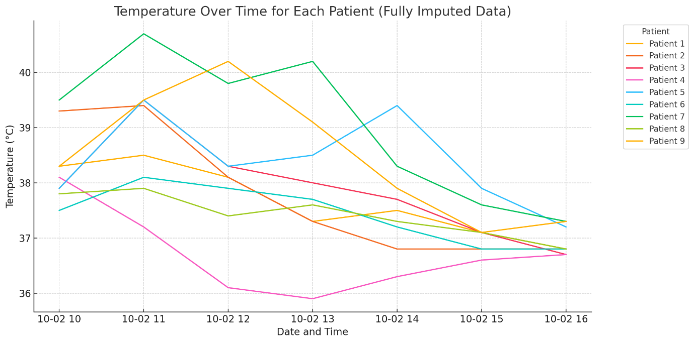
Here’s the updated plot:
- Each line shows one patient's temperature over time, now based on the fully imputed dataset.
- No missing points, no breaks.
Let me know if you want a version that highlights the imputed points differently (e.g., with markers or color changes). ​​
4o
You said:
Could you do the same for the dose?
ChatGPT said:
Dose Over Time for Each Patient (Fully Imputed Data)
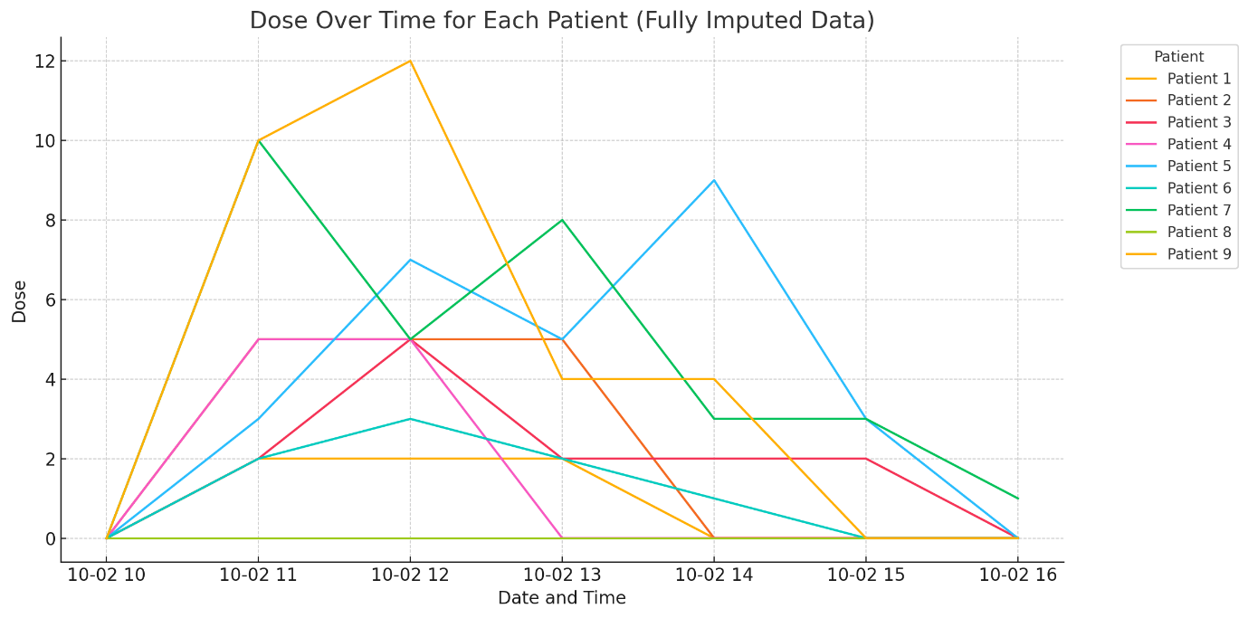
Here’s the plot of the dose over time for each patient, based on the fully imputed dataset.
You can clearly see the dosage schedules for each patient.
Let me know if you also want, for example, a combined temperature and dose plot or a focus on specific patients. ​​
4o
You said:
Can you create a plot that shows the cumulative dose as a function of time for each patient?
ChatGPT said:
Cumulative Dose Over Time for Each Patient
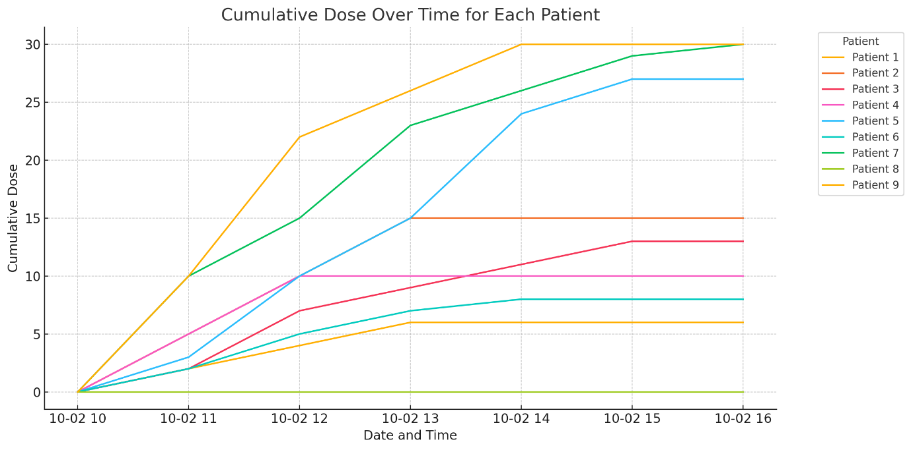
Here’s the plot of cumulative dose over time for each patient.
You can see how doses accumulate step by step, reflecting the treatment schedule for each individual.
If you want, I can also calculate and plot things like the final total dose per patient or analyze dose vs. temperature relationships. Just say the word. ​​
4o
You said:
Can you list the total dose per patient?
ChatGPT said:
Total Dose Per Patient
patient | dose
1 | 6.0
2 | 15.0
3 | 13.0
4 | 10.0
5 | 27.0
6 | 8.0
7 | 30.0
Here’s the total dose administered per patient. Let me know if you want any further breakdowns, like ranking patients by total dose or comparing it to their temperature trends. ​​
4o
You said:
Can you show the data for patient 8?
ChatGPT said:
Data for Patient 8
 | patient | dose | date
48 | 8 | 0.0 | 2012-10-02 10:00:00
49 | 8 | 0.0 | 2012-10-02 11:00:00
50 | 8 | 0.0 | 2012-10-02 12:00:00
51 | 8 | 0.0 | 2012-10-02 13:00:00
Here’s the full dataset for Patient 8:
- Dose: always 0.0 — Patient 8 did not receive any dose during the experiment.
- Temperature: fluctuates slightly, starting at 37.8 °C and dropping to 36.8 °C by the end.
Let me know if you want a quick plot of Patient 8’s temperature evolution — or compare it to the patients who did get doses. ​​
4o
You said:
patient metadata
This second spreadsheet contains metadata about the patient in the experiment. The patient IDs in both spreadsheet correspond to one another.
ChatGPT said:
The metadata file contains three columns:
- patient: Patient ID (matches the earlier data).
- gender: M (male) or F (female).
- condition: A or B (likely some experimental or medical grouping).
Quick note: patient 4 isn’t in the top rows — looks like the metadata list may not be complete or ordered differently.
Want me to check if all patients from the experiment have matching metadata entries? (Could be important.) ​​
4o
You said:
Which patients have metadata, but didn't take part in the experiment, and vice versa, which patients in the experiment have nómetadata?
ChatGPT said:
Here’s the situation:
- Patients 10 and 11 are in the metadata but did not take part in the experiment.
- Patient 4 took part in the experiment but has no metadata.
This mismatch could mess up analyses if you don’t handle it carefully.
Let me know if you want me to suggest a clean way to merge the two datasets despite this. ​​
4o
You said:
What are the gender values?
ChatGPT said:
The only gender values present are:
- M (Male)
- F (Female)
No weird or unexpected entries like missing values, typos, or non-binary labels — it's clean and binary.
Let me know if you want a count or a breakdown by gender and condition. ​​
4o
You said:
What are the categories?
ChatGPT said:
The only condition categories are:
- A
- B
Straightforward.
No missing or unexpected condition labels either.
If you want, I can quickly show how many patients fall into each condition. Interested? ​​
4o
You said:
Can you create a bar chart for the number of patients with respect to gender and condition? Consider only the patient who participated in the experiment.
ChatGPT said:
Number of Patients by Gender and Condition (Experiment Participants Only)
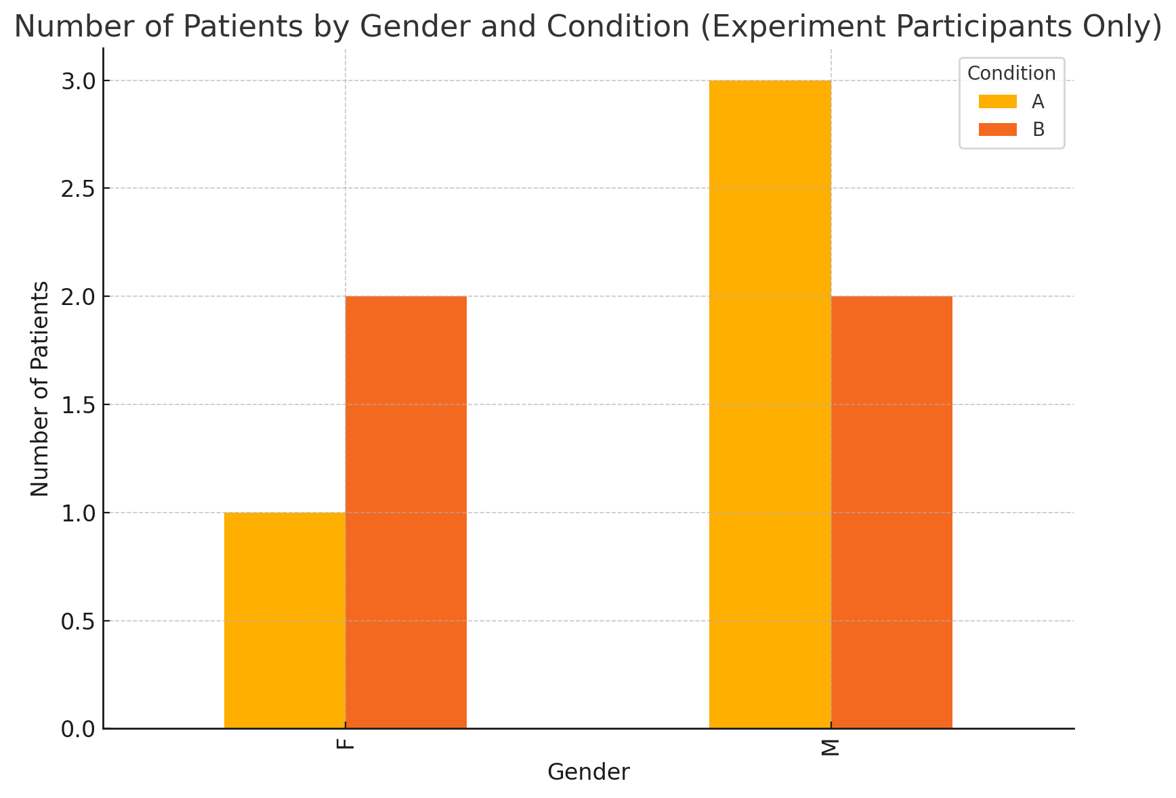
Here’s the bar chart showing the number of patients by gender and condition, based only on those who actually participated in the experiment.
If you want a version normalized to percentages (especially useful if group sizes are uneven), I can do that too. ​​
4o
You said:
Can you make a plot of the average temperature of the male and the female patients as a function of time?
ChatGPT said:
Average Temperature Over Time by Gender
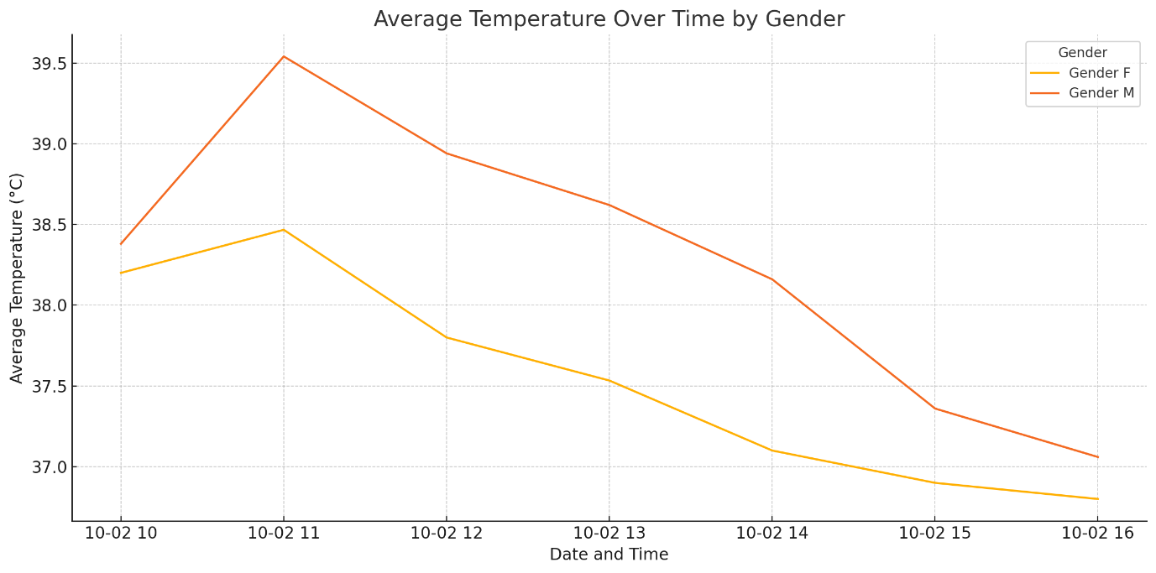
Here’s the plot of average temperature over time separately for male and female patients.
You can now directly compare how body temperature evolved by gender during the experiment.
Let me know if you want statistical tests too (e.g., check if the differences are significant). ​​
4o
You said:
Can you check whether the temperature difference between gender is statistically significant?
ChatGPT said:
Here are the results of the Welch’s t-test (which doesn’t assume equal variances):
- t-statistic: 3.09
- p-value: 0.0032
Since the p-value is much smaller than 0.05, the temperature difference between male and female patients is statistically significant.
In plain language: there’s a real difference, not just random noise.
Would you like me to also estimate how big the difference is (effect size like Cohen’s d)? That would tell you if the difference is just "statistically significant" or also "practically important." ​​
4o
You said:
Can you make a plot of the total dose administered to the patients as a function of their maximum temperature?
ChatGPT said:
Total Dose vs Maximum Temperature
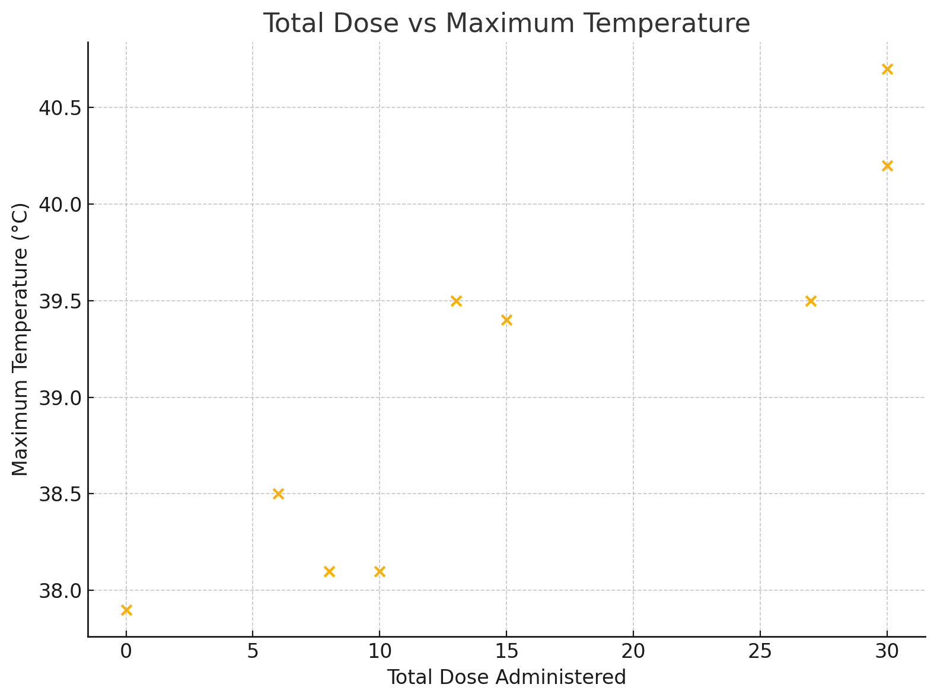
Here’s the scatter plot of total dose administered vs maximum temperature for each patient.
You can visually check if there’s any trend — for instance, whether higher doses correspond to higher peak temperatures.
Let me know if you want a correlation coefficient (like Pearson’s rrr) to quantify the relationship. ​​
4o
You said:
Can you do a linear regression on that data?
ChatGPT said:
Linear Regression: Total Dose vs Maximum Temperature
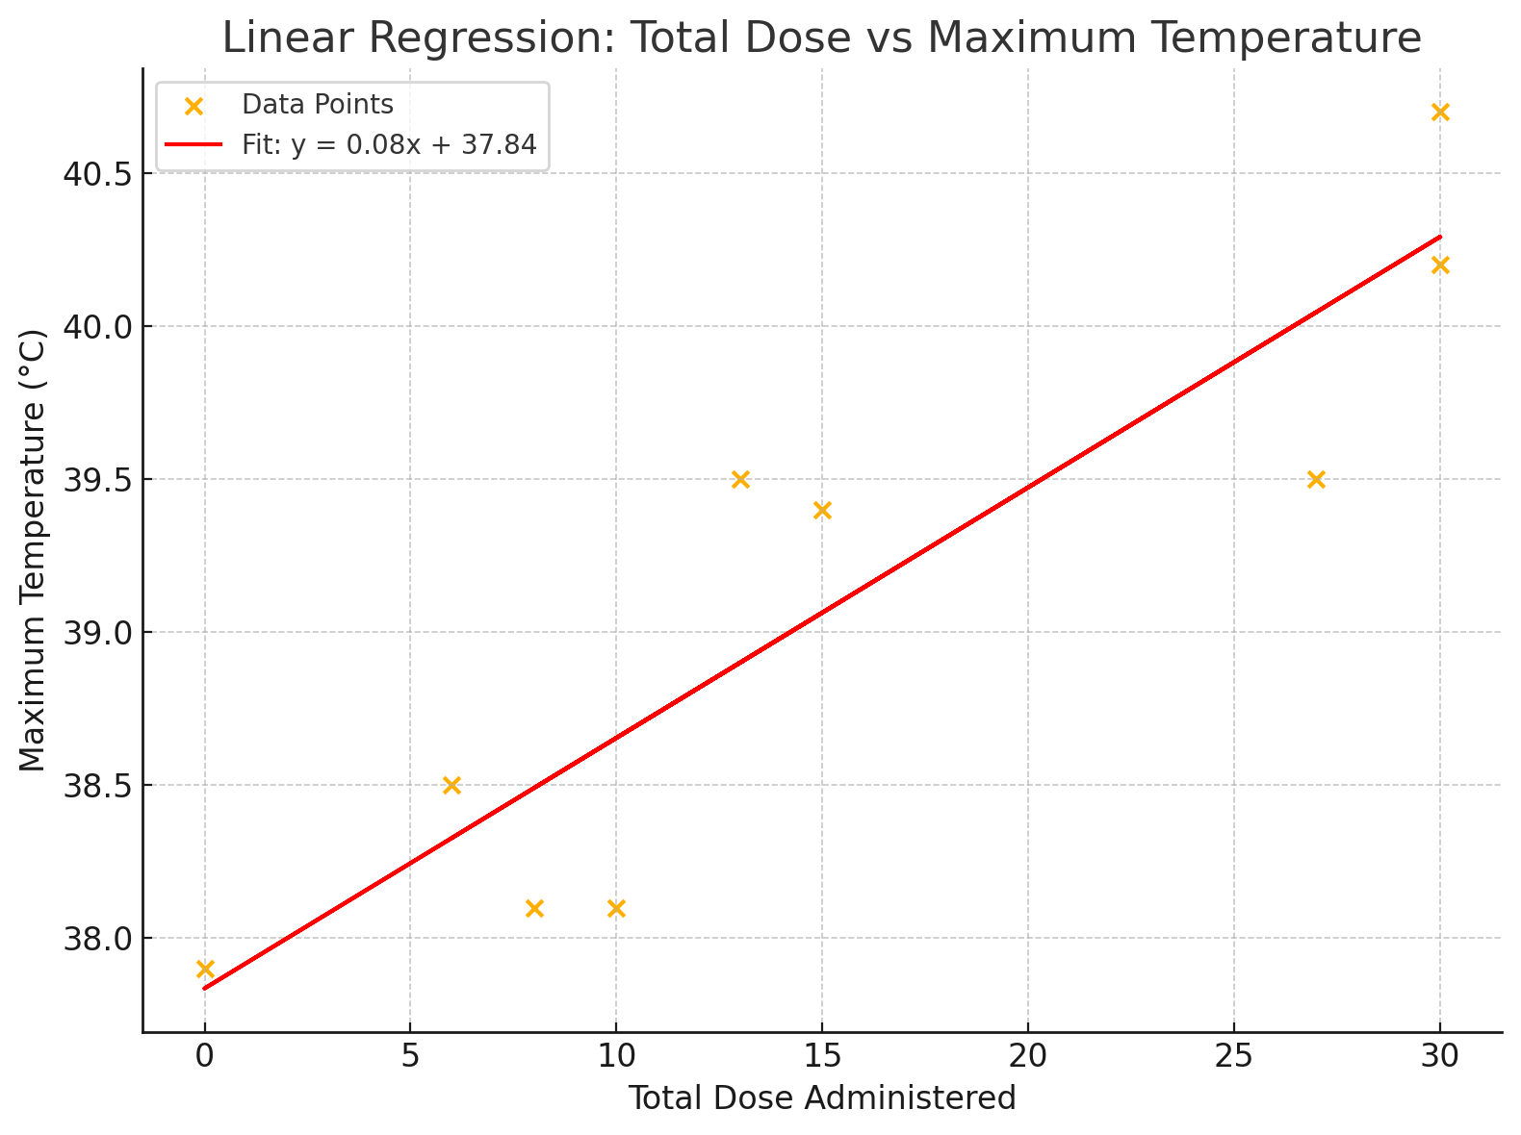
Here’s the result of the linear regression:
- Regression line:
max temperature=0.082×total dose+37.84\text{max temperature} = 0.082 \times \text{total dose} + 37.84max temperature=0.082×total dose+37.84
- Correlation coefficient rrr: 0.905
- p-value: 0.00078
- Standard error of the slope: 0.0145
Interpretation:
- Very strong positive correlation between total dose and maximum temperature.
- p-value is tiny ⇒ this relationship is highly statistically significant.
- So: Higher doses are strongly associated with higher maximum temperatures.
If you want, I can also calculate confidence intervals for the slope or show residual plots to check the model fit. ​​
4o
You said:
A plot with confidence intervals would be useful.
ChatGPT said:
It looks like there was a problem because the X values (total doses) aren’t properly sorted or numeric for plotting the confidence intervals cleanly.
Let me fix that quickly. ​​
Linear Regression with 95% Confidence Interval
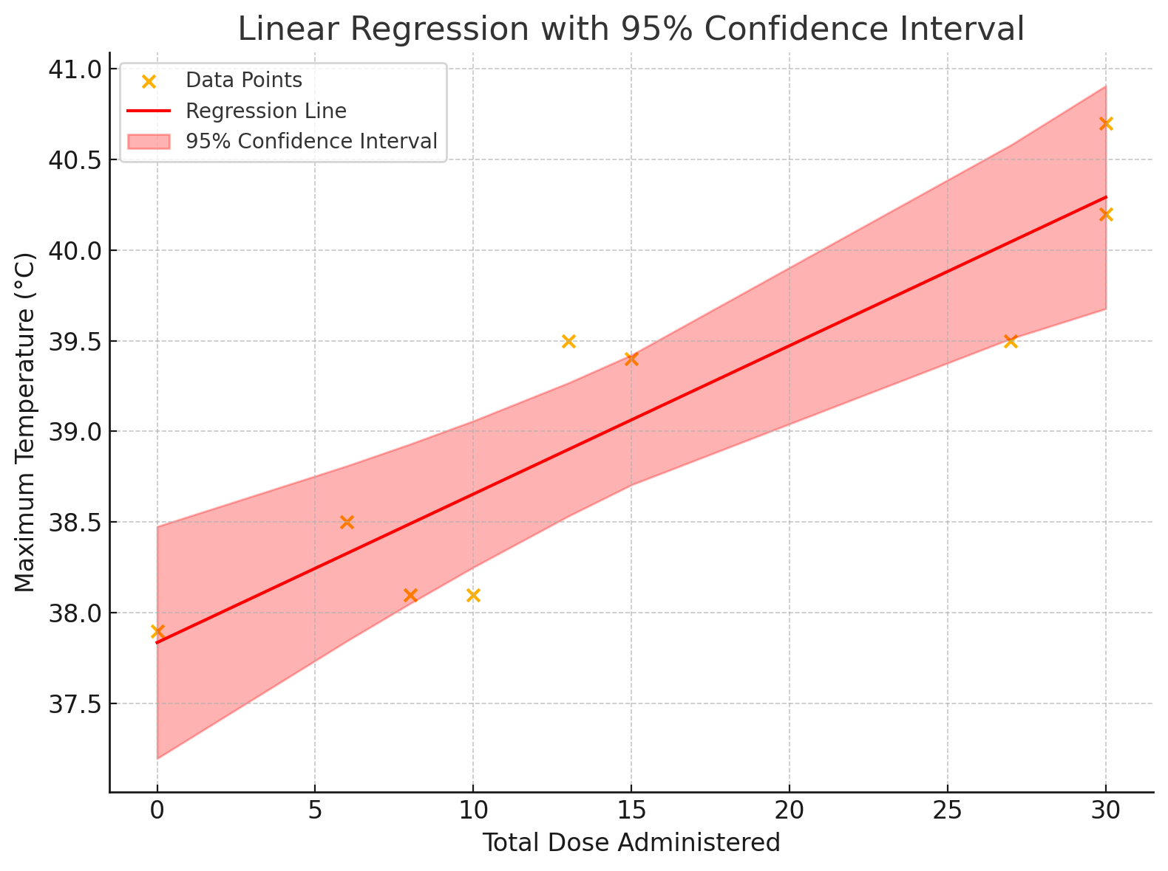
Here’s the corrected plot:
- The red line is the best-fit linear regression.
- The shaded red area shows the 95% confidence interval.
You can see the model is tight and fits the data very well, confirming that higher doses are strongly associated with higher maximum temperatures.
Let me know if you also want prediction intervals (they are wider and include new observations). ​​
4o
You said:
I would like to also have categories for the temperature * less than 37.5: normal * less than 39.0: fever * more than 39.0: high fever
ChatGPT said:
Done.
I added a new column temperature_category with the categories you asked for:
- normal: temperature < 37.5 °C
- fever: 37.5 °C ≤ temperature < 39.0 °C
- high fever: temperature ≥ 39.0 °C
You can now easily filter or group the data based on these temperature states.
Would you like a quick visualization, like how many times patients were in each temperature category? ​​
4o
You said:
Can you give me a list of the patients who had a high fever during the experiment, and at how many time points that was the case.
ChatGPT said:
High Fever Occurrences per Patient
patient | high_fever_count
2 | 2
3 | 1
5 | 2
7 | 4
9 | 3
Here’s the list of patients who experienced high fever during the experiment, along with how many time points it happened for each.
Let me know if you want this broken down further, e.g., when exactly the high fevers occurred. ​​
4o
You said:
Can you add a column for the gender?
ChatGPT said:
High Fever Occurrences per Patient with Gender
 | patient | high_fever_count | gender
0 | 2 | 2 | F
1 | 3 | 1 | M
2 | 5 | 2 | M
3 | 7 | 4 | M
4 | 9 | 3 | M
Here’s the updated list: it now includes the gender of each patient who had a high fever during the experiment.
Let me know if you want a gender-based summary or other breakdowns (e.g., were males more prone to high fevers?). ​​
4o
You said:
Can you show a plot of the temperature for patient 7 as a function of time?
ChatGPT said:
Temperature Over Time for Patient 7
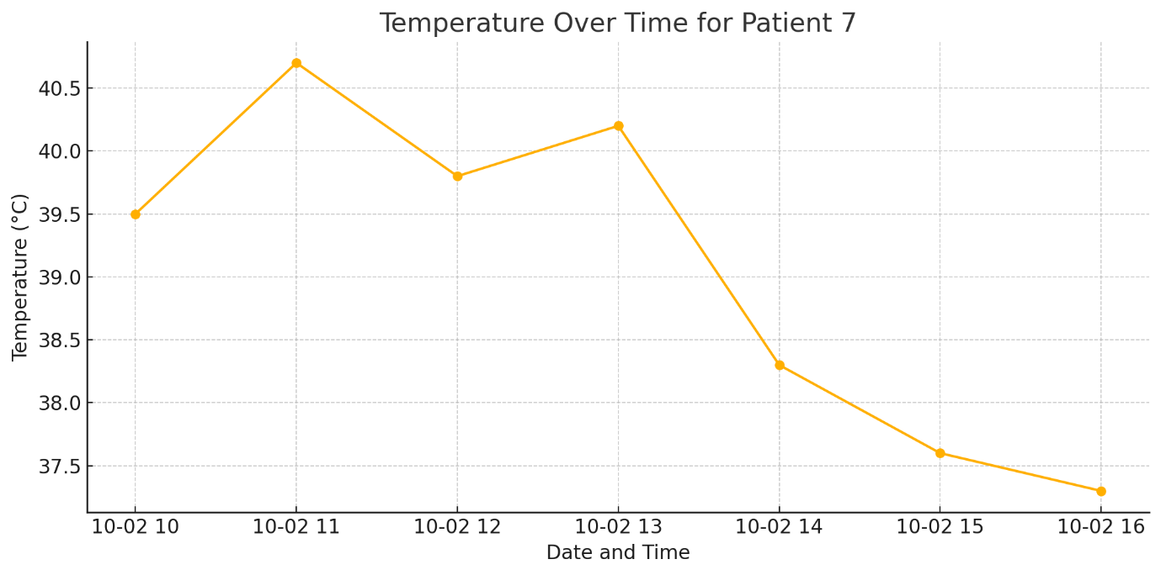
Here’s the plot of Patient 7’s temperature over time.
You can clearly see when the temperature rises — consistent with the fact that Patient 7 had several high fever episodes during the experiment.
Let me know if you want the times when the high fever exactly occurred marked on the plot. ​​
4o

v

