GrayNorm Algorithm

An experiment E checks a number of conditions N_{c}. For each condition C, the expression level of a set of genes G is determined, with N_{g} the number of genes. In order to make the experiment more robust, multiple biologically independent samples are created for each condition. Although there may be missing data, we assume that, for each of the N_{s} samples per condition, and for each condition C, the same set of N_{g} genes is monitored. Hence, a sample is basically a list of gene expression levels, e_{g}, where g denotes the gene index. Further, the gene expression levels can be ordered into a three-dimensional matrix with the first index c running over the conditions, the second s over the samples in a condition, and the third g over the genes, i.e., e_{c,s,g} denotes the expression of gene g under experimental condition c in sample s.
Formally:
Some of the conditions are controls, we denote this set by , and it is a proper subset of . Note that the conditions each have samples associated with them. Hence, the total number of control samples is given by .
Although the set of genes G considered for the purpose of normalization should include candidate normalization genes G_{CN}, one may wish to evaluate genes of interest G_{I} for their use in normalization as well, hence:
Thus, all genes can be considered candidate normalization genes, i.e., .
We consider all subsets of the set of candidate normalization genes, and select the optimal subset according to the algorithm described below. This optimal subset will be referred to as the set of normalization genes G_{N}. To determine this set, we first perform the following computation for each subset of the candidate normalization genes . Note that the total number of these subsets is given by:
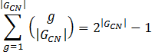
Although this number increases exponentially with the number of candidate normalization genes, this is computationally quite feasible for the size of the experiments we consider in this setting.
First, we compute the inverse geometric mean of the expression values of the genes for each sample (i.e. the inverse normalization factor per sample),
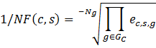
For which the average for the samples of the control group is given by
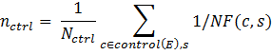
This value is used to normalize the , i.e,. we consider
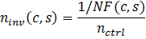
For each condition c the mean, standard deviation and standard error over its corresponding samples is computed, as well as , i.e.,

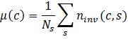
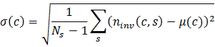
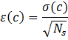
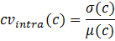
Note that corresponds to the average 1/NF for condition c, and to the standard error, that are represented in Figures 1 and 2, and that for the control condition equals 1.
Based on these values for each of the conditions, the overall statistics can be computed, i.e.,

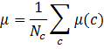
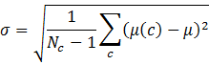
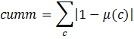
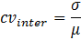
To provide the researcher with the maximum of information, the statistics for each candidate set are shown, ordered according to increasing . corresponds to the coefficient of variation of the 1/NFs averaged per condition, whereas corresponds to the cumulative deviation from 1.0 of the 1/NF averaged per condition. Although the set with the lowest value of will typically be selected as the normalization genes , the researcher may overrule this based on the provided metrics by sorting the table to a different statistic such as . The gene of interest expression data are then normalized by the geometric mean of G_{N} per sample, and the resolution is represented by and for each condition, with equal to 1 for the control condition.
Since the algorithm aims to identify the combination of reference genes that generally over all conditions yields the lowest deviation from 1 of the averaged 1/NF, thereby decreasing the “gray zone” of uncertainty, we propose to call this algorithm GrayNorm.

