Parking Friendly

Meeting Notes

horizontal line

14 September 2018/ 13:30 / North Town Coffee

# ATTENDEES

Gabriel Cabrera, Nicholas Greer, Michael Mogannam

# AGENDA

1. Agreed upon final project concept

## Last Meeting Follow-up

## New Business

* NodeJS - to run background server work
* React JS - to handle User Interface
* link to MMM book - <https://is.muni.cz/www/208322/The.Mythical.Man.Month.F.Brooks.pdf>

NOTES

* **building from the ground up except for..** multi state php from sharon
* **HSU color**, with black bold roboto font.
* **paypal**, for paying…. humboldtCoin(?)

# ACTION ITEMS

1. build a login screen - code from sharon for login
2. how to identify meter - ???
   1. mapped(visual representation) through the app && geolocated/geomapped through GPS, QR code sticker, number on meter, phone number to call through app if necessary
   2. back up through google maps(street view)?
3. build a map - ???
   1. how to sticker/ID parking meters || parking spots
4. Web page instead of app for now
   1. too many apps on phones
   2. can login and pay vs. downloading an app and then logging in and paying
   3. after web based is set up.. then perhaps develop an app.
5. web page should send text messages to give timer heads up, and ability to pay for extra time, if needed.

**Database Setup**

**-login/sign up**

**-> password reset**

**-> create an account**

**- meter ID & amount**

# NEXT WEEK’S AGENDA

how much of the labs are contributing to the actual project?

is there a list of milestones that need to be completed or an outline of all the parts of the actual project that need to be accomplished, available?

**how to geo-tag each meter?**

finish USE CASE Diagram begin working login page and username/password database

User logs in

Using app or webpage?

Prompt user for qr code or meter id

Qr code scanner and meter id options

Display info about metered space

Provide color coded map to show surrounding meters in area?

Input payment info

Paypal?

Interface for parking enforcement

Color coded parking map with time remaining display for individual spaces

Individual meter info for current and previous car

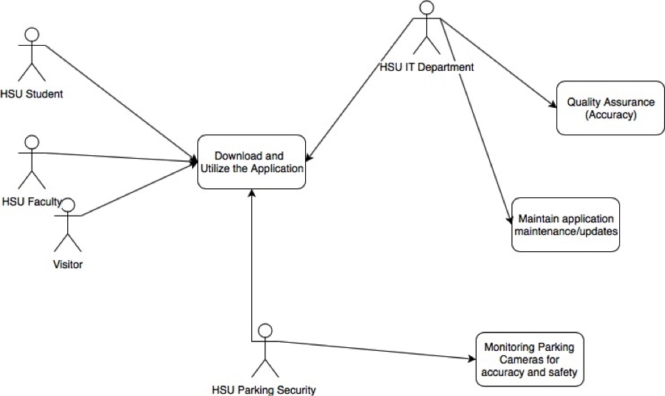

https://awwapp.com/b/uz6qoxjtq/