ME449 Final Project: youBot Simulation
Graham Clifford
12/7/2023

Introduction
This software is meant to plan a trajectory for the end-effector of the youBot mobile manipulator (a mobile base with four mecanum wheels and a 5Rrobot arm), perform odometry as the chassis moves, and perform feedback control to drive the youBot to pick up a block at a specified location, carry the block to a desired location, and put it down.

Explanation
The code starts by defining variables such as the initial configuration of the youBot, transformation matrices, screw axes, and other parameters.

The robot configuration is defined as:
chassis phi, chassis x, chassis y, J1, J2, J3, J4, J5, W1, W2, W3, W4, gripper state

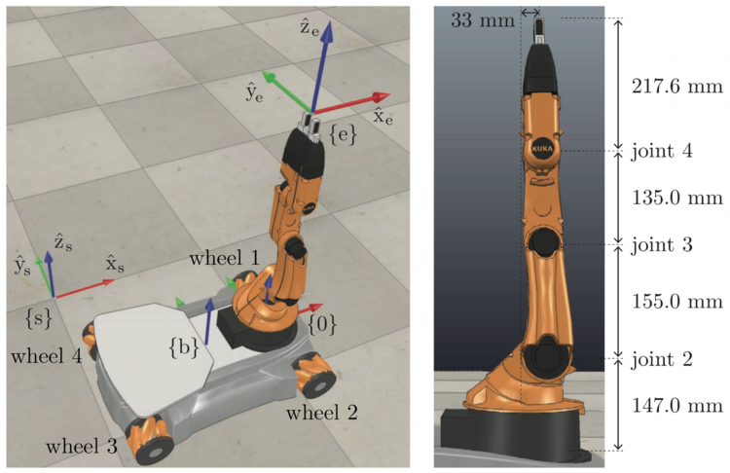Figure 1: The youBot robot arm at its home configuration, and the frames {s}, {b}, {0}, and {e}
CoppeliaSim is used to visualize the robot trajectory. To generate the trajectory, the first step is to generate the reference trajectory. This represents an ideal trajectory for the robot to follow to accomplish its goal of picking up and moving a block. After the reference trajectory is generated, the code begins to create the actual trajectory of the robot using task-space motion control as outlined in chapter 11.3.3 of the Modern Robotics textbook.

Results
The trajectory generated by my code allows the youBot to pickup the block and place it down at the goal location. The chassis does not turn to fully align with the block at either the initial or final location, but I believe this is because the control algorithm does not need to do this to accomplish the goal of moving the block. This is a small amount of jitter at the beginning of the simulation, which could potentially be avoided by picking better Kp and Ki parameters, or writing code to avoid joint limits and singularities. If I had more time, these are all things that I would do to improve the project.

