For each screen name
Note: Information provided in each subsection should provide sufficient information needed to run the test.
- Test Environment setup
The tests open the Kemyze web app in Google Chrome (using Selenium WebDriver) and log in to the live server at https://kemyze.vercel.app. Results can change if that server is updated after 11/6/2026, 9:49:49 PM.
The unit tests run with the server replaced by test data, so they do not need the internet.
Test account details are provided to the verifier separately. They are never stored in the repository or in this report.
- Test software used with version #'s
Software | Version
Node.js | v24.11.0
npm | 11.19.1
Google Chrome | 156.0.8078.74
ChromeDriver | 156.0.8078.80
jest | 29.7.0
jest-expo | 55.0.22
@testing-library/react-native | 14.1.0
selenium-webdriver | 4.51.0
expo | 55.0.32
react-native | 0.83.10
react | 19.2.0
- Test Environment operating system & version\build #
Windows 11 Home (Windows_NT 10.0.26300, x64)
- Any test git repo locations
Repository: https://github.com/gjhollmann/Kemyze.git
Commit tested: 8f79684e on branch main (2026-11-04 23:18:57 -0800)
Test script: frontEnd/acceptance/login.test.js
Test script: frontEnd/src/__tests__/index.test.tsx
Test script: frontEnd/src/utils/handleLogin.test.ts
  - How to pull test scripts
1. Get the code: git clone https://github.com/gjhollmann/Kemyze.git, then cd Kemyze, then git checkout 8f79684e, then cd frontEnd.
2. Run the tests: npm run tester
- Other important test setup procedures
You need Node.js and Google Chrome installed. npm run tester installs everything else, builds and starts the app, fills in the test accounts from db-testing/ec-users-testing.sql, and asks the Tester to pick their name from a list.
Before testing, it checks the app, the server and the test accounts, and prints "Environment ready". If something is missing, it stops and says what to fix.
The Tester and the Recorder work from separate computers. The Recorder watches the Tester's screen share for the whole run, then runs npm run record on their own computer to pick their name and record what they saw.
Each run saves the logs, screenshots, this document and a .tar.gz package in frontEnd/acceptance/results/.
No test changes live data or sends a real password reset email.

1.0 Login Screen: Screen Render
1.1 Brief Description of Test
Opens the app and checks that the login screen shows the Kemyze title, the Email address and Password fields, and the Log In, Forgot Password and QR Scanner Bypass buttons.
Test script: frontEnd/acceptance/login.test.js
1.2 Valid Test Inputs: description and value or sequence of values entered
Test ID | Description | Input (value or sequence entered) | Expected outcome | Actual outcome | Result | Date and time
AT-01 | The login screen renders all of its fields and buttons. | Open the app. | Kemyze title, Email address and Password fields, Log In, Forgot Password and QR Scanner Bypass are shown. | Confirmed: Kemyze title, Email address and Password fields, Log In, Forgot Password and QR Scanner Bypass are shown. | PASS | 11/6/2026, 9:51:37 PM
1.3 In-Valid Test Inputs: To test error handling/recovery
Not applicable: this test only opens the screen and takes no input.
Test Author
Joshua Zamora
1.4 Tester Name
Matthew Fronda
1.5 Recorder/Observer Name
Not assigned
1.6 Date Tested
11/6/2026
1.7 Results
Deviations from the test plan: Detected: the code had uncommitted changes.
1.7.1 Did it pass? PASS
Yes. AT-01 passed.
1.7.2 If not, include Jira/Other link – Strikethrough when resolved
Not applicable: every test passed.
Screenshots (the banner on each shows the test ID, PASS or FAIL, the date and time, and any message the app showed):
Figure AT-01: The login screen renders all of its fields and buttons. PASS
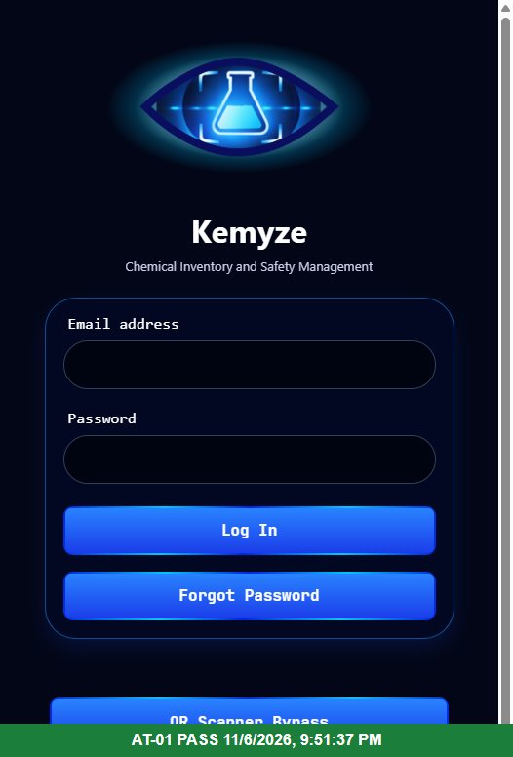

2.0 Login Screen: Log In
2.1 Brief Description of Test
Presses Log In with missing, wrong and correct credentials, and logs in once each as a Primary, Secondary and Tertiary user. Checks the messages shown, that a failed login stays on the login screen, and that a successful login goes to the QR Scanner with the Accounts tab for those access levels.
Test script: frontEnd/acceptance/login.test.js
2.2 Valid Test Inputs: description and value or sequence of values entered
Test ID | Description | Input (value or sequence entered) | Expected outcome | Actual outcome | Result | Date and time
AT-07 | Log In with the test account. | Email and password of the test account | The app leaves the login screen and goes to the scanner. | Confirmed: The app leaves the login screen and goes to the scanner. | PASS | 11/6/2026, 9:51:48 PM
AT-11 | Log In as a Primary user (access level 1). | Email and password of the Primary test account | The app goes to the scanner and the navigation bar shows the "Accounts" tab. | Confirmed: The app goes to the scanner and the navigation bar shows the "Accounts" tab. | PASS | 11/6/2026, 9:52:02 PM
AT-12 | Log In as a Secondary user (access level 2). | Email and password of the Secondary test account | The app goes to the scanner and the navigation bar shows the "Accounts" tab. | Confirmed: The app goes to the scanner and the navigation bar shows the "Accounts" tab. | PASS | 11/6/2026, 9:52:05 PM
AT-13 | Log In as a Tertiary user (access level 3). | Email and password of the Tertiary test account | The app goes to the scanner and the navigation bar shows the "Accounts" tab. | Confirmed: The app goes to the scanner and the navigation bar shows the "Accounts" tab. | PASS | 11/6/2026, 9:52:07 PM
2.3 In-Valid Test Inputs: To test error handling/recovery
Test ID | Description | Input (value or sequence entered) | Expected outcome | Actual outcome | Result | Date and time
AT-02 | Log In is pressed with no email or password. | Email: (empty), Password: (empty) | Browser alert "Missing email / Please enter your email." | Browser alert "Missing email / Please enter your email.", as expected. | PASS | 11/6/2026, 9:51:38 PM
AT-03 | Log In is pressed with an email but no password. | Email: user@csus.edu, Password: (empty) | Browser alert "Missing password / Please enter your password." | Browser alert "Missing password / Please enter your password.", as expected. | PASS | 11/6/2026, 9:51:38 PM
AT-06 | Log In with the test account email and a wrong password. | Email: test account, Password: wrong-password-for-acceptance-test | The user stays on the login screen. (The "Login Failed" message uses Alert.alert, which shows nothing on the web; the unit tests check it.) | Confirmed: The user stays on the login screen. (The "Login Failed" message uses Alert.alert, which shows nothing on the web; the unit tests check it.) | PASS | 11/6/2026, 9:51:45 PM
Test Author
Joshua Zamora
2.4 Tester Name
Matthew Fronda
2.5 Recorder/Observer Name
Not assigned
2.6 Date Tested
11/6/2026
2.7 Results
Deviations from the test plan: Detected: the code had uncommitted changes.
2.7.1 Did it pass? PASS
Yes. All 7 tests passed: AT-02, AT-03, AT-06, AT-07, AT-11, AT-12, AT-13.
2.7.2 If not, include Jira/Other link – Strikethrough when resolved
Not applicable: every test passed.
Screenshots (the banner on each shows the test ID, PASS or FAIL, the date and time, and any message the app showed):
Figure AT-02: Log In is pressed with no email or password. PASS
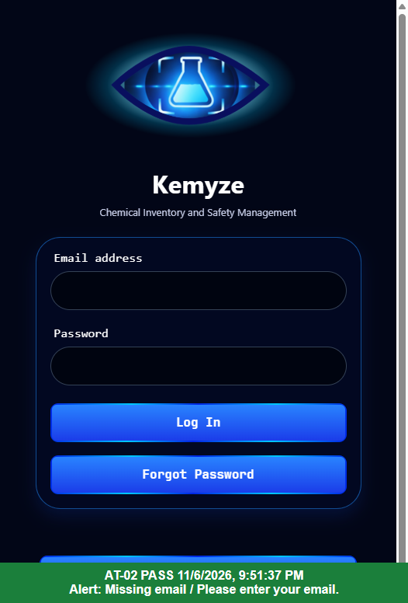
Figure AT-03: Log In is pressed with an email but no password. PASS
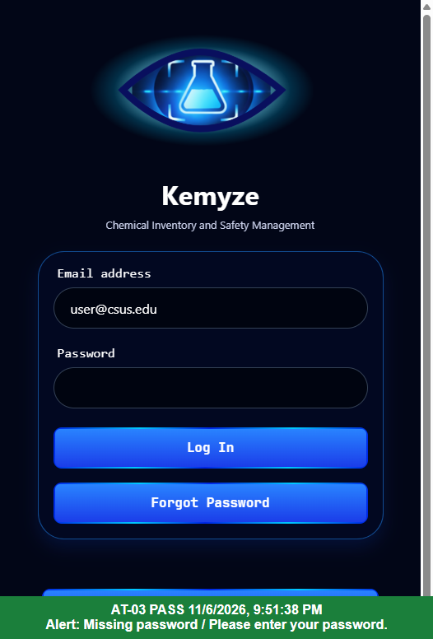
Figure AT-06: Log In with the test account email and a wrong password. PASS
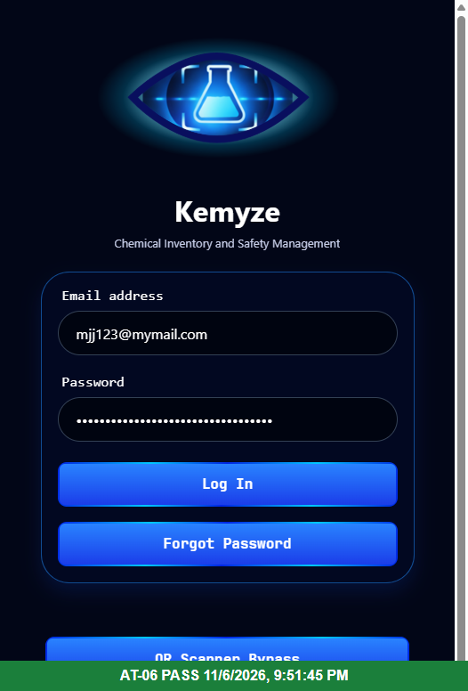
Figure AT-07: Log In with the test account. PASS
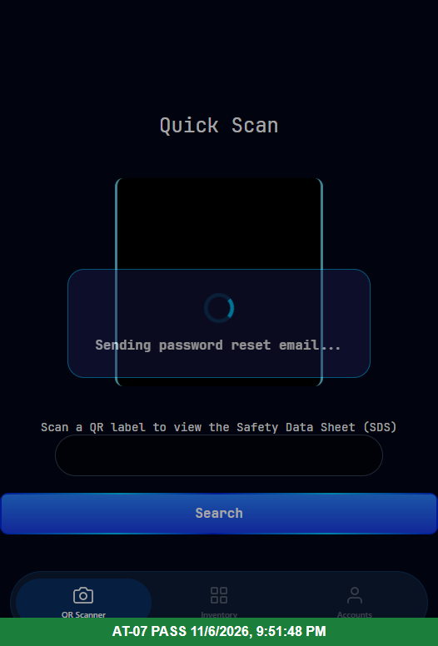
Figure AT-11: Log In as a Primary user (access level 1). PASS
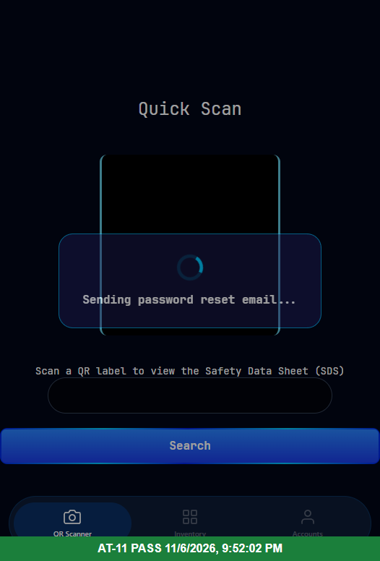
Figure AT-12: Log In as a Secondary user (access level 2). PASS
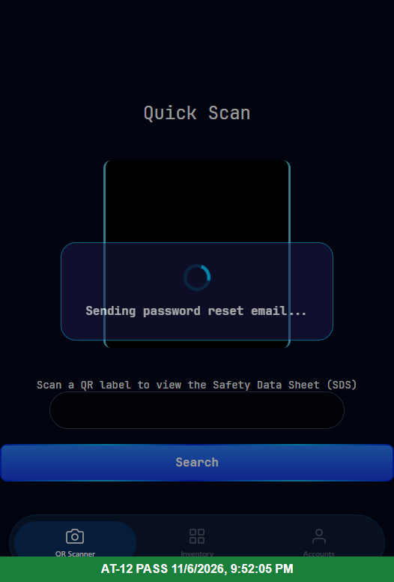
Figure AT-13: Log In as a Tertiary user (access level 3). PASS
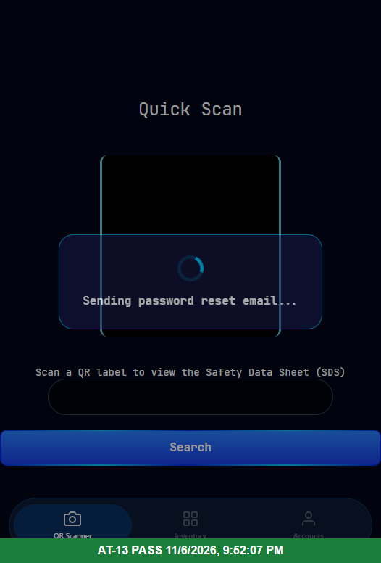

3.0 Login Screen: Forgot Password
3.1 Brief Description of Test
Presses Forgot Password with an empty and an invalid email, and with a valid email while the server answers with success, an error, or no answer. The server answers are simulated in the browser, so no real reset email is sent.
Test script: frontEnd/acceptance/login.test.js
3.2 Valid Test Inputs: description and value or sequence of values entered
Test ID | Description | Input (value or sequence entered) | Expected outcome | Actual outcome | Result | Date and time
AT-08 | Forgot Password with a valid email; the server answers that the email was sent. | Email: user@csus.edu; simulated server answer: 200 "Password reset email has been sent." | Browser alert "Success / Password reset email has been sent." No real email is sent. | Browser alert "Success / Password reset email has been sent.", as expected. | PASS | 11/6/2026, 9:51:49 PM
3.3 In-Valid Test Inputs: To test error handling/recovery
Test ID | Description | Input (value or sequence entered) | Expected outcome | Actual outcome | Result | Date and time
AT-04 | Forgot Password is pressed with an empty email. | Email: (empty) | Browser alert "Error / Please enter your email." | Browser alert "Error / Please enter your email.", as expected. | PASS | 11/6/2026, 9:51:39 PM
AT-05 | Forgot Password is pressed with an invalid email address. | Email: not-an-email | Browser alert "Error / Please enter a valid email address." | Browser alert "Error / Please enter a valid email address.", as expected. | PASS | 11/6/2026, 9:51:40 PM
AT-09 | Forgot Password when the server returns an error. | Email: user@csus.edu; simulated server answer: 400 "No account found with that email." | Browser alert "Error / No account found with that email." | Browser alert "Error / No account found with that email.", as expected. | PASS | 11/6/2026, 9:51:49 PM
AT-10 | Forgot Password when the server never answers. | Email: user@csus.edu; simulated server: no answer | After 10 seconds, browser alert "Error / Request timed out. Please try again." | Browser alert "Error / Request timed out. Please try again.", as expected. | PASS | 11/6/2026, 9:52:00 PM
Test Author
Joshua Zamora
3.4 Tester Name
Matthew Fronda
3.5 Recorder/Observer Name
Not assigned
3.6 Date Tested
11/6/2026
3.7 Results
Deviations from the test plan: Detected: the code had uncommitted changes.
3.7.1 Did it pass? PASS
Yes. All 5 tests passed: AT-04, AT-05, AT-08, AT-09, AT-10.
3.7.2 If not, include Jira/Other link – Strikethrough when resolved
Not applicable: every test passed.
Screenshots (the banner on each shows the test ID, PASS or FAIL, the date and time, and any message the app showed):
Figure AT-04: Forgot Password is pressed with an empty email. PASS
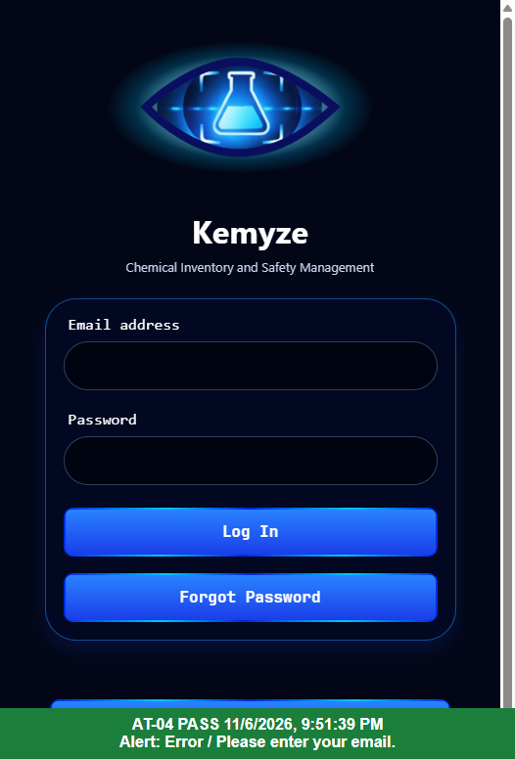
Figure AT-05: Forgot Password is pressed with an invalid email address. PASS
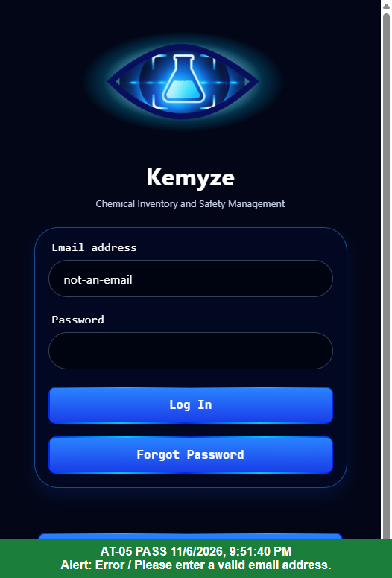
Figure AT-08: Forgot Password with a valid email; the server answers that the email was sent. PASS
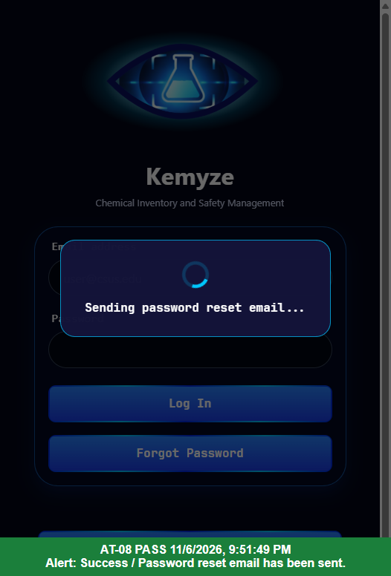
Figure AT-09: Forgot Password when the server returns an error. PASS
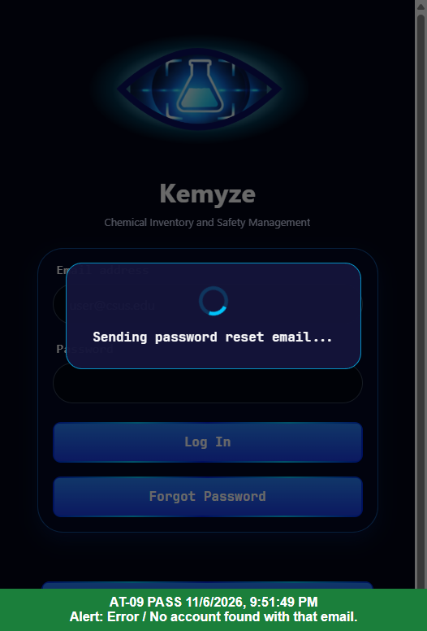
Figure AT-10: Forgot Password when the server never answers. PASS
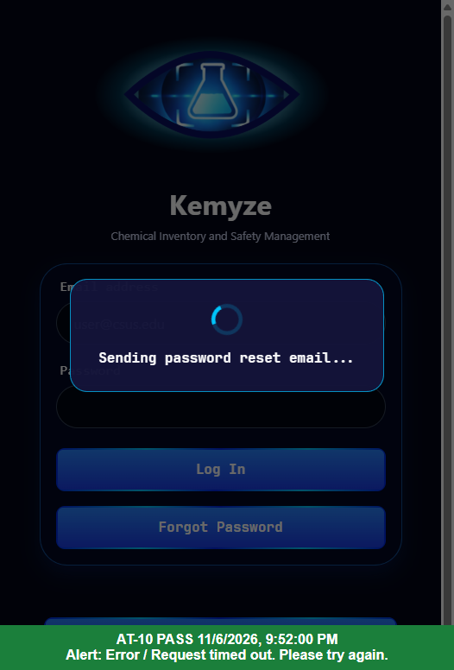

4.0 Automated Unit Tests (Jest and React Native Testing Library)
4.1 Brief Description of Test
Runs every unit test in the repository with npm test. The login tests call handleLogin, onPressLogin, handleForgotPassword and showPopup directly with the server mocked, and run as iOS.
Test script: frontEnd/src/__tests__/index.test.tsx
Test script: frontEnd/src/utils/handleLogin.test.ts
4.2 Valid Test Inputs: description and value or sequence of values entered
Correct email and password (server answers 200 with the user); valid email for Forgot Password (server answers success); login screen render.
4.3 In-Valid Test Inputs: To test error handling/recovery
Empty and whitespace email and password; invalid emails not-an-email, user@csus and user @csus.edu; server error response; request timeout; server unreachable.
Test Author
Joshua Zamora
4.4 Tester Name
Matthew Fronda
4.5 Recorder/Observer Name
Not assigned
4.6 Date Tested
11/6/2026
4.7 Results
Deviations from the test plan: Detected: the code had uncommitted changes.
4.7.1 Did it pass? PASS
Yes. UT-ALL passed.
4.7.2 If not, include Jira/Other link – Strikethrough when resolved
Not applicable: every test passed.

