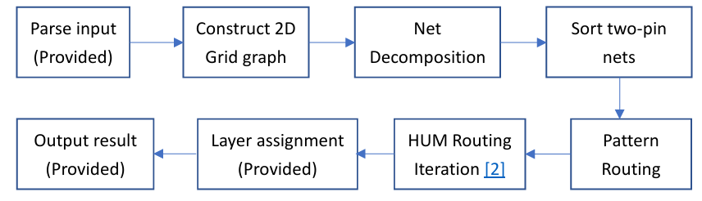
- Implement
  - Construct 2D Grid graph: Sum up cap in different layers.
  - Net Decomposition
    - <=9 pins: FLUTE
    - >=10 pins: minimum spanning tree
  - Sort two-pin nets: Sort by increasing order of HPWL().
  - Pattern Routing:
    - Same x or y: straight line
    - Other: upper or lower L shape
  - HUM routing: Implement as routing course 4-2.pdf
  - Cost function: nonlinear + history cost
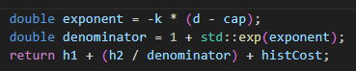
    - Nonlinear function
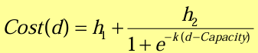
    - History cost = weight*(RipUp wire width + minSpace in curr Iter)

- Testcase
  - Adaptec5.gr: TOF:28, MOF:2
  - Newblue1.gr: TOF:22, MOF:4
  - newblue5.gr: TOF:2070, MaxOF=20
  - Other: no overflow

