The company we are designing our database for is YELP. YELP is an American multinational corporation that runs a website and a mobile app that provide information about local businesses. Through Yelp, users can look up businesses by category and location; for example, coffee shops in downtown Boston. In addition to basic information about the business, Yelp also provides user submitted reviews and photos to help them in their decision process.

Our team members: Jeffery Cui, Minh Ho, and Gianni Jiang.

The image below is a ‘pseudo’ simplified version of Yelp’s entity-relationship diagram. We assumed that:

* All the businesses are in the US; therefore, we did not include a field for “Country” in the business table.
* Users must be registered to submit reviews and photos.
* Business hours are the same for all days
* 1 to Many relationships:
  + A business has many reviews and photos
  + A user can submit many review and photos
  + A category can include many businesses

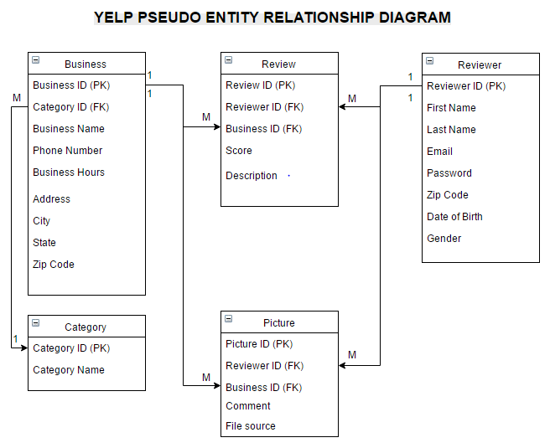 \*Picture – 1