Intro to Programming (Python)

Assignment 01

# Overview

In this activity, you will learn about creating and using python script.

This assignment will include the following tasks:

1. Watch the module videos.
2. Review some web pages.
3. Watch the external videos.
4. Apply your knowledge.
5. Document your knowledge.
6. Submit your work.

We are trying to answer the following questions:

* How is python used?
* What are some differences between python and operating system shell scripting?
* How do you run a python script from your desktop?
* How do you run a python script from a command shell?
* What is a console application?
* What is a python script?
* How do you know if python is working?
* Does the python code look different on different operating systems?

# Assignment Steps

The following assignment steps will ask you to read about programing, do some programing, write about what you did.

## Step 1- Watch the Module Videos

Please watch the following videos:

* Mod01-1-Module01 Overview
* Mod01-2-What Is Python
* Mod01-3-Console Applications
* Mod01-4-Programming Basics
* Mod01-5-Comments
* Mod01-6-Case Sensitivity
* Mod01-7-Functions
* Mod01-8-Chapter1 Review
* Mod01-9-Lab1 Starter
* Mod01-10-Lab1 Answer
* Mod01-11-Assignment01 Starter

All these can be found on my YouTube channel at:

<https://www.youtube.com/playlist?list=PLfycUyp06LG9OVfidlxwfjz7JYRhq83PN> (external site)

## Step 2 - Review the following web pages

Please review the following web pages:

1. <http://www.computerhope.com/jargon/m/msdos.htm> (external site)
2. <http://www.computerhope.com/issues/ch000619.htm> (external site)
3. <http://www.computerhope.com/batch.htm> (external site)

## Step 3 - Watch the following videos

1. Introduction to Batch files <https://youtu.be/rhV4L3T3BMc> (external site)
2. Introduction to Bash files <https://youtu.be/nZqi3BqqeqI> (external site)

## Step 4 - Apply your knowledge

Now that you have reviewed the websites and videos, I want you to do some programing with the Python language.

### Step 4.1 Create a Python Script

Create a python script file with the code shown in Figure 1.

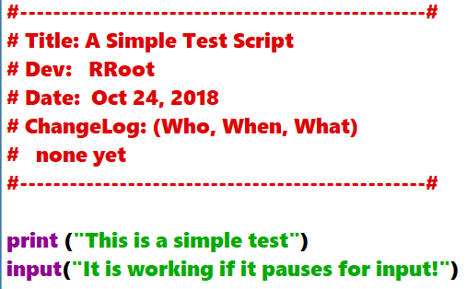

Figure 1: The code in test.py

**Note:** Mac comes with Python 2 already installed, but I please use version 3.x. unless you have a good reason, like “it is what is use at your work.”

### Step 4.2 Save your script to a folder

**Create a folder** on your computer **called _PythonClass**. Please use the **C: Drive** on a Windows OS **or** the **Documents** folder on a Mac OS (using the Desktop on either OS is not recommend).

Inside this folder **create** **another folder called Assignment01** and save your script file into this subfolder **as** **test.py**.

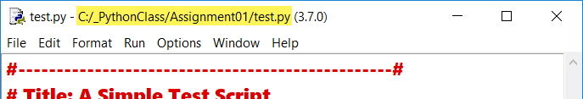

Figure 2: Idle showing the file is saved in the correct folder on Windows OS

### 

Figure 3: Idle showing the file is saved in the correct folder on Mac OS

### Step 4.3 Run Your Script

With the script created, and saved in the proper location, run the script in a OS command/shell window and capture an image of it working on your computer (Figure 4).

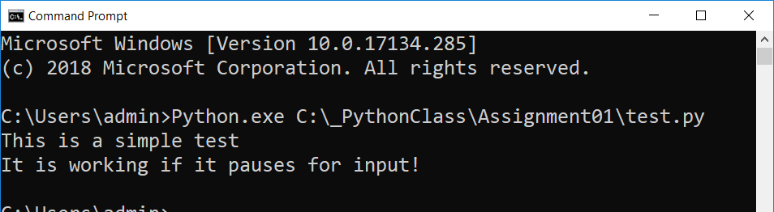

Figure 4: A screenshot of the script running in a

command window.

**Note**: if you are using a Mac your image will look like Figure 5.

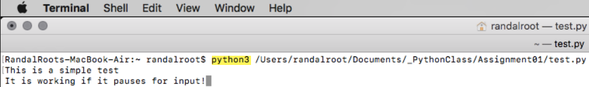

Figure 5: A screenshot of the script running in a Mac Shell window.

## Step 5 - Document your knowledge

After you have created and tested your Python script, create a document describing the steps you took in performing this assignment.

**Note**: Make sure you put it in proper, professional level, formatting! It does not have to be perfect, but if you turn in a simple blob of text, you will not get credit for it! Here is a link that may help you understand what I am looking for: <https://www.youtube.com/watch?v=Kjs2aewQBbk&feature=youtu.be> (External Site)

## Step 6 - Submit your work

Now place your document with the python script in the Assignment01 folder. Zip this folder into a “.zip” file, then upload the file to the class assignment page.

Congratulations! You are done!