Intro to Programming (Python)

Assignment 02

# Overview

In this activity, you will learn about built-in functions and operators; what they are and how you use them. You will also learn how to create your own demonstration scripts and document your knowledge.

This assignment will include the following tasks:

1. Watch the module videos.
2. Review some web pages.
3. Watch the external videos.
4. Apply your knowledge.
5. Document your knowledge.
6. Submit your work.

# Assignment Steps

The following assignment steps will ask you to read about programing, do some programing, write about what you did.

## Step 1- Module Videos

Please watch the following videos:

* Mod02-1-Module 02 Overview
* Mod02-2-What is Data?
* Mod02-3-Declaring Constants and Variables
* Mod02-4-Assigning Values
* Mod02-5-Choosing Data Types
* Mod02-6-Escape Characters
* Mod02-7-Line Continuation Character
* Mod02-8-Overloaded Methods
* Mod02-9-Concatenation
* Mod02-10-Operational Constructs
* Mod02-11-Lab 2-1 Starter
* Mod02-12-Lab 2-1 Answer
* Mod02-13-Value vs. Reference Types
* Mod02-14-Chapter 02 Review
* Mod02-15-Assignment 02 Starter
* Python Mod02-16 What is Next

All these can be found on my YouTube channel:

<https://www.youtube.com/playlist?list=PLfycUyp06LG_Ui56yzznsHhfEosKZSahX> (external site)

## Step 2 - Web pages

Please review the following web pages:

1. <http://www.learnpython.org/en/Variables_and_Types>(external site)
2. <http://www.learnpython.org/en/Basic_Operators>(external site)

## Step 3 - Additional Videos

Watch the following videos:

* Variables - <http://www.youtube.com/watch?v=667ZeuZ0Q8M>(external site)

## Step 4 - Apply your knowledge

Now that you have reviewed the websites and videos, try to create a new program that asks the user to input 2 numbers then prints out the sum, difference, product, and quotient.

### Step 4.1 Create a Python Script

Create a python script file with the code shown in Figure 1.

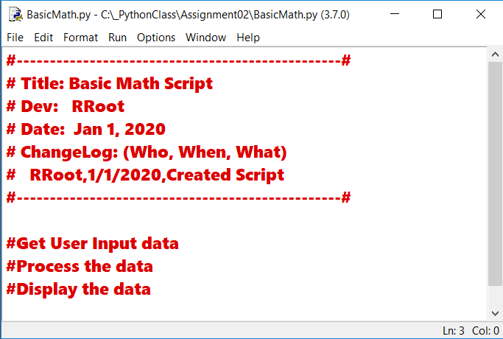

Figure 1: The code in BasicMath.py

**Note:** Mac comes with Python 2 already installed, but I please use version 3.x. unless you have a good reason, like “it is what is use at your work.”

### Step 4.2 Save your script to a folder

Save the python script **file** **as** **BasicMath.py** in a **new sub-folder** **called Assignment02** you created inside of the folder you created in Module 01 **called** **_PythonClass**. Please use the C: Drive on a Windows OS or the Documents folder on a Mac OS (using the Desktop on either OS is not recommend).

### Step 4.3 Run Your Script

Add code to the script to capture user input data, process that data, and display the resulting data.

### Step 4.4 Run Your Script

With the script created, and saved in the proper location, run the script in a OS command/shell window and capture an image of it working on your computer (Figure 2).

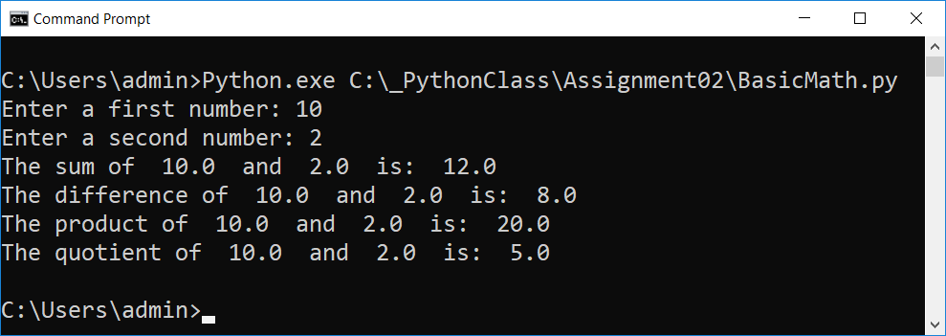

Figure 2: A screenshot of the script running in a command window.

## Step 5 - Document your knowledge

After you have created and tested your Python script, create a document describing the steps you took in performing this assignment. Use screenshots and code sample to explain the process, just as was done in your book, my programming notes, and the web pages you reviewed. Make sure the document is in a Microsoft Word document (.doc or .docx).

**Note**: Make sure you put it in proper, professional level, formatting! It does not have to be perfect, but if you turn in a simple blob of text, you will not get credit for it! Here is a link that may help you understand what I am looking for: https://youtu.be/9ojhSW9ljjo (External Site)

## Step 6 - Submit your work

Now place your document with the python script in the Assignment02 folder. Zip this folder into a “.zip” file, then upload the file to the class assignment page.

Congratulations! You are done!