George Kim

January 15, 2019

Foundations of Programming: Python

Assignment 02

Creating the BasicMath Script In Python

# Introduction

For assignment 2, we were asked by Professor Root to create the BasicMath.py script by getting the User input, process the data and display the data. This paper will be going over the steps I took to accomplish this, with the use of screen shots. I took a step to make it visually friendly for the user to read also. Information from the videos, were used such as data, declaring variables, and using escape characters for this assignment.

**The Start of the Script**

In almost every script you run, when you initiate it, the information displays on the screen pretty fast with no delay. I started this assignment to delay each line for the user to read by ***importing*** the ***time function***. I also used some escape characters (new line\n, and tab\t) to separate the print statement when the script is initiated (**Figure 1**)

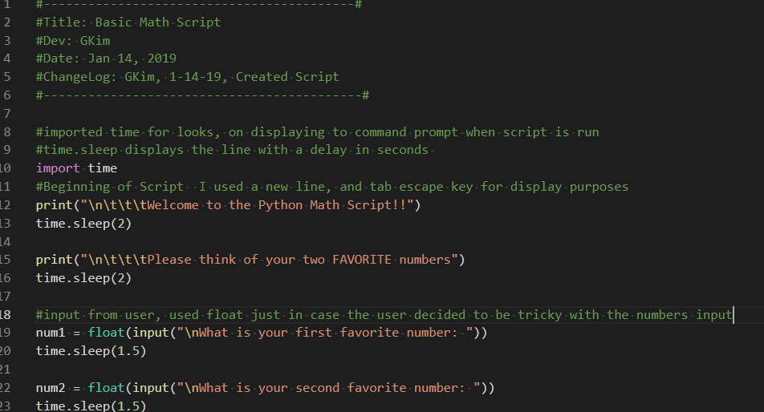

***Figure 1. Beginning of script and showing the time import and escape characters***

The output shows each line having spaces in between, but what is not shown is the delay that it took each line to display (**Figure 2**). In figure 1 above, you can see the start of my variable sets that I will go over in the next section.

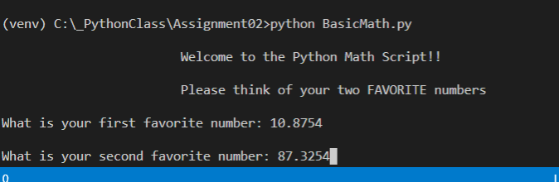

***Figure 2 Output from the beginning script***

**Declaring my Variables**

After I initiated my beginning script, I knew I would need to set some variables. The script askes the user to input 2 numbers, num1 and num2. Setting these two variables (num1, num2) and making sure if the user tries to be tricky and inputs a number that is a float, I used the float function to make it easy to call on them to perform the task ahead. The assignment asks that we *print out the sum, difference, product, and quotient*, of the two numbers given by the user. As you can see in **Figure 3**, the *variables of add, sub, product* and *quotient* were used to save the data from the task at hand. I knew there might be decimal places from the potential float input and rounded the answer to 3 spots.

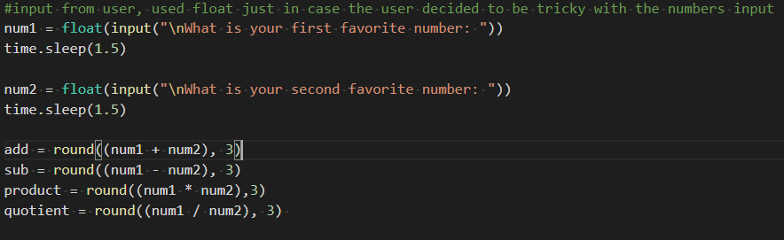

***Figure 3. Declaring Variables, assuming a potential float***

**Displaying User input, Answers, and Exit**

I then created print statements to show the input from the user and the answer. Each line is displayed on a new line and is put on a delay to give the user time to read. **Figure 4** shows the script , and **Figure 5** displays the output:

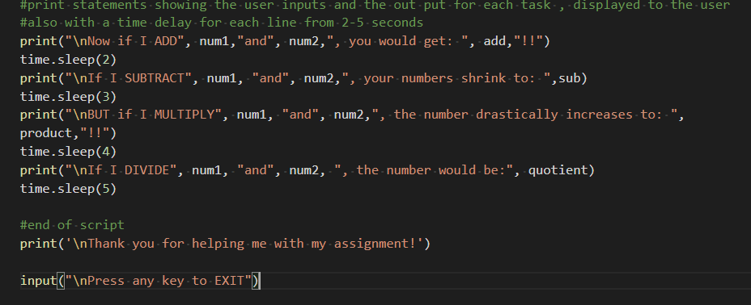

***Figure 4. The script showing time delays and new line escape characters.***

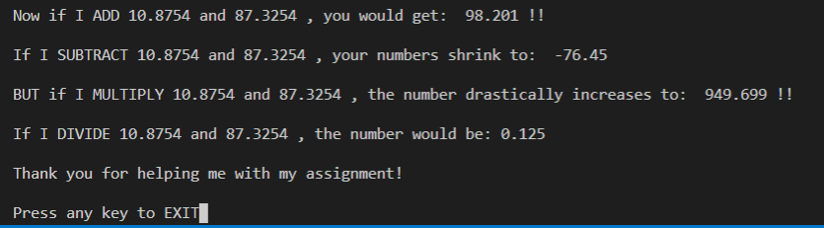

***Figure 5. Output***

Again, what is not displayed is the delay that each line takes to output to the user. I find this more visually appealing when reading lines in the command prompt. To finish the code, I thank the user for helping me out and use and input function to end the script.

**Summary**

When making a python script, I am finding out that setting clear and uncomplicated variables are really important in coding. You want people to read your code and understand what you are trying to do. Learning all the different type of functions, such as float() , to help in gathering that information from your user, are really important to grasp in Python when you are trying to calculate information. To make clean code, it will take practice and understanding of how the syntax works for any programming language. Assignments like this one, will give you the practice you need to make working code.