Intro to Programming (Python)

Assignment 03

# Overview

In this activity, you will learn about typical programming statements and constructs. You will also learn about how to download, install, and use a new Integrated Development Environment (IDE) called PyCharm. Once again you create your own scripts and document your knowledge. In later modules, your documents will be reviewed by your peers, so practice making your document and code look professional.

This assignment will include the following tasks:

1. Watch the module videos.
2. Review some web pages.
3. Watch the external videos.
4. Apply your knowledge.
5. Document your knowledge.
6. Submit your work.

# Assignment Steps

The following assignment steps will ask you to read about programing, do some programing, write about what you did.

## Step 1- Module Videos

Please watch the following Module videos:

* Module03-1-Overview
* Module03-2-Using an Integrated Development Environment
* Module03-3-Pseudo Code
* Module03-4-Conditional Statements
* Module03-5-Lab 03-1 Starter
* Module03-6-Lab 03-1 Answer
* Module03-7-Comparison Operators
* Module03-7-Boolean Values
* Module03-9-Loops
* Module03-10-Program Arguments
* Module03-11-Lab 03-2 Starter
* Module03-12-Lab 03-2 Answer
* Module03-13-Writing Data to a File
* Module03-14-Lab03-3 Starter
* Module03-15-Lab03-3 Answer
* Module03-16-Chapter 03 Review
* Module03-17-Assignment 03 Starter

<http://www.youtube.com/playlist?list=PLfycUyp06LG-GGDv8SLraTbBaxhnBm7hr> (Links to an external site)

## Step 2 - Web pages

Please review the following web pages. These are shorter than the book and provide online resources you can use later.

1. <http://www.tutorialspoint.com/python/python_if_else.htm> (Links to an external site)
2. <http://www.tutorialspoint.com/python/python_while_loop.htm> (Links to an external site)
3. <http://www.tutorialspoint.com/python/python_files_io.htm> (Links to an external site)

## Step 3 - Additional Videos

Please watch this video. It will explain things a bit differently, which helps with learning!

1. Working with Files - <http://videolecture.blogspot.com/2011/04/python-programming-tutorial-41-working.html> (Links to an external site)

## Step 4 - Apply your knowledge

Now that you have reviewed the websites and videos, create a new program that asks the user for the name of a household item, and then asks for its estimated value. Store, both pieces of data in a text file called, HomeInventory.txt

### Step 4.1 Create a Folder

Create a **new sub-folder** **called Assignment03** inside of the folder you created in Module 01 **called** **_PythonClass**. Please use the C: Drive on a Windows OS or the Documents folder on a Mac OS (using the Desktop on either OS is not recommend).

### Step 4.2 Create a new Project in PyCharm

Create a new project in PyCharm that uses the _PythonClass\Assignment03 folder as its location (figure1).

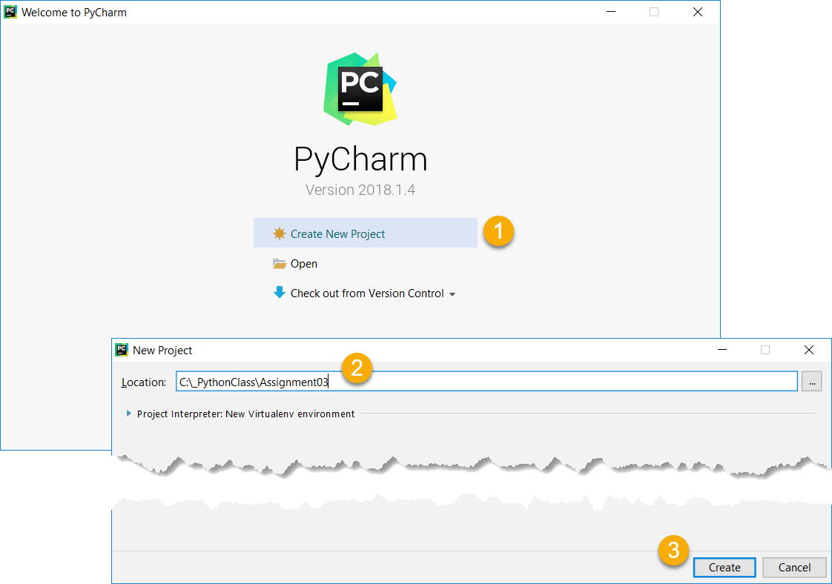

Figure 1: Creating a new project in PyCharm

### Step 4.3 Create a Python Script

Create a python script file within your project (Figure 2).

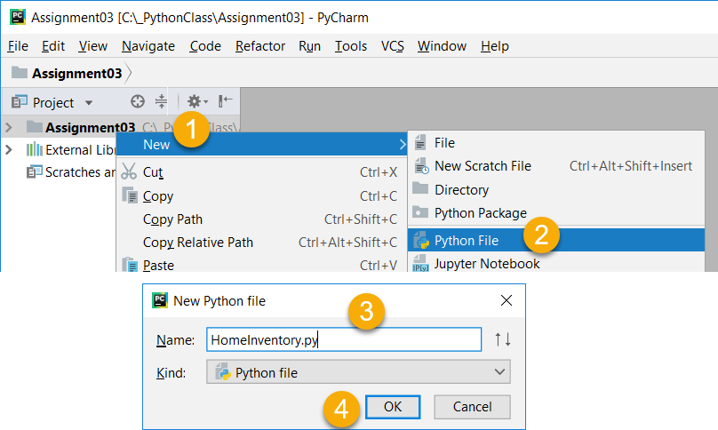

Figure 2: Creating a new Python Script in the Project

### Step 4.3 Add Code to the Script

Add code to your script that will perform that assignment’s task. I suggest you start by adding the header and some basic comments about what you are going to do (Figure 3).

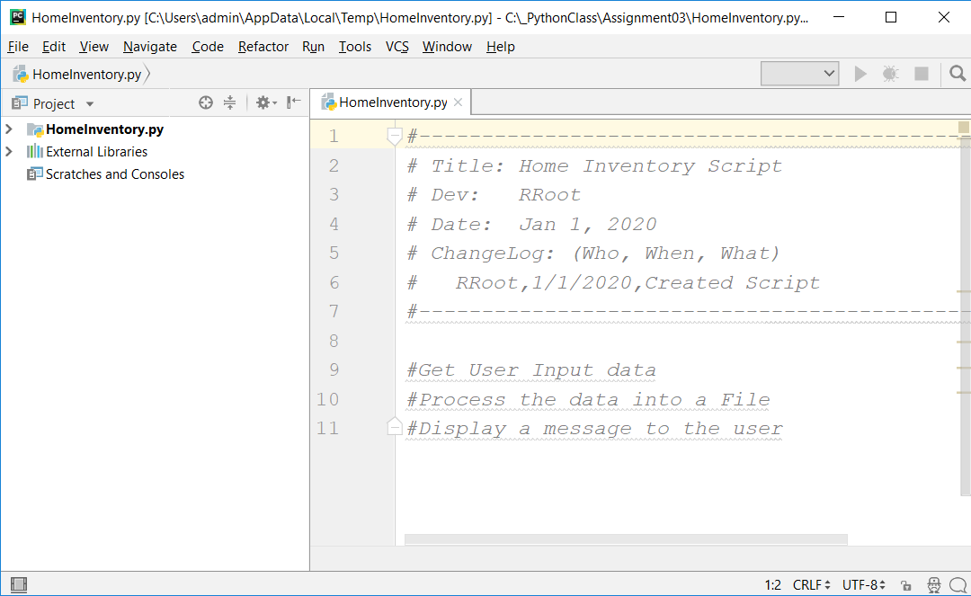

Figure 3: The start of code in HomeInventory.py

### Step 4.4 Run Your Script

With the script created in its proper location, run the script in **BOTH** PyCharm and a OS command/shell window and capture images of it working on your computer (Figure 4 and 5).

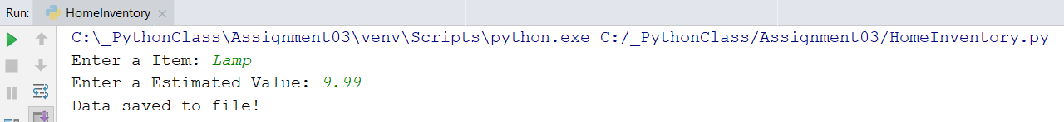

Figure 4: A screenshot of the script running in PyCharm.

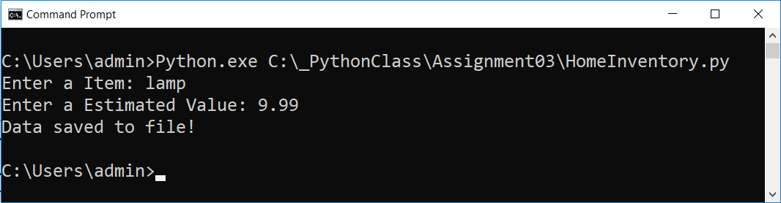

Figure 5: A screenshot of the script running in a command window.

### Step 4.5 Verify that it Worked

Locate the text file and open it in a text editor (Figure 6).

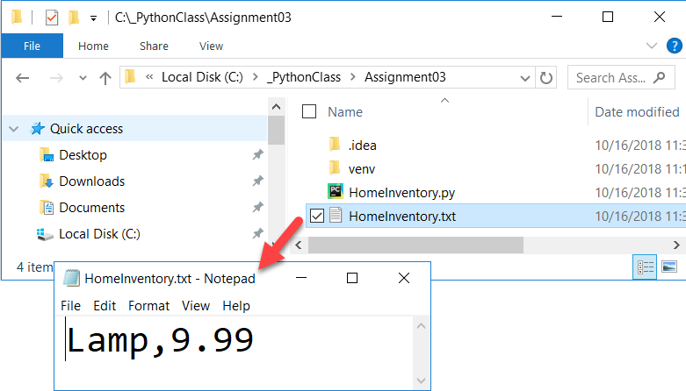

Figure 6: Verifying that the file has data

## Step 5 - Document your knowledge

After you have created and tested your Python script, create a document describing the steps you took in performing this assignment. Use screenshots and code sample to explain the process, just as was done in your book, my programming notes, and the web pages you reviewed. Make sure the document is in a Microsoft Word document (.doc or .docx).

**Note**: Make sure you put it in proper, professional level, formatting! It does not have to be perfect, but if you turn in a simple blob of text, you will not get credit for it! Here is a link that may help you understand what I am looking for: https://youtu.be/9ojhSW9ljjo (External Site)

## Step 6 - Submit your work

Now place your document with the python script in the Assignment03 folder. Zip this folder into a “.zip” file, then upload the file to the class assignment page.

Congratulations! You are done!