George Kim

January 22, 2019

Foundations of Programming: Python

Assignment 03

Home Inventory in Python and Text

# Introduction

In Assignment 3, we are asked to get an input from the user on a house hold item and the price/cost of the house hold item and save that data to a text file. We are introduced to an Integrated Development Environment (IDE), known as PyCharm, and we will be writing the reminder of our python scripts on this IDE. I will be going over the steps of downloading and setting up PyCharm and the process of my python script(s).

**PyCharm**

PyCharm is an IDE, that makes writing code easier, such editing and seeing indentation errors. It has a lot of great functions that help in running your script, debugging, and systematically going line by line to see how your code runs. I first went to the website <https://www.jetbrains.com/pycharm/>, to download PyCharm. (**Figure 1**). You want to start you download on the Community side of PyCharm (**Figure 2**). You do not want the professional version, which is only a trial version and it will expire. Once you click that



***Figure 1. Jetbrains.com is where you download PyCharm***

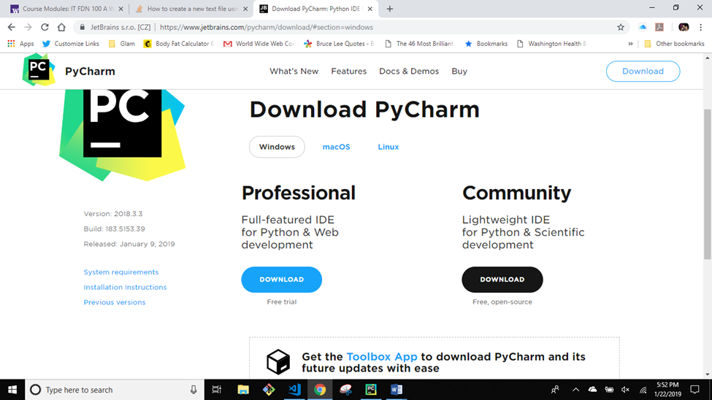

***Figure 2 Download on the Community side***

link it will automatically download. You will go to your setup page and click on the current version of PyCharm(Figure 3). Make sure that you save it to PATH. Now we are ready to start a project in PyCharm and begin a python script file!

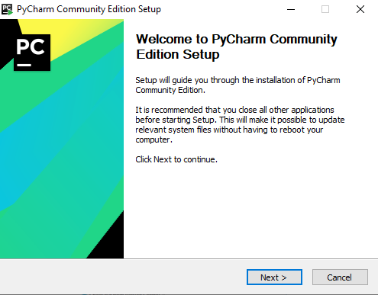

***Figure 3 Start of setup for PyCharm***

**Creating a Project and a Python file**

We first must download the Module 3 zip file from the Canvas page and open that file and save it in our _PythonClass folder (**Figure 4**). PyCharm is now ready to go and we are ready to start our assignment. We first click on the file button on the top left corner and select ‘New Project’. We then create a project by saving it to the _PythonClass and then in the download Module03 zip file, we create our Assignment03 folder in the Module03 folder (**Figure 5**).

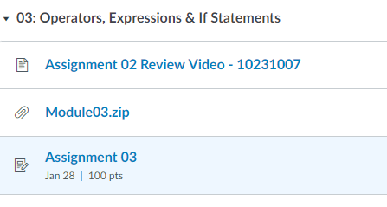

***Figure 4 Module03.zip***

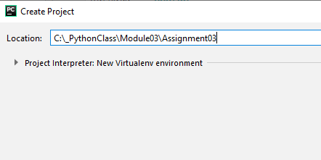

***Figure 5 Creating New Project folder***

Now we can create our Assignment 3 python script called *HomeInventory.py.* First, we right-click on the Assignment 3 folder, select *New*, then click *Python file* (**Figure 6**). It will then open a new window where we name our file, *HomeInventory* (**Figure 7**)*.* A new python file has been created and we now can begin our script!

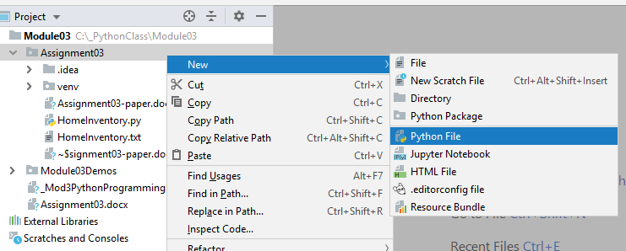

***Figure 6 Steps to create a new Python file***

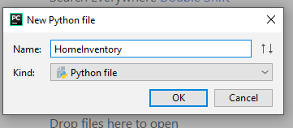

***Figure 7 Naming the file***

**Python Script**

The assignment asks that we get the input from the user of a household item and the cost/price of that item. Pretty simple, right? I incorporated two different python script: one to fulfill the basic requirements (**Figure 8a**), and the other to add a challenge with a While Loop (**Figure 9a**). The challenge of the While Loop was given to us by Professor Root at the end of class.

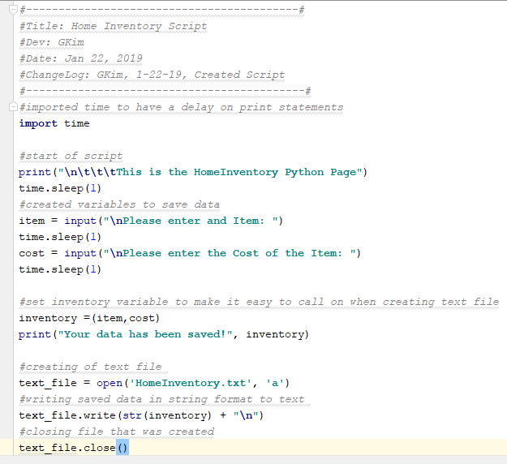

***Figure 8a Basic HomeInventory.py file***

I know, I know, you are probably getting tired of seeing me *import time* on my scripts. I like to give the user time to read my input statements by seeing the next lines of code pause. This is just for looks, but you can write a script without it. Now as you can see above, I start by setting two input commands that have variables set to capture the data given to us by the user, *item* and *cost*. *Inventory* is then created to capture *item* and *cost*. I figured this would make it easier to make a text file. A print statement letting the user know the data has been saved, and the data themselves are displayed to the user. For the second part of the assignment, the data stored must be written on a text file related to the python script.

At the bottom of **Figure 8a,** it shows that I created the text file associated with my python script. Honestly, I started this assignment without looking at the programming notes fully. It gave directions from the notes page that I overlooked. From here on out I will read through the programming notes, as it will save me more time to completing my assignments. I got my information from stack overflow website. (Stackoverflow.com, https://stackoverflow.com/questions/48959098/how-to-create-a-new-text-file-using-python/48964410 , answered by Bentaye), (External site)(**Figure 8b**), where I was able to find the answer..

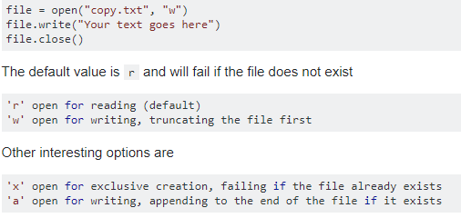

***Figure 8b Stackoverflow web page with instructions on how to write a text file***

First create variable name for your text file creation, it can be any name, but keep it simple(**Figure 8c**). *Text_file* is used, in this example, where you open a text document by assigning the file a name (*‘HomeInventory.txt’*) and choose how you want it to write. A “a” will write and append to the end of the file, that we are creating. There are other options on the bottom of **Figure 8b**, that you can review on your own. Next, we write what we want in that file. In this case we want that saved data given to us by the user. Remember that we have to convert things into a string when writing to a text data. As you can see, I used *str(inventory)* to do so, and made sure that any other data would be saved on a new line by concatenating with *“\n”,* which is a new line*.* Then we make sure to close the file with *.close().* This is an important part, as closing the file will save the data you want on your text file. In **Figures 8d** and **8e**, shows the output and text file.

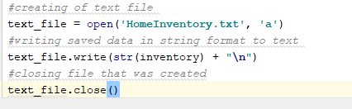

***Figure 8c. The script showing time delays and new line escape characters.***

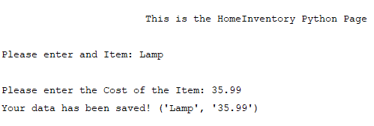

***Figure 8d. Output from python script***

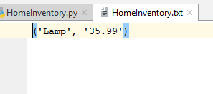

***Figure 8e. Text document***

Success! We completed the basic assignment. I will go over briefly the *while loop* version of this in the next segment.

**While Loop Home Inventory**

In the while loop version of this assignment, the main body of the code is the same (**Figure 8a**). What I added was the while loop and another variable and moved a print statement out of the loop in the beginning of the script (**Figure 9a**). I set a variable called *choice* and set it to *None*. The reason for this is for the beginning of the program it prints the initial print statement and goes into the loop while the user has *not* given a choice. The next print statement then shows the user the choices available and waits for the input from the user with in the loop.

This is where my first conditional starts. *If choice == “1”:* , means if the user enters “1”, go through the main body of the code from **Figure 8a.**  At the end of the code from **Figure 8a** , I added another line, *response = input("\nWould you like to enter more ( y or n)? “) (***Figure 9b)**. This variable is capturing a “y” or and “n”. I nested another conditional within the first one, where it will loop back through the beginning of the while loop(*if response.lower() == "y":*). In simpler terms, **if** the user enters a capital “Y” , we are going to lower case that , and if that equals “y” we will set the variable *choice = None* thus starting the beginning of the while loop. There is and escape clause with the else statement where if the user doesn’t select “y” it will change the variable choice to “0” and go into the second conditional.

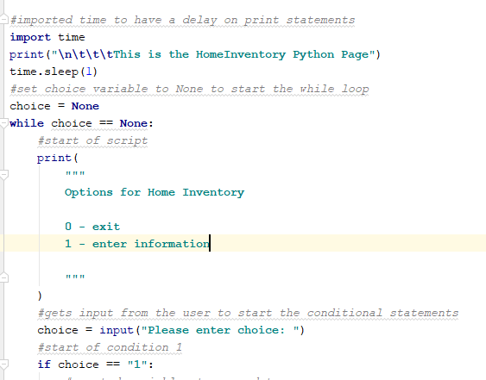

***Figure 9a. While loop with beginning of first condition on the bottom of page.***

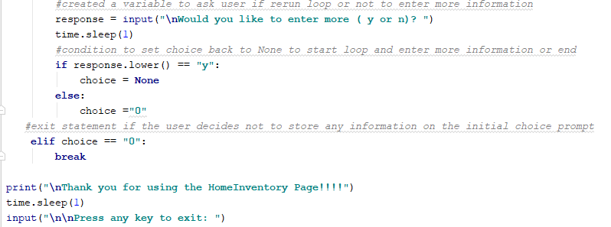

***Figure 9b. Shows added variable, response, and the nested conditional. Also second conditional to end loop.***

The second conditional states that if the user inputs “0” break out of the loop and print Thank you for using the HomeInventory Page!!!! and an input key to end the program. **Figures 9c**, **9d** and **9e** will show the command prompt screen with the output with the loop and the text file with multiple saved values and the exit condition being executed.

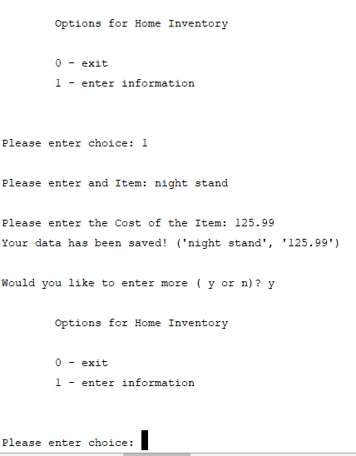

***Figure 9c. While loop being executed , giving the user option to input more***

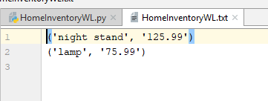

***Figure 9d. Text document created and saving multiple data on separate lines.***

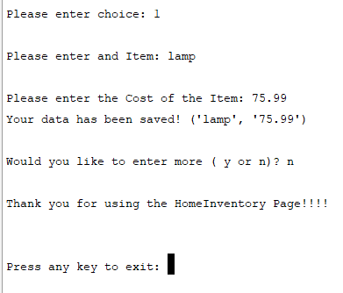

***Figure 9e. second loop to enter in more data , then user inputs “n” and ends the program.***

**Summary**

This was a fun assignment to do with the while loop challenge. With more practice, using while loops will be a big benefit for future use. Not getting stuck in a loop will be the main challenge for me. Getting information from our user and saving to a text file, is a great way to print a list of information from a text file instead of trying to find the list on a saved variable in python. As Professor Root stated in class, that we are building on making our own functional application for a Home Inventory project, and this assignment really helps on the base of that project. Using and IDE(PyCharm) will make it easier to see errors and run code line by line for this future project. Practice makes perfect, so doing more code on the IDE will be an advantage in being more comfortable in writing python code.