Intro to Programming (Python)

Assignment 05

# Overview

In this activity, you will learn to work with for Lists and Dictionaries. Once again you will create your own scripts and document your knowledge. You will also learn how to post work to GitHub as is common in the industry.

This assignment will include the following tasks:

1. Watch the module videos.
2. Review some web pages.
3. Watch the external videos.
4. Apply your knowledge.
5. Document your knowledge.
6. Post to GitHub
7. Submit your work.
8. Peer Review (Not Graded)

# Assignment Steps

The following assignment steps will ask you to read about programing, do some programing, and write about what you did.

## Step 1- Module Videos (Optional for In-Person Course)

Please watch the following Module videos:

* <https://www.youtube.com/playlist?list=PLfycUyp06LG9I4194n8OvgCbmEXQt3a8z> (external site)

## Step 2 - Web pages

Please review the following web pages. These are shorter than the book and provide online resources you can use later.

* <http://en.wikibooks.org/wiki/Non-Programmer's_Tutorial_for_Python_2.6/Lists> (external site)
* <http://www.bogotobogo.com/python/python_dictionaries_tuples.php>(external site)
* <http://www.afterhoursprogramming.com/tutorial/Python/Reading-Files/> (external site)

## Step 3 - External Videos

Please watch this video. It will explain things a bit differently, which helps with learning!

* Reading from a text file: <https://youtu.be/m0o0CkYsDzI> (external site)

## Step 4 - Apply your knowledge

Now that you have reviewed the websites and videos, you will **create** a new script that manages a "ToDo list." This project is like to the last one, but different enough to be a challenge.

This time the ToDo file will contain different columns of data (Task, Priority) which are stored in a Python *Dictionary*. Each Dictionary will represent one row of data and these rows of data are added to a Python *List* to create a table of data.

1. **Create** a text file called Todo.txt using the following data:

Clean House,low

Pay Bills,high

1. When the program starts, **load** each **row** of data from the ToDo.txt text file **into** a Python **d*ictionary***. (The data will be stored like a row in a table.)

**Tip**: You can use a for loop to read a single line of text from the file and then place the data into a new dictionary object.

1. After you get the data in a Python dictionary, **Add** the new **dictionary** “row” **into** a Python **list** object (now the data will be managed as a table).
2. **Display** the contents of the List to the user.
3. Allow the user to **Add** or **Remove** tasks from the list using numbered choices. *Something* like this would work:

Menu of Options

1) Show current data

2) Add a new item.

3) Remove an existing item.

4) Save Data to File

5) Exit Program

1. **Save** the data from the table into the Todo.txt file when the program exits.

**Tip:** I have provided a starting template to help you organize and help with some of the coding. You can use it or create your own file from scratch, but you have a lot of work to do in this module so, you may want to take advantage of the help.

### Step 4.1 Create a Folder

Create a **new sub-folder** **called Assignment05** inside the **_PythonClass folder**.

### Step 4.2 Create a new Project in PyCharm

Create a new project in PyCharm that uses the _PythonClass\Assignment05 folder as its location

### Step 4.3 Create a Python Script

Create a python script file within your project.

### Step 4.3 Add Code to the Script

Add code to your script that will perform that assignment’s task.

### Step 4.4 Run Your Script

With the script created in its proper location, run the script in **BOTH** PyCharm and a OS command/shell window and capture images of it working on your computer.

### Step 4.5 Verify that it Worked

Locate the text file and open it in a text editor.

## Step 5 - Document your knowledge

After you have created and tested your Python script, create a document describing the steps you took in performing this assignment. Use screenshots and code sample to explain the process, just as was done in your book, my programming notes, and the web pages you reviewed. Make sure the document is in a Microsoft Word document (.doc or .docx).

**Note**: Make sure you put it in proper, professional level, formatting! It does not have to be perfect, but if you turn in a simple blob of text, you will not get credit for it! Here is a link that may help you understand what I am looking for: https://youtu.be/9ojhSW9ljjo (External Site)

## Step 6 - Post your Code to GitHub

In this module, you need to **post** your zip file on a public GitHub so that others may review it.

Here are some videos to help you learn what GitHub is and how it is used.

* What Is GitHub: <https://youtu.be/VUaBfYCmJls>
* How to use GitHub for Beginners: <https://youtu.be/E8TXME3bzNs>
* Setting up a GitHub Account: <https://youtu.be/Sk1_DU2ky48>

Once, you understand how it works, perform the following to create a repository for your code:

1. Login to <https://github.com> (Make a new account if needed!)

2. Create a repository called ***IntroToProg-Python, under your account.***

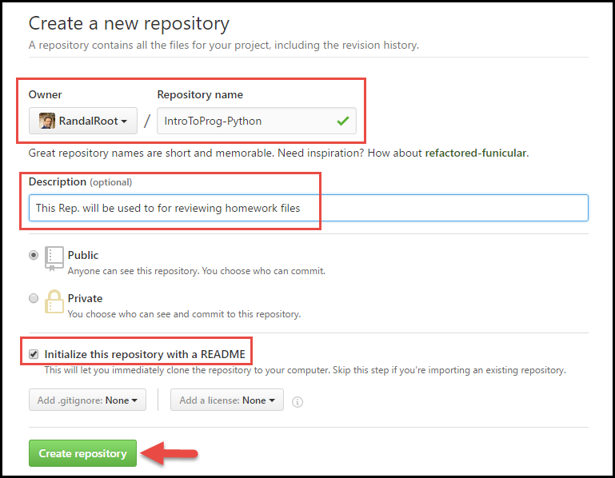

**Note:** You may use a new email account and made up name if you are concerned about security. If you need more than that, please talk to your instructor.

3) Upload your file to the repository

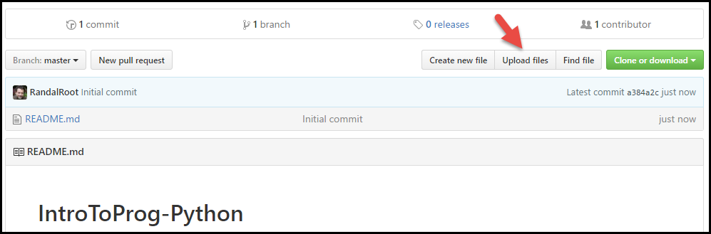

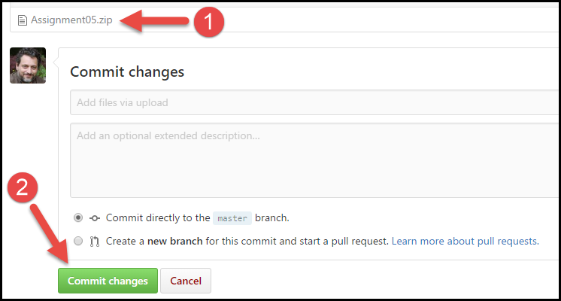

### 6.1 Link Your Document to Your Repository

Include a link to you your GitHub repository in the assignment’s document!

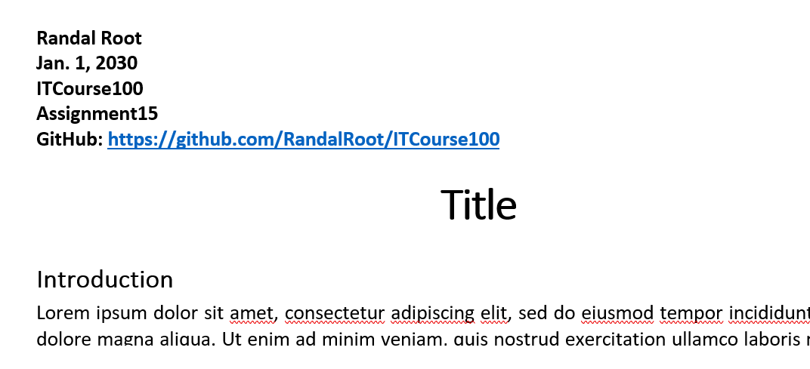

## Step 7 - Submit your work

Now place your document with the python script in the Assignment05 folder. Zip this folder into a “.zip” file, then upload the file to the class assignment page.

***Important:*** *You must also upload your python script to both GitHub and the Canvas assignment’s Zip file.*

## Step 8: Perform a Peer Review (Not Graded!)

You have been assigned a Peer Partner for this assignment. Keep watch for your partners posting to thier GitHub repostitorie after the assignment’s due date. One you see it, review their work and post some comments about it on the discussion forum.

Make sure to:

* Say two things that you liked about their work
* Say one thing that could make the work better

Congratulations! You are done!