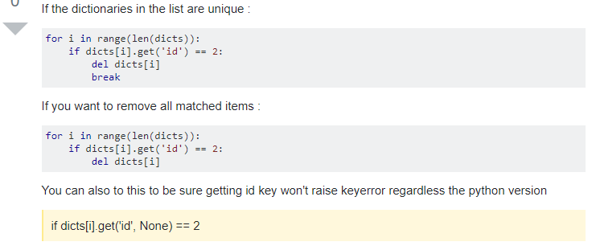

<https://stackoverflow.com/questions/1235618/python-remove-dictionary-from-list>, nixmind

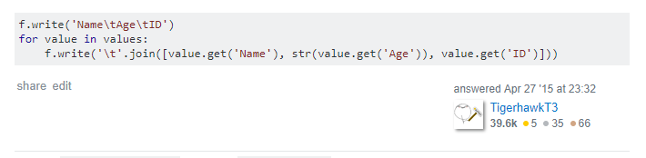

<https://stackoverflow.com/questions/29907715/write-list-of-dictionary-values-to-file>, TigerhawkT3

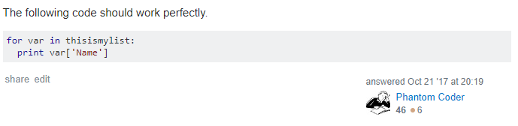

<https://stackoverflow.com/questions/17117912/python-accessing-values-in-a-list-of-dictionaries>, Phantom Coder

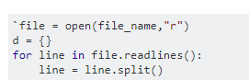

<https://stackoverflow.com/questions/53491406/how-can-i-take-multiple-lines-of-a-text-file-as-the-values-in-a-tuple-for-a-ke>, user10642683

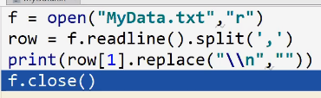

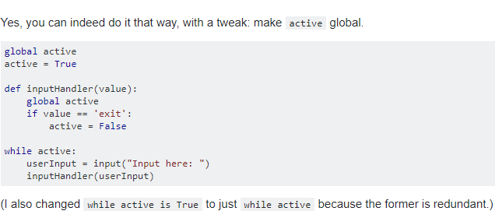

(stackoverflow,<https://stackoverflow.com/questions/33906813/can-you-break-a-while-loop-from-outside-the-loop>, 2019 answered by El'endia Starman)(External Website)

