Intro to Programming (Python)

Assignment 06

# Overview

In this activity, you will learn to work with for Lists and Dictionaries. Once again you will create your own scripts and document your knowledge. Your documents will be reviewed by your peers, so make your document and code look professional. You will also learn how to post work to GitHub as is common in the industry.

This assignment will include the following tasks:

1. Watch the module videos.
2. Review some web pages.
3. Watch the external videos.
4. Apply your knowledge.
5. Document your knowledge.
6. Submit your work.
7. Peer Review (Not Graded)

# Assignment Steps

The following assignment steps will ask you to read about programing, do some programing, and write about what you did.

## Step 1 - Module Videos (Optional for In-Person Course)

Please watch the following Module videos:

* <https://www.youtube.com/playlist?list=PLfycUyp06LG-7xrsqU6kCTOXr2TLDPgD2> (external site)

## Step 2 - Web pages

Please review the following web pages. These are shorter than the book and provide online resources you can use later.

* <http://www.tutorialspoint.com/python/python_functions.htm>(external site)
* <http://www.learnpython.org/en/Functions>(external site)

**Note**: remember, these additional links are to give you a different opinion / viewpoint of the material we are covering! You only need to review the web pages to see what is out there as a resource. You do not need to read them thoroughly. The idea is to expose you to many different ways of looking at these topics and provide you will link to sites you can use in the future.

## Step 3 - External Videos

Please watch this video. It will explain things a bit differently, which helps with learning!

* Creating Functions: <https://youtu.be/qO4ZN5uZSVg>(external site)

## Step 4 - Apply your knowledge

Now that you have reviewed the websites and videos, you will create a new script that manages a "ToDo list." This project is like to the last one, but different enough to be a challenge. This project is very **like the last one**, **but** this time you will **place the code** you created for working with your ToDo.txt file **into Functions and a Class**.

***NOTE:*** *Just in case you had problems with the last assignment, I have provided my answer script in the Module’s zip file! You can use either my script to get started or make your script from scratch.*

1. To give you a little help, here is some pseudo code to get you started.

*#-- Input/Output --#  
# User can see a Menu (Step 2)  
# User can see data (Step 3)  
# User can insert or delete data(Step 4 and 5)  
# User can save to file (Step 6)  
  
#-- Processing --#  
# Step 1  
# When the program starts, load the any data you have**# in a text file called ToDo.txt into a python List and Dictionary.**# Step 2  
# Display a menu of choices to the user  
  
# Step 3  
# Display all todo items to user  
  
# Step 4  
# Add a new item to the list/Table  
  
# Step 5  
# Remove a new item to the list/Table  
  
# Step 6  
# Save tasks to the ToDo.txt file**# Step 7  
# Exit program*

### Step 4.1 Create a Folder

Create a **new sub-folder** **called Assignment06** inside the **_PythonClass folder**.

### Step 4.2 Create a new Project in PyCharm

Create a new project in PyCharm that uses the _PythonClass\Assignment06 folder as its location

### Step 4.3 Create a Python Script

Create a python script file within your project.

### Step 4.3 Add Code to the Script

Add code to your script that will perform that assignment’s task.

### Step 4.4 Run Your Script

With the script created in its proper location, run the script in **BOTH** PyCharm and a OS command/shell window and capture images of it working on your computer.

### Step 4.5 Verify that it Worked

Locate the text file and open it in a text editor.

## Step 5 - Document your knowledge

After you have created and tested your Python script, create a document describing the steps you took in performing this assignment. Use screenshots and code sample to explain the process, just as was done in your book, my programming notes, and the web pages you reviewed. Make sure the document is in a Microsoft Word document (.doc or .docx).

**Note**: Make sure you put it in proper, professional level, formatting! It does not have to be perfect, but if you turn in a simple blob of text, you will not get credit for it! Here is a link that may help you understand what I am looking for: https://youtu.be/9ojhSW9ljjo (External Site)

## Step 6 - Post your Code and Document to GitHub

You need to **post** your code and Word document files to GitHub so that others may review it.

1. Login to <https://github.com> (Make a new account if needed!)
2. Access your repository called ***IntroToProg-Python*** that you made in Module 05
3. Upload your file to the repository

### 6.1 Link Your Document to Your Repository

Include a link to you your GitHub repository in the assignment’s document!

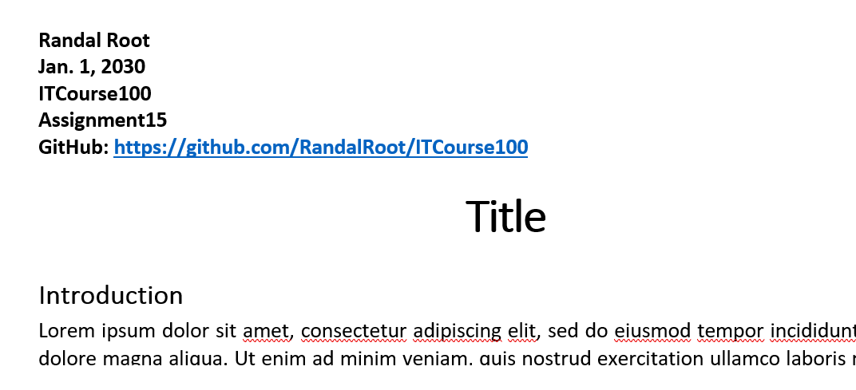

## Step 7 - Post your document

You need to post a **link to your GitHub repository in the discussion forum** so that others may review it, by adding your link to the “Assignment 06 Links for Review.”

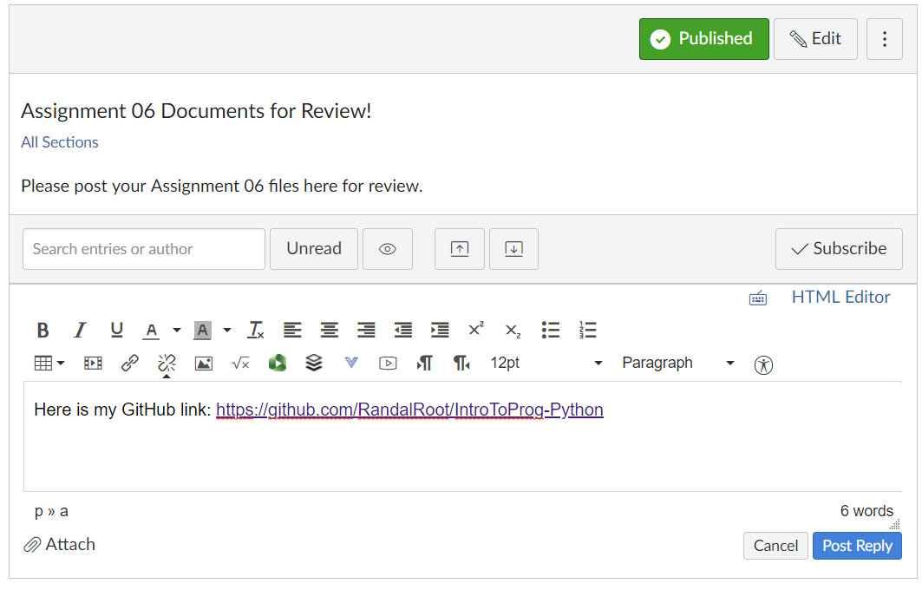

## Step 8 - Submit your work

Now place your document with the python script in the Assignment06 folder. Zip this folder into a “.zip” file, then upload the file to the class assignment page.

***Important:*** *You must also upload your python script to both GitHub and the Canvas assignment’s Zip file.*

Congratulations! You are done!

## Step 9: Perform a Peer Review (Not Graded!)

You have been assigned a Peer Partner for this assignment. Keep watch for your partners posting to thier GitHub repostitorie after the assignment’s due date. One you see it, review their work and post some comments about it on the discussion forum.

Make sure to:

* Say two things that you liked about their work
* Say one thing that could make the work better

Congratulations! You are done!