Intro to Programming (Python)

Assignment 07

# Overview

In this activity, you will learn about exception handling and Python’s pickling module, and how you use them.

So far, I have provided links for you, but now it is your turn to do the research! I am hoping this will be easy for you, since you have visited a lot of websites while performing the other modules.

One last twist; in addition to using Word documents for your write-up, you will create a free Google Blog (Instruction are lower down in this document). Make your document and code look professional as you can while getting used to the Blogger interface. Don’t stress if the Blog does not look as nice as your Word document, it seldom does!

This assignment will include the following tasks:

1. Watch the module videos.
2. Review some web pages.
3. Research Exception Handling.
4. Research Pickling.
5. Apply your knowledge.
6. Document your knowledge.
7. Submit your work.
8. Perform a Peer Review.

# Assignment Steps

The following assignment steps will ask you to read about programing, do some programing, and write about what you did.

## Step 1 - Module Videos (Optional for In-Person Course)

Please watch the following Module videos:

* <https://www.youtube.com/playlist?list=PLfycUyp06LG_Rg7NYLURKCS-Y1wtAkILW> (external site)

## Step 2 - Research Exception handling in Python

Search the web for examples of how to use Python’s Exception handing features.

## Step 3 - Research Pickling in Python

Search the web for examples of how to use Python’s Pickling features.

## Step 4 - Apply your knowledge

Now that you have reviewed the websites and videos, try to do the following tasks.

1. Create a **simple** example of how you would use Python Exception Handling. Make sure to comment your code.
2. Create a **simple** example of how you would use Python Pickling. Make sure to comment your code.

### Step 4.1 Create a Folder

Create a **new sub-folder** **called Assignment07** inside the **_PythonClass folder**.

### Step 4.2 Create a new Project in PyCharm

Create a new project in PyCharm that uses the _PythonClass\Assignment07 folder as its location

### Step 4.3 Create a Python Script

Create a python script file(s) within your project.

### Step 4.3 Add Code to the Script

Add code to your script(s) that will perform that assignment’s task.

### Step 4.4 Run Your Script

With the script created in its proper location, run the script in **BOTH** PyCharm and a OS command/shell window and capture images of it working on your computer.

### Step 4.5: Post Your Code

You need to **post** your code file(s) on a public GitHub so that others may review it.

a) **Login** to <https://github.com> (Make a new account if needed!)

b) **Access** your repository called ***IntroToProg-Python*** you made in Module 05

c) **Upload** your file to the repository

## Step 5 - Document your knowledge

After you have created and tested your Python script, create a document describing the steps you took in performing this assignment. Use screenshots and code sample to explain the process, just as was done in your book, my programming notes, and the web pages you reviewed. Make sure the document is in a Microsoft Word document (.doc or .docx).

## Step 6 - Create a Blog

In addition to the Word document, you will also **create a Blog** describing the steps you took in performing this assignment.

***Tip:*** *To make a Blog, I often use Word first, since it is a better text editor, and then upload my text to the Blog.*

Here is a simple Blog on Google’s Blogger as an example of what one might look like: <http://pythonsummer2015rroot.blogspot.com/>

**Note**:

* I’ve created a video that will instruct you on the process: <https://youtu.be/L8kePEXR7zk>
* Make sure to include the URL to your GitHub repository in your Blog
* You can make a new account, instead of your personal Google account, if you wish to remain anonymous
* Get the blog page looking good enough for the assignment. You can always update it to look better when you have more experience and free time
* Make sure to place a link to your Blog in your Word document.

Students often hate the Blog at first, but later come to see the advantages. So, hang in there! You can always delete it later and besides, this is a great way to show you employer or future employers your new coding skills. You can later link your blog in emails, Linked-in, Facebook, or even resumes.

### 6.1 Link Your Documents and Files

Include a link to your GitHub repository and your Blog in the assignment’s document!

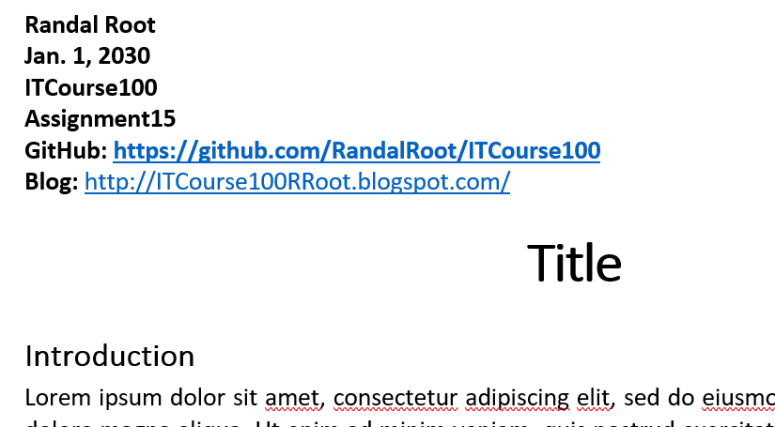

***NOTE****: If you cannot create a Blog, let me know! I may allow you to turn in a Word document as usual.*

## Step 7 - Post your document

You need to post a **link to your Blog in the discussion forum** so that others may review it, by adding your link to the “Assignment 07 Links for Review.”

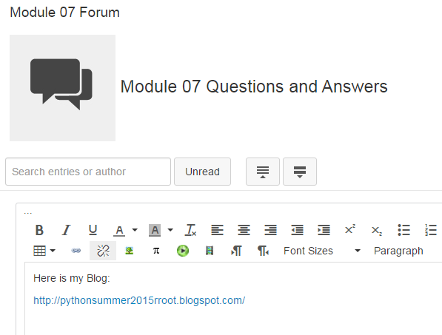

## Step 8: Submit your work

Place your Word document and your python script(s) in the Assignment07 folder. Zip this folder into a “.zip” file, then upload the file to the class assignment page as usual.

***Important:*** *You must also upload your python script to both GitHub and the Canvas assignment’s Zip file.*

## Step 9: Perform a Peer Review (Not Graded!)

You have been assigned a Peer Partner for this assignment. Keep watch for your partners posting to thier GitHub repostitorie after the assignment’s due date. One you see it, review their work and post some comments about it on the discussion forum.

Make sure to:

* Say two things that you liked about their work
* Say one thing that could make the work better

Congratulations! You are done!