AAA 524: Introduction to Virtual (and Augmented) Reality

Korea University, Spring 2021

**Take home exam**

Your mission is to draft a detailed project proposal with the following theme and components. The general theme is “first person fighting” (not shooting) environment (something like what is shown in the figure below). Elements that need to be included in the proposal are listed below. Your proposal will be graded by the maturity and feasibility. For each element of the proposal, try to explain your design choices as much and detailed as possible. Also where needed, provide technical details to convince the reader that your approach will be indeed feasible and implementable. You are free to borrow any techniques that have been developed by others. In fact, you are encouraged to look up the latest research results and apply them toward your project. Remember this is not a game - do not carry out any “game design” aspects – like to how to score, level design, missions, etc.

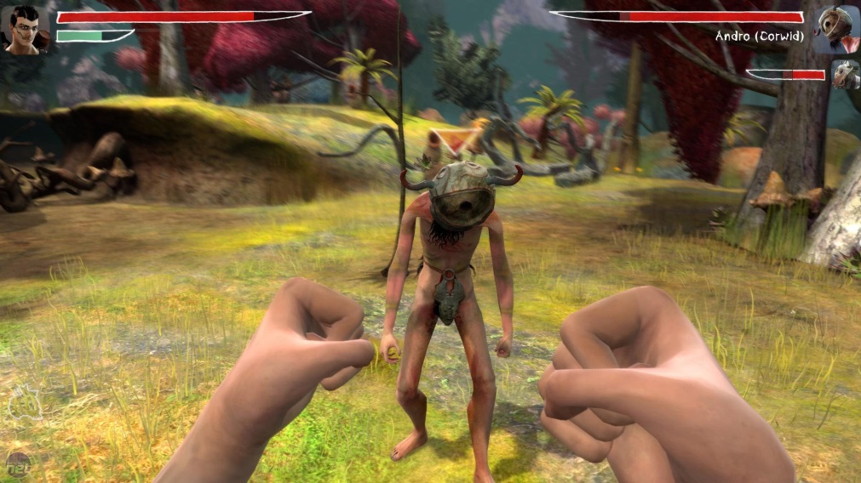

1. Scenario and what makes your scenario fit as VR based game.
2. How the major scenes and objects will be modeled and organized
   1. User, enemies, other objects
   2. Simulated behaviors and animations
   3. Special effects – Visual, Sound, Haptic, etc.
   4. Others
3. System configuration
   1. Platform
   2. Displays and sensors
   3. Other devices (if needed)
4. Presence and co-presence elements
5. How usability of the system (including sickness) will be addressed
6. What kind of intelligence/AI can be or should be incorporated and how
7. Interaction/experience design
   1. Navigation
   2. Fighting
   3. Others – Selection of weapons, armory, shields, …
8. Budget/cost and development timeline