My First Markdown

Nick Stamboglis

20 June 2020

## R Markdown

This is an R Markdown document. Markdown is a simple formatting syntax for authoring HTML, PDF, and MS Word documents. For more details on using R Markdown see <http://rmarkdown.rstudio.com>.

When you click the **Knit** button a document will be generated that includes both content as well as the output of any embedded R code chunks within the document. You can embed an R code chunk like this:

summary(cars)

## speed dist   
## Min. : 4.0 Min. : 2.00   
## 1st Qu.:12.0 1st Qu.: 26.00   
## Median :15.0 Median : 36.00   
## Mean :15.4 Mean : 42.98   
## 3rd Qu.:19.0 3rd Qu.: 56.00   
## Max. :25.0 Max. :120.00

## Including Plots

You can also embed plots, for example:

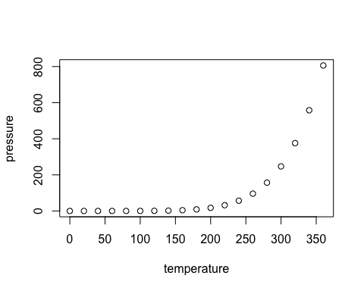

Note that the echo = FALSE parameter was added to the code chunk to prevent printing of the R code that generated the plot.

## GGplot2 Graph

Here’s the same plot in ggplot2

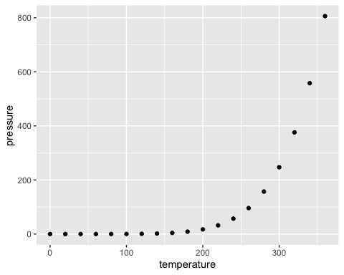

## Equations

### In Text

Equations can be embed in a text line: $E=mc^{2}$

### Separate from text

Equations can be put on a different line:

$$\underset{x→∞}{\text{lim}}f(x)$$

### Equation of the *mean*

$$\overline{x}=\frac{1}{n}\sum_{i=1}^{n}{x_{i}}$$

## Tables

### Table Without Alignment Formatting

|  |  |  |
| --- | --- | --- |
| Col 1 | Col 2 | Col 3 |
| Value | Value | Value |
| Value | Value | Value |

### Table With Alignment Formatting

|  |  |  |
| --- | --- | --- |
| Col 1 Left | Col 2 Center | Col 3 Right |
| Value | Value | Value |
| Value | Value | Value |

## Other Languages Chunk

## Python

python_string = "hello, world"  
print(python_string.split(" "))

## ['hello,', 'world']