**Math, Genes, and You**

Week 2, Day 1: Allele and Genotype Frequencies

**Plan for today**

Problem set 1

Class activity: Genetics trivia

Lecture: Allele and genotype frequencies

Class activity: Genotype simulator

Ask for volunteers for genetics news

**Course Documents**

In addition to Open Learning, you can now access them here: <https://github.com/gjmzajac/math-genes-you>

**Definitions**

**Allele Frequency** – The frequency *p* at which a particular allele occurs at a variant in the population. For a variant with two alleles, A and B:

**Genotype Frequency** – The frequency at which a particular genotype occurs in the population.

**Hardy-Weinberg Equilibrium** – A model for predicting genotype frequencies in a population using allele frequencies. For a variant with two alleles:

**Bi-allelic variant** – A variant site with two alleles, for example, A and C.

**Multi-allelic variant** – A variant site with three or more alleles, for example A, C, and G.

|  |  |
| --- | --- |
| Individual 1: | -T-G-A-G-G-**A**-T-T-T-T- |
|  | -T-G-A-G-G-**A**-T-T-T-T- |
|  |  |
| Individual 2: | -T-G-A-G-G-**C**-T-T-T-T- |
|  | -T-G-A-G-G-**G**-T-T-T-T- |

**SNP** – single-nucleotide polymorphism. A single-base change in the DNA sequence.

|  |  |
| --- | --- |
| Individual 1: | -T-G-A-G-G-**A**-T-T-T-T- |
|  | -T-G-A-G-G-**A**-T-T-T-T- |
|  |  |
| Individual 2: | -T-G-A-G-G-**A**-T-T-T-T- |
|  | -T-G-A-G-G-**C**-T-T-T-T- |

**INDEL** – Insertion-deletion polymorphism. A change in the DNA sequence that modifies its length.

|  |  |
| --- | --- |
| Individual 1: | -T-G-A-G-G-**A**-T-T-T-T- |
|  | -T-G-A-G-G-**A**-T-T-T-T- |
|  |  |
| Individual 2: | -T-G-A-G-G-**A**-T-T-T-T- |
|  | -T-G-A-G-G-**A**-**C**-T-T-T-T- |

**Chromosome** – A single DNA molecule, often tens of millions of bases in length. Humans have 23 chromosome pairs in each cell, a total of 46 chromosomes.

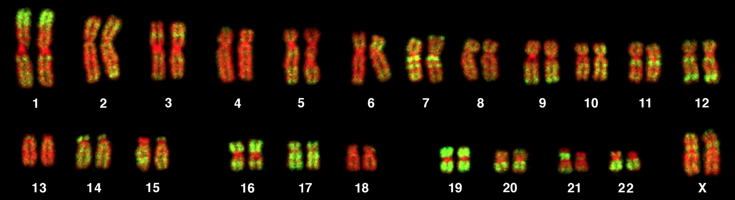

src: <https://journals.plos.org/plosbiology/article?id=10.1371/journal.pbio.0030157>

**Ploidy** – The number of copies of each chromosome in each cell that an organism has.

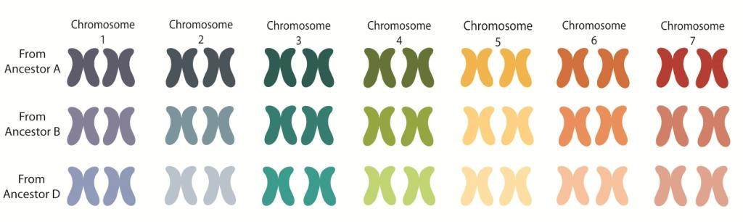

src: <https://coloradowheat.org/2013/11/why-is-the-wheat-genome-so-complicated/>

**Diploid** – An organism that has two copies of each chromosome in each cell. Humans are diploid.

**Examples**

Example 1: Predicted genotype frequencies with equal allele frequencies *pA* = *pB* = ½

Example 2: Predicted genotype frequencies with equal allele frequencies *pA* = 0.9; *pB* = 0.1

**Genetics Trivia**

* Split each team into a breakout room
* Your team will have one minute to answer each of five questions in the first round
* You may wager 1, 2, 3, 4 or 5 points on a question. You can only use each wager for only one question.
* Submit your wager and answer to the teacher or TA in your room
* Add up your points at the end of the first round. We will report the totals for each team.
* Decide on your wager for the final question. You may wager up to the number of points you have. This time, if you get the question wrong, your wager will be deducted from your total.
* Then, your team will have one minute to answer the last question
* We will read the final question and whichever team has the most points, wins!

**Genotype Simulator**

Pick an allele frequency *pA* and we will simulate genotypes for you.

**Problem set 2:**

Submit your answers to Open Learning:

1. You observe a variant with the following genotypes in 10 individuals: *nAA*=5, *nAB*=4, *nBB*=1. What are the allele frequencies at this variant?
   1. Is the variant in Hardy-Weinberg Equilibrium?
2. Consider a bi-allelic variant with alleles A and B. If *pA*=0.3, what are the expected genotype frequencies?
3. Consider a bi-allelic variant with alleles A and B. If p(AA) = 0.5, what are
   1. *pA* =
   2. *pB* =
   3. p(AB) =
   4. p(BB) =
4. Consider a multi-allelic variant with three alleles, A, B, and C. Assume *pA*=*pB*=*pC*. What are the possible genotypes and their expected frequencies?