**Math, Genes, and You**

Week 2, Day 2: Allele and Genotype Frequencies (Continued)

**Plan for today**

Group activity: Genetics Terms Kahoot

Class activity: Genotype simulator

Ask for volunteers for genetics news

**Definitions**

All definitions also now available here: <https://github.com/gjmzajac/math-genes-you/blob/master/Math_Genes_You_Important_Definitions.docx>

**Allele Frequency** – The frequency *p* at which a particular allele occurs at a variant in the population. For a variant with two alleles, A and B:

**Genotype Frequency** – The frequency at which a particular genotype occurs in the population.

**Hardy-Weinberg Equilibrium** – A model for predicting genotype frequencies in a population using allele frequencies. For a variant with two alleles:

**Bi-allelic variant** – A variant site with two alleles, for example, A and C.

**Multi-allelic variant** – A variant site with three or more alleles, for example A, C, and G.

|  |  |
| --- | --- |
| Individual 1: | -T-G-A-G-G-**A**-T-T-T-T- |
|  | -T-G-A-G-G-**A**-T-T-T-T- |
|  |  |
| Individual 2: | -T-G-A-G-G-**C**-T-T-T-T- |
|  | -T-G-A-G-G-**G**-T-T-T-T- |

**SNP** – single-nucleotide polymorphism. A single-base change in the DNA sequence.

|  |  |
| --- | --- |
| Individual 1: | -T-G-A-G-G-**A**-T-T-T-T- |
|  | -T-G-A-G-G-**A**-T-T-T-T- |
|  |  |
| Individual 2: | -T-G-A-G-G-**A**-T-T-T-T- |
|  | -T-G-A-G-G-**C**-T-T-T-T- |

**INDEL** – Insertion-deletion polymorphism. A change in the DNA sequence that modifies its length.

|  |  |
| --- | --- |
| Individual 1: | -T-G-A-G-G-**A**-T-T-T-T- |
|  | -T-G-A-G-G-**A**-T-T-T-T- |
|  |  |
| Individual 2: | -T-G-A-G-G-**A**-T-T-T-T- |
|  | -T-G-A-G-G-**A**-**C**-T-T-T-T- |

**Chromosome** – A single DNA molecule, often tens of millions of bases in length. Humans have 23 chromosome pairs in each cell, a total of 46 chromosomes.

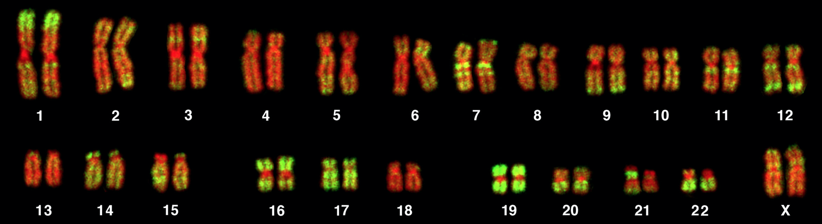

src: <https://journals.plos.org/plosbiology/article?id=10.1371/journal.pbio.0030157>

**Ploidy** – The number of copies of each chromosome in each cell that an organism has.

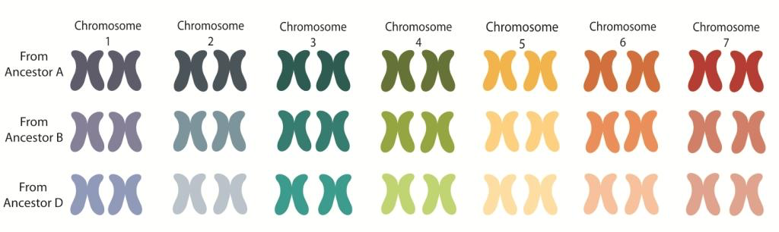

src: <https://coloradowheat.org/2013/11/why-is-the-wheat-genome-so-complicated/>

**Diploid** – An organism that has two copies of each chromosome in each cell. Humans are diploid.

**Genetics Terms Kahoot**

* Carried out in breakout rooms with TAs
* Answer questions related to genetics terms we discussed in class

**Examples**

Example 1: Predicted genotype frequencies with equal allele frequencies *pA* = *pB* = ½

Example 2: Predicted genotype frequencies with equal allele frequencies *pA* = 0.9; *pB* = 0.1

**Genotype Simulator**

* <https://gzajac.shinyapps.io/hwe_simulator>
* Change the allele frequency *pA* with the slider
* Re-simulate genotypes with the button
* See how the predicted and observed genotype frequencies change

**Problem set 2:**

Submit your answers to Open Learning:

1. You observe a variant with the following genotypes in 10 individuals: *nAA*=5, *nAB*=4, *nBB*=1. What are the allele frequencies at this variant?
   1. Is the variant in Hardy-Weinberg Equilibrium?
2. Consider a bi-allelic variant with alleles A and B. If *pA*=0.3, what are the expected genotype frequencies?
3. Consider a bi-allelic variant with alleles A and B. If p(AA) = 0.5, what are
   1. *pA* =
   2. *pB* =
   3. p(AB) =
   4. p(BB) =
4. Bonus Problem: Consider a multi-allelic variant with three alleles, A, B, and C. Assume *pA*=*pB*=*pC*. What are the possible genotypes and their expected frequencies?