**Cell** – Basic biological unit and building block of all life

**DNA** – The genetic material in each cell that is passed down from parents to offspring. Exists in long molecules (called chromosomes) as a double-stranded helix.

**Base** – One of four chemicals that form the DNA sequence, represented by the letters A, C, G, T

**Variant** – A specific place in the DNA sequence where two individuals can differ. For example:

|  |  |
| --- | --- |
| Individual 1: | -T-G-A-G-G-**A**-T-T-T-T- |
|  | -T-G-A-G-G-**A**-T-T-T-T- |
|  |  |
| Individual 2: | -T-G-A-G-G-**A**-T-T-T-T- |
|  | -T-G-A-G-G-**C**-T-T-T-T- |

**Allele** – One of the possible sequences an individual can have at a variant site. In the above example, the two alleles and A and C.

**Genotype** – The alleles that an individual has at a variant. In the above example, the genotypes are AA and AC.

**Allele Frequency** – The frequency *p* at which a particular allele occurs at a variant in the population. For a variant with two alleles, A and B:

**Genotype Frequency** – The frequency at which a particular genotype occurs in the population.

**Hardy-Weinberg Equilibrium** – A model for predicting genotype frequencies in a population using allele frequencies. For a variant with two alleles:

**Bi-allelic variant** – A variant site with two alleles, for example, A and C.

**Multi-allelic variant** – A variant site with three or more alleles, for example A, C, and G.

|  |  |
| --- | --- |
| Individual 1: | -T-G-A-G-G-**A**-T-T-T-T- |
|  | -T-G-A-G-G-**A**-T-T-T-T- |
|  |  |
| Individual 2: | -T-G-A-G-G-**C**-T-T-T-T- |
|  | -T-G-A-G-G-**G**-T-T-T-T- |

**SNP** – single-nucleotide polymorphism. A single-base change in the DNA sequence.

|  |  |
| --- | --- |
| Individual 1: | -T-G-A-G-G-**A**-T-T-T-T- |
|  | -T-G-A-G-G-**A**-T-T-T-T- |
|  |  |
| Individual 2: | -T-G-A-G-G-**A**-T-T-T-T- |
|  | -T-G-A-G-G-**C**-T-T-T-T- |

**INDEL** – Insertion-deletion polymorphism. A change in the DNA sequence that modifies its length.

|  |  |
| --- | --- |
| Individual 1: | -T-G-A-G-G-**A**-T-T-T-T- |
|  | -T-G-A-G-G-**A**-T-T-T-T- |
|  |  |
| Individual 2: | -T-G-A-G-G-**A**-T-T-T-T- |
|  | -T-G-A-G-G-**A**-**C**-T-T-T-T- |

**Chromosome** – A single DNA molecule, often tens of millions of bases in length. Humans have 23 chromosome pairs in each cell, a total of 46 chromosomes.

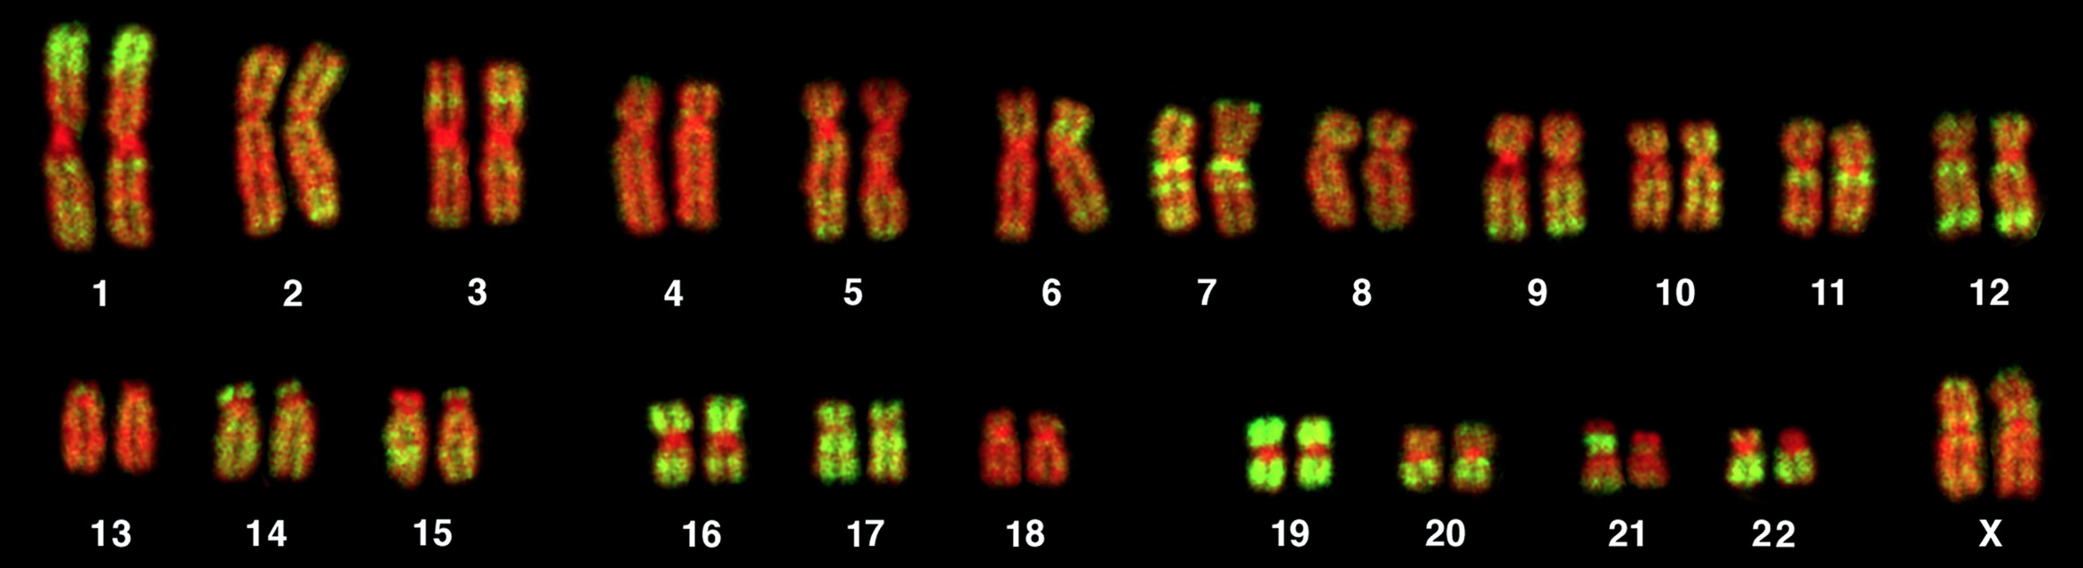

src: <https://journals.plos.org/plosbiology/article?id=10.1371/journal.pbio.0030157>

**Ploidy** – The number of copies of each chromosome in each cell that an organism has.

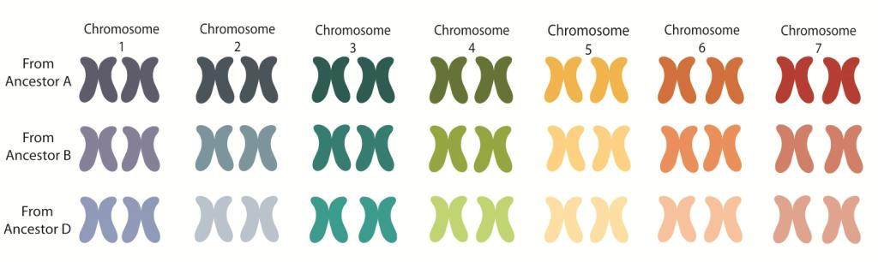

src: <https://coloradowheat.org/2013/11/why-is-the-wheat-genome-so-complicated/>

**Diploid** – An organism that has two copies of each chromosome in each cell. Humans are diploid.

**Pedigree** – A record of individuals’ descent and genetic relationships. Also called a **family tree**.

**Male** – square



**Female** – circle



**Unspecified sex** – diamond



**Parent-child relationship**



**Full Siblings** – A pair of siblings that share both parents



**Nuclear family** – A family consisting of parents, children, and siblings



**Half siblings** – A pair of siblings that share only one parent



**Step siblings** – A pair of siblings who do not share a biological parent



**Identical twins** – Twins who have an exact copy of each other’s DNA



**Fraternal twins** – Twins who share as much DNA as full siblings



**First cousins** – Relatives who share a pair of grandparents



**Grandparent-grandchild relationship**



**Avuncular relationship** – Uncle-nephew, uncle-niece, aunt-nephew, aunt-niece

