View original page on Canvas

Video

Example File
- Word Examples (.docx)

Guide

Images: Part 1
In this course, we’ll use the term “image” as a generic term when speaking about all types of non-text content. Some examples of non-text content in Word and PowerPoint are:
- Pictures
- Icons
- SmartArt
- Charts
This section is covered in three videos. This video will focus on examples using the Pictures tool. The Part 2 video will provide information on the Icons, SmartArt, and Chart tools. The final video of this section will address how to position an image in Word so that its content and/or function is presented to all users.

Objectives
- State two questions for determining equivalent and effective Alt Text for an image.
- Describe the method in Word and PowerPoint for adding Alt Text to an image.
- State the method in Word and PowerPoint for identifying an image as decorative.

Alternative Text
Providing alternative text is vital for users that cannot see images. When correctly added, it is read by screen reading software when a user comes to an image. I’ll open the example document in Word on Windows. Listen to how NVDA responds when it comes to an image with appropriate alternative text.
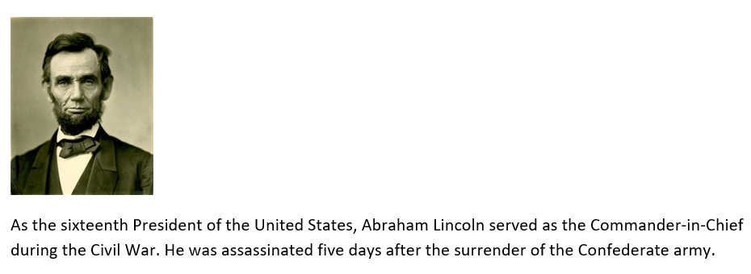
"Graphic: Abraham Lincoln. As the sixteenth President of the United States, Abraham Lincoln served as the Commander-in-Chief during the Civil War, until he was assassinated five days after the surrender of the Confederate army."
[narrator resumes]
For the purposes of this course we will define the term alternative text as: Text that is equivalent to an image that has content and/or a function in a document. In Word and PowerPoint, alternative text can be provided through document text that is nearby to an image. Another method for providing alternative text is to add information to an image itself. In Office 365 this is done through the “Alt Text” pane.

Alt Text
Once you have determined that an image has content and/or a function, and that at least part of this information is not contained in nearby document text, you will need to add Alt Text that is equivalent and effective.

Equivalent
The first step when determining equivalent Alt Text for an image is to ask yourself two questions:

- If I remove this image from the document, what text would I add instead?
- What is the function of the image?
If the answer to question number one is “none”, then the image is decorative. For question number two, in Office 365 images can function as a link to a web page or a file, another place in the document, or to an email address. I’ll demonstrate how to address both of these scenarios in upcoming examples.

Efficient
It is important to ensure that Alt Text is as efficient as possible. In most cases Alt Text:
- Uses just a few words
- Is not redundant with nearby document text
- Avoids phrases such as "graphic of…", or "image of...".
Keep these characteristics in mind as I have NVDA reread the information provided by the image of Abraham Lincoln and the document text.
"Graphic: Abraham Lincoln. As the sixteenth President of the United States, Abraham Lincoln served as the Commander-in-Chief during the Civil War, until he was assassinated five days after the surrender of the Confederate army."
[narrator resumes]

Succinct
Good Alt Text should be succinct, as it is in this example: “Abraham Lincoln”. Information that is not part of an image’s content, as determined by its context in the document, should not be included. In this example, incidental visual information such as the fact that Mr. Lincoln is wearing a bow tie, or that he has a beard, is not part of the image’s content.

Not Redundant
Although the Alt Text value duplicates information in the document text below it, it is not redundant. This image acts as a visual “heading” that precedes the text. If I were to ask myself the question “If I remove this image from the document, what text would I use instead?”, the answer would be “Abraham Lincoln”, and I would format the text as a heading.

Avoids unnecessary phrases
NVDA labeled the image as a “graphic” automatically, so there is no need to add this information to the Alt Text value. NVDA would also identify if the image functioned as a link.

Adding Alt Text

Example 1
To practice adding Alt Text to an image, I'll navigate to Example 1––an image of the Microsoft Word logo with the text "Microsoft Word 365" beside it.
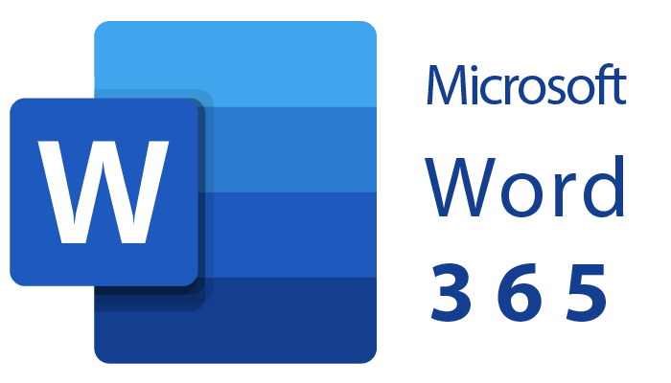
I will use this content as my Alt Text. In most cases text within an image will be at least part of the Alt Text value.
The process to add Alt Text is the SAME on Windows and Mac operating systems, for both Word and PowerPoint.


To add an Alt Text value to an image in Word (or PowerPoint) for Windows (and Mac):
- Right-click on the image.
- Select “Edit Alt Text” from the menu (the Alt Text panel opens on the left-hand side of the user interface).
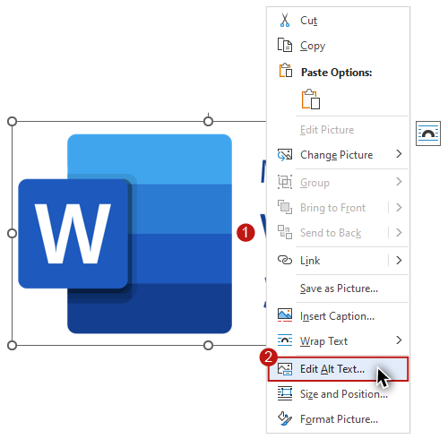
- Place the alternative text value in the text field.
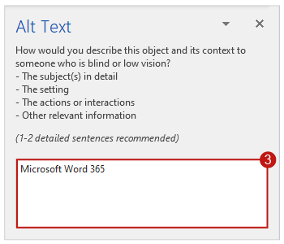
When the Alt Text panel first opened, the text field contained the following text: “A picture containing text, sign | Description automatically generated.” In WebAIM’s testing, these automatically-generated descriptions are usually not equivalent to the image’s content. We do NOT recommend this tool for adding Alt Text.
[The words "NOT RECOMMENDED" are stamped across the Alt Text panel.]

Example 2
Example 2 shows an image of Ellen Ochoa followed by this text: "As the first Hispanic woman to go to space, and, later, the first Hispanic director of Johnson Space Center, Ellen Ochoa is widely regarded as a role model."
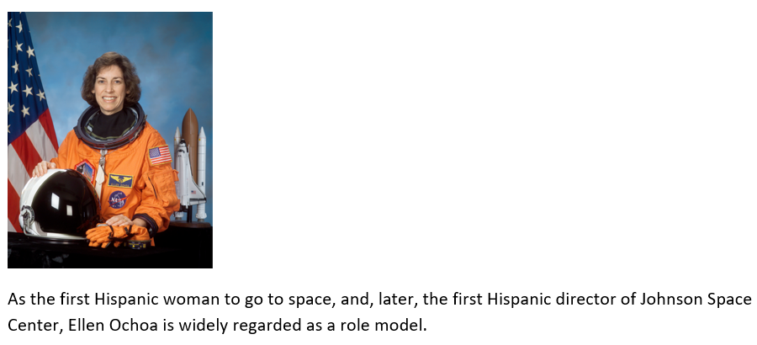

What would be equivalent and effective Alt Text for the image in Example 2?
The options listed are:
- “Image of Ellen Ochoa, Astronaut”
- "Astronaut Ellen Ochoa"
- “Ellen Ochoa, the first Hispanic woman to go into space”.
Option A includes the unnecessary phrase: “image of”. As you have learned, screen reading software will identify an image with a term such as "graphic" by default. Option C provides information that is not part of the image’s content, and it also duplicates document text. Option B identifies the occupation of the woman pictured. This is prominently featured in the image, and directly relevant to the context. It also provides her name. I’ll use the same process that I did in example 1 to add this Alt Text value to the image.

Example 3
Example 3 features the same image and document text as Example 2, with the addition of a text element just below the image that reads: “Ellen Ochoa, Astronaut”.
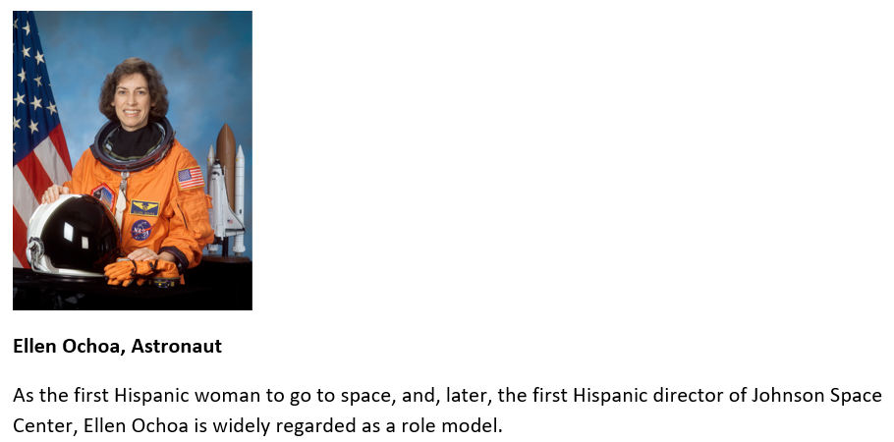

What would be equivalent and effective Alt Text for the image in Example 3?
The options listed are:
- An Alt Text value of “Image”
- An Alt Text value of "Astronaut Ellen Ochoa"
- None—equivalent alternative text is already provided.
The text value in Option A is not necessary. The Alt Text in Option B is redundant with information provided by nearby document text. Option C is the correct answer.
In Word and PowerPoint, when an image’s content is conveyed in nearby document text, or if an image does not require equivalent text because it does not provide content and/or have a function, the image should be marked as decorative.
To mark an image as decorative in Word (or PowerPoint) for Windows (and Mac): 1. Right-click on the image; 2. Select “Edit Alt Text” from the menu (the Alt Text panel opens on the left-hand side of the user interface); and, 3. Check the “Mark as decorative” checkbox.

Example 4
Example 4 features the same image and document text as Example 3, but a blue border has been added to the image, which is a visual convention for a linked image.
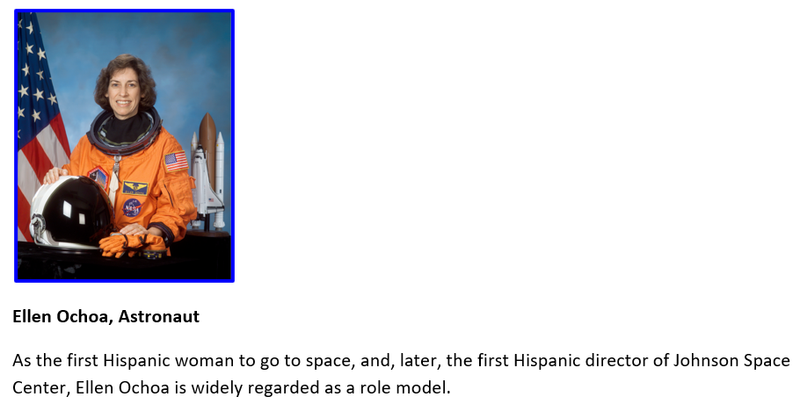
When I hover over the image with my mouse, I see a ScreenTip that indicates that the image is linked to a Wikipedia article on Ms. Ochoa.
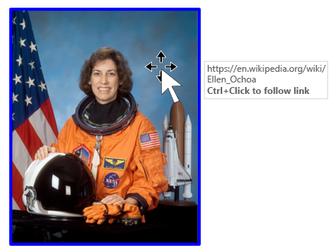

What would be the best alternative text for the content and function of the image of Ellen Ochoa?
The options are:
- Alt Text of “Astronaut Ellen Ochoa”
- Alt Text of “Wikipedia entry for Ellen Ochoa”
- Mark this image as decorative.
Option B provides information that is not conveyed by the image itself. Option C is incorrect because linked images must always have an Alt Text value. Option A, an Alt Text value of “Astronaut Ellen Ochoa” is correct. A screen reader would typically read "Link, Image, Astronaut Ellen Ochoa. Ellen Ochoa, Astronaut".
The redundancy is necessary to adequately describe the function of the linked image, especially if it were to be accessed in isolation from the adjacent text. As you will see in the following section on Links, screen reader users have the ability to navigate through a document from link to link. Even with visual formatting such as a blue border, sighted users may not always detect when an image is linked. A better way to structure this content would be to link the text that functions as a caption to the Wikipedia article, and mark the image as decorative.
Now that you have learned when and how to provide equivalent and effective alternative text, and how to add Alt Text to Pictures, you are ready to explore alternative text principles and processes for Icons, SmartArt, and Charts.

