View original page on Canvas

Video

Guide

Adding and Editing Hyperlinks
Hyperlinks are a powerful tool for expanding the formats and methods for presenting information in an electronic document. Links to resources such as articles, videos, podcasts, and social media allow authors to leverage some of the awesome potential of web-based documents.

Objectives
- Identify the process for adding and editing Hyperlinks.

Introduction
The process for adding and editing hyperlinks is the SAME in the Windows and Mac versions of Word and PowerPoint. There are some differences between the look and layout of the Windows and Mac user interfaces—
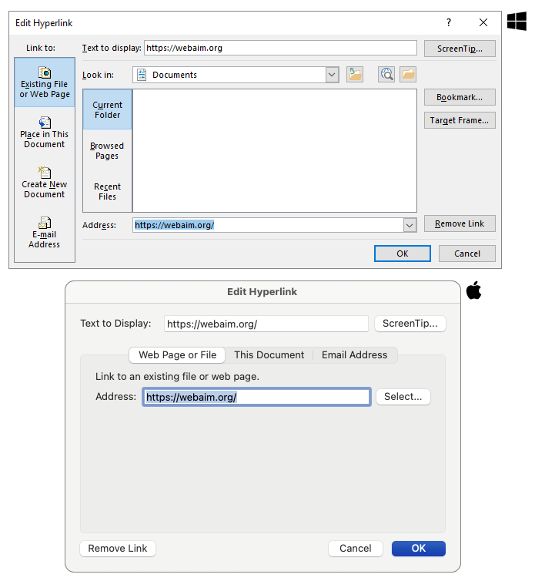
—but the labels for the fields and buttons used to add and edit links are the same.

Adding Hyperlinks
I'll open up a new PowerPoint presentation using the Windows version to demonstrate how to add hyperlinks.If I type (or copy and paste) text that is formatted like a URL, and hit Space or Enter, the URL will become a Hyperlink.

Adding a Hyperlink with a URL
For this demonstration I will paste in the following text—"Saqib, a core Microsoft developer who lost the use of his eyes at age 7, is featured in this video”—followed by a URL to a YouTube video. A link to this video—“Seeing AI 2016 Prototype - A Microsoft research project”—is available in the “Resource Links” for this section."
As I mentioned in a previous video, it is best to avoid using the full text of a long URL as the linked text.

Screen Reader Software demonstration
If I navigate to this link using the NVDA screen reading software, it will read the URL:
[NVDA speaks]
"Link: https://www.youtube.com/watch?v=R2mC-NUAmMk, out of link"
[narrator resumes]

Adding a Hyperlink with Existing Text
This link is not understandable when heard or seen without the context of the preceding text. To fix this issue I'll create a Hyperlink from existing document text. I'll copy this example and switch to Word on Windows to demonstrate how to do this.
First I'll paste in my example. Then I’ll cut the video's URL to remove the current Hyperlink, and use the "this video" text for a new link.


To create a Hyperlink with existing document text, I'll:
- Highlight and right-click the document text;
- Select “Link” from the menu;
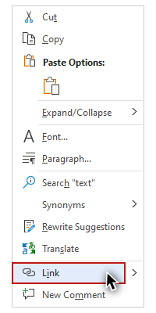
- Type (or paste) the URL in the "Address" field; and,
- Click "OK."
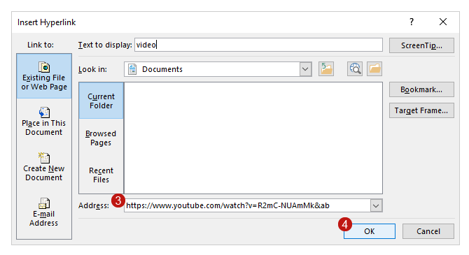
You can also use the keyboard shortcut Control + K on Windows (Command + K on Mac) to add a Hyperlink.

Editing Hyperlinks
Now I have some new linked text. But I also have a problem. The linked text—“this video”—is not very specific or descriptive. It does not adequately convey the function of the link. I'll address these issues by changing this text.


To edit linked text I'll:
- Right-click the Hyperlink.
- Select "Edit Hyperlink" from the menu.
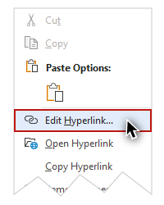
- Change the text in the "Text to Display" field.
- Click "OK."
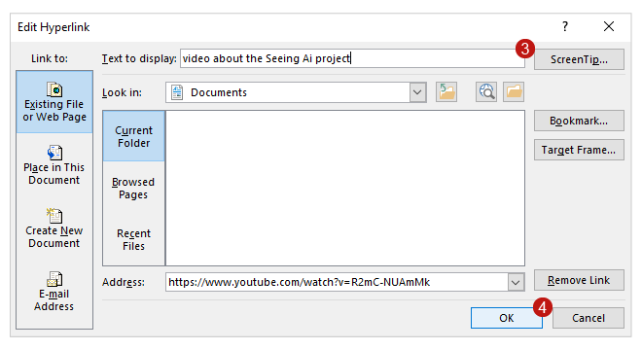
Control + K on Windows (Command + K on Mac) will also open the Edit Hyperlink dialog.

Screen Reader Software demonstration
I've changed the linked text from video" to "video about the Seeing AI project". NVDA now reads:
"link: video about the Seeing AI project, out of link"
[narrator resumes]

Hyperlinked Images
Microsoft Office users can also add a hyperlink to a document’s graphic elements, such as a Picture, Shape, Icon, or Chart. As I mentioned previously, I will demonstrate this process in the “Images” section of this course.
By implementing the principles and processes presented in this section, you will increase access to linked resources in your documents.

