View original page on Canvas

Video

Example File
- Word Examples (.docx)

Guide

Contrast: Part 1
Contrast is the difference in brightness between text and the background of that text. Poor contrast negatively impacts all sighted users. Users with low vision, color blindness, or reading disabilities may be impacted even more significantly. In this video I’ll:
- Review the WCAG requirements for contrast.
- Demonstrate how to identify and resolve contrast issues in Word documents.
- Demonstrate how to check for additional contrast issues using a free third-party application.
In the Part 2 video I’ll explore techniques for identifying contrast issues in PowerPoint presentations and introduce WCAG’s contrast requirements for graphical objects, such as a chart.

Objectives
- State three steps for measuring contrast in Word documents.
- Identify the types of contrast issues that the built-in checker can detect.
- Explore a third-party tool for measuring additional contrast issues.

WCAG contrast ratio requirements
WCAG provides guidance on the minimum level of contrast that is required between the color values of text and its background. The formula WCAG uses measures the perceived “luminance”––or brightness difference––between two colors. This difference is presented as a ratio ranging from 1:1 to 21:1. No brightness difference between the two colors is 1:1. The highest possible contrast difference, which can only be accomplished with black text on a white background, or white text on a black background, is 21:1.
For most text, WCAG requires at least a 4.5:1 contrast between the text and its background. Large text, such as a Heading in Word, or a slide Title in PowerPoint, must have at least 3:1 contrast. Large text is defined as 18 point or larger, or 14 point and larger if the text is bold.

Measuring Contrast
We recommend that you follow a three-step process for measuring contrast:
- Start with a visual inspection.
- Review contrast issues identified by the Check Accessibility tool.
- Explore additional contrast issues with a third-party tool (e.g., Colour Contrast Analyser).
I'll open the example document in Word on Windows, and use these steps to measure contrast in four examples.

Visual Inspection
Users with sufficient vision should start with a visual inspection of a document, and note elements that may have insufficient contrast. Remember, WCAG’s requirements are for the minimal level of contrast. If text appears to lack contrast, proactively increasing it will often benefit many sighted users with and without disabilities.
In Example 1, the text color is an extremely light shade of blue.

The contrast ratio between this text and the white background is about 1.4:1, far below the minimum of 4.5:1. For many sighted users, it will be clear that this text should be darker.
In other cases, it may be difficult to determine if text has sufficient contrast just by looking at it. In the second example, there is red text that looks like it has more contrast than the light blue text, but does it meet the minimum requirement?
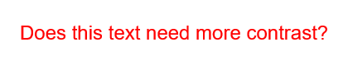
What about the larger text in Example 3?

Let’s look at the answers to these questions by running the Accessibility Checker.

Accessibility Checker
Both Word and PowerPoint have a built-in tool that can automatically identify some accessibility issues. I’ll explore the full range of these issues in Module 3. In this video I’ll focus on identifying and resolving contrast issues in Word. The process to open this tool is the same on Windows and Mac.


To check for contrast issues on Windows (and Mac):
- Select the REVIEW tab on the Ribbon.
- Click the Check Accessibility tool (the Accessibility pane will open).
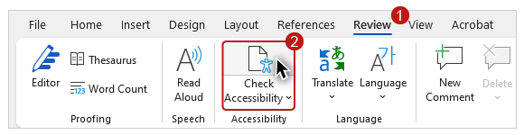
- In the Inspection Results, under the “Warnings” section, look for “Hard-to-read text contrast.”
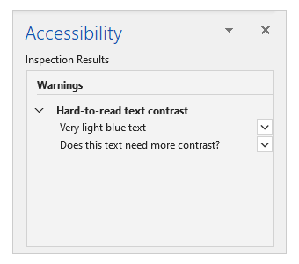
I see two issues listed.

Example 1
The first issue that I see listed is the very light blue text in Example 1. When I click on this issue in the Accessibility pane, the text in the document receives focus as if I had selected it with the mouse or the keyboard.
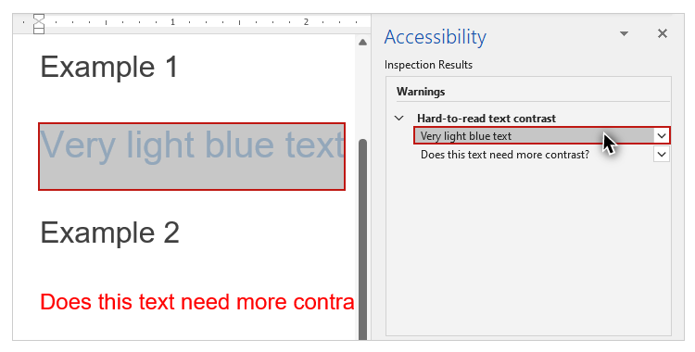
To change the text color, I’ll select the HOME tab on the Ribbon, and click on the “down arrow” symbol on the Font Color tool to open the menu. I’ll select a darker shade of blue from the Theme Colors section. I’ll know I have picked a color with sufficient contrast when this text is no longer flagged in the Inspection Results.

Example 2
The next warning is for the red “Does this text need more contrast?” text in Example 2. I’ll click on this issue to highlight the text, and reopen the font color menu. I see that the highlighted color chip for this red is in the Standard Colors section of the menu.
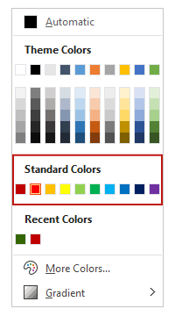

At the current time the color values in the Standard Colors section labeled “red, orange, yellow, light green, green, and light blue” do NOT have sufficient contrast for regular text on a white background.
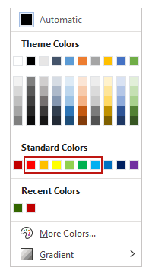
I’ll select the “dark red” standard color. This text is no longer flagged in the Inspection Results, so I know it has sufficient contrast with the white background.

Example 3
The text in Example 3 appears to be the same color red as the text in Example 2. When I inspect the “font size” value on the HOME tab, I see that this font is 18 point. Under WCAG’s definition, this qualifies as “large text”. This text is not flagged, so its contrast ratio must be greater than 3:1.

Colour Contrast Analyser
When you want to measure a contrast ratio directly, and detect contrast issues that are not flagged by the built-in checker, you will need a third-party application. In this video I’ll use the Colour Contrast Analyser (or CCA), which is listed in the Resource Links for this section. I have previously downloaded and installed this free tool on my local machine. To explore this tool, you will need to do the same. Please note: our most recent testing revealed an issue with the CCA running on the latest version of Mac OS.
When I open the CCA, the user interface is a dialog window that is displayed “over” the Word example file. It has fields for a foreground color and a background color. I’ll click the “sliders” button on each color field to display the sliders for adjusting each color’s values. At the bottom of the CCA there is also a sample preview section, followed by a “WCAG 2.1 results” section.
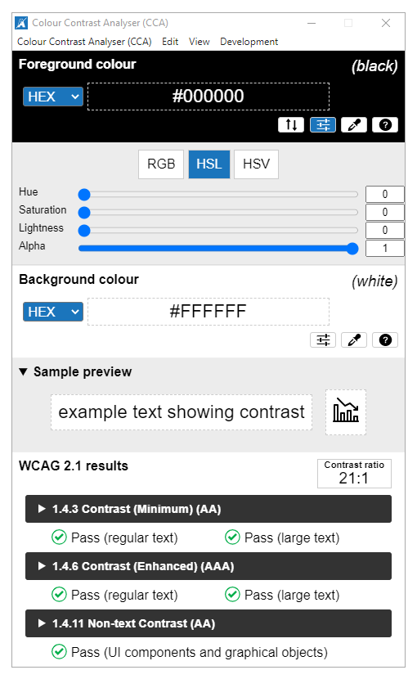
In the “Foreground color” section I’ll select the color picker tool. My mouse cursor is replaced with a circular tool that is zoomed in to a grid of the individual pixel elements of whatever I hover over, with one pixel highlighted in the middle of the circle.
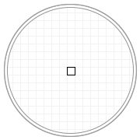
I’ll hover over the text in Example 3 and click to select the highlighted color value. In the “WCAG 2.1 results” section I see that this color value has a 4.1:1 contrast ratio with the white background. This meets the standard for large text, so the Example 3 text was not flagged in the Inspection Results. The Example 2 text was flagged because this contrast ratio is slightly below the minimum required for regular text.

Example 4
Example 4 shows white text on a linear gradient background that is light-blue in the middle, fading out to white at the top and bottom.

From a visual inspection one might think that there is insufficient contrast between the text and the background, but nothing is flagged in the inspection results. The Check Accessibility tool cannot measure contrast between text and a gradient background.
I’ll use the foreground color picker on the text. This text is pure white, which is represented by the hex (which is short for hexadecimal) value: #FFFFFF. Hex values always start with the “#” symbol. Using the background color picker, I’ll get the value of the light-blue color adjacent to the white text: #B4D2EC. In the results section I see that the contrast ratio is insufficient––1.6:1.
To find a color value with sufficient contrast for regular text, I’ll use the sliders below the foreground color field. I’ll use the “lightness” slider to reduce the value until the contrast ratio is above 4.5:1. At a lightness value of 34, the contrast ratio is 4.6:1.
To change the color of this text, I’m going to use the hex value displayed for this darker gray text: #575757. The color tool on both Windows and Mac also accepts RGB (red-green-blue) values, but this requires filling in three separate fields.

Changing a Hex value
In order to use this hex value for the text in Example 4, I’ll need to change the current value. Changing a hex value in Office is slightly different in Windows and Mac, so I’ll demonstrate the process on both operating systems.

Windows


To change the hex value of text in Word (or PowerPoint) on Windows:
- Highlight the text.
- Select the Home tab on the Ribbon.
- Click the down arrow symbol on the “Font Colors” tool (the font colors menu opens).
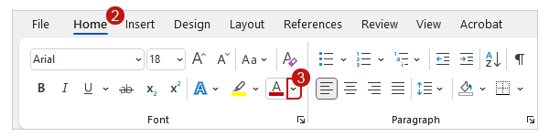
- Select “More Colors” (the “Colors” dialog opens).
[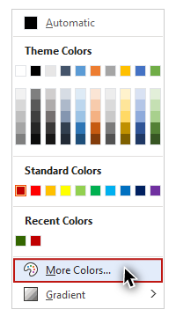
- Select the "Custom" tab.
- Type in the new value (including the hash symbol) in the “Hex” field.
- Click “OK.”
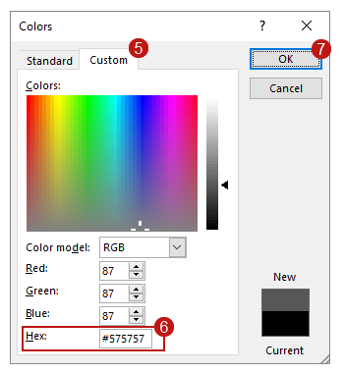

Mac
Now I’ll open the example file in Word running on a Mac.


To change the hex value of text in Word (or PowerPoint) on Mac:
- Highlight the text.
- Select the Home tab on the Ribbon.
- Click the down arrow symbol on the “Font Colors” tool (the font colors menu opens).
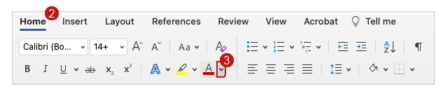
- Select “More Colors” (the “Colors” dialog opens).
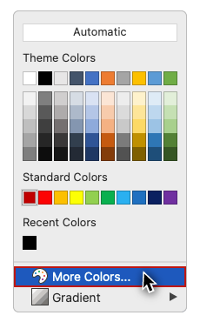
- Select the “Color Sliders” tab (this should be selected by default).
- Type in the new value (without the hash symbol) in the “Hex Color” field.
- Click “OK.”
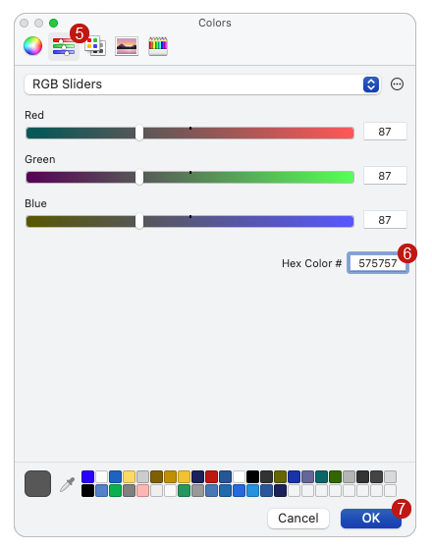
In this video you have learned three methods for identifying contrast issues in Word documents:
- Starting with a visual inspection.
- Reviewing contrast issues identified by the Check Accessibility tool.
- Exploring additional contrast issues with a third-party tool.
In Part 2, you’ll learn specific methods for identifying contrast issues in PowerPoint, and receive an introduction to WCAG’s contrast requirements for graphical objects.

