View original page on Canvas

Video

Example File
- Word Examples (.docx)

Guide

Color Reliance
Color reliance is using hue, shade, tint or tone as the only means of conveying information. Color reliance impacts users with color vision deficiency, and blind users; and it may impact users with low vision.

Objectives
- Gain an understanding of color reliance and its impact on some users.
- Review three best practices for avoiding color reliance.

Color Vision Deficiency
In the U.S., approximately 8% of men, and .1% of women—or about 4% of the population—have color vision deficiency, commonly called "color blindness". This condition makes it difficult to differentiate certain color combinations.
There are seven official diagnoses of color blindness. Four different types of color blindness fall into the red-green category. There are two types in the blue-yellow spectrum, and in one type people completely lack the ability to perceive color. Red-green color deficiency is the most common type.
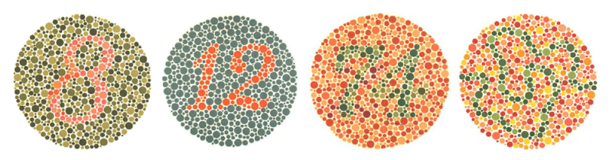

Other Issues with Color

While it may seem obvious once you think about it, if someone is blind, they are also color blind. Screen reading software doesn't typically indicate colors in documents.
Also, some users with low vision may have difficulty perceiving certain colors. They may override the colors in a document to view them in a combination that works best for them.

Examples
I’ll open the example file on Word for Windows.

Example 1
Example 1 reads—
"Gather samples of some of the mushrooms we have studied this semester. You might be tempted to taste them in the field. Just remember that the mushrooms listed in red text may kill you :)"
—followed by a list: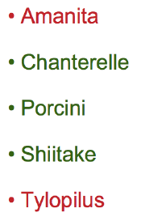
Amanita and Tylopilus are both listed in red text. The only way a person would know some very important information—that these mushrooms may kill them—is by the color of the text.

- How could this information be made accessible without relying on color alone?

Example 2
Probably the best approach is to group the mushrooms in separate lists—one for edible mushrooms, and another for poisonous mushrooms—as shown in Example 2.
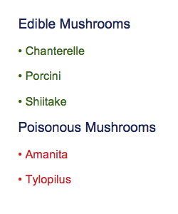
This information could be a matter of life or death, and this would remove all ambiguity.

Example 3
Example 3 shows that you could still use color to help reinforce the information provided by the document’s visual presentation and structure.
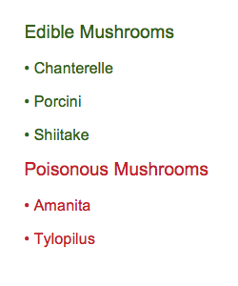

Example 4
Another method might be to use text labels to differentiate the poisonous mushrooms. In Example 4 the word "poisonous" is added in parentheses after the Amanita and Tylopilus text.
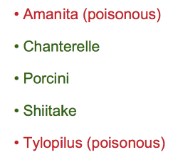
Using Word’s list tool creates the document structure needed to ensure that this information is presented correctly to screen reading software users. When the list is read, the text label will be grouped with the correct item in the list.

Example 5
Example 5 demonstrates using a skull and crossbones image to differentiate the poisonous mushrooms:
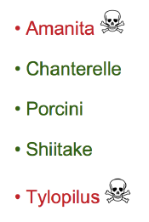
The images must be given alternative text so that screen reading software users will be presented with the information that is provided visually. In this example the images have Alt Text of “poisonous”. When using this technique, be sure to follow the best practices for alternative text provided in the “Images” section of this course.

Text styling
In addition to relying on color alone, do NOT rely on text formatting (e.g., bold or italics) as the ONLY means of differentiating important content or information. Screen reading software does NOT typically present additional information for visual formatting applied to text.

Charts and Graphs
Spreadsheets, charts, or graphs may also contain color-reliant information. Strategies for avoiding this issue are covered in Module 5: Accessible Excel.

Three Best Practices
To summarize, our three best practices for avoiding color reliance are:
- Separate your content.
- Provide text labels.
- Use images with alternative text.
By understanding the impacts of color-reliant information and implementing best practices, your documents will be optimized for users with color vision deficiency, users with low vision, and blind users. This concludes the section on Contrast & Color Reliance.

