View original page on Canvas

Video

Example Files
- Word Examples | English (.docx)
- Word Examples | Spanish (.docx)

Guide

Plain Language, Spelling, and Grammar
Everyone benefits from clearly written, understandable text. For users with cognitive or learning disabilities, simple and clear writing is more than just beneficial––it is a critical component of accessibility.
Modules 2, 3, and 4 focus on creating documents with the proper structure and information to support all users––including those that use assistive technologies. Although optimizing structure is important, the foundation of accessibility is content that can be understood the first time it is read or heard.

Objectives
- Identify six principles of plain language that should be considered.
- State the process for checking and fixing spelling and grammar issues.
- Describe the process for setting the language type for a block of text.

Plain Language
The Plain Writing Act of 2010 defines plain language as: Writing that is clear, concise, well-organized, and follows other best practices appropriate to the subject or field and intended audience.
According to plainlanguage.gov, your material is written in plain language if the audience can:
- Find what they need
- Understand what they find the first time they read or hear it
- Use what they find to meet their needs

Six principles of plain language
You can simplify the language in your documents by adopting these six principles:
- Write for your audience;
- Focus on the most important information;
- Use technical or complex terms only when necessary;
- Use active verbs and personal pronouns;
- Explain unknown acronyms and abbreviations; and,
- Use proper spelling and punctuation.
For information on these and other principles, follow the link for WebAIM’s "Writing Clearly and Simply" article in the Resource Links for this section.

Reviewing Spelling and Grammar in Word
Content with proper spelling and grammar is easier to understand. As you create your document text, use Word’s built-in tools to review spelling and grammar. These tools help writers of all abilities check for mistakes, such as repeated or omitted words, or typos.
I’ll open a blank document in Word on Windows and type a sentence with two types of issues.
Word flags a spelling issue with a red squiggly underline, and it flags a grammar issue with a blue double underline.

Enabling Spelling and Grammar

Windows
If I wasn’t seeing these flags,


To check spelling and grammar during typing in Word on Windows:
- Click FILE on the Ribbon.
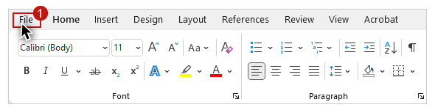
- Select Options on the side pane.
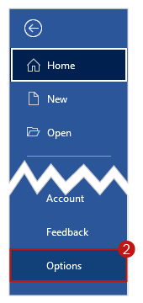
- Click “Proofing” on the Word Options dialog.
- In the "When correcting spelling in Word” section, check both “Check spelling as you type”––
- “Mark grammar errors as you type."
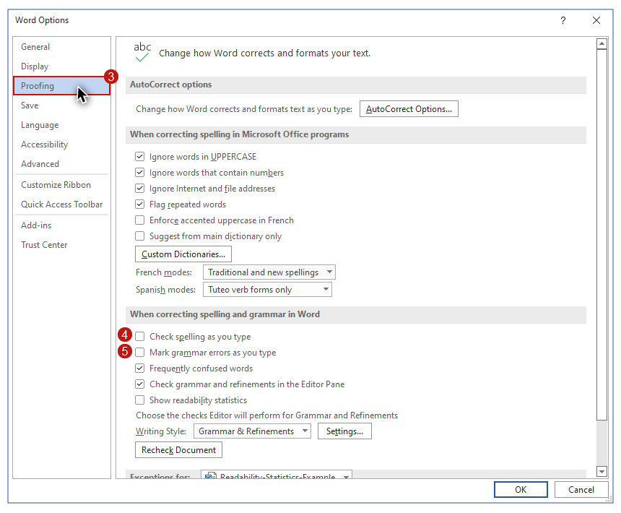
Before I click OK, I am going to check “Show readability statistics” in this same section to activate this tool for the upcoming “Readability” video.
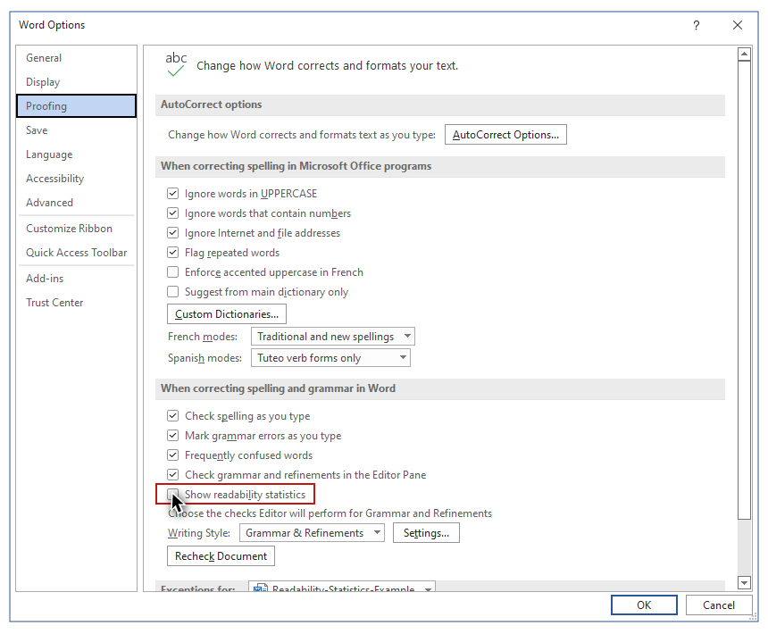

Mac


To enable spelling and grammar checking during typing in Word on Mac:
- Click the Word application menu.
- Select “Preferences.”
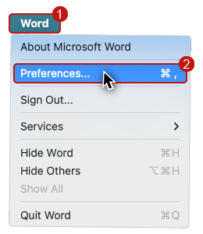
- In the Authoring and Proofing Tools section, click the “Spelling & Grammar” option.
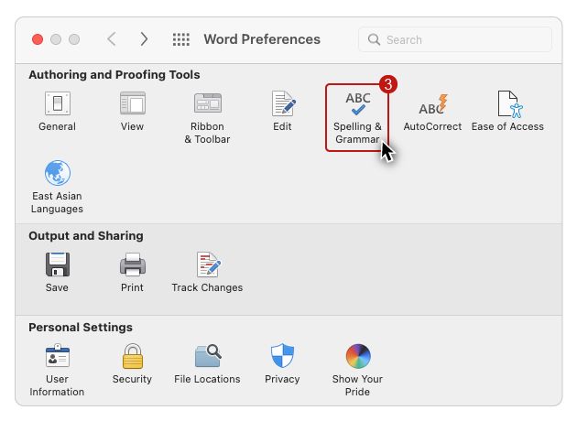
- In the Spelling section click the “Check spelling as you type” option.
- In the Grammar section check the “Check grammar as you type” option.
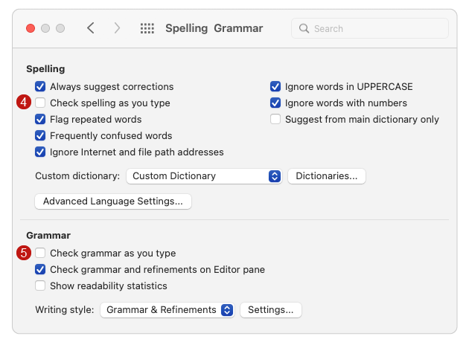
Before I close the dialog, in the Grammar section I will check “Show readability statistics”.
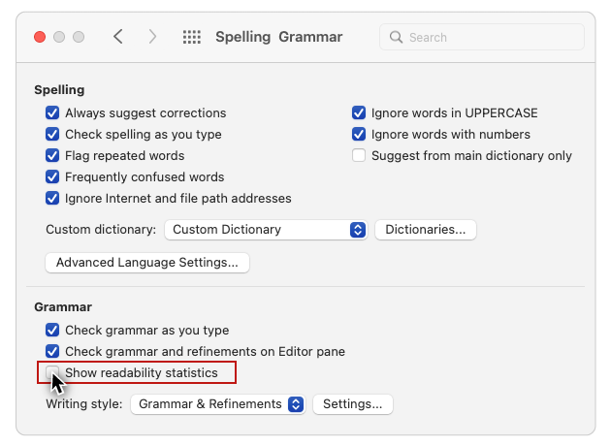
As of the filming of this video, Mac users must turn on Office Connected Experiences in the Security & Privacy preference pane to enable this option.

Editor
On the Review tab, there is a tool called “Editor”. There are some minor differences between the Windows and Mac versions of this tool, but these differences do NOT impact the general review process.
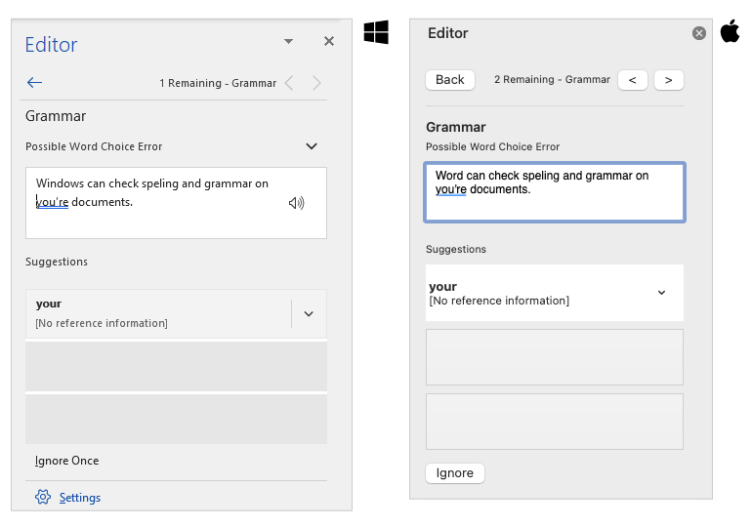
I'll open the “Word Examples” file provided for this section. Because Word is checking spelling and grammar while I type, four issues are flagged. When I click on the Review tab, and open the Editor, I see three issues listed for spelling, and one for grammar.
I’ll click on “Spelling” (the Mac interface requires a double-click). The issue displayed, and in focus in the document, is based on where a user is currently working. Because I’ve just opened the document, focus is placed on the first issue.

Ignore Options
There are two Latin words flagged: trias politica. One way to resolve this issue would be to mark this text as Latin, but this process is usually reserved for blocks of text. I’ll demonstrate the process for identifying text in a language that is different from the main language at the end of this video.
- Ignore Once: will remove the flag from this instance;
- Ignore All: will remove flags for all instances in this document; and,
- Add to Dictionary: will remove flags for all instances in this document, and no longer flag instances in future documents.
On the Mac interface these options are labeled: Ignore, Ignore All, and Add. I’m going to ignore these two words.

Suggestions and Changes
For the next issue, Word has provided a Suggestion for the misspelled word “administored”, and it is the correct spelling. If there were other instances of this word in my document, I would expand the options menu and select “Change All”, but in this case I will just click the suggestion to change this instance.

Grammar
Next I’ll click the Grammar button on the Editor side pane. When I read the sentence that is highlighted––“These branches is first defined in the U.S. Constitution”––I can see that the form of the verb needs to match the plural subject. The Editor provides the correct form as a Suggestion, so I will click on it to change the verb from “is” to “are”.
Remember that Word and PowerPoint cannot identify all errors. A manual spelling and grammar review of the document is always recommended.

Documents with Multiple Languages
Now let’s circle back to issues caused by documents with more than one language. In order for screen reading software to function correctly, the language of the content in a document needs to be correctly identified.
For instance, what if this document were in Spanish? When I open the “Word Examples - Spanish” file, there are red squiggly underlines everywhere. When go to the Review tab on the Ribbon, and click “Language”, I see that it is set to English. The cause of this visual mess is a disconnect between the language of the document text––Spanish––and the English dictionary being used to check spelling.
I’ll use the keyboard shortcut CTRL + A ( command + A on Mac) to select all of the document text. When I change the Language setting to Spanish, the spelling flags disappear.
While this disconnect may be annoying for visual users, it can present a significant issue for screen reading software users.

Screen reading software demonstration
I’ll demonstrate this by switching the Language back to English, opening NVDA and reading the last three sentences:
[NVDA reads]
“El poder judicial es el sistema judicial. Explica y aplica las leyes. Esta rama hace esto escuchando y tomando decisiones sobre varios casos legales.”
[narrator resumes]
I’ll reopen the Language tool, select Spanish, and click OK. When NVDA reads this text with its language correctly identified, many of the pronunciations change.
[NVDA reads]
“El poder judicial es el sistema judicial. Explica y aplica las leyes. Esta rama hace esto escuchando y tomando decisiones sobre varios casos legales.”
[narrator resumes]
Following the principles of plain language, and using the built-in spelling and grammar tools, will help you create materials that are easy for your users to understand.

