View original page on Canvas

Video

Example File
- Word Example (.docx)

Guide

Readability
It is important to write content that is easy to read, and written at a reading level appropriate for your target audience. Word’s built-in Readability Statistics tool provides helpful information such as a document’s average number of sentences per paragraph, and the percentage of sentences written in the passive voice.
The Web Content Accessibility Guidelines recommend writing for a “lower secondary education level.” This is a WCAG Level AAA guideline. This strictest level of compliance is not applicable to all documents. For example, the content in an advanced college chemistry class would be beyond the reading level appropriate for the first years of high school.

Objectives
- Identify how to use the Readability Statistics tool.

Measuring Readability
The process for using this tool is very similar in the Windows and Mac versions of Word. I’ll start off by demonstrating the manual process for opening this tool on Mac. After that I will demonstrate the process on Windows, and provide you with numerical guidelines for five key statistics.

Mac
First, I’ll open the example file in Word on Mac.


To enable the "Readability Statistics” tool in Word for Mac:
- On the Review tab on the Ribbon––
- click the Editor tool.
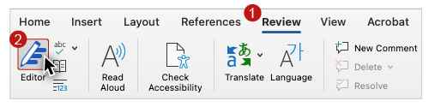
- On the Editor panel, in the Insights section click “Document stats.”
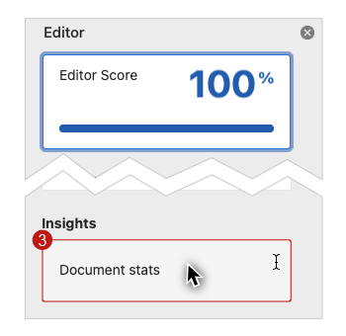
- If a dialog box appears asking if you want to continue, click “OK.”
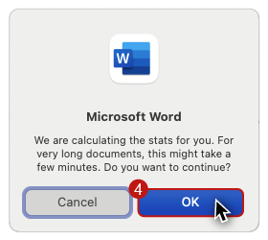

Windows
Now I’ll open the example file in Word on Windows, click the Review tab, and click the Editor tool. Because there are no corrections to address, the Readability Statistics dialog opens automatically.

Readability Statistics
The results in this dialog are organized into three sections: counts, averages, and readability.
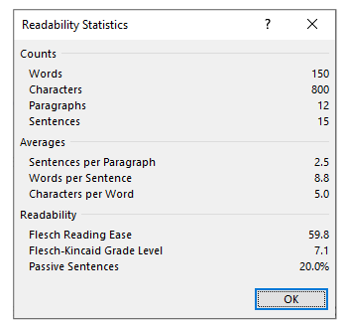

Averages
In the Averages section we recommend reviewing:
- Sentences per Paragraph
- Words per Sentence
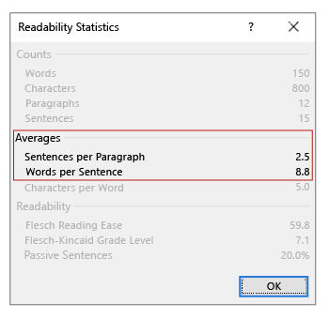
If you average more than 5 sentences per paragraph, review your longer paragraphs. Two methods to consider for shortening paragraphs are:
- Trimming sentences, phrases, or words
- Grouping related items into lists
If you average more than 20 words per sentence, review your more lengthy sentences. One way to reduce sentence length is to reduce the number of clauses it has. For example, it may be possible to separate an independent clause and a dependent clause. By adding some text and restructuring, you should be able to form two new, shorter sentences.

Readability
Word provides three measures of readability:
- Flesch Reading Ease
- Flesch-Kincaid Grade Level
- Passive Sentences
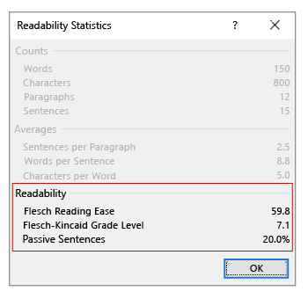
The first two readability tests measure:
- the number of words per sentence
- the number of syllables per word.

Flesch Reading Ease
The Flesch Reading Ease score ranges from 0 to 100, with 100 being the easiest to read. Unless your content needs to be complex, we recommend reviewing your content if the score is under 50.

Flesch-Kincaid Grade Level
The Flesch-Kincaid Grade Level score is based on grade levels in U.S. schools. For most documents, we recommend reviewing your content if the score is over 8.

Passive Sentences
Sentences written in a passive voice distance the action from the subject performing the action. Use sentences written in an active voice directly link the subject with the action.
For example, consider the following sentences:
- The document with optimized accessibility was created by Megan. (passive voice)
- Megan created a document with optimized accessibility. (active voice)
Consider increasing the use of the active voice in your content if your Passive Sentences score is over 20%.

Hemingway App
A useful free tool for measuring readability is the Hemingway App available at hemingwayapp.com.
Paste in the text content of your document and Hemingway will provide suggestions. As you make changes, the application will rescore the content dynamically.
Optimizing the readability of your documents provides benefits for many users. In the next video you will learn how to increase the legibility of your documents.

