View original page on Canvas

Video

Guide

Legibility
For the purposes of this course, a legible document is an electronic file that is easy to see and read based on its visual presentation.

Objectives
- Describe aspects of document presentation that may impact legibility.
- Identify four types of text formatting that may impact legibility.

Text Presentation
In this video I'll address the following:
- Font type and size
- Text formatting
- Line length
- Amount of white space in a document

Font type and size
Use common font faces, such as: Calibri and Times New Roman. Text in overly-complex, fancy, and atypical font faces can take the user more time to read.
Small text can be difficult for users with low vision to see, and it can also create issues for those with cognitive and/or learning disabilities. The impact of small text can vary based on factors such as the font type, and the size and resolution of the display screen. In a Word document, we recommend using 11-point text, or larger, when possible. For PowerPoint presentations, text should generally be as large as the slide will allow, while maintaining adequate word and line spacing. One way to accomplish this is to limit the amount of text on each slide.

Text formatting
Text formatting that can impact legibility includes:
- Italics
- Text justification
- Underline
- Contrast

Italics 
Using italics to emphasize words or phrases can be helpful, but large blocks of italicized text can be difficult to read, and should be avoided when possible.

Text justification 
Using the “Justify” tool on large blocks of text––where each line extends to the right and left margins––can cause the word spacing to vary from line to line. This makes scanning text more difficult. Justified text can also create spaces that align in distracting ways. These "rivers of white" can aggravate the effects of dyslexia. By default, Word presents text as left aligned. This alignment style is usually the most legible.

Underline 
Avoid emphasizing or differentiating text with an underline. In electronic documents, we recommend reserving the use of underline for indicating linked content.
There is an additional issue with underline that may impact users with dyslexia and other visual disabilities. As an example, let's look at a word like “typography”. In the context of electronic documents, typography is the art and technique of styling and arranging text. Good typography makes text legible, and appealing.
This word has four letters with descenders––a portion of the letter that extends below the baseline of the font.
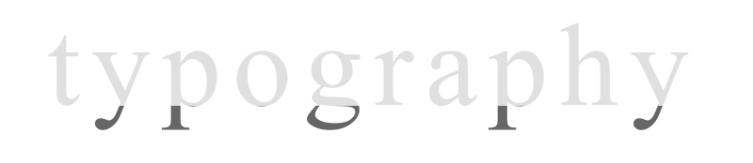
When underline is applied, it covers the descenders on the two y’s, the two p’s, and the g.
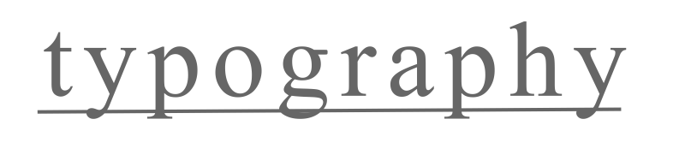
This can make it more difficult to read these characters.
Instead of using underline to emphasize text in your documents, we recommend using the tone of your writing and the words that you choose. In addition to your tone and word choice, you might also use bold or italic formatting, but not for long sections of text.

Contrast 
Use a text color that has strong contrast with the document's background color. See the Contrast video for information on contrast requirements and how to meet them.

Line length
Line length is the number of text characters per line. Very long lines require more time, and greater effort, to visually track from the end of one line to the beginning of the next. Readers may even lose track of which line they are on. Very short lines force a reader to move to the beginning of new lines more often, reducing reading speed. For most documents, between 60 and 100 characters per line is optimal.

White space
The amount of white space in a document is determined by:
- Line length
- The distance between the characters, words, and lines
- The distance between the characters, words, and lines; and the distance between text and other elements (for example, icons).
Documents with too little white space may be difficult for some users to read. The default settings in Word and PowerPoint generally provide an adequate amount of white space, so use caution when decreasing the distance between document elements.

Fortunately, most Word and PowerPoint Themes are legible with their default settings.
By following the recommendations I have covered in this video, if you do make changes to these settings, you should be able to do so without reducing legibility.

