View original page on Canvas

Video

Example File
- Word Examples (.docx)

Guide

The Importance of Headings
Heading formatting and structure is often the most important accessibility component of a document for many users. When a user encounters a document—especially one that is more than a few pages—she or he will often rely upon headings as a visual or structural guide to scan through the document quickly.

Objectives
- Describe how a screen reading software user navigates through a Word document with a heading structure.
- Explain the function of main headings, major headings, and subheadings.

A Critical Component of Optimized Documents
Sighted users usually look for headings that describe sections of content. They may also rely on the visual formatting of these headings to identify sections and subsections. By doing so, they can quickly gain an overview of the content and organization of the document.
Adding heading text to a document’s structure provides an equivalent method for reviewing its content and organization for screen reading software users. In fact, this is one of the most common ways screen reading software users move through a document.
In WebAIM’s ninth screen reader survey, respondents were asked the following question:

When trying to find information on a lengthy web page, which of the following are you most likely to do first?
The top answer was “Navigate through the headings on the page,” chosen by more than two-thirds of respondents.
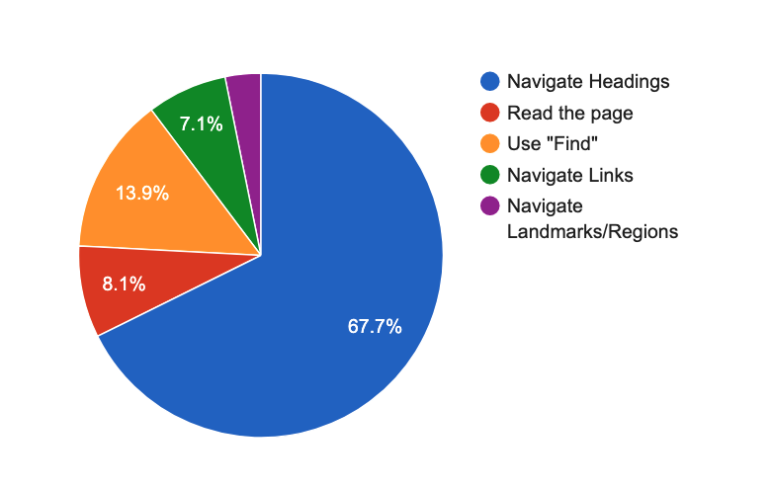
Screen reader users can navigate by headings or scan a list of all available headings in a Word document.
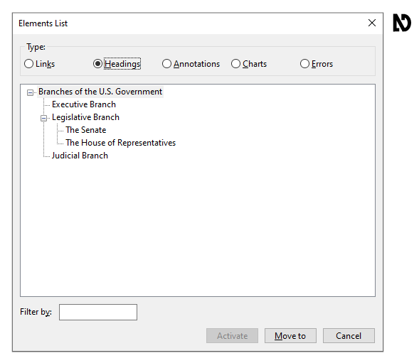
Their software will also identify headings while they are reading through the document. I’ll demonstrate how to review a document’s heading structure in the “Creating Headings” video. For many users who have cognitive or learning disabilities, a well-structured document will help them visually process and understand content.

Heading Structure
Headings should clearly and succinctly describe a section of the document. Just as the order of headings in the document’s structure is critical for accessibility, so is the visual hierarchy of headings.

The Main Heading
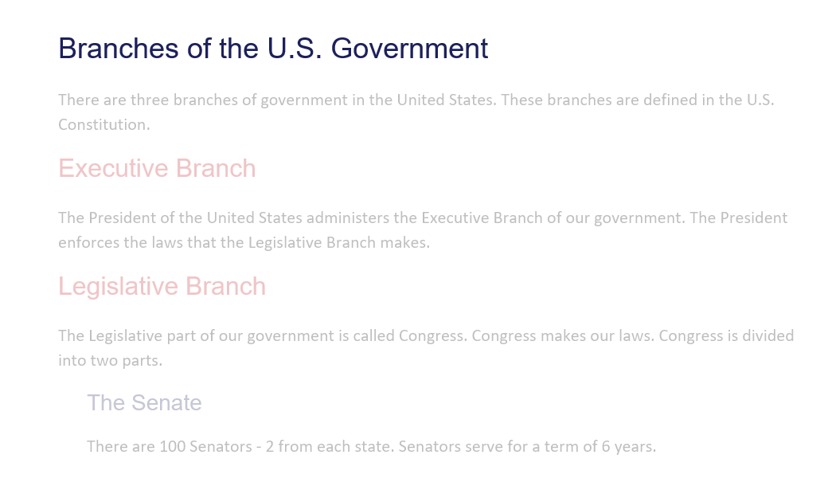
Most documents begin with big, bold text that describes the entire document. This main heading for the document should be defined as a Heading 1. There should generally be only one Heading 1 (or first-level heading) per document. One exception might be a document that is a collection of multiple individual documents, each with its own Heading 1.

Major Headings and Subheadings
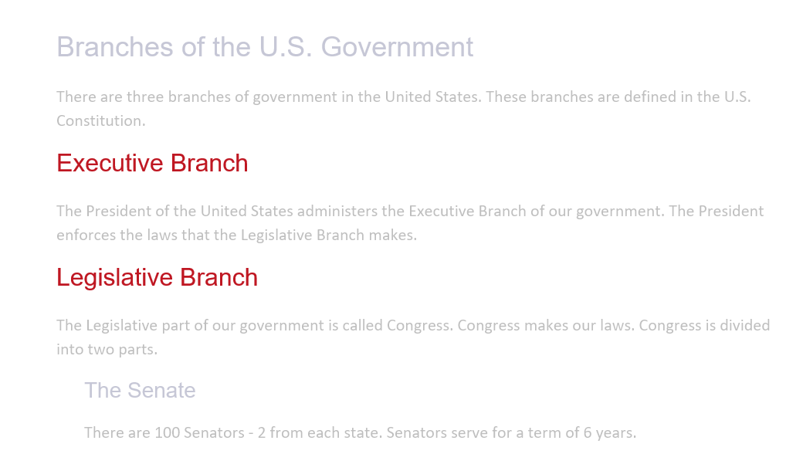
A Heading 2 (or second-level heading) identifies, and should describe, a major section of the document.
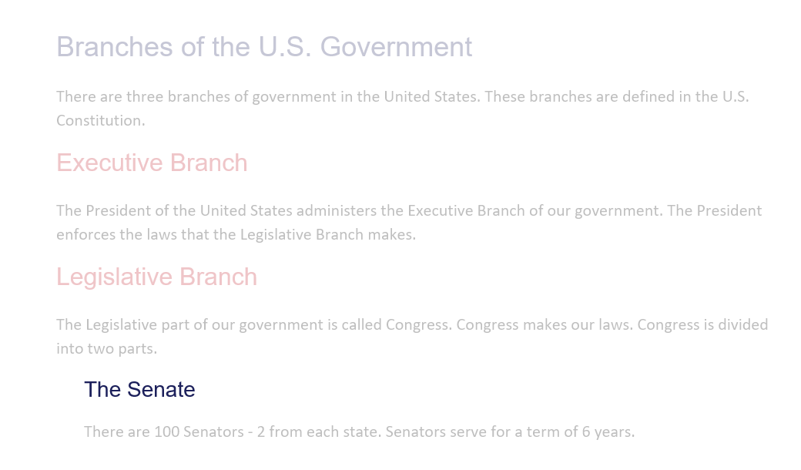
A Heading 3 identifies a subsection of the Heading 2 section, and so on.

Document Structure
Because headings define the document structure, you should not skip heading levels. For example, a Heading 4 should not be the next heading after a Heading 2. There should always be a Heading 3 between a Heading 2 and a Heading 4. No matter how many subsections there are, the next major section is labeled Heading 2.
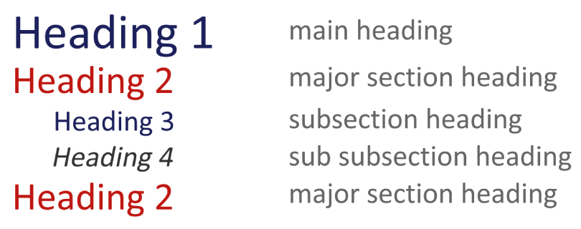

Navigating headings with a screen reader
I will demonstrate how a user of the NVDA screen reading software might navigate through the headings of the example document for this video. It will move from one heading to the next as they are read.
[NVDA speaks]
"Heading level 1—Branches of the US Government; Executive Branch—heading level 2; Legislative Branch—heading level 2; The Senate—heading level 3; The House of Representatives–heading level 3; Judicial Branch–heading level 2."
[narrator resumes]
Now that you understand the purpose of headings, the next step is to create them.

