View original page on Canvas

Video

Example File
- Word Examples (.docx)

Guide

Creating Headings
This video will teach you how to create appropriate headings and apply Heading styles.

Objectives
- Describe the process for creating headings using the Styles gallery.
- State the method for checking that heading text has been added to the correct position in a document’s heading structure.

The Styles Gallery
In Word for Windows and Mac, Headings are created and updated using the Styles gallery. There are some minor differences between the Windows and Mac user interfaces, but these differences do NOT impact the process:
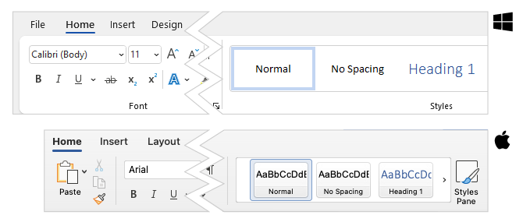

Creating Headings from new text
I'll demonstrate how to create headings from scratch by opening a new document in Word for Windows. When you open a new document, the HOME tab on the Ribbon is active. The Styles tools are located on the right side of the HOME ribbon in the Styles gallery, and by default the only heading styles that are visible are Heading 1 and Heading 2.
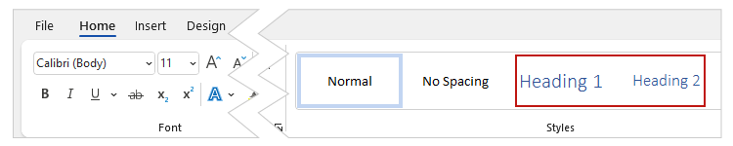
To create my main heading, I'll click Heading 1 and type in my text: “My Main Heading.” Notice that Heading 1 is outlined in the Styles gallery. This reinforces that I’m currently creating a Heading 1. Next, I'll hit Enter to complete my Heading 1 and then paste in some placeholder text for my first paragraph.
To create a second-level heading for my first major section, I will select Heading 2 from the Styles gallery and type in the text: “My First Major Heading.” Now that I've added a Heading 2 to my document, Heading 3 is visible in the gallery.
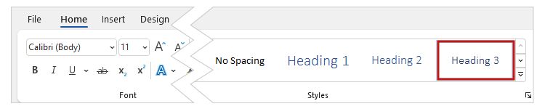
I’ll continue creating my document, adding a Heading 3 and a Heading 4 using the appropriate buttons in the gallery.

Creating Headings from existing text
Next I'll open the example document in Word for Windows.

Reviewing Heading structure

Word
To review any existing heading structure, I will use the Navigation pane. I'll click the VIEW tab on the Ribbon—
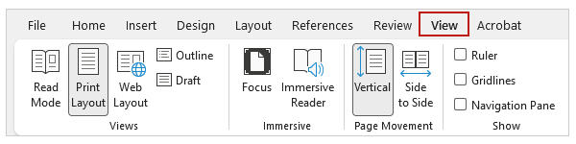
and check the "Navigation Pane" checkbox.
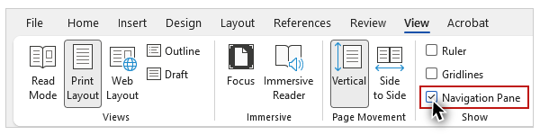
On Windows, you will want to make sure the "Headings" section is activated.
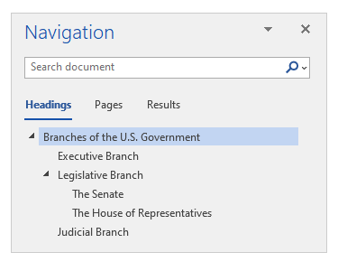

Mac
The Mac user interface has a different look and layout, so I’ll open the example document on a Mac. The process to open the Navigation pane on Mac is the same:
- Click the VIEW tab.
- Check the “Navigation Pane” checkbox.
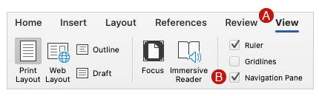
To review the heading structure I’ll click the "Document Map" tab on the pane.
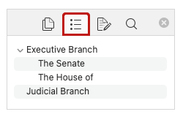

Applying Heading Styles to Text
I’ll return to the example document on Windows. The indented structure of the outline gives an indication of each heading's level. Clicking on a heading will take you directly to that heading in the document.
The text at the top of this document—"Branches of the U.S. Government"—is larger than the other headings, so it has the visual formatting that one would expect for the main heading. However, this text is not listed in the heading structure shown on the navigation pane, so it has not been properly identified with a heading style. I’ll navigate to this text with the mouse or keyboard, and click the HOME tab on the Ribbon to show the Styles gallery. I can see that this text is identified as “Normal” but it doesn’t look like normal text, so its visual appearance must have been changed with the “Font” tools on the HOME tab. To make this a first-level heading, I’ll click the Heading 1 button. Now this text has the Heading 1 formatting applied and it is added to the document’s heading structure.
Next, I'll click within the text that looks like the first major heading—"Executive Branch". In the navigation pane I see that it is indented below the Heading 1 I just added to the heading structure, and it’s identified as a Heading 2 in the Styles gallery. This text has the correct visual formatting and it is located in the right place in the heading structure.
Moving on to the "Legislative Branch" text—which looks identical to "Executive Branch"—in the navigation pane I can see that it has not been properly identified as heading because it is not listed.

Shortcut Keys
To correct this, I'll use the shortcut keys that are available to apply heading styles. In Windows, press Control + Alt + the numbers 1, 2, or 3 to identify first-, second-, and third-level headings. On a Mac, press Command + Option + 1, 2, or 3. I'll highlight this text and press Control + Alt + 2 to make it a Heading 2.

Ordering Headings
The next lines of text that look like headings are "The Senate" and "The House of Representatives". They are listed in the navigation pane below the heading I just created, but when I place my focus on one of them, I see that it has been identified as a Heading 4. As you learned in the video "The Importance of Headings", heading levels must not be skipped, so I will change both of these headings from Heading 4 to Heading 3. In both cases, this heading text now has the correct visual formatting, and it is listed in the correct position in the heading structure.
Now that you know how to create and identify headings, in the next video you will learn how to modify the appearance of your headings, while maintaining an accessible heading structure.

