View original page on Canvas

Video

Example Files
- Word Example (.docx)
- Word Example | No Headings (.docx)

Guide

Modifying Headings
This video will review how to change the appearance of headings. Before modifying headings, you may want to review the Legibility video to ensure that your visual changes to headings will not impact accessibility.

Objective
- Identify the processes for modifying Heading styles.

Modifying Heading Styles
If the default headings styles do not suit you, there are two ways to modify the appearance of an individual Heading style:
- Change the formatting with Modify Style.
- Change the formatting with Update to Match Selection.

Modify Style
I'll open the example file on a Mac and demonstrate how to change the appearance of a Heading 3 within the Styles gallery.


To modify a heading style on Mac (or Windows):
- Right-click a Heading type in the Styles gallery and select "Modify".
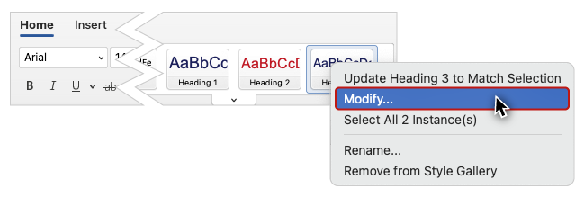
- In the Modify Style dialog, make formatting changes such as: font style, size, or color; alignment, line spacing, or indentation.
- Click "OK."
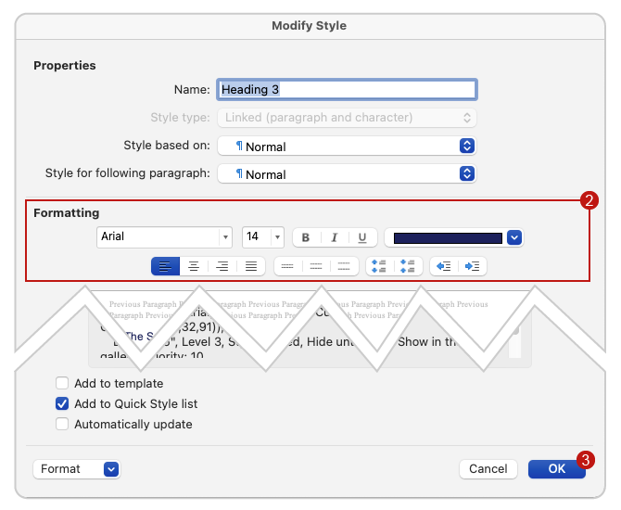
The formatting changes that I made—from blue normal text to black italicized text—have been applied to both instances of Heading 3. These changes will also be applied to any new Heading 3 that I add.

Update to Match Selection
You may find yourself working with a document that has heading text with a visual formatting style that you like, but the text is not listed in the document’s heading structure. “Update to Match Selection” allows you to change the visual appearance of a Heading style, and add the text to the heading structure at the same time.
I'll open the No Headings example on a Mac. This document looks like it has headings, but when I use the Navigation Pane
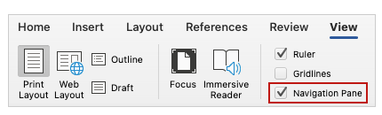
to view the Document Map,
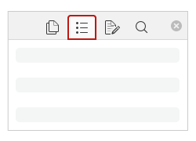
I can see that none of the text is defined as a heading. I'll start with this text that should be identified as Heading 1.


To apply the current formatting to a heading style on Mac (or Windows):
- Highlight or click within the formatted text.
- Right-click the appropriate Heading type in the Styles gallery.
- On the menu, select "Update to Match Selection."
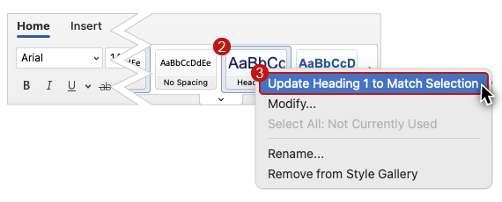
This text is now properly identified as a Heading 1 and has my desired formatting.
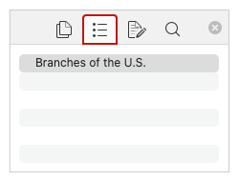
I can quickly use “Update to Match Selection” to define the remaining headings and customize their styles to the current formatting.
I can also use this technique to make quick changes to heading styles. I will change this Heading 3 text to be italic and black, then update the Heading 3 style in the gallery to match the selection. This new formatting is now applied to both instances of Heading 3.
By modifying the visual formatting of your headings using Styles, you will preserve any existing document structure. Modifying your headings’ formatting will also be easier––especially with larger documents––as any change to one heading is automatically applied to other headings that are identified at the same level. In the next video you will learn how a proper heading structure can also be used to easily generate a table of contents.

