View original page on Canvas

Video

Guide

Themes and Layouts
Microsoft PowerPoint is often used to organize thoughts for a meeting or a lesson, to present key points in a live presentation, and to even create standalone lessons. Leveraging PowerPoint's built-in Themes and Templates correctly will allow you to create a solid foundation for accessibility.

Objectives
- State two advantages of using built-in slide Layouts.
- Describe the function of a Title Placeholder.

Themes and Templates
The Windows and Mac versions of PowerPoint 365 are very similar. In the three videos in this section I’ll be demonstrating processes in Windows, and I’ll point out any significant differences in the Mac version.
The first step in creating a PowerPoint presentation is choosing a slide theme. Although you can change a presentation's theme at any time, we recommend selecting a theme as early as possible. I’ll open a blank presentation on Windows, and go to the DESIGN tab on the Ribbon. I see several built-in Themes that are available.
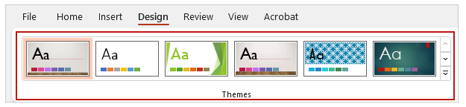
If I want to see more themes, I can use the up and down selector buttons to navigate between the different rows, or click the “more” button to open up a gallery.
Be sure to choose a theme with good contrast and simple backgrounds. Please keep in mind that a presentation that will be projected onto a screen may require more contrast between slide elements. Unfortunately, some of Office’s built-in themes do not meet contrast requirements. As an example, I’ll select the "Metropolitan" theme and run a check on it.
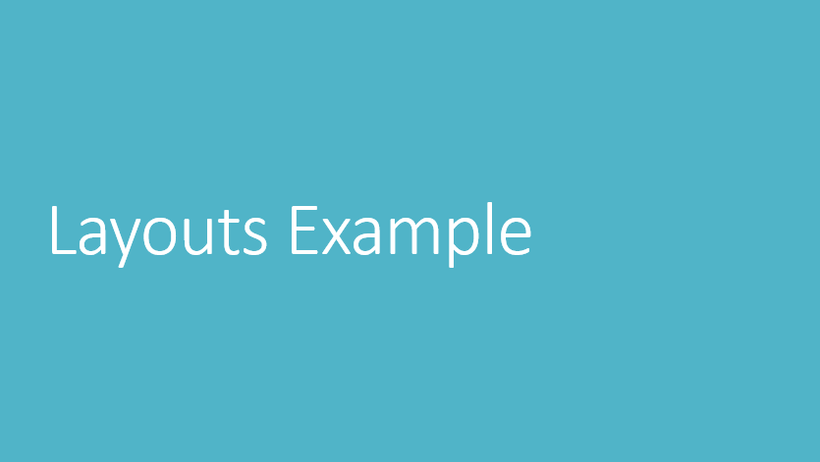
I’ll open the WebAIM's Color Contrast Checker that was introduced in the Contrast: Part 1 video in Module 1. When I click the paint chip and use the built-in eyedropper tool to measure the color values of the white text and the aqua background, the tool calculates a contrast ratio of 2.28:1. This does not meet the WCAG requirement of at least 3:1 for large text.
I'll re-open the Themes menu, and select the “Gallery” theme, which appears to have good contrast and legibility.
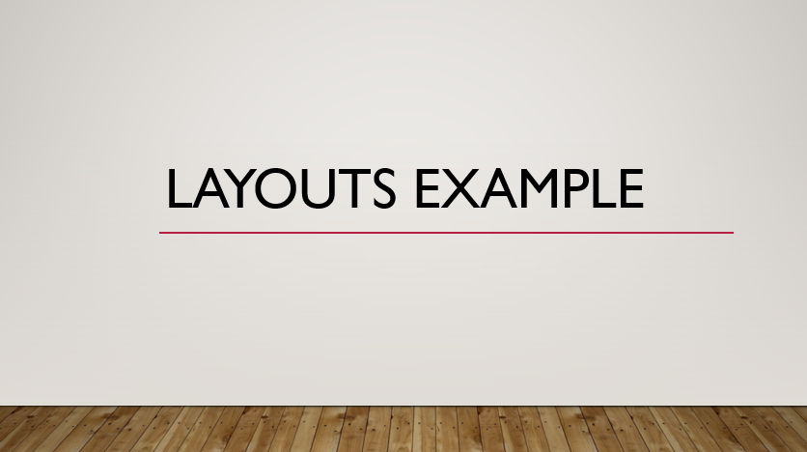
I’ll reuse the Contrast Checker to measure the color values of the black text and the tan background. With a contrast ratio over 15:1 this theme has excellent contrast.

Online Templates
In addition to the built-in themes, there are thousands of themes available for download when connected to the internet. I’ll select File > New,
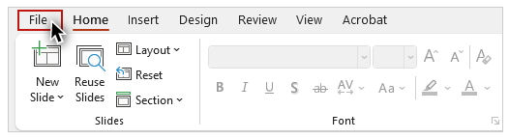
and then type in the word “accessible” in the search field:
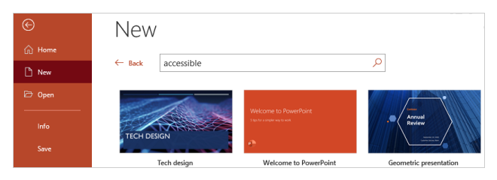
While this doesn’t guarantee that the theme will meet accessibility guidelines, it does increase the likelihood. Microsoft also has an online Accessible PowerPoint template sampler that you can reach through the Resource Links for this section.

Slide Layouts
The default slide in my new presentation uses the Title Slide layout. The title on this slide applies to the whole presentation, and it functions like the Heading 1 in a Word document. I’ll enter “My Presentation” into the text field for the title.

Create a new slide with the default Layout


To create a new slide on Windows:
- Select the HOME tab on the Ribbon.
- Click the top half of the"New Slide" tool.
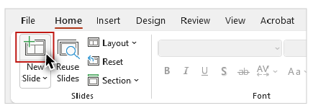
I could also navigate to the Insert tab on the Ribbon and use the “New Slide” tool there.
Layouts are a key factor in creating a PowerPoint presentation that is optimized for accessibility. When used correctly, layouts ensure that a slide has the correct structure to support assistive technologies.
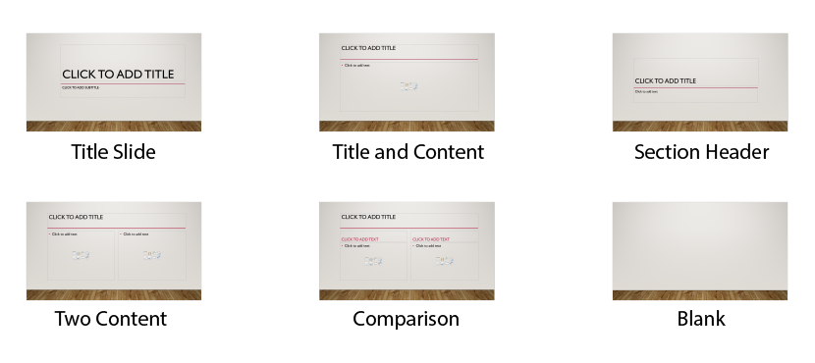
With the exception of the Blank layout, layouts include one or more Placeholder areas for adding content such as a title, text, or an image.
When I added a new slide, the Title and Content layout was used by default. Like most layouts, this slide has a Title placeholder at the top of the slide. While the main title entered into the Title Slide layout is presented like a Heading 1, titles on subsequent slides are presented the same way as a Heading 2.
Most users will benefit from a title that is concise and descriptive. Provide each slide with a unique title when possible, keeping in mind that screen reading software users may use them to navigate a presentation. I’ll enter the text “My First Slide” into the Title placeholder. This slide also has a Content placeholder for adding text, and other slide elements such as a table, chart, or image.
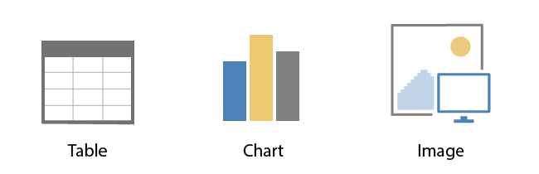

Create a new slide with a specific Layout
If I wanted to have text and an image, I would select a different layout. Although you can change the layout of a slide at any time, we recommend choosing your layout when creating a new slide.

Windows


To create a new slide with a specific layout on Windows:
- Select the Hᴏᴍᴇ tab on the Ribbon
- Click the bottom-half of the "New Slide" tool to open the gallery of layout options.
- Select a layout.
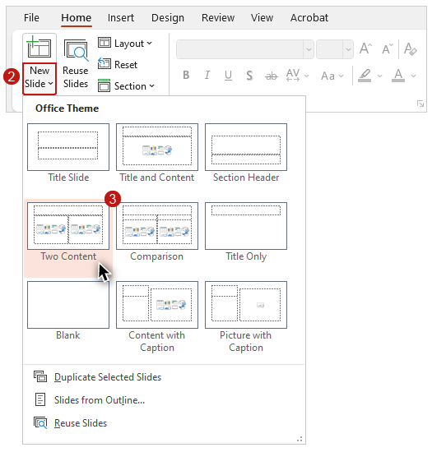
I’ll choose “Two Content.”

Mac
The New Slide tool is slightly different on Mac.


To create a new slide with a specific layout on Mac:
- Select the HOME tab on the Ribbon.
- Click the down arrow symbol on the right side of the New Slide to open the gallery of layout options.
- Select a layout.
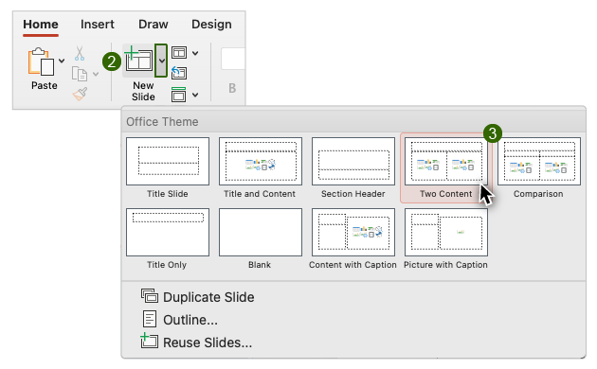

Change a slide layout
It is also possible to change the layout for a slide that you have already created.


To change the layout of an existing slide:
- Select the slide you would like to change.
- On the HOME tab, select Layout.
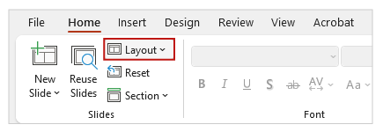
- Choose the desired layout from the Gallery.
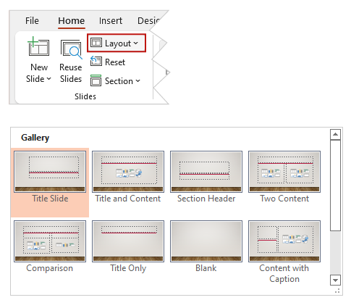
PowerPoint will try to move the slide contents to the correct place in the new layout. If you’re moving from one layout to another—for example, from Title and Content to Two Content—this usually works fairly well. But when you have a slide with content that is not in a placeholder—for instance, if you’ve selected the Blank layout, and then added a picture—applying a new layout will require additional work like cutting and pasting, and deleting unused boxes. In this case, it is often easier to add your content to a new slide created with a built-in layout.
Now that you have been introduced to the accessibility benefits of themes and layouts, in the next video you will learn about making changes to existing layouts, and how to create your own custom layouts.

